Sanctuary OS Master Design Manual
Version 1.2 — Sanctuary Control Plane and Commissioning Standard
This document serves as the master reference for Sanctuary OS and defines its vision, philosophy, room identities, lighting standards, and automation architecture.

Vision
Build the most intentional apartment possible. The home should feel premium, calm, intelligent, and personal. Luxury comes from consistency, not cost.

Core Principles
• Guide instead of command.
• One emotional purpose per automation.
• One primary room per mode.
• Supporting rooms echo the primary room.
• Background rooms stay unobtrusive.
• Never interrupt an occupied room unless required.
• Technology should disappear into the experience.

Room Identity
Office — Command Center
Bedroom — Recovery
Bathroom — Wellness
Living Room — Hospitality
Dining Area — Transition
Kitchen — Nourishment
Hallway — Navigation
Entry — Welcome
Patio / Outside — Reflection and Decompression

Daily Timeline
6:30 Sunrise Start
6:40 Sunrise Progress
6:50 Sunrise Activation
7:00 Full Wake & Launch
7:20 Launch Window
9:30 Wind Down
10:00 Thunderstorm Bedtime
10:30 Deep Sleep

Lighting Standards
Default Ambient: warm, layered, and low-to-moderate brightness.
Night Path: very dim warm light only where navigation is required.
Wind Down: low blue transitioning toward Thunderstorm blue.
Home Base: 2700–3000K at comfortable moderate brightness.
Studio / Learn / Focus: task-appropriate neutral light without unnecessary maximum brightness.
Business: brighter professional light limited primarily to the Office and supporting Living Room.
Cleaning and detailed task modes: high-output light only where visibility requires it.
Sunrise: gradual increase from dim warm light toward alerting neutral light; abrupt full brightness is prohibited.

Architecture
Household:
SP-001 Sleep
SP-002 Morning
SP-003 Welcome Home
Personal:
Studio Launch
Focus
Create
Business
Learn
Recover
Victory

Future Roadmap
Cleaning, Vacation, Date Night, Security, Away, Wellness, Entertainment, Motion Sensors, Smart Speakers, Presence Detection, AI Assistant.

Constitution
1. Every room has a purpose.
2. Every light communicates a state.
3. Every automation should reduce cognitive load.
4. Build systems, not isolated automations.
5. Consistency creates luxury.

Document Governance

Document Name: Sanctuary OS Master Design Manual

Version: 1.2

Status: Production

Owner: Giovanni Biscotti

Effective Date: July 18, 2026

Last Updated: August 23, 2026

Purpose

This document is the single source of truth for the Sanctuary OS environment.

Change Policy

All permanent design, automation, equipment, and operating decisions shall be reflected in this manual before implementation. Future changes shall be recorded as versioned revisions.

Terminology Standard

“Dining Area” is the canonical term for the apartment’s two-seat dining and romance space and shall be used in device names, routine names, chapter references, and operating instructions.

Chapter 1 — Welcome to Sanctuary

1.1 Introduction

Sanctuary OS is an intentional home operating system designed around the principle that a home should actively support the life of the person living in it. Unlike traditional smart homes, which focus on controlling individual devices, Sanctuary focuses on designing complete experiences.

Within Sanctuary, lights are not treated as isolated bulbs, rooms are not treated as isolated spaces, and automations are not treated as isolated routines. Every component exists as part of a unified system whose purpose is to reduce cognitive load, create emotional consistency, and make daily life feel more effortless.

The apartment itself becomes an active participant in the day. Rather than demanding attention through notifications, reminders, or excessive automation, it communicates through subtle environmental changes. A shift in light color, brightness, or room emphasis becomes a language that quietly guides behavior.

The objective is not to build the smartest apartment possible. The objective is to build the most intentional apartment possible.

1.2 What Sanctuary Is

Sanctuary OS is an operating philosophy for living spaces.

It combines environmental psychology, interior design, lighting design, automation, and future artificial intelligence into a single system.

Instead of asking, “What should this light do?” Sanctuary asks, “What should this room help me accomplish?”

Every decision begins with purpose. Technology exists only to reinforce that purpose.

1.3 Mission Statement

The mission of Sanctuary OS is to create an environment that quietly supports focus, recovery, productivity, creativity, wellness, and rest by allowing the apartment itself to adapt to the natural rhythm of daily life.

Every automation should reduce effort. Every room should communicate intention. Every experience should feel calm, consistent, and purposeful.

1.4 Vision Statement

The long-term vision of Sanctuary OS is to create a home that understands its occupant well enough to become an invisible partner in daily life.

Instead of reacting only to commands, the home should eventually understand routines, anticipate transitions, and adapt its environment accordingly while always leaving the occupant in control.

Sanctuary should never feel robotic. It should feel natural.

1.5 The Sanctuary Philosophy

Sanctuary is built on a simple belief: A home should improve the quality of life of the person living inside it.

That improvement does not come from owning more technology. It comes from using technology intentionally.

An expensive-looking home is not created by purchasing expensive objects. It is created through consistency, thoughtful design, restrained use of color, quality lighting, and spaces that each serve a clearly defined purpose.

Luxury is experienced through atmosphere rather than price.

1.6 Design Goals

Every design decision within Sanctuary OS should satisfy one or more of the following goals:

• Reduce mental effort.
• Encourage healthy routines.
• Support productivity without creating stress.
• Make transitions between activities feel natural.
• Create emotional consistency throughout the apartment.
• Make technology feel invisible.
• Improve comfort without increasing complexity.
• Allow the apartment to evolve over time without losing coherence.

If a proposed feature does not contribute to one of these goals, it should be reconsidered.

1.7 What Makes Sanctuary Different

Traditional smart homes focus on devices: turning lights on with voice commands, scheduling lights to turn off, controlling thermostats remotely, or playing music through speakers.

Sanctuary views those features as tools rather than objectives. The objective is to create meaningful environmental states.

Sleep is not simply turning off lights. Sleep is a carefully designed transition from activity to recovery.

The studio is not simply illuminating the office. It transforms the apartment into a workspace where the office becomes the primary destination and surrounding rooms quietly support that purpose.

1.8 Success Criteria

Sanctuary OS is successful when:

• The apartment feels calmer than it did before.
• Daily routines require less conscious effort.
• Lighting naturally communicates what the apartment is doing.
• Automations are rarely noticed because they feel expected.
• Every room contributes to a larger experience.
• New technology integrates without disrupting existing design principles.
• Guests notice that the apartment feels intentional, even if they cannot immediately explain why.

1.9 Scope

Version 1.1 of Sanctuary OS governs apartment design, lighting, automation, smart-home hardware, daily routines, room identity, environmental psychology, and future expansion planning.

Future versions will extend Sanctuary to include adaptive artificial intelligence, advanced sensors, predictive automation, and additional living spaces.

1.10 Guiding Principle

The defining principle of Sanctuary OS is: The home should quietly guide the person, never compete for their attention.

Technology should not become the focal point of the home. The person should remain the center of the experience.

End of Chapter 1

1A. Apartment Floor Plan

This floor plan is the spatial foundation of Sanctuary OS. It reflects the apartment’s actual orientation, with the kitchen to the left upon entry, and identifies the second bedroom as the Office. All room identities, lighting zones, pathways, automations, and future sensor placements reference this layout.

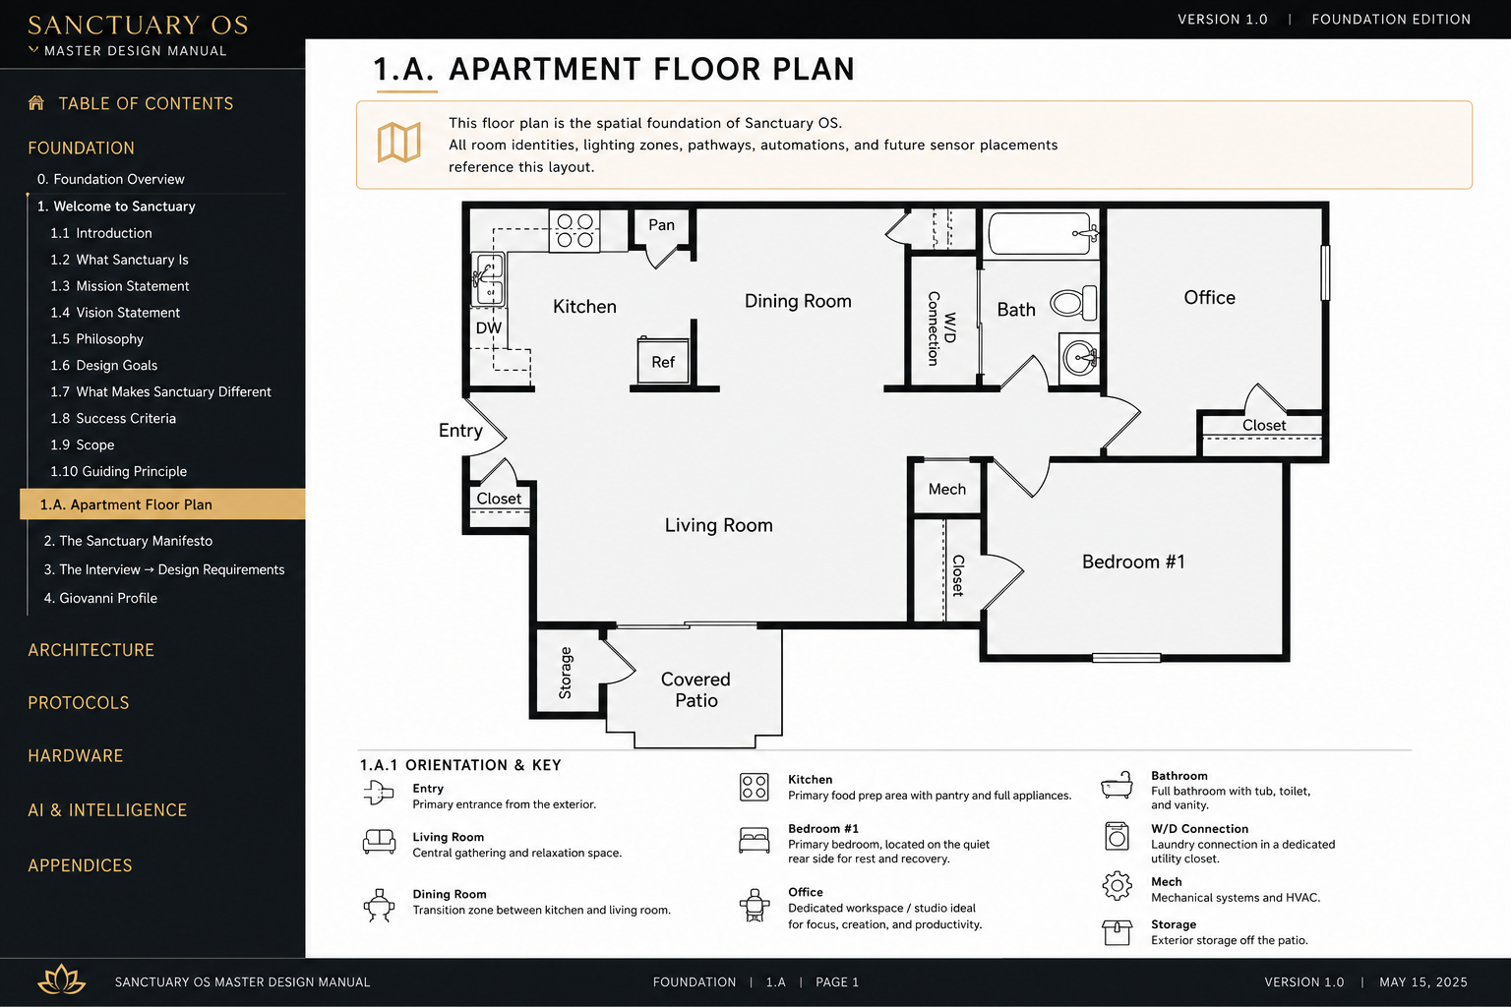
Figure 1. Official Sanctuary OS foundation blueprint. The Office replaces Bedroom #2, and the mirrored orientation matches the apartment as experienced from the entry.

1B. Existing Conditions Photo Survey

Photo LR-001 — Living Room Entry View
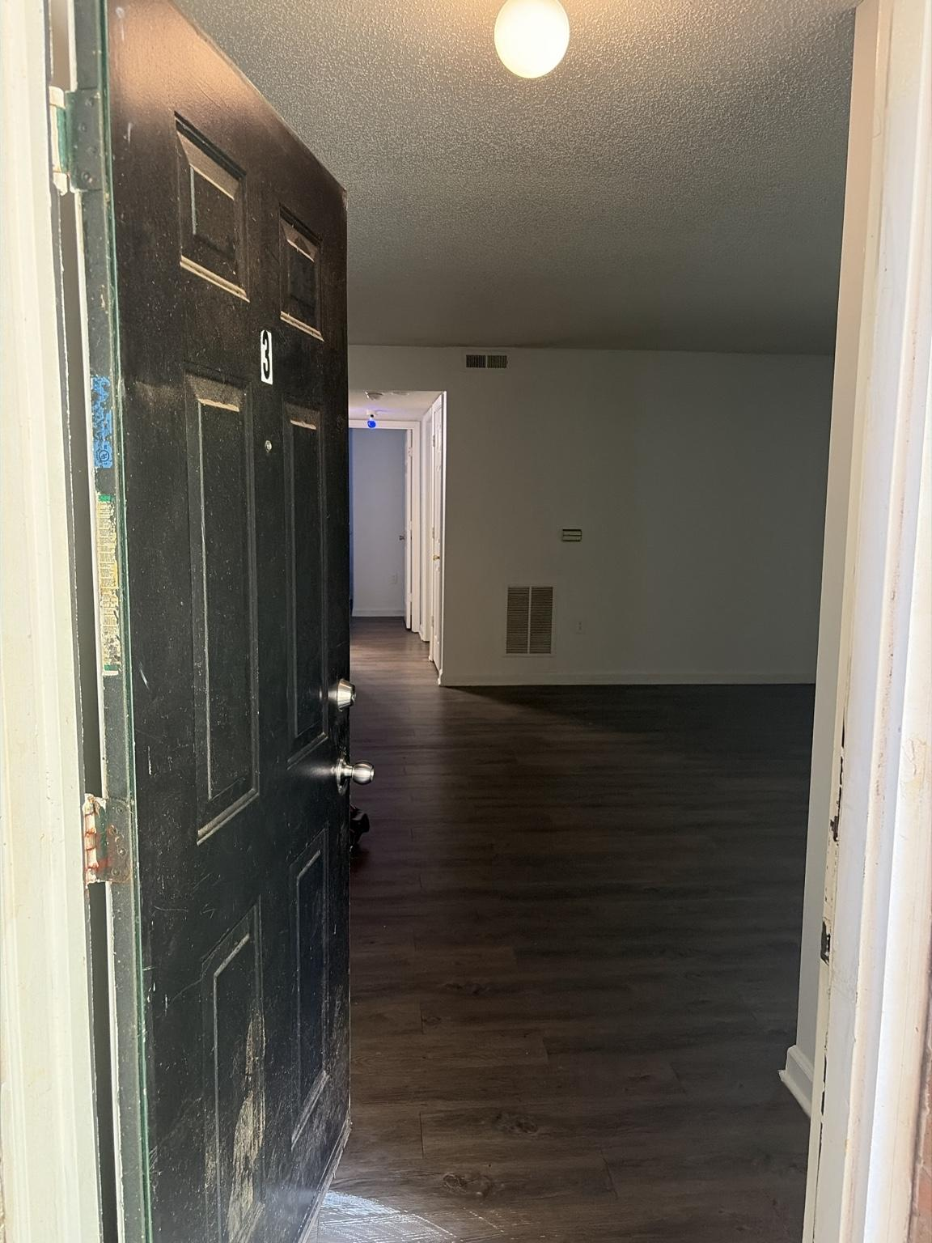
Figure 2. LR-001 documents the apartment from the open front door, looking across the living room toward the private-room hallway.

Observed conditions:
• The living room functions as both the arrival zone and the apartment’s principal circulation hub.
• Dark wood-look flooring continues from the living room into the hallway, creating visual continuity.
• The walls and trim form a neutral white architectural shell suitable for the warm-modern Sanctuary design language.
• A single ceiling fixture near the entry provides the visible built-in illumination in this view.
• The main interior wall contains the thermostat, a low return-air grille, and an upper supply vent; these elements must remain unobstructed.
• The hallway establishes the direct route from the entry toward the Bedroom, Bathroom, and Office.
• The open floor area must preserve a clear entry-to-hallway travel path when furniture and rugs are installed.

Design and system implications:
• The Living Room remains the primary room for Welcome and Arrival behavior.
• Entry lighting should provide immediate orientation without making the entire living room excessively bright.
• Furniture placement shall preserve access to the thermostat and HVAC grilles.
• Future ambient lighting, entertainment equipment, and decorative layers should reinforce Hospitality while keeping technology visually restrained.
• This photograph records existing conditions only; measurements and unseen wall, outlet, window, and fixture details require confirmation from subsequent photographs.

Photo EN-001 — Interior Entry and Front Door

Fi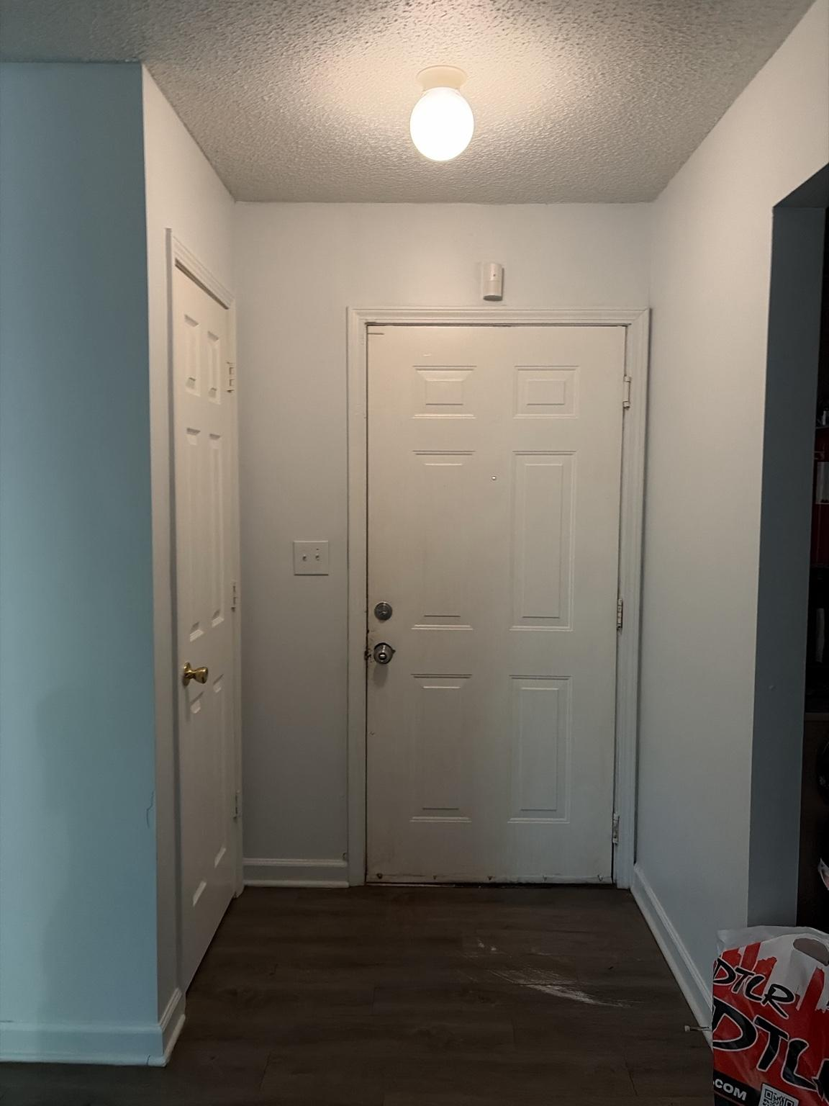gure 3. EN-001 documents the interior entry vestibule facing the apartment’s flat-panel front door.

Observed conditions:
• The flat-panel door centered in the image is the apartment’s front door.
• A ceiling-mounted entry light provides the primary built-in illumination for the vestibule.
• A two-position wall control is located to the left of the front door.
• The first switch controls the entry light.
• The second switch controls power serving the internet equipment and must remain on at all times.
• The door positioned on the left side of the vestibule is the entry closet door.
• Dark wood-look flooring continues through the entry and into the adjoining living area.
• The entry is compact and must remain clear for safe arrival, departure, and access to the front door.

Control and safety requirements:
• EN-SAF-001 — The second wall switch shall never be operated by Sanctuary automations, routines, smart relays, guests, or normal manual-lighting behavior.
• EN-SAF-002 — The second wall switch shall be treated as protected infrastructure because switching it off disconnects internet service.
• EN-SAF-003 — Any future smart-switch installation at this wall plate must control only the first switch circuit unless an electrician positively identifies and isolates the circuits.
• EN-SAF-004 — The protected internet-power switch should receive a physical guard, lockout cover, or clear label to prevent accidental operation.
• EN-SAF-005 — Entry-light automations shall target the light device directly and shall not depend on toggling the protected second switch.

Design and system implications:
• The Entry remains the primary Welcome zone and the first environmental cue experienced on arrival.
• Entry lighting should activate promptly while preserving a calm transition into the Living Room.
• Decorative additions must not obstruct the front door, wall controls, or entry closet door.
• The internet-power circuit is a critical system dependency and must remain continuously energized.

Photo LR-002 — Living Room Entry-Wall View

Fig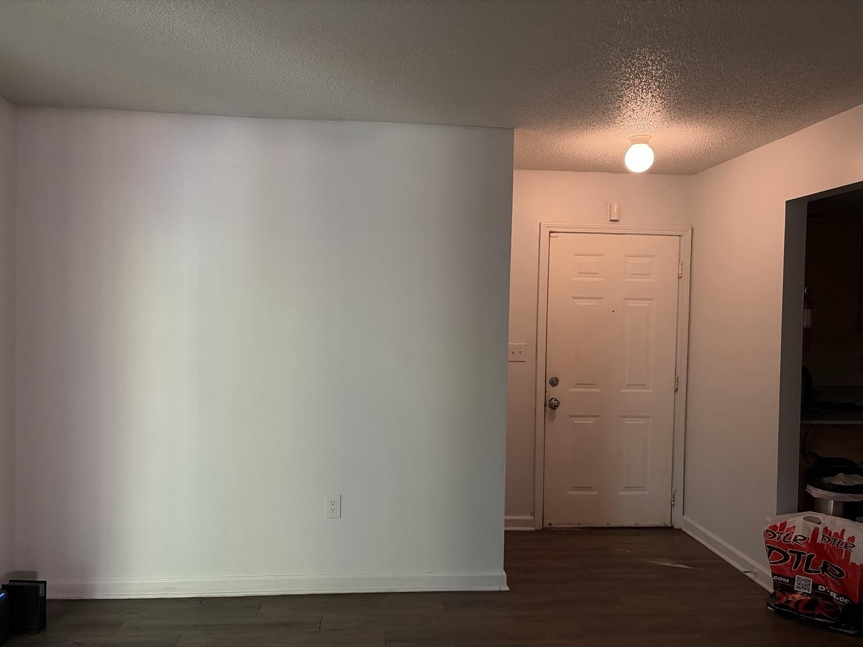ure 4. LR-002 documents the living room wall adjacent to the entry vestibule, with the front door and open entry closet visible to the right.

Observed conditions:
• A broad, largely uninterrupted wall occupies the left and center of the view.
• One standard wall receptacle is visible low on this wall.
• The wall projects forward from the entry vestibule, creating a clear architectural separation between the main living area and the front-door zone.
• The front door, entry ceiling light, and protected two-switch wall control remain visible from the living room.
• The entry closet is shown open at the far right, confirming its direct adjacency to the front door.
• Dark wood-look flooring continues continuously across the living room and entry.
• The ceiling plane changes at the vestibule, visually distinguishing the Entry from the larger Living Room.

Design and system implications:
• The large blank wall is a high-value furnishing and display surface, but its final use must be coordinated with the opposite-wall layout, circulation, and confirmed room dimensions.
• Any furniture placed on this wall must preserve access to the visible receptacle and maintain a clear approach to the front door and entry closet.
• The Entry and Living Room have a direct visual relationship; entry-light color and brightness will influence the perceived atmosphere of the living room.
• The entry closet should remain functional storage rather than becoming visually overloaded or blocked by living-room furniture.
• Because the wall is visible immediately upon entry, artwork, furniture scale, cable management, and surface condition will materially affect the apartment’s first impression.
• Final designation of this wall as a television wall, sofa wall, console wall, or art wall remains pending additional photographs and measurements.

Photo LR-003 — Living Room Patio-Door Wall

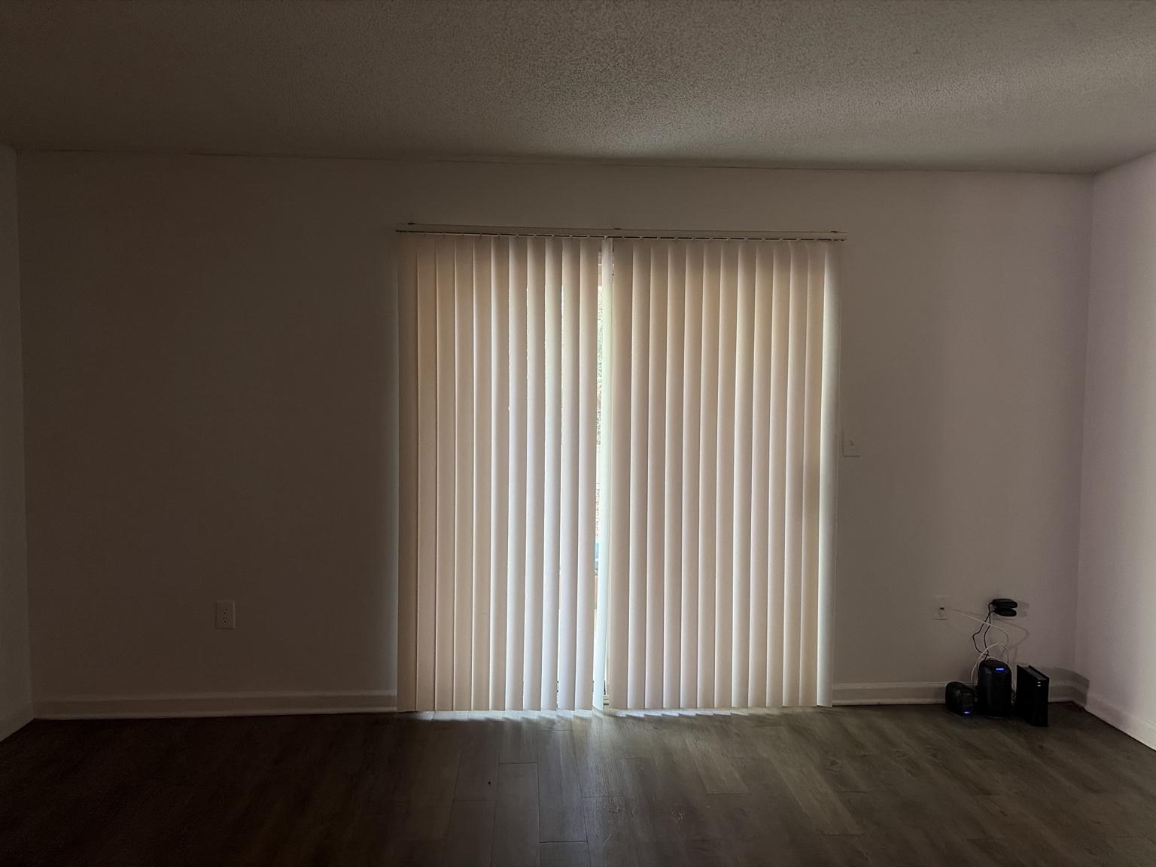Figure 5. LR-003 documents the exterior-facing living-room wall centered on the sliding patio door and vertical blinds.

Observed conditions:
• A wide sliding glass patio door forms the primary source of natural light for the living room.
• White vertical blinds currently provide privacy and daylight control.
• The opening is centered within a broad wall, leaving usable wall area on both sides.
• A standard wall receptacle is visible to the left of the patio door.
• A wall control or switch plate is visible to the right of the patio door.
• Networking equipment and associated exposed cabling are currently located low in the right corner near wall power and service connections.
• Dark wood-look flooring continues to the patio threshold.
• The patio-door path requires permanent clearance for access, ventilation, daylight, and exterior use.

Design and system implications:
• The patio opening is the living room’s principal daylight feature and should remain visually unobstructed.
• Furniture placement must preserve a direct walking path to the sliding door and allow the blinds to rotate and traverse freely.
• Tall furniture should not crowd either side of the opening or materially reduce daylight distribution.
• The networking equipment should remain continuously powered, ventilated, and serviceable while receiving improved cable management and a visually restrained enclosure or placement solution.
• Any enclosure around networking equipment must not trap heat, block wireless performance, or prevent access to power and service connections.
• Future window treatments may add a more finished appearance, but they must be compatible with the sliding-door operation and apartment rules.
• Daylight from this wall should be considered when locating the television to reduce glare and reflections.
• Future patio-door or daylight sensors could support Arrival, Away, climate-awareness, and natural-light-responsive lighting behavior.

Photo LR-004 — Living Room HVAC and Hallway Wall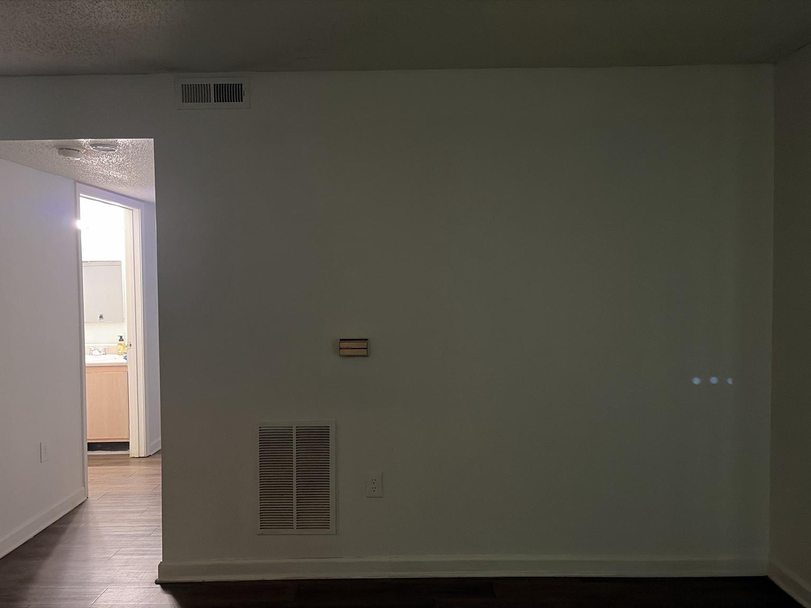

Figure 6. LR-004 documents the living room’s interior HVAC wall and the adjacent opening toward the private-room hallway and bathroom.

Observed conditions:
• The wall contains a high supply-air register, a centrally mounted thermostat, and a large low return-air grille.
• A standard wall receptacle is located to the right of the return-air grille.
• The wall is broad but functionally constrained by the HVAC components and thermostat.
• The opening at the left leads toward the hallway, with the bathroom visible beyond.
• The hallway opening creates a direct sightline from the living room into the bathroom when its door is open.
• Flooring continues without a threshold change from the living room into the hallway.
• The wall’s right side terminates at an inside corner, creating a shallow furniture zone rather than a fully uninterrupted feature wall.

Control, clearance, and furnishing requirements:
• LR-HVAC-001 — Furniture, artwork, acoustic panels, curtains, and decorative objects shall not cover or materially restrict the upper supply register or lower return-air grille.
• LR-HVAC-002 — The thermostat shall remain visible, reachable, and exposed to representative room air; heat-producing electronics or lighting shall not be placed immediately around it.
• LR-HVAC-003 — A clear service path shall be maintained to the return grille and thermostat.
• LR-HVAC-004 — Furniture placed along this wall must remain low-profile or offset sufficiently to preserve airflow and receptacle access.
• LR-HVAC-005 — Sanctuary lighting and media equipment shall not create localized heat or direct radiant light that could distort thermostat readings.

Design and system implications:
• This wall is unsuitable for a full-width built-in, oversized media installation, or dense gallery treatment because the HVAC system must remain visually and physically unobstructed.
• The usable wall areas may support restrained artwork or narrow furnishings only after exact grille, thermostat, outlet, and furniture dimensions are confirmed.
• The direct bathroom sightline should be considered when planning guest presentation, door habits, and nighttime lighting.
• The hallway opening reinforces the Living Room’s role as the central circulation hub connecting the public and private zones.
• Future temperature, occupancy, or air-quality sensors should not be mounted directly beside the supply register, return grille, or thermostat because airflow could bias readings.

Photo PT-001 — Covered Patio Existing Conditions Survey

Figures 7–11. PT-001A through PT-001E document the ground-level covered patio from the exterior, side approach, interior floor area, exterior light, storage-door wall, and sliding-door junction.

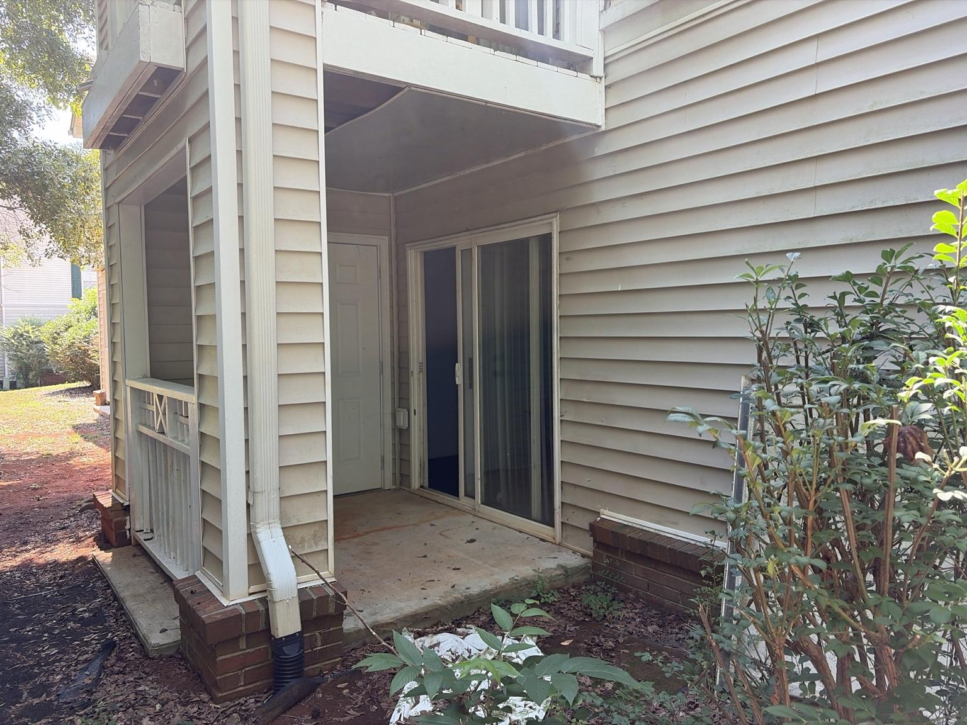
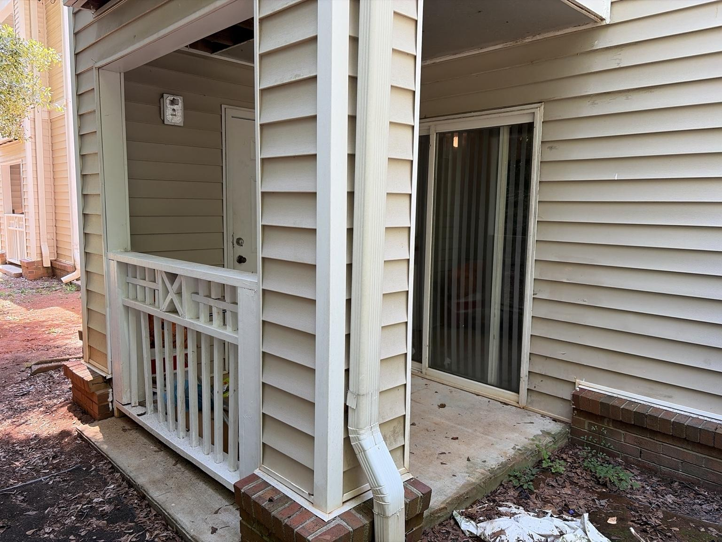
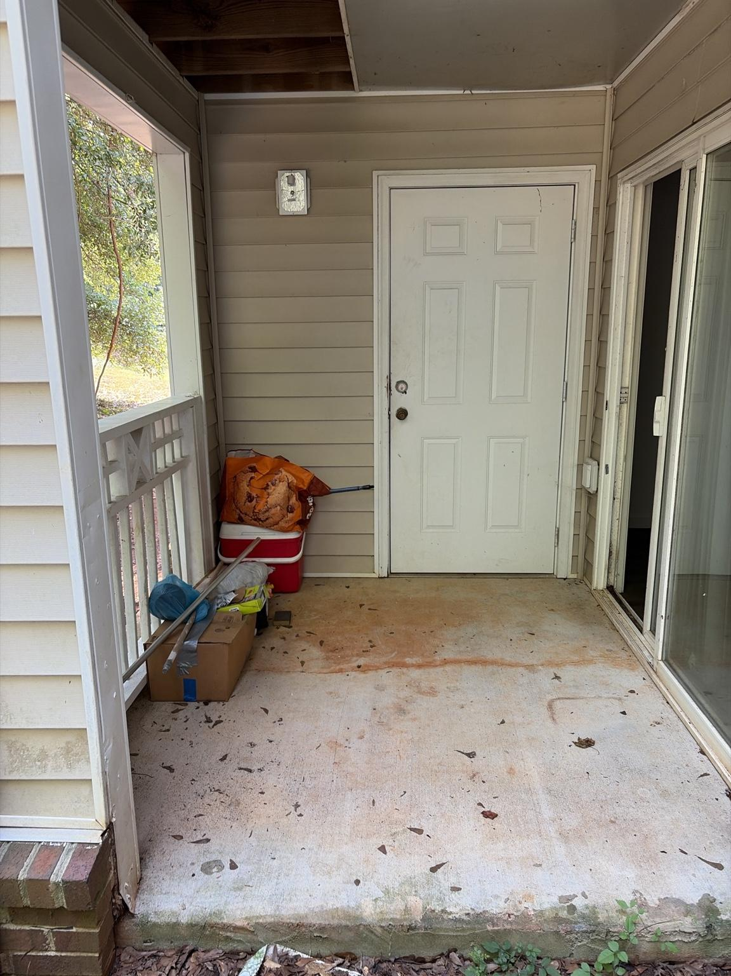
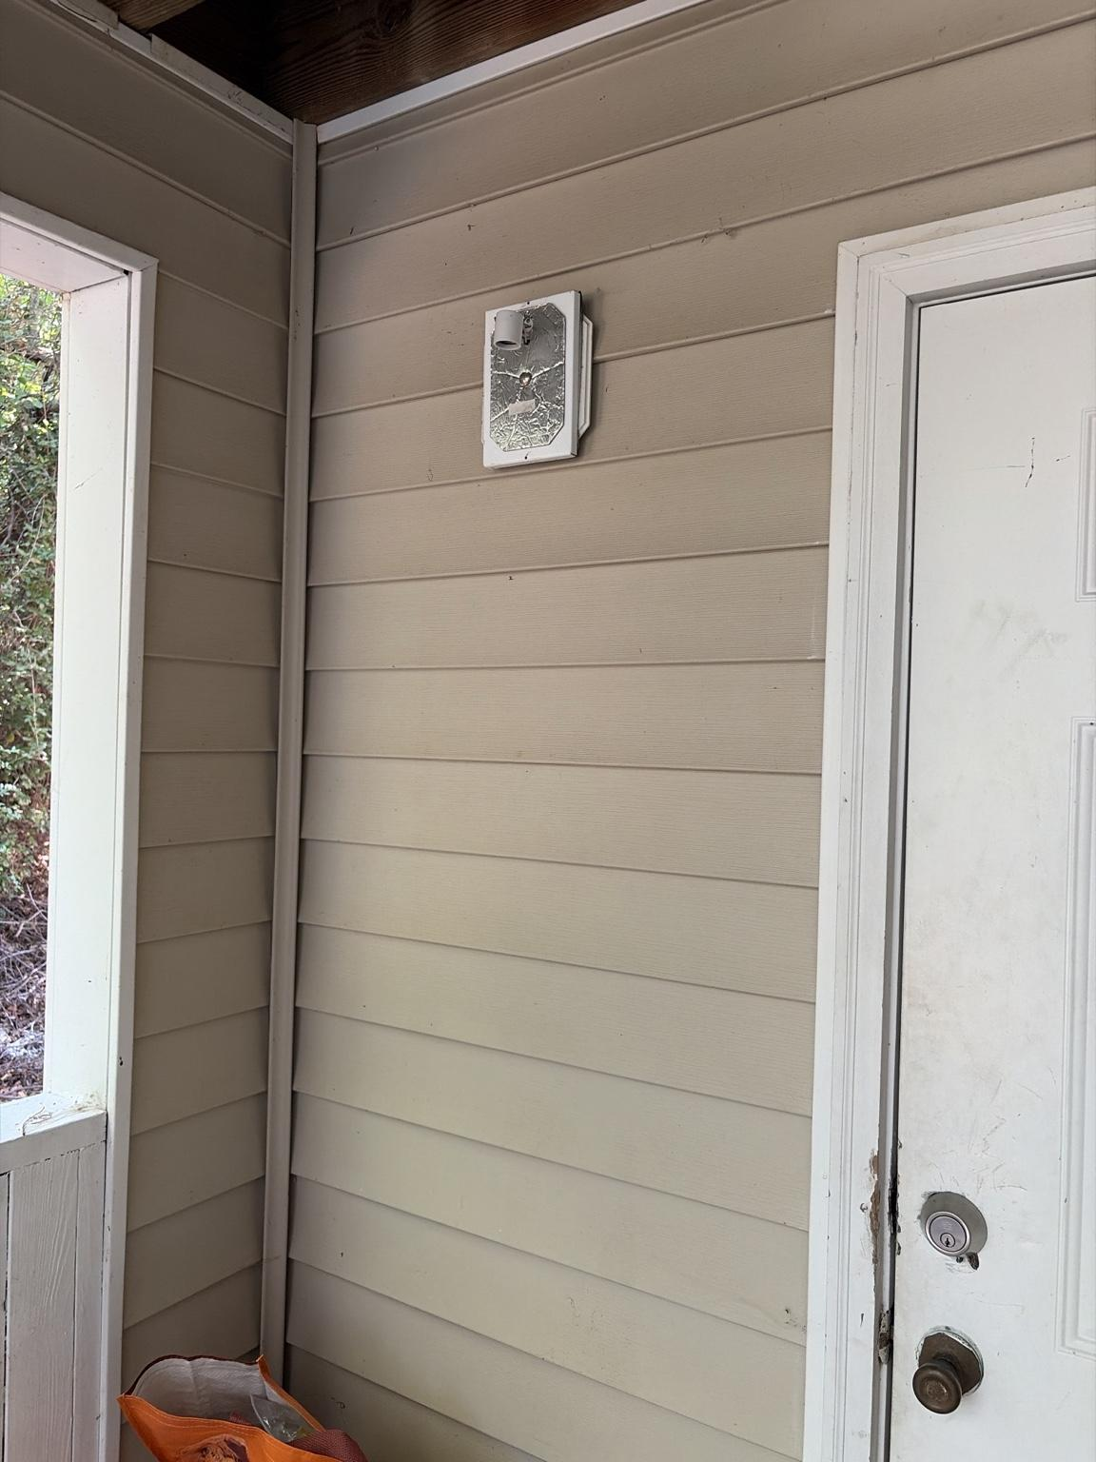
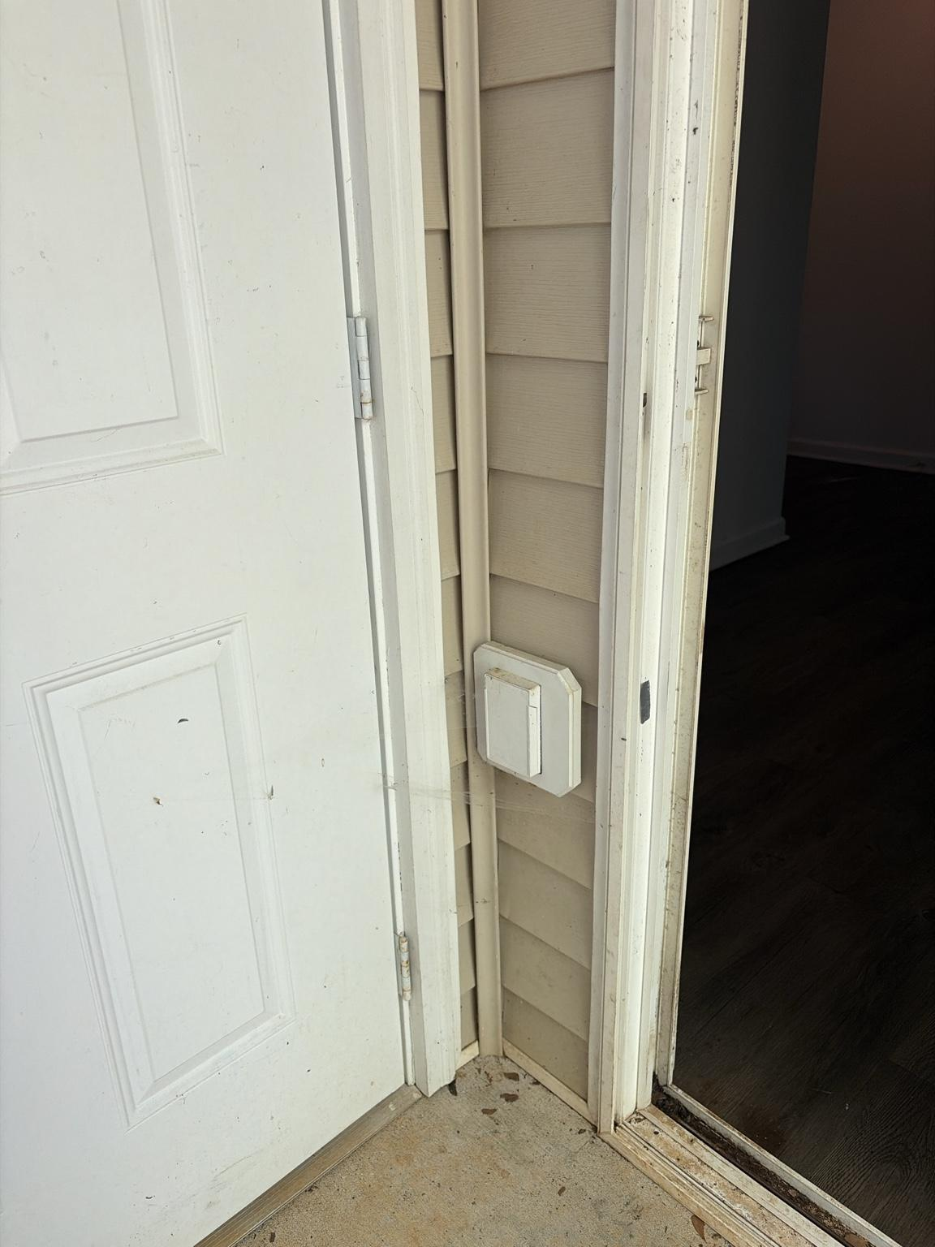

Observed conditions:
• The patio is a covered, ground-level concrete slab directly connected to the Living Room by the sliding glass door.
• A separate hinged exterior door is located on the patio’s rear wall and appears to provide access to an exterior storage or utility compartment; its exact function remains to be confirmed.
• The patio is partially enclosed by siding walls, structural posts, and a painted wood railing, with an open side facing landscaped common ground.
• An upper-level balcony or floor structure forms the patio ceiling, providing shade and weather protection.
• The ceiling and soffit show exposed framing or incomplete panel coverage in several areas.
• A wall-mounted exterior light fixture is present near the hinged door; the fixture lens or cover appears damaged or missing.
• A weather-resistant exterior wall control or electrical box is mounted between the hinged door and sliding door.
• A downspout terminates at the front corner and transitions into a black corrugated drain extension.
• Brick pier bases support the patio posts, and a low brick ledge runs along part of the exterior wall.
• The concrete slab shows dirt, organic debris, staining, edge wear, and localized vegetation growth.
• The siding, trim, doors, railing, and sliding-door track show visible dirt, scuffs, weathering, and maintenance needs.
• The patio currently contains cleaning tools, a cooler, bags, and miscellaneous stored materials that reduce usable floor area.
• Shrubs and surrounding vegetation are close to the patio edge and may contribute leaves, moisture, insects, and reduced visibility.

Safety, maintenance, and control requirements:
• PT-SAF-001 — The sliding-door threshold and patio walking surface shall remain free of stored objects and trip hazards.
• PT-SAF-002 — The hinged exterior door shall remain fully accessible until its ownership, function, and required service clearance are confirmed.
• PT-SAF-003 — The damaged exterior light fixture shall not receive a smart bulb or automation upgrade until the fixture is inspected, repaired, and confirmed weather-safe by property maintenance or a qualified electrician.
• PT-SAF-004 — The exterior electrical box or control shall not be modified, covered, or assumed to control a specific device until positively identified.
• PT-SAF-005 — Furniture and décor shall not obstruct the downspout, drain extension, structural posts, railing, sliding door, or hinged door.
• PT-SAF-006 — No permanent attachment, drilling, wiring, or structural modification shall occur without landlord or property-management approval.
• PT-SAF-007 — Exterior-rated equipment only shall be used on the patio, with cords and connections protected from moisture and physical damage.

Design and system implications:
• The patio is a distinct Sanctuary zone for Reflection, Decompression, fresh air, and smoking rather than a general storage area.
• Before decorating, the patio requires a full reset: remove stored materials, sweep and wash the slab, clean the sliding-door track, and request maintenance for damaged or deteriorated building components.
• A compact seating arrangement should preserve the center travel path between the sliding door, railing opening, and hinged door.
• Because the patio is shaded and visually enclosed, lighter outdoor textiles, warm wood tones, and controlled greenery can prevent the area from feeling dark or neglected.
• Any future lighting should be warm, low-glare, weather-rated, and subordinate to neighbors and property rules.
• The existing exterior fixture may eventually support a Patio Arrival or Decompression scene only after its circuit, switch, condition, and compatibility are verified.
• A door sensor on the sliding door could support security, climate awareness, and occupancy logic, but installation methods must remain renter-safe.
• The patio’s proximity to vegetation and common grounds requires easy-to-clean, moisture-resistant, and pest-resistant furnishings.
• Final furniture dimensions and layout remain pending patio measurements and confirmation of the hinged door’s purpose.

Photo KT-001 — Kitchen Existing Conditions Survey

Figures 12–17. KT-001A through KT-001F document the kitchen cabinetry, sink and dishwasher wall, countertop work zones, electric range, pantry door, refrigerator, and openings to the Dining Area and Living Room.
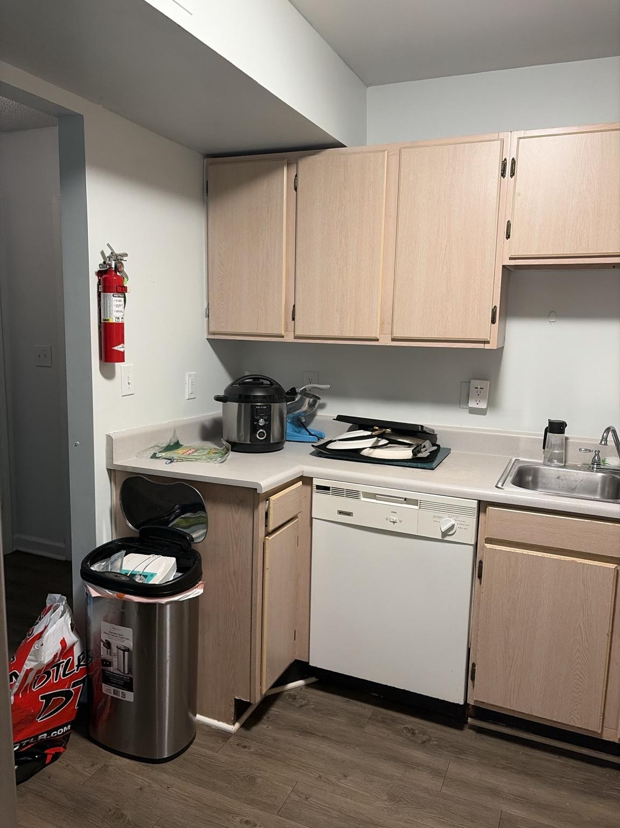
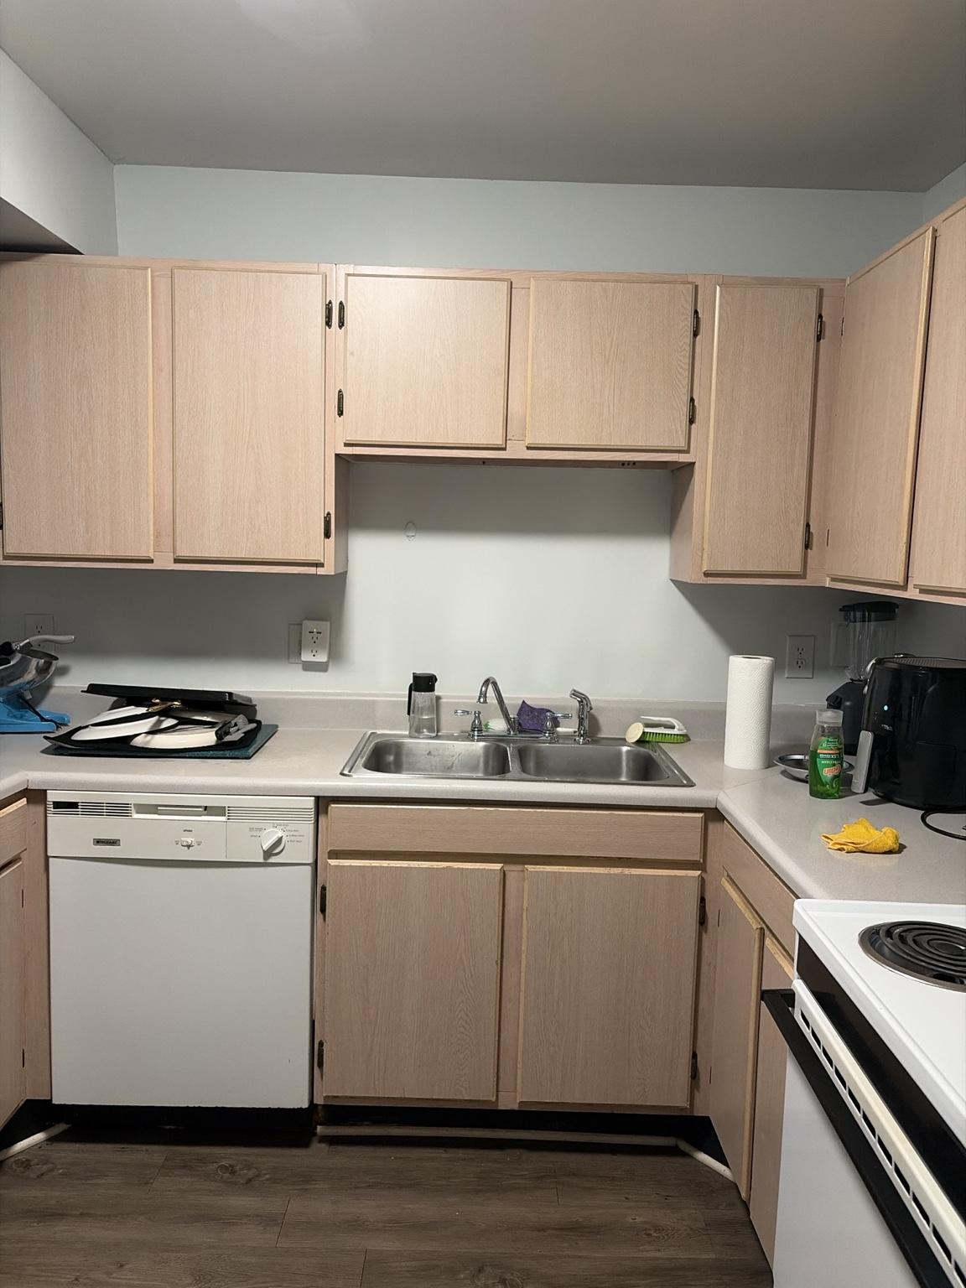
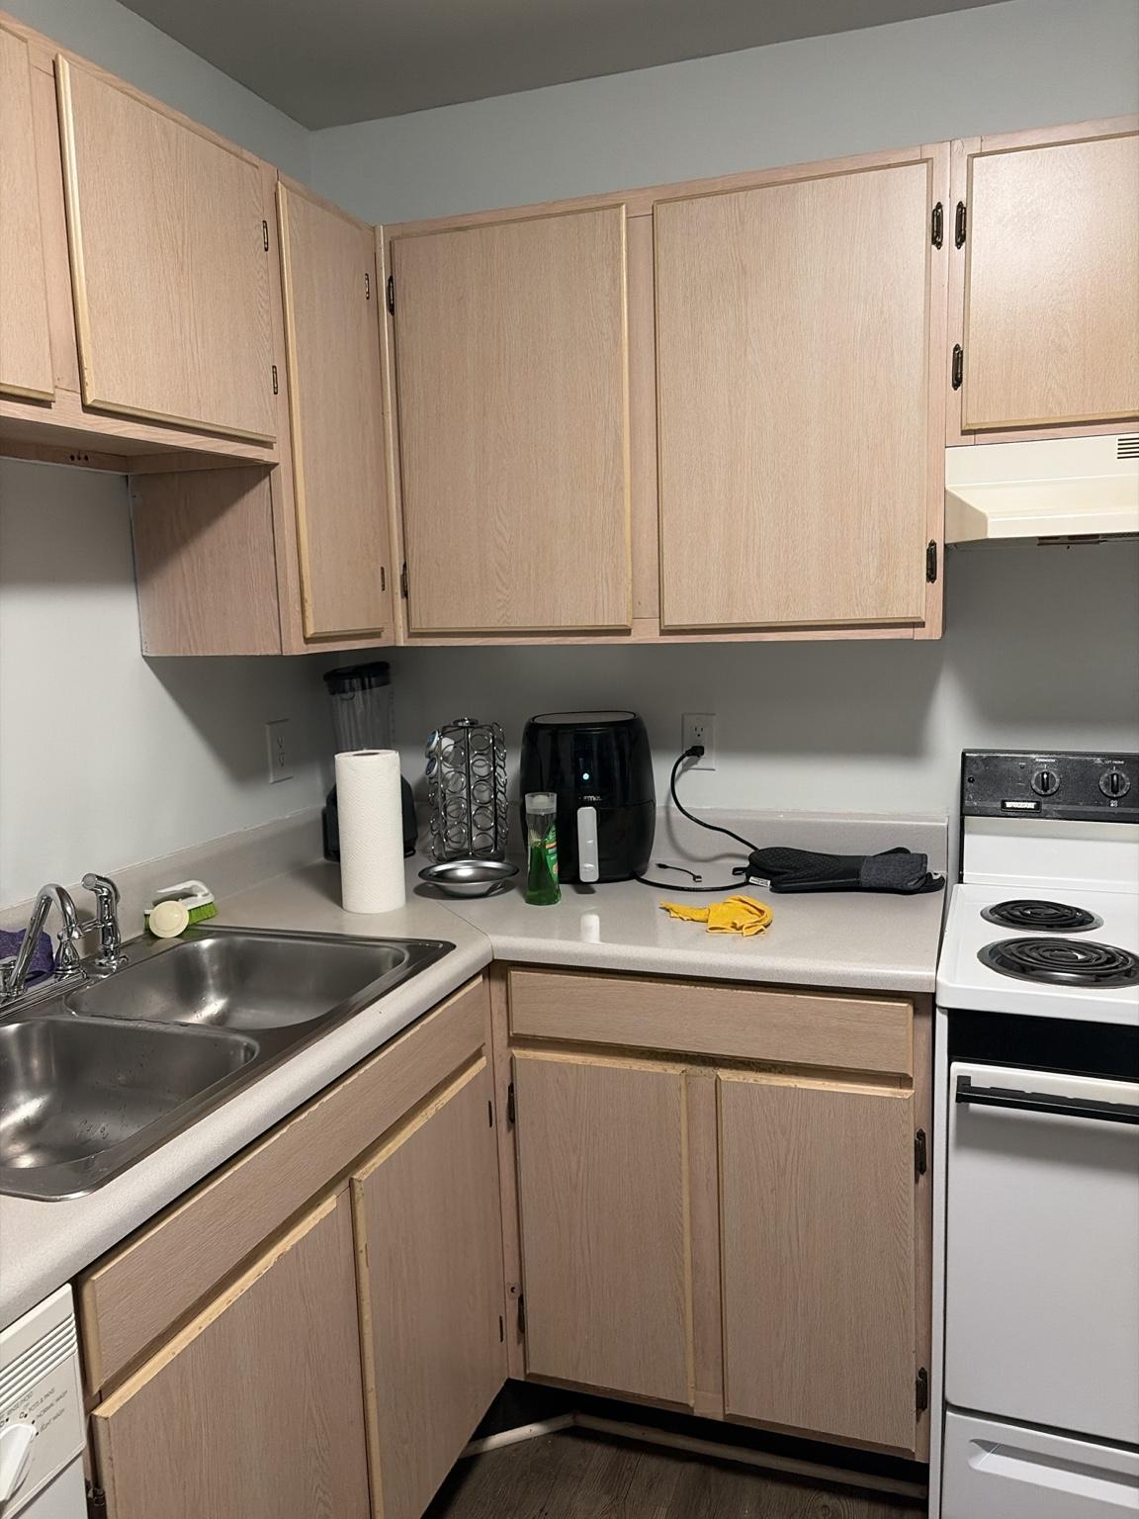
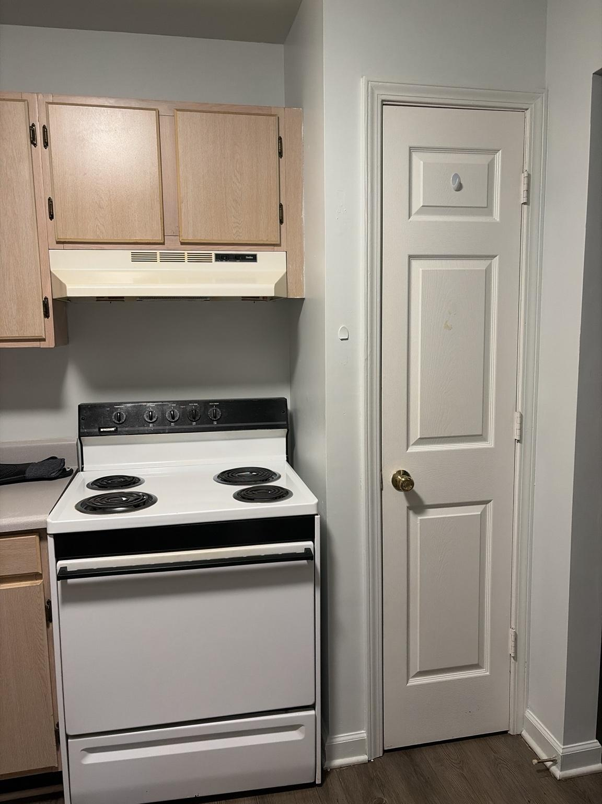
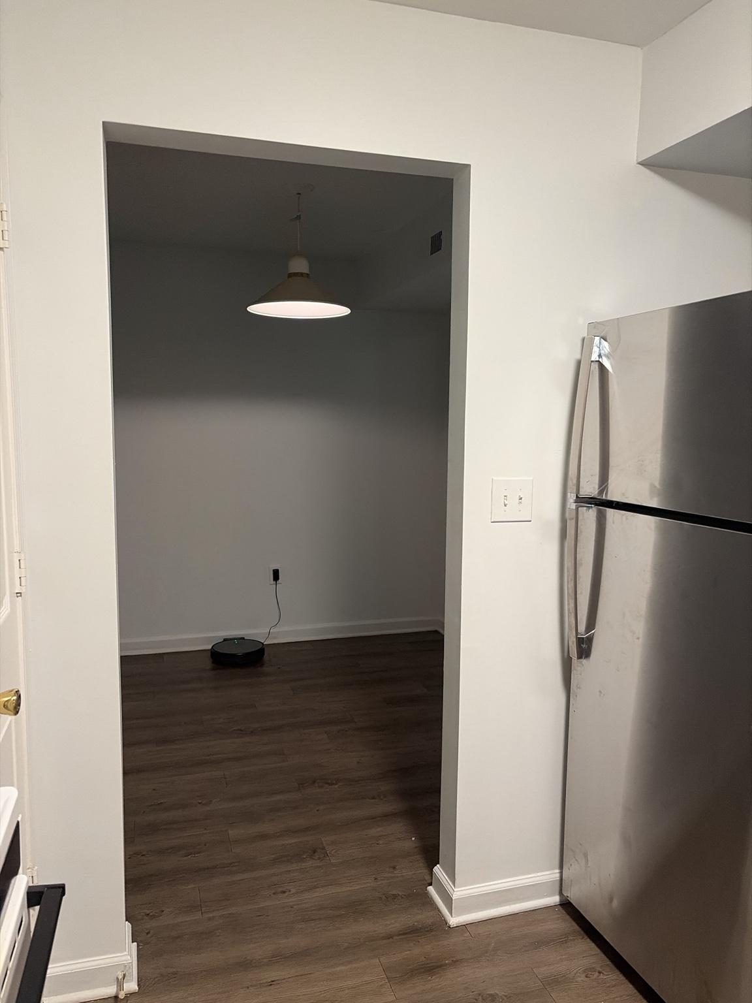
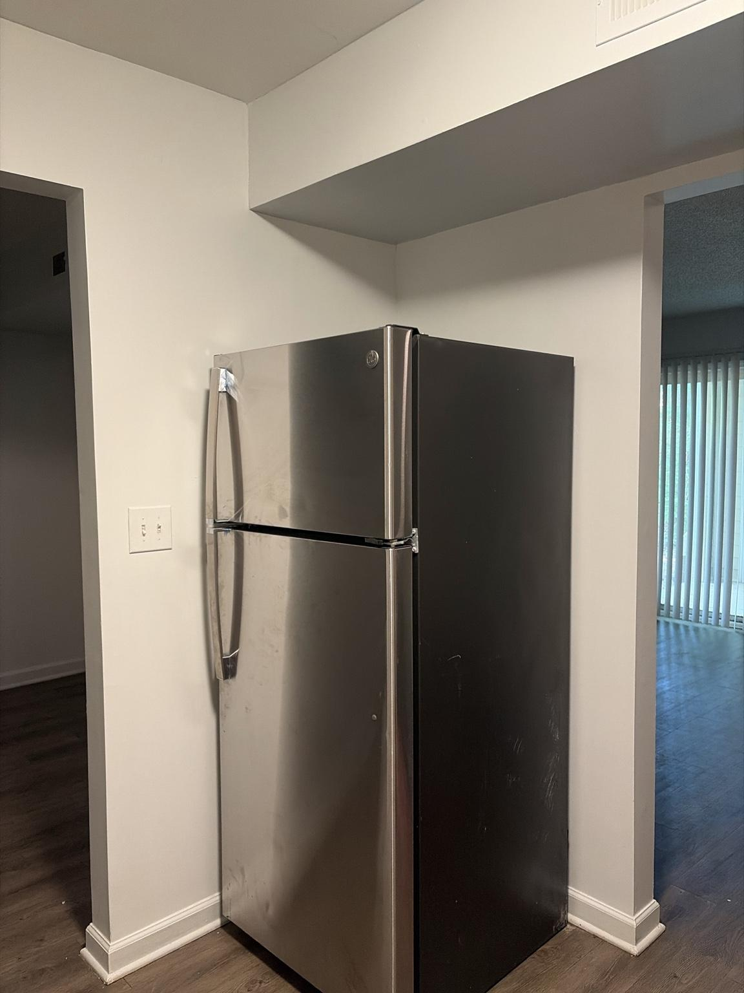

Observed conditions:
• The kitchen is a compact U-shaped work area with light wood-look upper and lower cabinets, pale laminate countertops, dark toe-kicks, and continuous dark wood-look flooring.
• Major appliances include a top-freezer refrigerator, electric coil range with oven, recirculating range hood, built-in dishwasher, and double-basin stainless-steel sink.
• The sink wall contains the dishwasher on the left, double sink at center, and a corner work surface extending toward the range.
• The left counter currently holds a pressure cooker and cookware; the right counter contains an air fryer, blender, paper towels, dish soap, drying accessories, and small items.
• Multiple wall receptacles are distributed along the backsplash area, including at least one GFCI-style receptacle.
• A fire extinguisher is wall-mounted near the kitchen entrance.
• A freestanding trash can occupies the left side near the entry and partially narrows circulation.
• A full-height door beside the range is the Kitchen Pantry, providing enclosed food and household storage.
• The refrigerator occupies a recessed zone between the Dining Area opening and the Living Room side opening.
• A two-switch wall plate is located near the refrigerator and Dining Area opening; switch functions remain to be confirmed.
• The kitchen has no visible exterior window and depends on electric lighting plus borrowed light from adjacent rooms.
• The wide opening toward the Dining Area confirms that Dining functions as the primary approach and transition zone into the Kitchen.
• The opening beside the refrigerator provides a secondary visual and circulation relationship with the Living Room.
• Cabinet faces, trim, doors, appliance surfaces, and counters show ordinary wear and would benefit from cleaning, hardware consistency, and visual simplification.

Safety, appliance, and clearance requirements:
• KT-SAF-001 — The fire extinguisher shall remain visible, reachable, unobstructed, and within its inspection or replacement period.
• KT-SAF-002 — Combustible items, towels, paper goods, cords, and countertop appliances shall remain clear of the electric range and active burners.
• KT-SAF-003 — The range hood and its controls shall remain accessible; any future replacement or lighting modification requires property approval.
• KT-SAF-004 — Dishwasher, refrigerator, range, pantry-door, and cabinet-door swing clearances shall remain unobstructed.
• KT-SAF-005 — Countertop appliances shall use grounded receptacles appropriate to their load and shall not share unsafe extension cords or overloaded adapters.
• KT-SAF-006 — Water-sensitive smart devices, plugs, speakers, and lighting controllers shall not be installed in splash zones around the sink.
• KT-SAF-007 — The refrigerator requires permanent ventilation and door clearance; decorative panels or storage shall not block its sides, top, rear airflow, or hinge path.
• KT-SAF-008 — The two-switch wall plate near the refrigerator shall not be automated or replaced until both switch functions are positively identified.
• KT-SAF-009 — The Kitchen Pantry door shall remain fully accessible and shall not be blocked by the range, trash can, storage, or future furniture.

Design and system implications:
• The Kitchen’s permanent Sanctuary identity is Nourishment, with efficiency, cleanliness, and safe task visibility taking priority over dramatic color effects.
• Because the existing ceiling or fixed lighting is not yet documented as smart-controllable, renter-safe under-cabinet lighting remains the highest-value future lighting upgrade.
• Under-cabinet lighting should provide neutral-to-warm white task light, concealed wiring, independent control, and no interference with cabinet doors, outlets, sink use, or heat-producing appliances.
• Countertop zones should be simplified into clear functions: food preparation, appliance station, dishwashing, and temporary landing space.
• The trash can should be relocated or integrated so it does not constrict the primary entrance path.
• Appliance grouping and cable management should reduce visual clutter while preserving ventilation and daily usability.
• Cabinet hardware may eventually be standardized to a consistent finish, but permanent refinishing or replacement requires landlord approval.
• The refrigerator wall is a transition point between Kitchen, Dining Area, and Living Room; lighting here should support orientation without making the Kitchen visually dominant during relaxation modes.
• The Dining Area remains the preferred low-level nighttime route toward food and water, while Kitchen task lighting should activate only when needed.
• Future leak detection beneath the sink and dishwasher, plus a refrigerator-area temperature or power-loss alert, would provide measurable value.
• Exact cabinet dimensions, ceiling fixture type, outlet circuits, and switch functions remain pending confirmation.

Photo DR-001 — Dining Area Partition Wall

F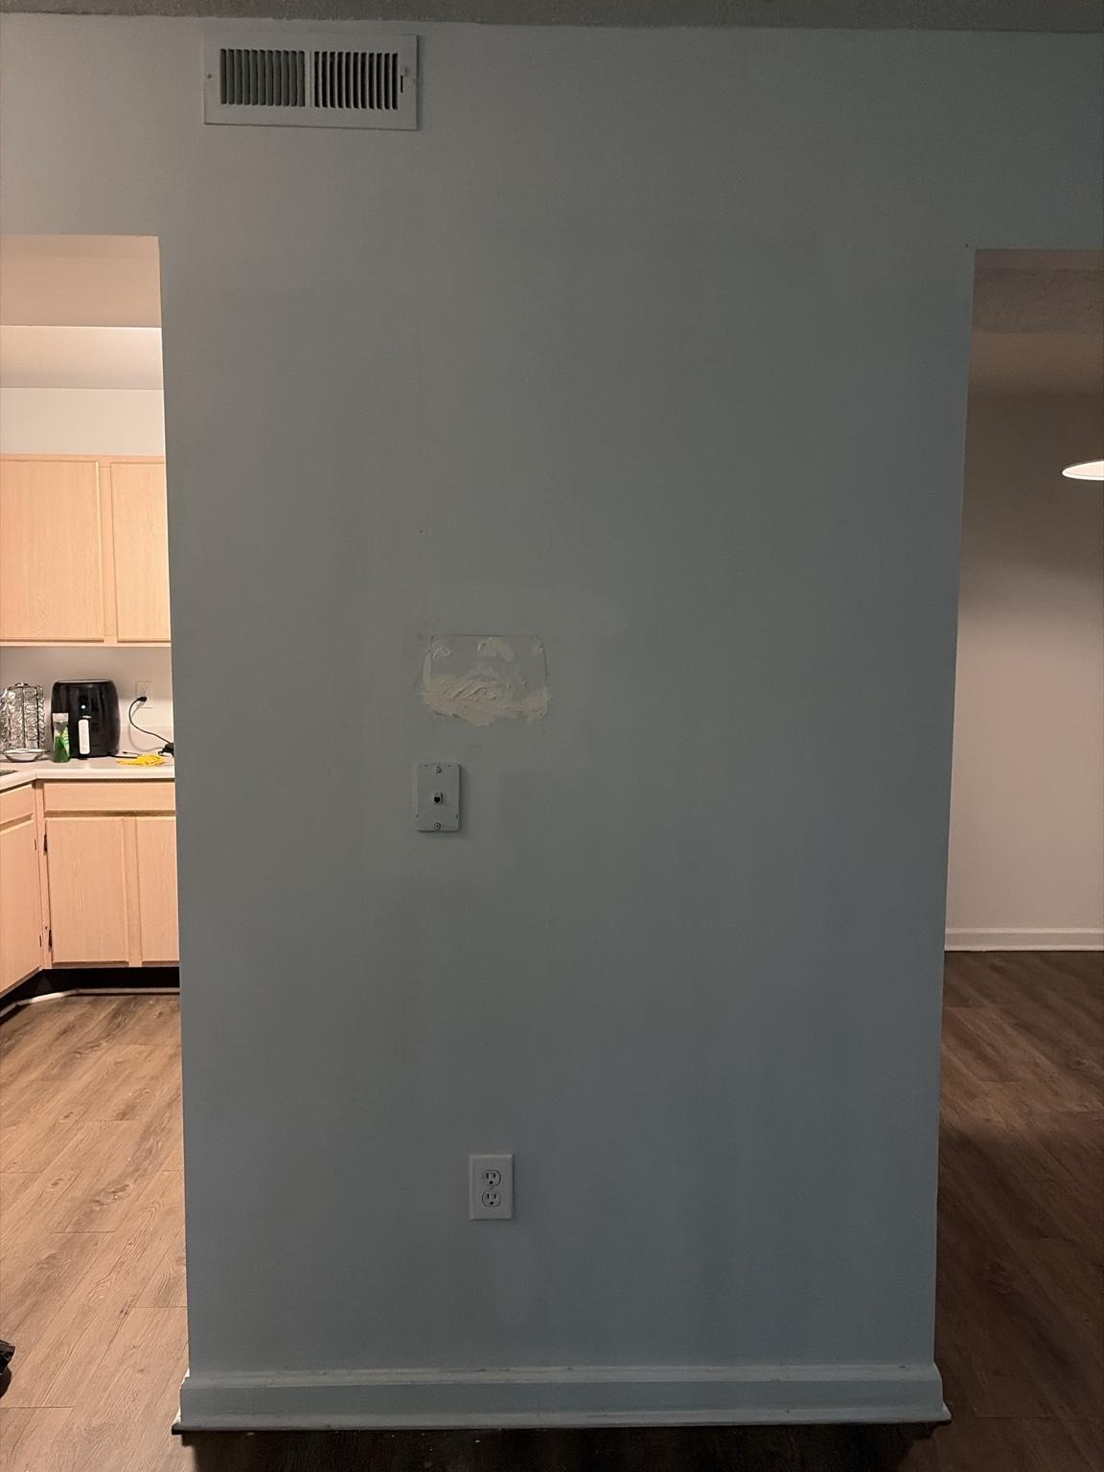igure 18. DR-001 documents the central Dining Area partition wall positioned between the Kitchen opening on the left and the Living Room opening on the right.

Observed conditions:
• The wall functions as a visual divider and circulation hinge between the Kitchen, Dining Area, and Living Room.
• A high HVAC supply register is positioned near the ceiling.
• A standard duplex receptacle is located low on the wall.
• A small wall plate or former communications/control connection is mounted at approximately mid-height; its function remains unidentified.
• A visibly patched area above the mid-height plate indicates a prior wall-mounted device, cable route, or repair.
• The wall is narrow relative to its height and is framed by open passages on both sides.
• The Kitchen is directly visible through the left opening, while the Dining Area pendant and Living Room are visible through the right opening.
• Continuous dark wood-look flooring reinforces the connection among all three spaces.

Control, clearance, and furnishing requirements:
• DR-WALL-001 — The upper HVAC register shall remain unobstructed by artwork, shelving, curtains, or tall furniture.
• DR-WALL-002 — The lower receptacle shall remain accessible for temporary or approved low-load use.
• DR-WALL-003 — The mid-height plate shall not be removed, covered permanently, or used for automation until its function and wiring are positively identified.
• DR-WALL-004 — Wall-mounted décor shall avoid the patched area until the substrate condition and prior attachment points are assessed.
• DR-WALL-005 — Furniture placed against this wall shall remain shallow enough to preserve both side passages and normal Kitchen-to-Living-Room circulation.

Design and system implications:
• This wall is suitable for a restrained focal treatment rather than a large furniture installation.
• A mirror, narrow artwork composition, or slim console may help define the Dining Area while maintaining openness, but exact dimensions and traffic clearances must be confirmed first.
• Because the wall is visible from both the Kitchen and Living Room, its finish should coordinate all three spaces and reinforce the Dining Area’s identity as Transition.
• The patched area should be repaired and painted before final décor installation so the wall reads as intentional rather than unfinished.
• The visible receptacle could support a low-profile accent lamp or seasonal décor only if cords remain controlled and do not cross either walkway.
• The wall should not become a television or heavy-storage location because of its narrow width, HVAC register, circulation role, and unidentified wall connection.

Photo DR-002 — Dining Area Existing Conditions Survey

Figures 19–22. DR-002A through DR-002D document the Dining Area from the Kitchen side, the primary dining wall, the robot-vacuum charging wall, and the wide opening into the Living Room.

Obser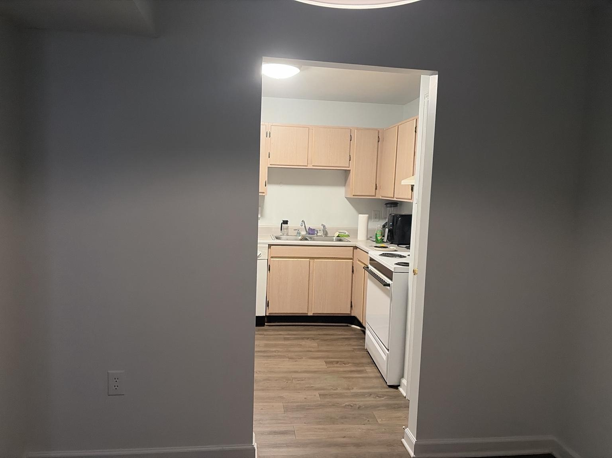v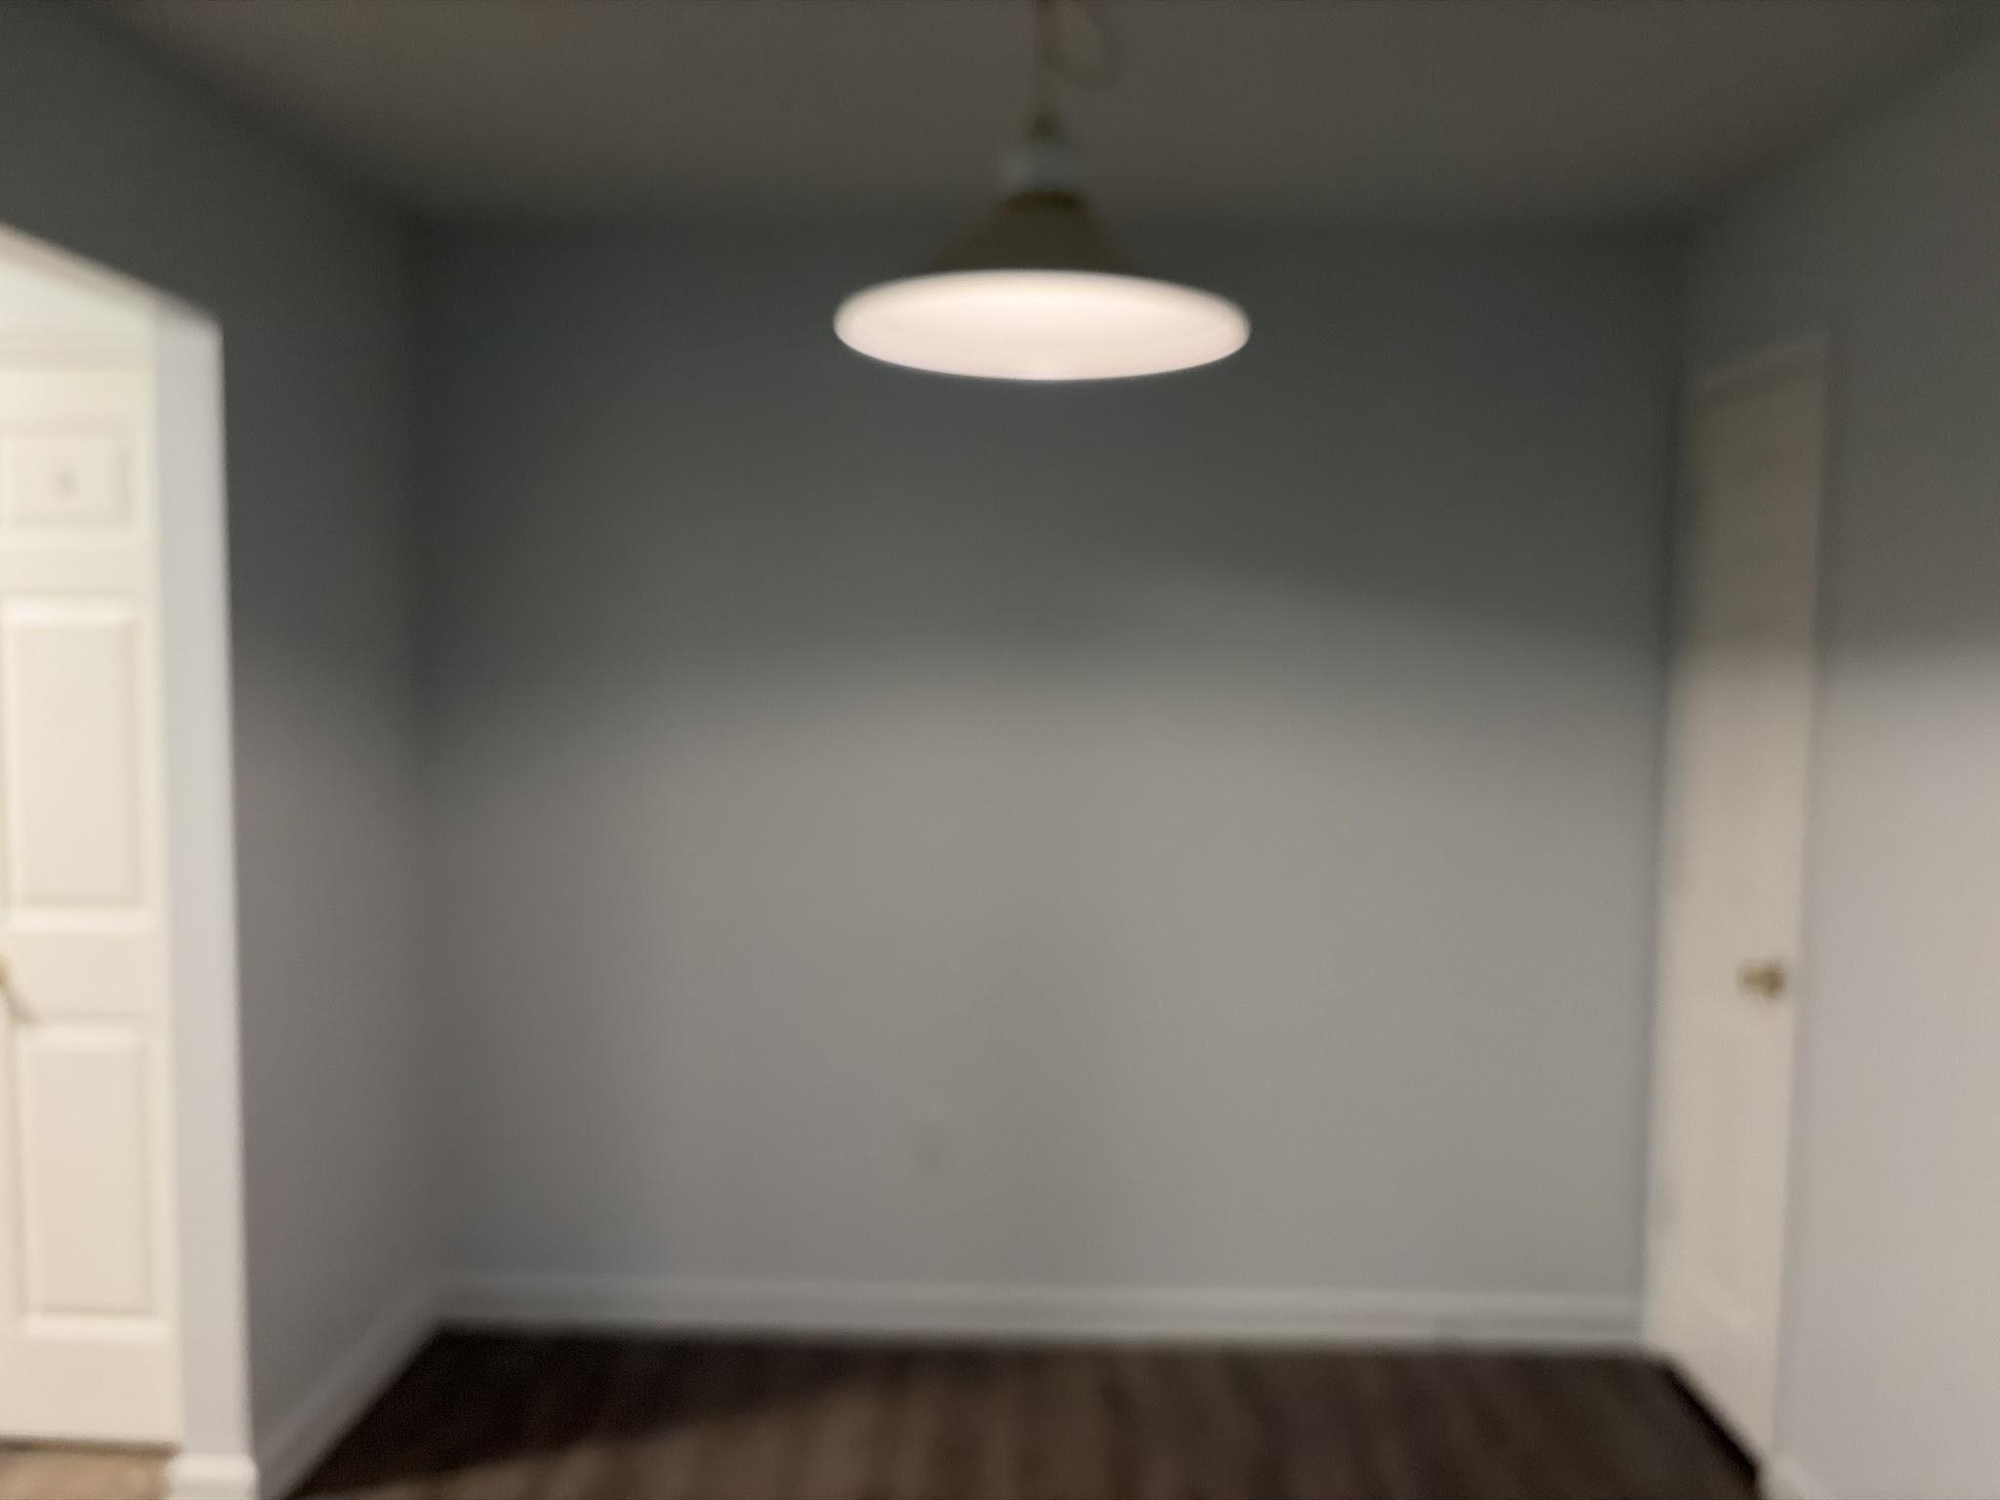e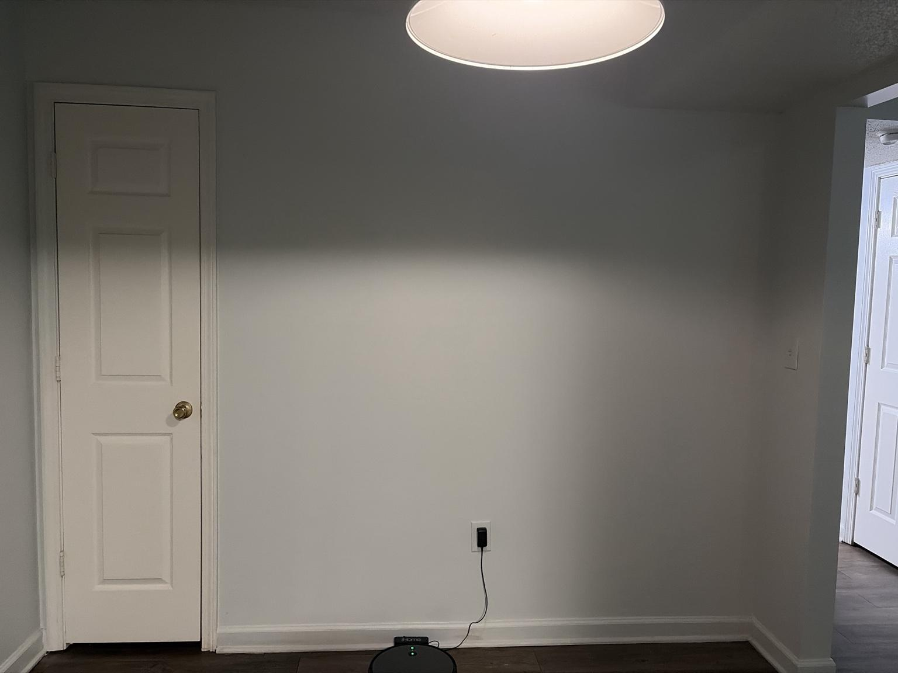d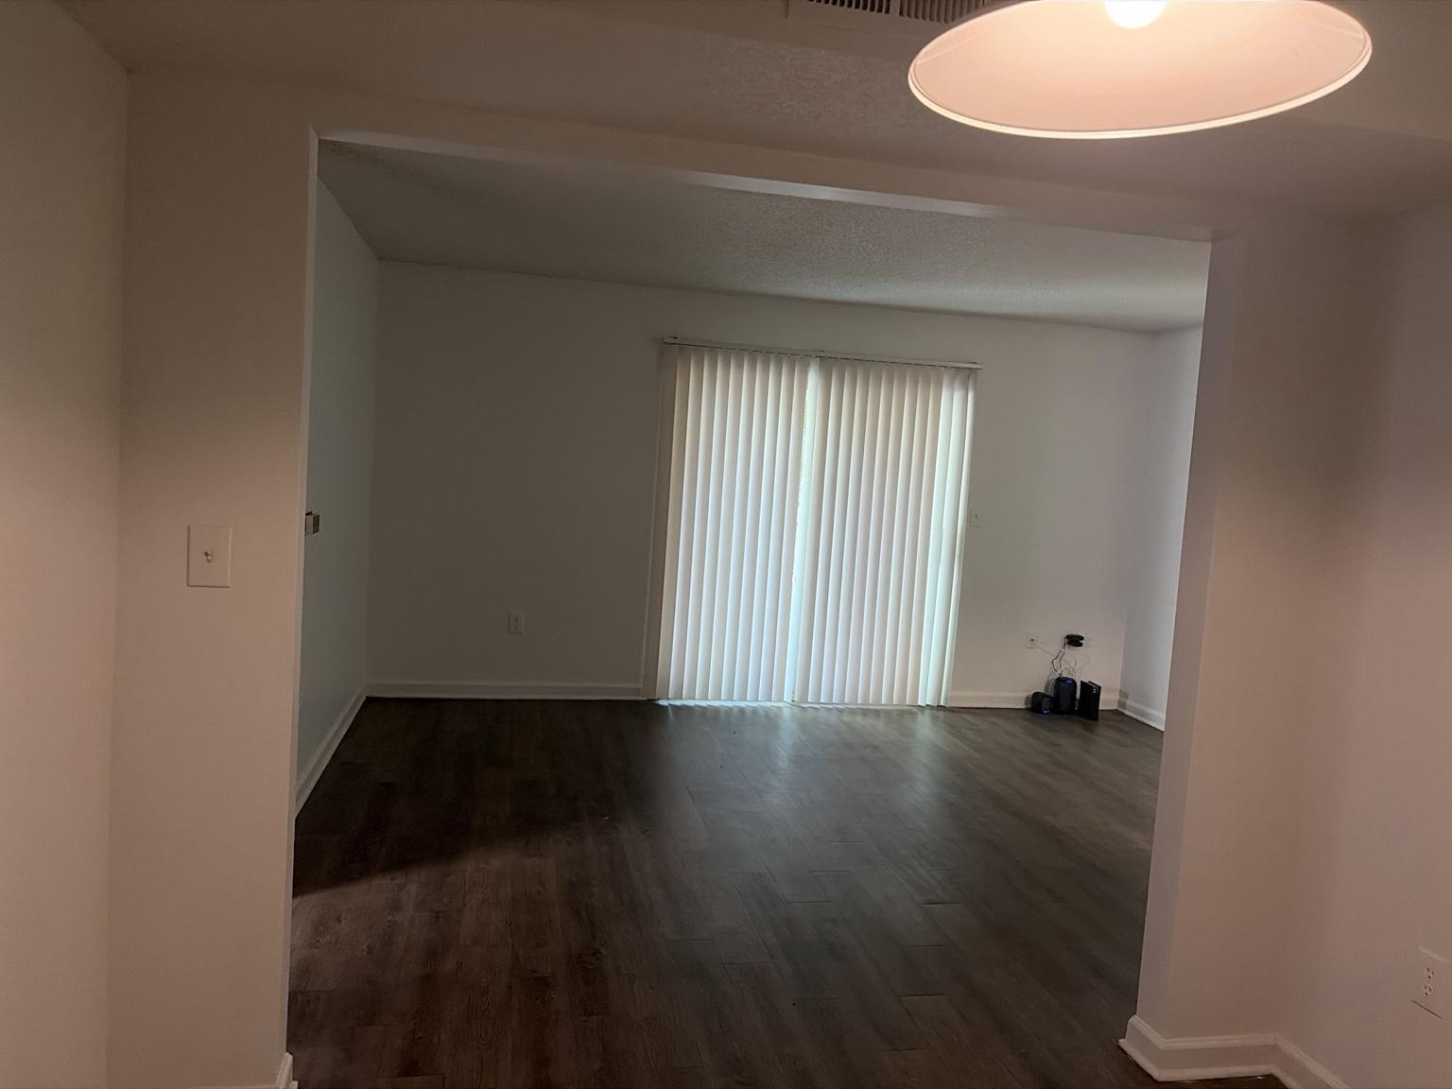 conditions:
• The Dining Area is a compact rectangular transition space positioned directly between the Kitchen and Living Room.
• A wide opening on one side frames the Kitchen and provides the primary route for food service and daily movement.
• A broader opening on the opposite side connects the Dining Area visually and physically to the Living Room.
• A single pendant-style ceiling fixture is centered over the main dining area and functions as the room’s primary built-in light.
• One broad wall is largely uninterrupted and suitable for a dining table relationship, artwork, or a restrained focal treatment.
• A second wall contains a standard receptacle used by the iHome robot-vacuum charging dock.
• The iHome charging position confirms the Dining Area currently serves as the robot vacuum’s home base.
• A full-height interior door is located at the left side of the charging wall; its function is not confirmed in these photographs.
• A wall switch or control plate is visible on the right side of the charging wall near the Living Room opening.
• Continuous dark wood-look flooring visually merges the Dining Area with both adjacent spaces.
• The Dining Area receives borrowed daylight from the Living Room patio door but has no visible exterior window of its own.

Control, circulation, and furnishing requirements:
• DR-SAF-001 — The Kitchen-to-Living-Room travel path through the Dining Area shall remain continuously clear.
• DR-SAF-002 — The robot-vacuum dock shall remain connected to constant power and shall have adequate front and side clearance for reliable docking and departure.
• DR-SAF-003 — Dining furniture shall not block the full-height door, either room opening, the visible wall switch, or the robot-vacuum docking path.
• DR-SAF-004 — Pendant clearance shall be checked against the final dining-table height and location; the fixture shall not become a head-strike hazard in an open walkway.
• DR-SAF-005 — Cords serving the robot-vacuum dock shall remain secured against the wall and outside walking paths.
• DR-SAF-006 — The unidentified full-height door shall remain accessible until its function is confirmed and documented.

Design and system implications:
• The Dining Area’s permanent Sanctuary identity remains Transition, but the space should also feel intentional enough to support meals, conversation, and visual continuity.
• The dining table should be centered under or intentionally aligned with the pendant while preserving comfortable passage between Kitchen and Living Room.
• Because the room is open on two sides, furniture depth and chair pull-out clearance are more important than filling the entire footprint.
• The broad blank wall is the strongest candidate for dining-room artwork, a mirror, or a shallow console after exact measurements are confirmed.
• The charging wall must remain visually calm so the iHome dock can function without making the room feel like a utility zone.
• A low-profile cable channel, dock alignment, and disciplined floor clearance will help the robot vacuum disappear into the room’s design.
• Dining lighting should support warm meals and low-level nighttime navigation without overpowering the Living Room or Kitchen.
• The pendant can serve as the primary Dining Area scene device, while future accent lighting should remain secondary and renter-safe.
• The wide Living Room opening confirms that Dining lighting will spill directly into the Hospitality zone; brightness and color temperature should therefore be coordinated across both rooms.
• Final table dimensions, door function, switch function, fixture height, and robot-vacuum clearance dimensions remain pending confirmation.

Photo HL-001 — Hallway Existing Conditions Survey

Figures 23–25. HL-001A through HL-001C document the private-room hallway from the Living Room side, including the Bathroom opening, the HVAC-closet door, adjacent room doors, and the ceiling light.

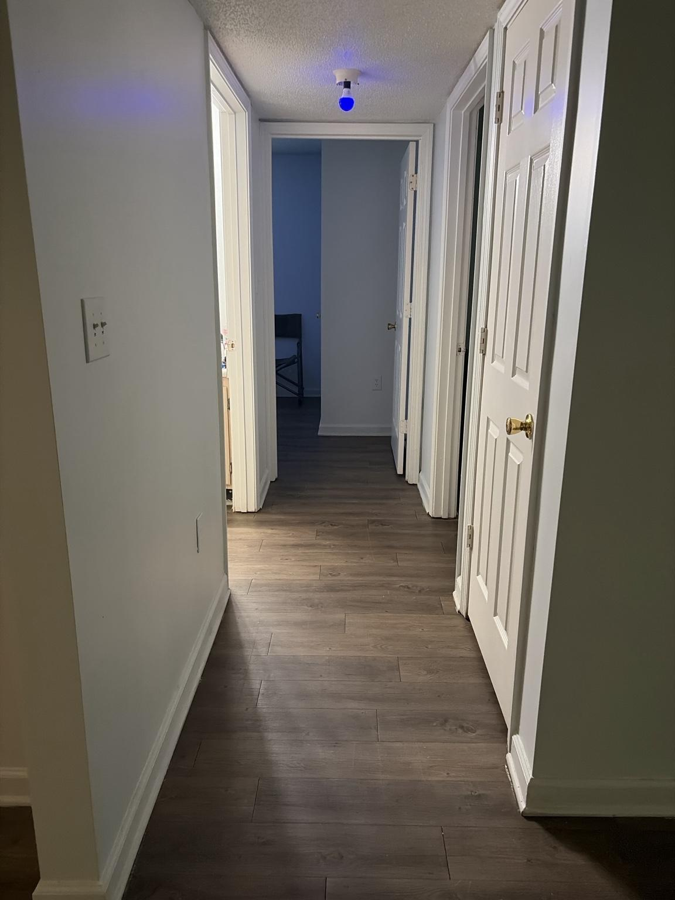
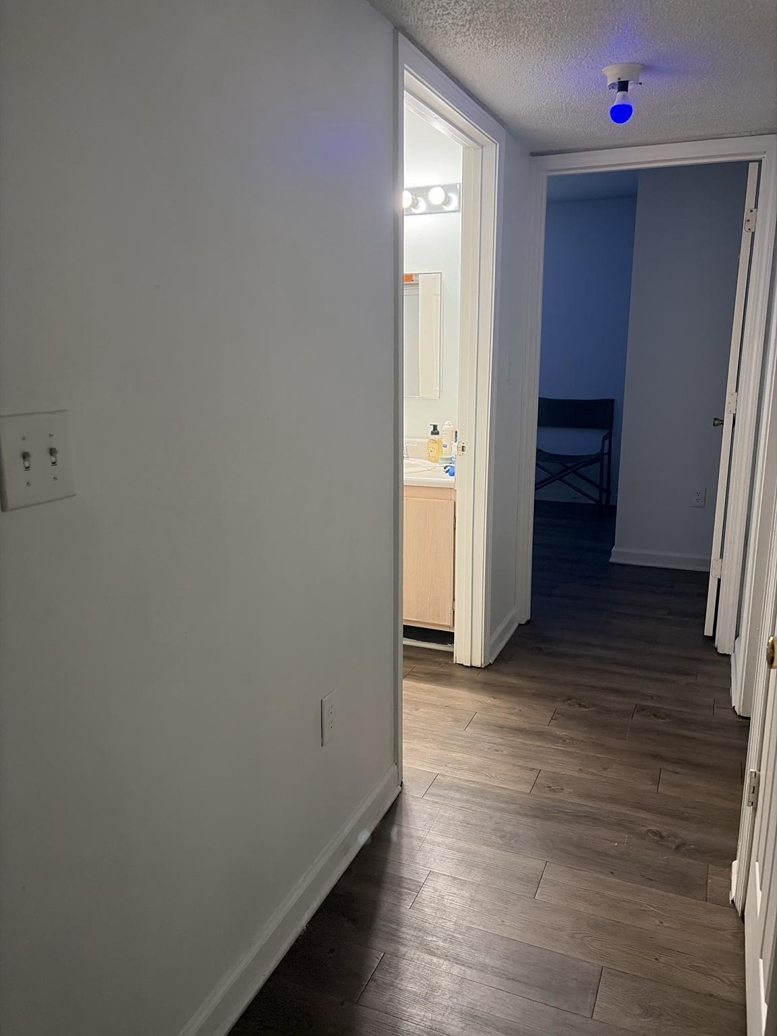
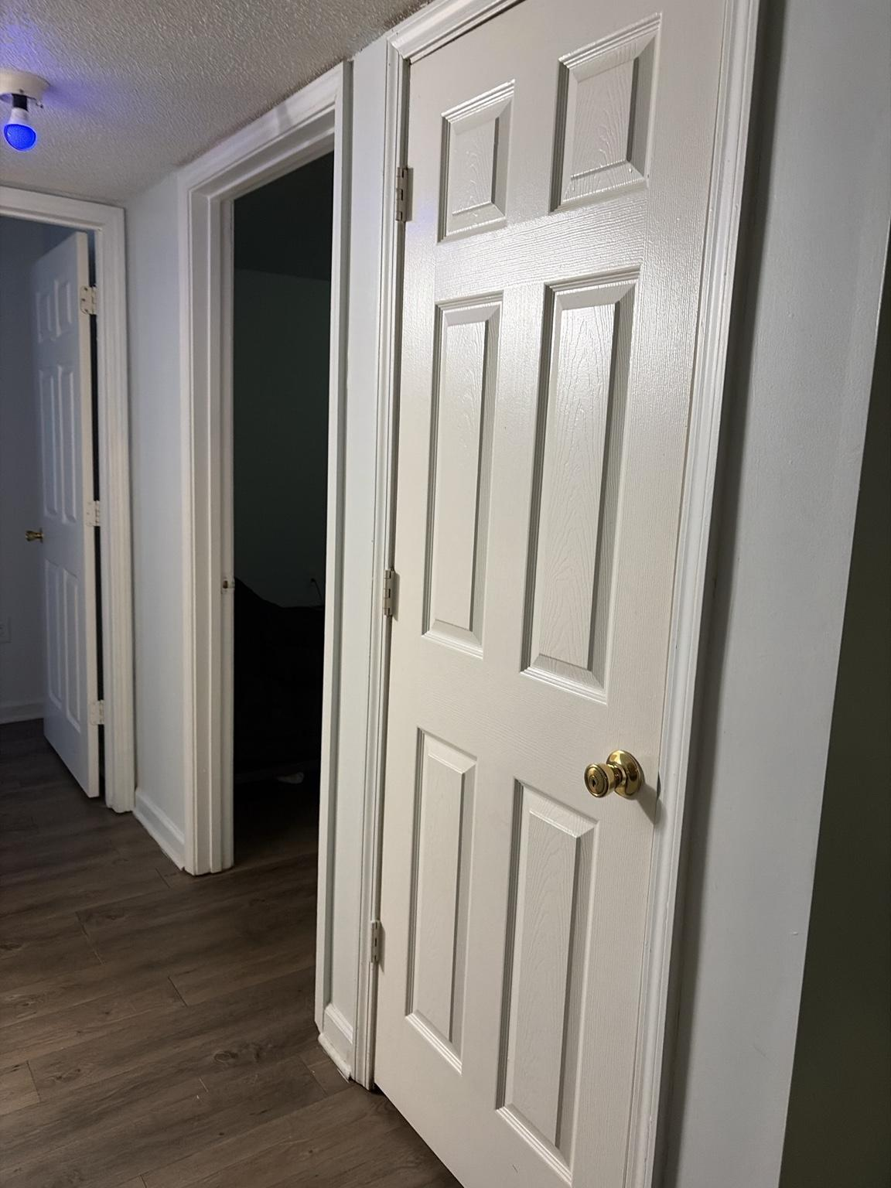

Observed conditions:
• The hallway is the primary circulation spine connecting the Living Room with the Bathroom, Bedroom, Office, and building-services access.
• A single exposed-bulb ceiling fixture provides the hallway’s built-in lighting; the installed smart bulb is shown operating in blue.
• The first full-height door on the right side of the hallway is confirmed as the HVAC closet.
• The Bathroom opening is located on the left side near the front of the hallway.
• Additional full-height doors line the right side and far end of the corridor; their specific room identities are documented separately as each room is surveyed.
• A two-position wall switch plate is located on the left wall near the Living Room end of the hallway.
• A standard wall receptacle is located lower on the left wall.
• Dark wood-look flooring continues without interruption through the corridor and into the connected rooms.
• Door swings narrow the usable corridor width when multiple doors are open simultaneously.
• Light from the Bathroom and adjoining rooms spills directly into the hallway, creating strong cross-room lighting interactions.

Safety, access, and control requirements:
• HL-SAF-001 — The HVAC-closet door shall remain fully accessible and shall never be blocked by furniture, storage, décor, or robot-vacuum equipment.
• HL-SAF-002 — The HVAC closet shall not be used for general household storage unless property management explicitly permits it and required mechanical clearances are maintained.
• HL-SAF-003 — No automation, smart relay, shelving, wall treatment, or decorative installation shall interfere with HVAC service access, ventilation, controls, or equipment operation.
• HL-SAF-004 — The hallway shall remain free of floor-standing furniture and loose objects that reduce the required travel path or create nighttime trip hazards.
• HL-SAF-005 — Door-swing conflicts shall be considered in all room layouts; no object may prevent any hallway door from opening sufficiently for normal access or emergency egress.
• HL-SAF-006 — The two-position wall switch plate shall not be replaced or automated until both switch functions are positively identified.
• HL-SAF-007 — The exposed ceiling bulb shall remain securely installed; any future fixture replacement requires renter-safe installation and property approval where applicable.

Design and system implications:
• The Hallway’s permanent Sanctuary identity is Navigation; it functions as a passage and orientation zone rather than a destination or storage area.
• Hall lighting should prioritize low-glare navigation, especially during nighttime Bedroom-to-Bathroom movement.
• Blue or saturated-color lighting may be appropriate for selected scenes, but routine nighttime use should favor dim warm-white output to protect sleep adaptation and improve visibility.
• The hallway light may mirror selected Office modes when intentional spillover is desired, but it should remain subordinate to the Office and should not illuminate the private rooms unnecessarily.
• Motion or presence sensing could add value if configured with conservative nighttime brightness, manual override, and no activation from minor movement inside adjacent rooms.
• The left wall may support minimal flat artwork only if the switch plate, receptacle, and walking clearance remain unobstructed.
• The corridor should remain visually quiet so doorways, Bathroom access, and the route to the Office and Bedroom are immediately legible.
• Exact switch functions, remaining door identities, corridor width, ceiling-fixture specifications, and HVAC-closet interior conditions remain pending confirmation.

Photo BA-001 — Bathroom and Laundry Closet Existing Conditions Survey

Figures 26–32. BA-001A through BA-001G document the Bathroom entry, vanity, toilet, tub and shower, wall controls, and the adjoining laundry closet with washer and dryer hookups.

Observed conditions:
• The Bathroom 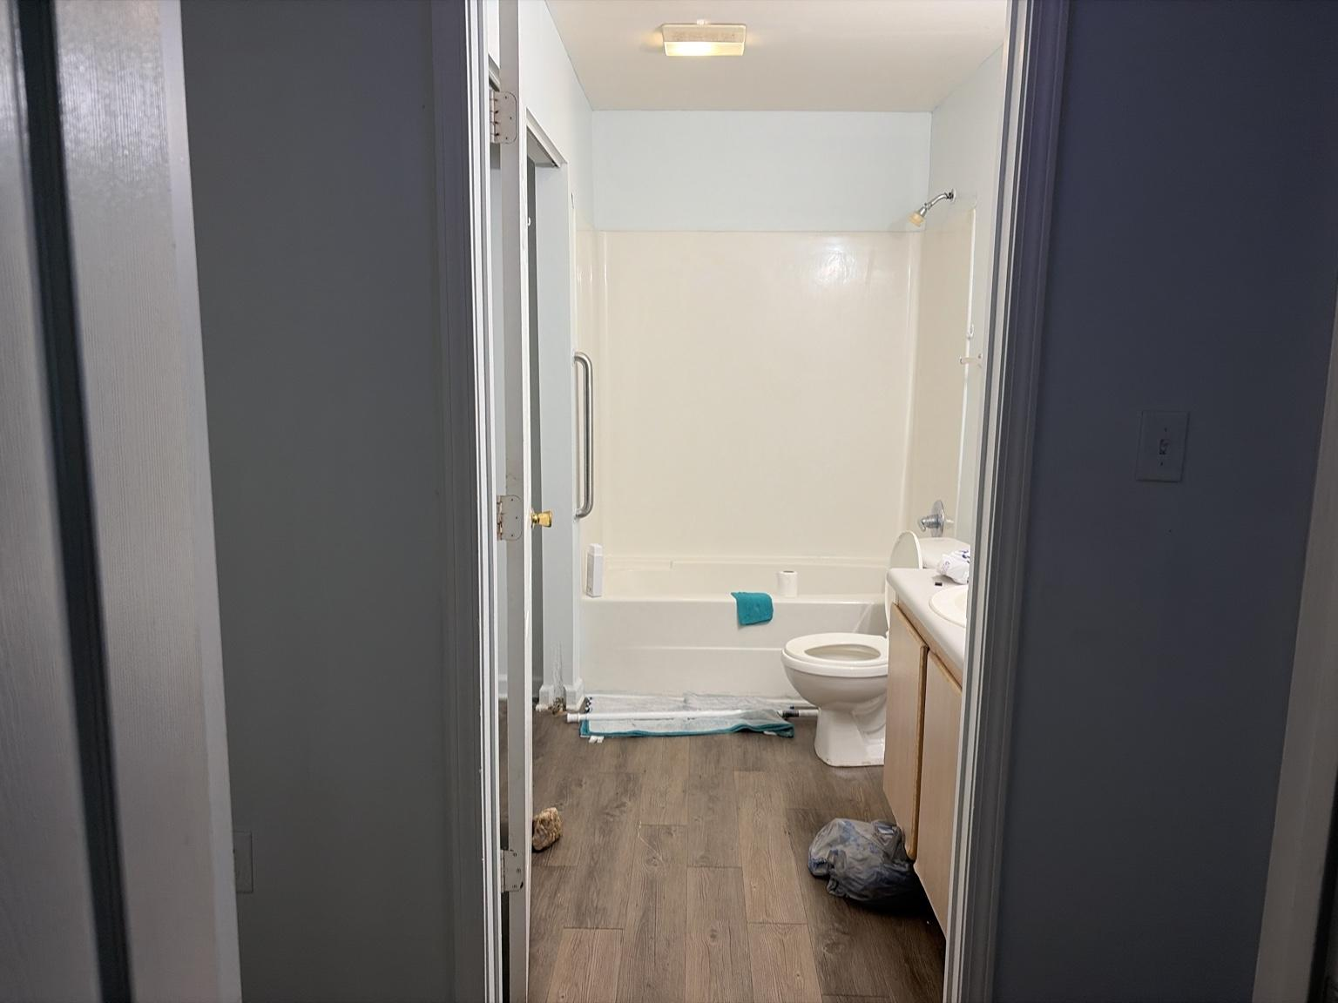o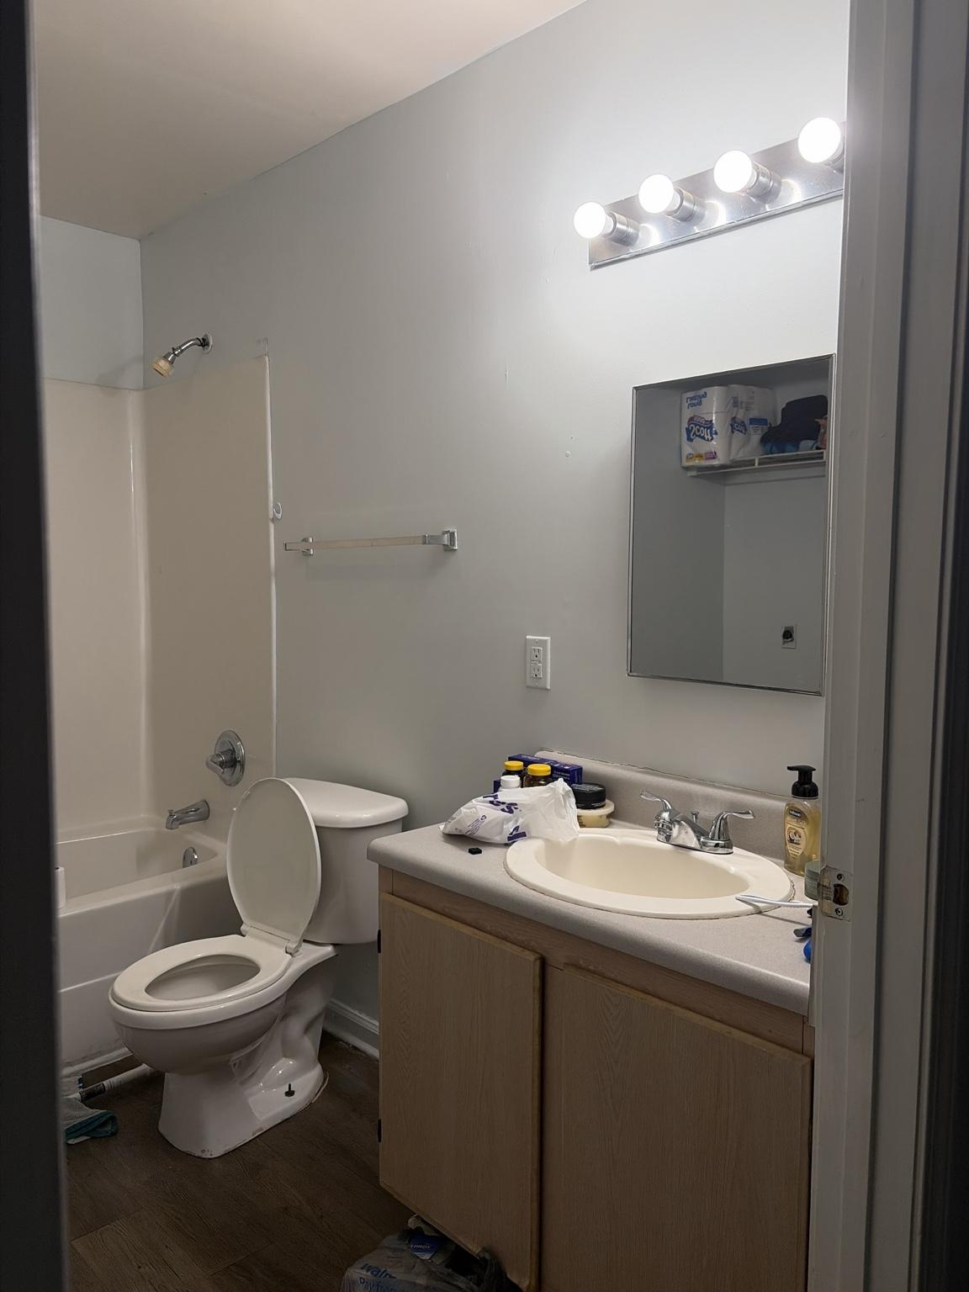p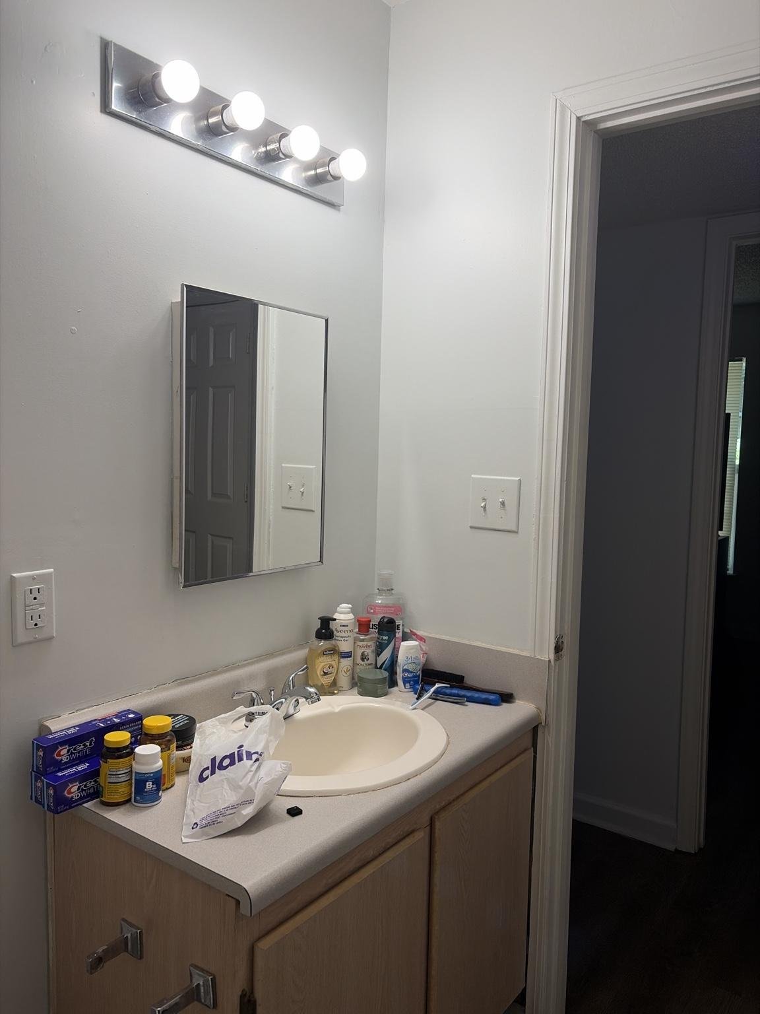e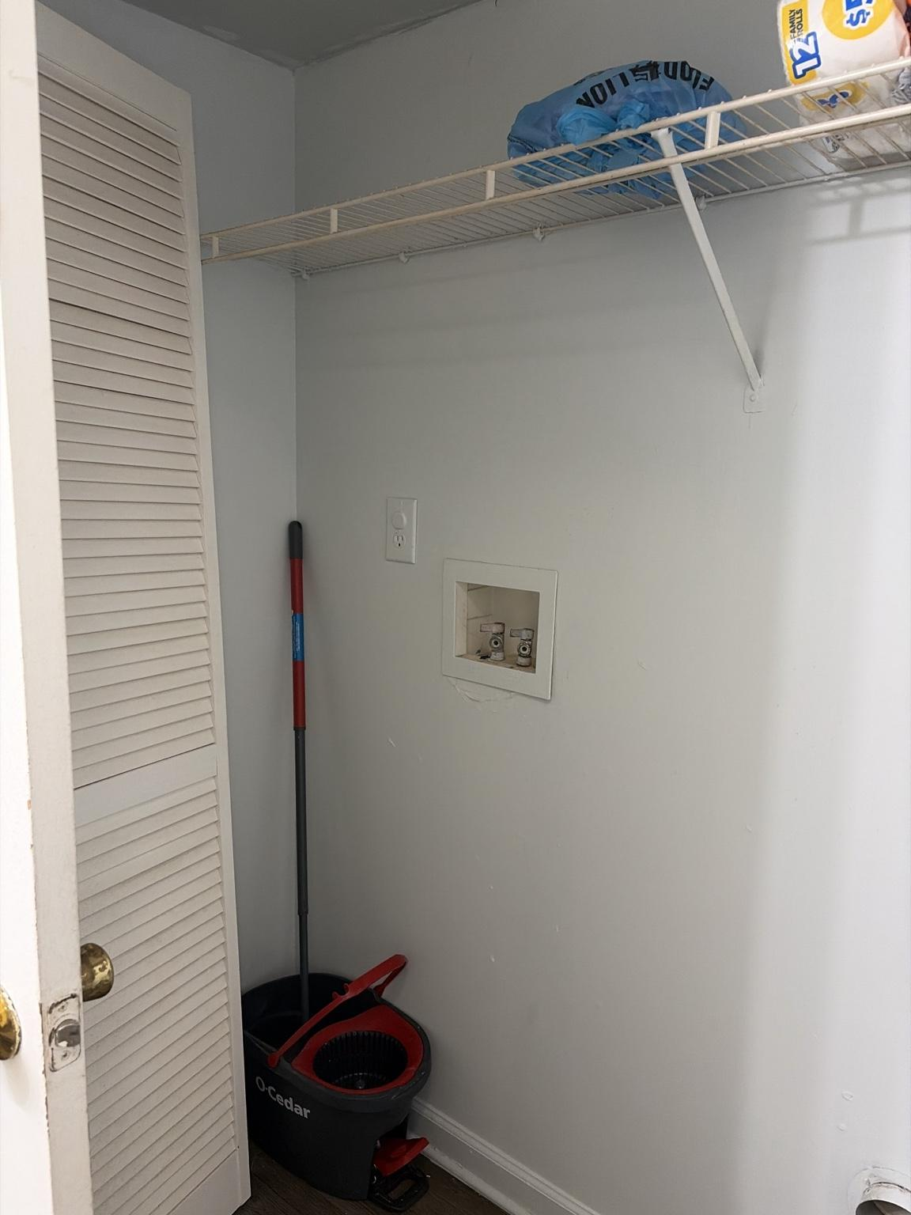n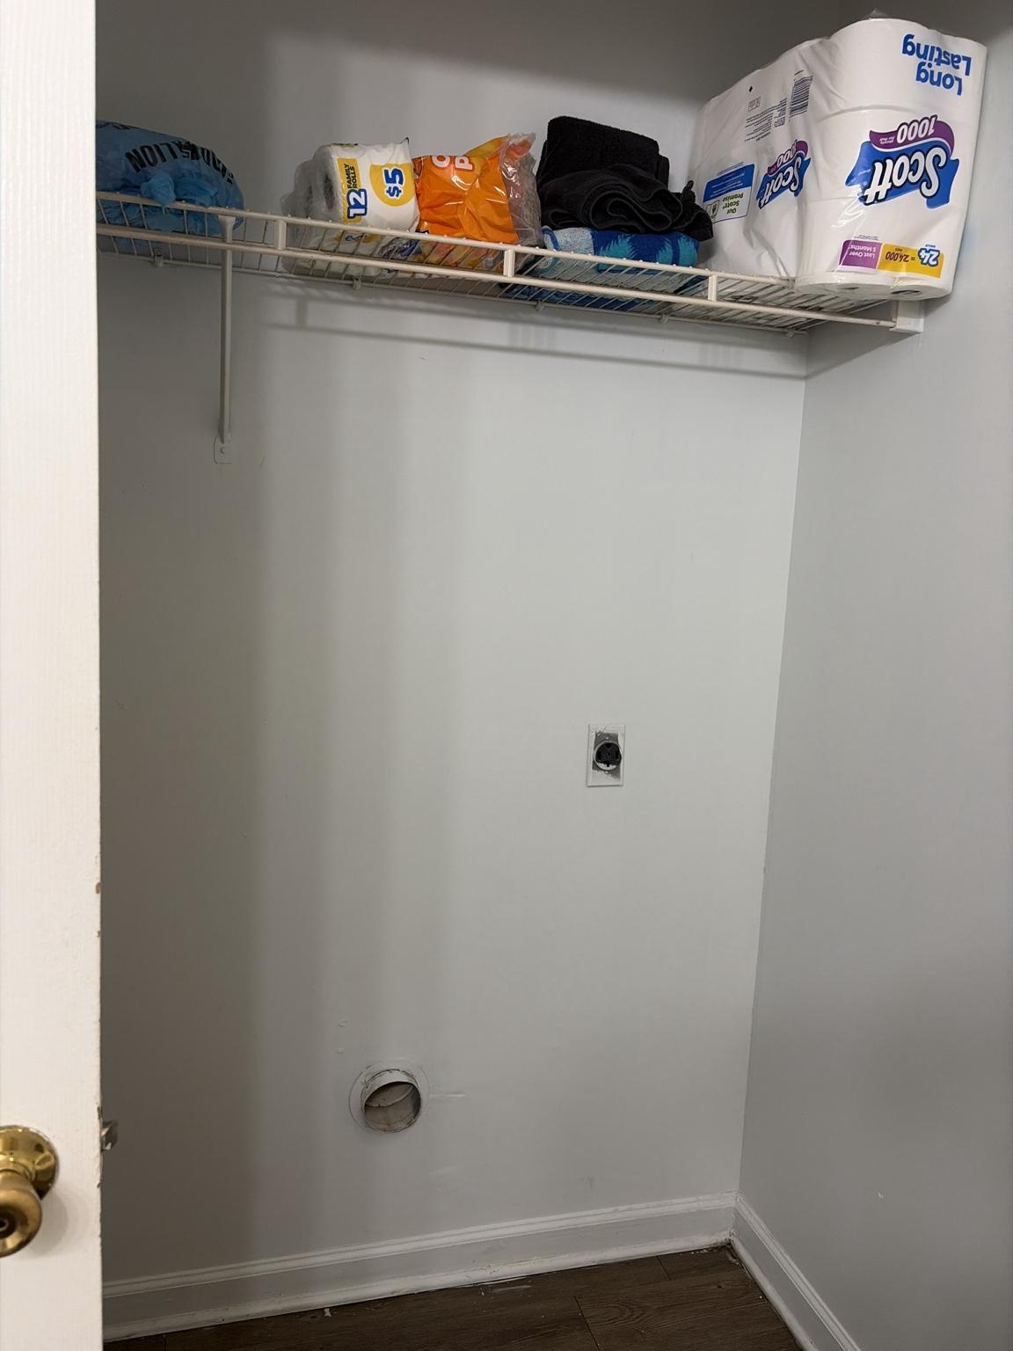s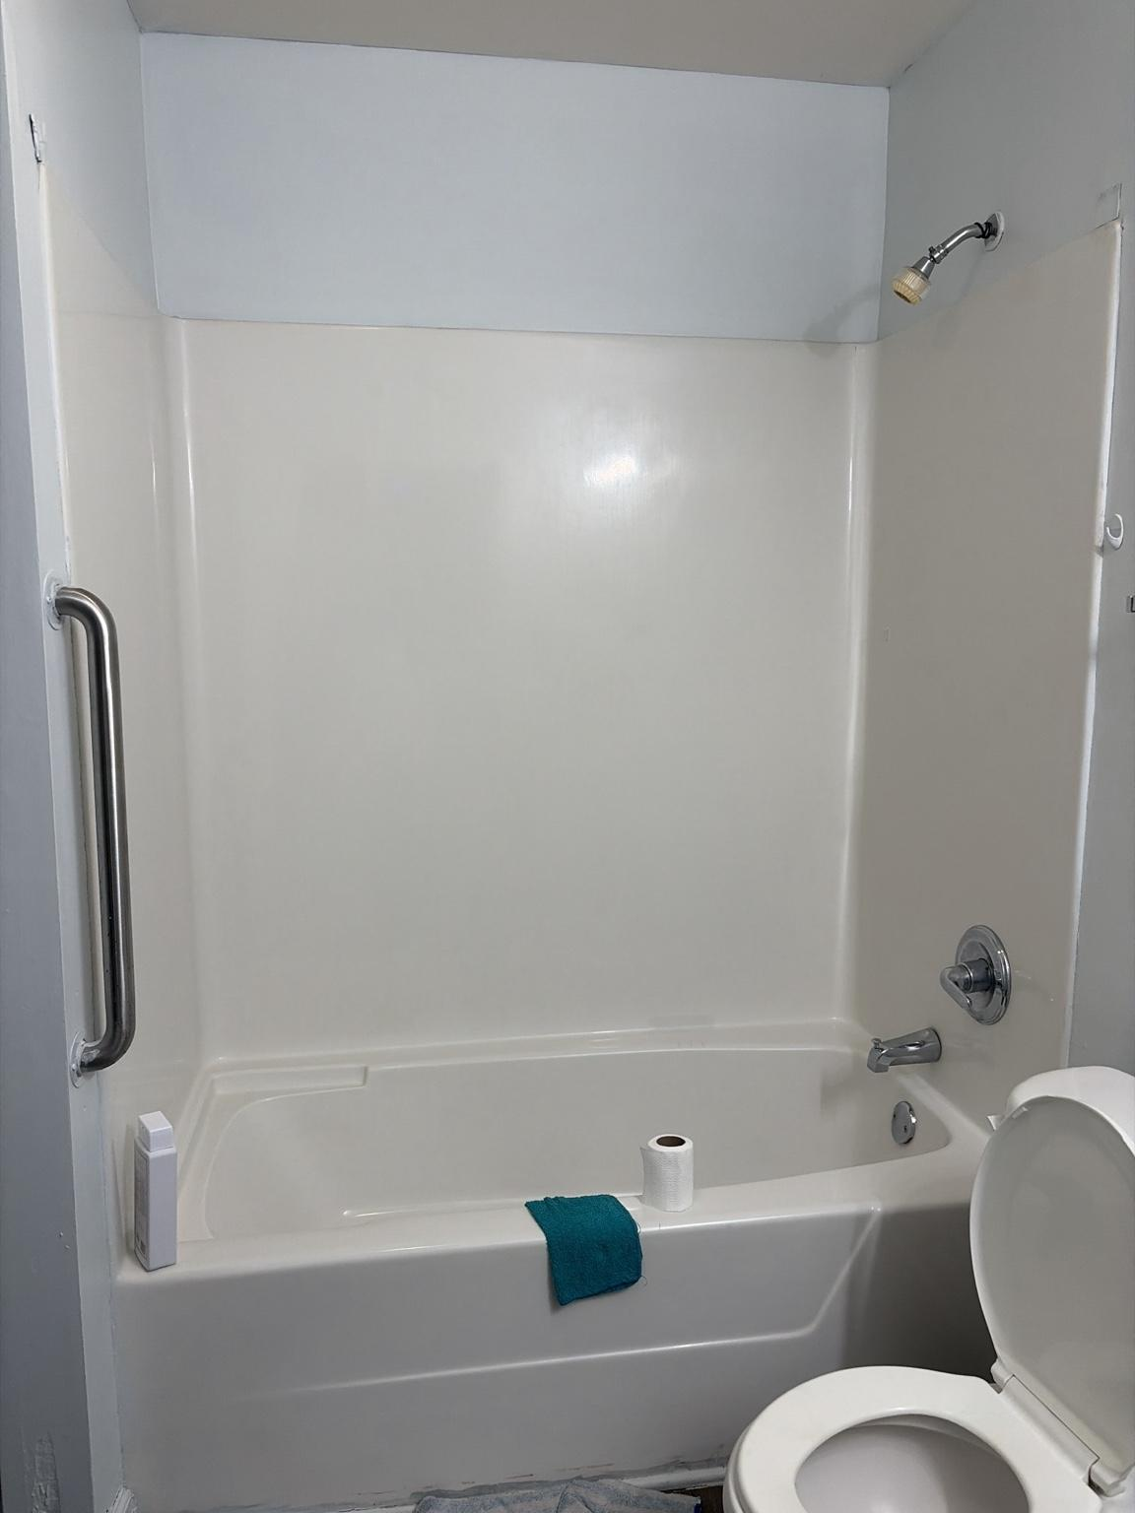 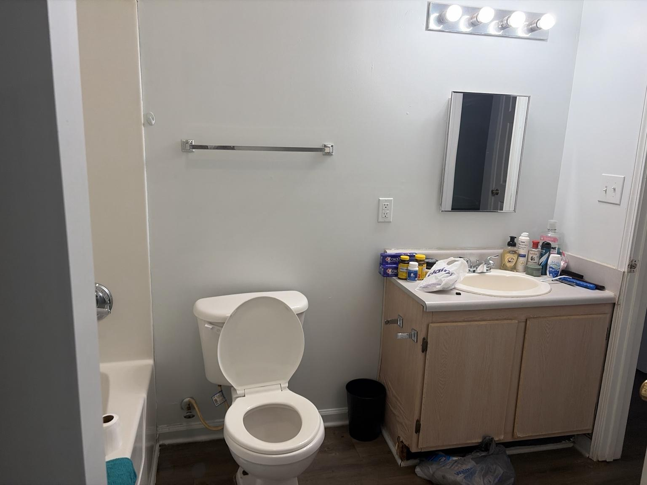directly from the private-room hallway and is visible from the Living Room when the bathroom door remains open.
• The room contains a tub-and-shower combination, toilet, single-sink vanity, wall mirror, towel bar, and a four-lamp vanity light.
• A ceiling-mounted exhaust fan or fan/light unit is positioned above the tub area.
• The tub surround includes a fixed vertical safety grab bar at the entry side.
• The shower uses a fixed wall-mounted showerhead and standard tub controls.
• The vanity has a light wood-look cabinet, pale countertop, integrated sink, and exposed countertop storage.
• A GFCI-style receptacle is located beside the vanity mirror.
• A two-switch wall plate is positioned near the bathroom entry; exact switch functions remain to be confirmed.
• The bathroom floor continues the apartment’s dark wood-look finish into a moisture-prone environment.
• A louvered-door laundry closet adjoins the Bathroom and contains hot and cold water valves, a drain standpipe, an electrical receptacle, a dryer vent opening, and a wire storage shelf.
• The laundry closet is currently used for paper goods, towels, cleaning supplies, and a mop bucket while no washer or dryer is installed.
• The laundry hookups confirm that the closet is intended for a stacked or compact washer-and-dryer installation, subject to property specifications and exact measurements.
• Vanity surfaces, floor areas, and the laundry closet currently contain loose items that reduce clear working space.

Safety, moisture, electrical, and access requirements:
• BA-SAF-001 — The Bathroom shall use only moisture-appropriate lighting and electrical devices, with all smart equipment kept outside direct splash zones.
• BA-SAF-002 — The GFCI receptacle shall remain accessible and shall not be covered by cabinetry, mirrors, décor, or permanent cable routing.
• BA-SAF-003 — The tub grab bar shall remain unobstructed and shall not be used as a storage rail.
• BA-SAF-004 — The tub edge, floor, and doorway shall remain free of loose rugs, cords, bags, and stored items that create slip or trip hazards.
• BA-SAF-005 — The exhaust fan shall remain operational and should be used during bathing and for an adequate period afterward to control humidity.
• BA-SAF-006 — The two-switch entry plate shall not be replaced or automated until the light and exhaust-fan circuits are positively identified.
• BA-SAF-007 — Any smart bulb used in the vanity fixture must be approved for enclosed or damp-location use as applicable and must not exceed fixture wattage limits.
• BA-SAF-008 — The laundry water valves, drain, receptacle, and dryer vent shall remain visible, accessible, and free of stored objects.
• BA-SAF-009 — No washer or dryer shall be installed until closet dimensions, electrical service, vent compatibility, drain condition, water connections, and property requirements are verified.
• BA-SAF-010 — Heavy paper goods and towels stored on the wire shelf shall be arranged so they cannot fall onto hookups, appliances, or the floor.
• BA-SAF-011 — Cleaning chemicals shall be stored securely and separated from personal-care items and paper products.

Design and system implications:
• The Bathroom’s permanent Sanctuary identity is Wellness, with restoration, cleanliness, flattering light, humidity control, and safe nighttime use taking priority.
• The four-lamp vanity fixture is the primary candidate for Bathroom lighting scenes, including Spa, Luxury, Grooming, Cleaning, and Night modes.
• Spa and Luxury modes should use warm, softened light; Grooming and Cleaning modes should use brighter neutral-white light for accurate visibility.
• A low-output nighttime Bathroom scene should provide enough light for safe movement without fully waking the occupant or flooding the hallway.
• The bathroom door and hallway light should be coordinated so open-door light spill does not disrupt Bedroom sleep modes.
• Countertop organization should consolidate daily-use items into controlled trays or concealed storage to restore usable sink space.
• A future leak sensor beneath the vanity and another near the laundry hookups would provide high-value early warning.
• A humidity sensor may support exhaust-fan reminders or automation only after fan control and electrical compatibility are confirmed.
• The laundry closet should be treated as a dedicated utility zone, not overflow storage, once appliances are installed.
• Before appliance purchase, exact closet width, depth, height, door clearance, hookup spacing, and vent path must be measured.
• If the closet remains without appliances temporarily, storage should be organized on the upper shelf while preserving the entire lower hookup zone.
• Final switch functions, fan specifications, vanity-bulb compatibility, laundry appliance format, and moisture performance remain pending confirmation.

Photo OF-001 — Office Existing Conditions Survey

Figures 33–39. OF-001A through OF-001G document the Office entry, ceiling light, window wall, closet and room doors, electrical and communications connections, workstation wall, recording equipment, and open floor area.

Observed conditions:
• The O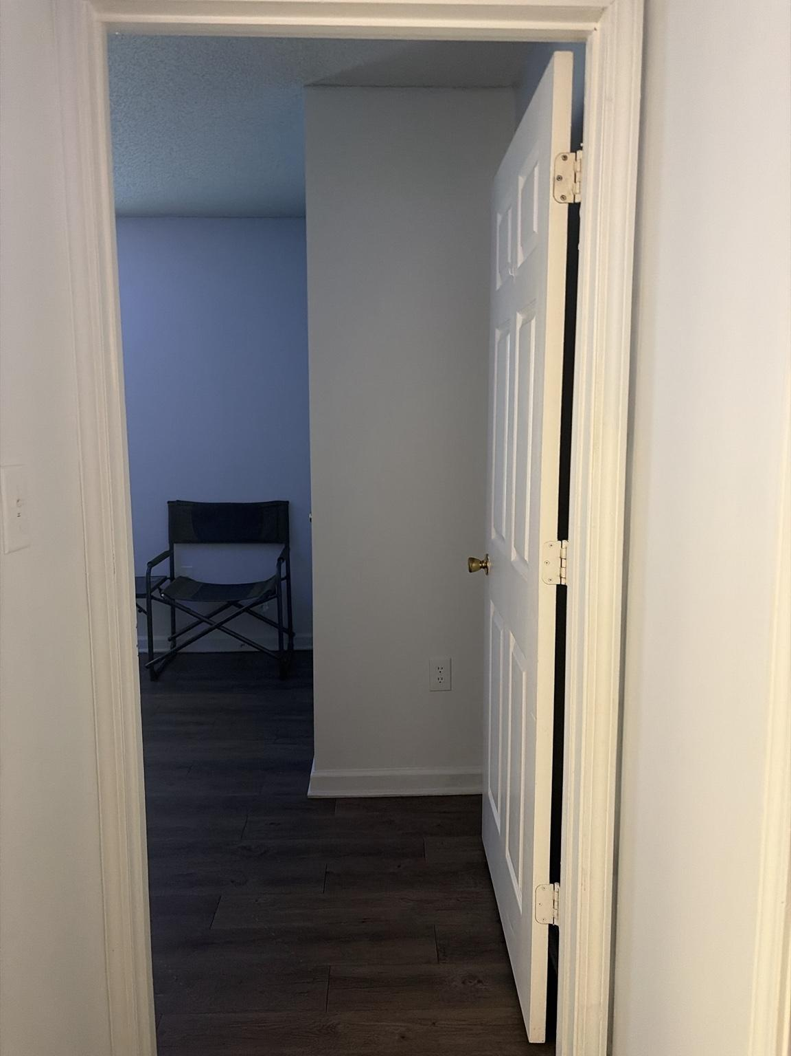f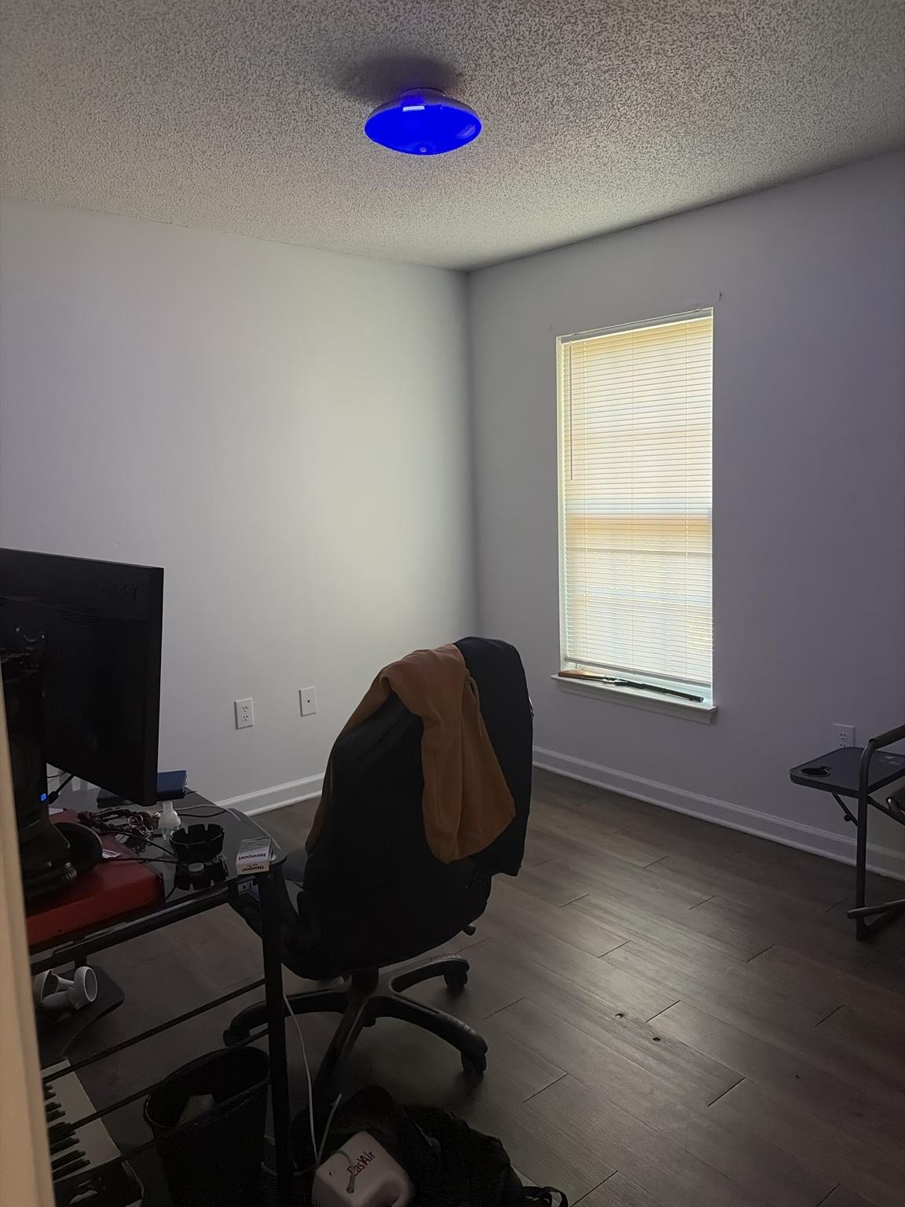f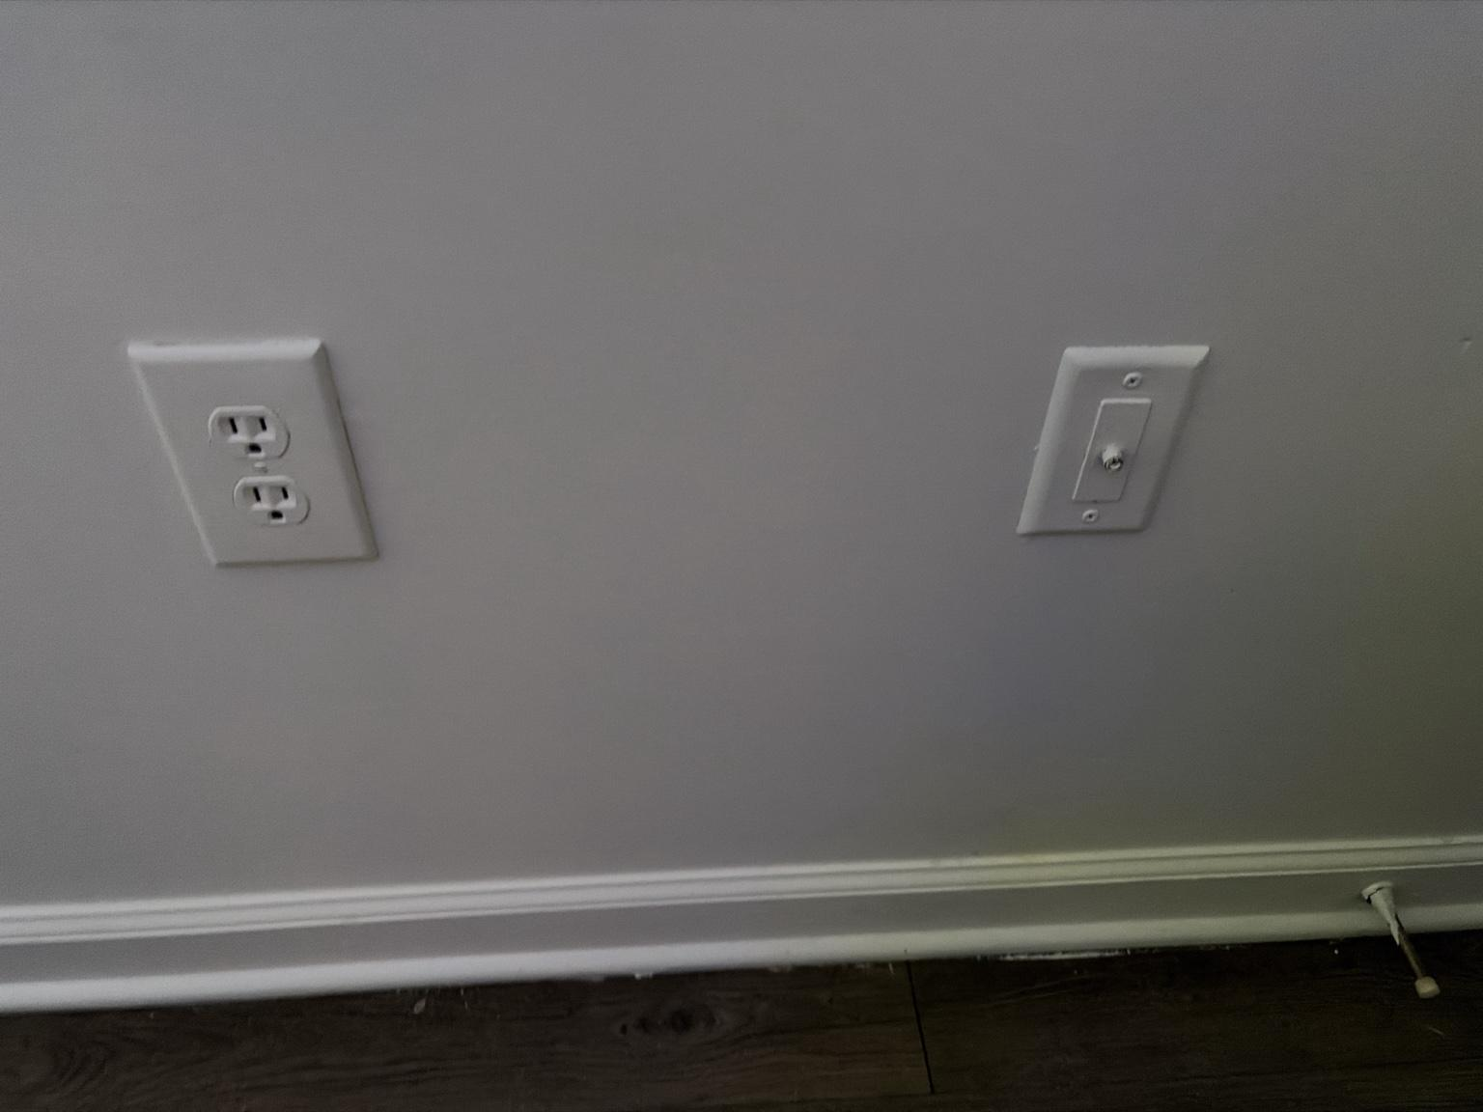i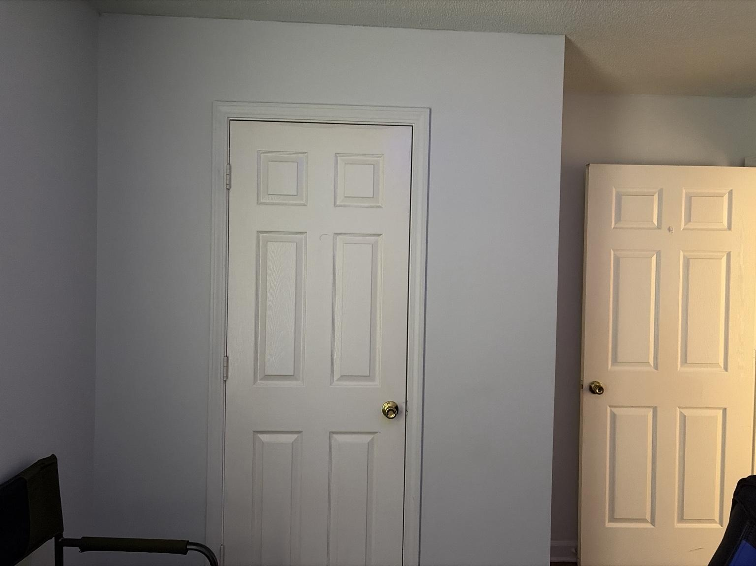c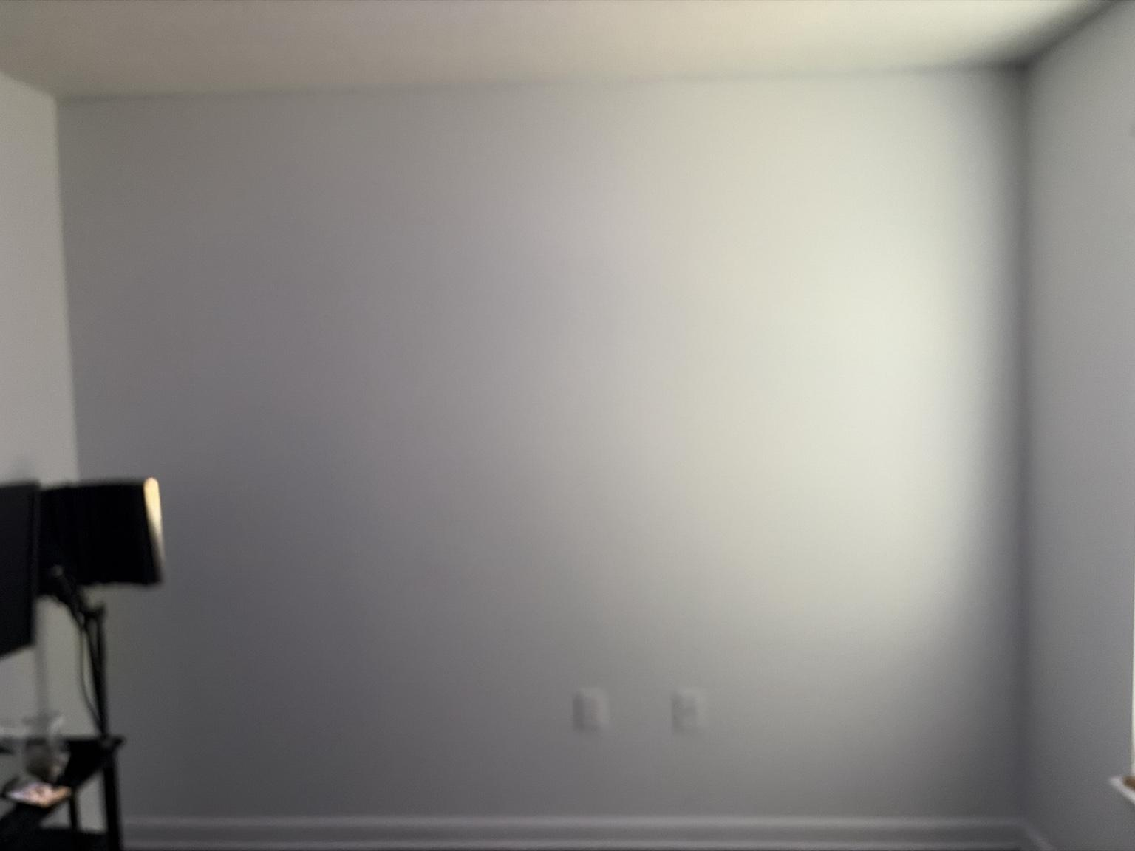e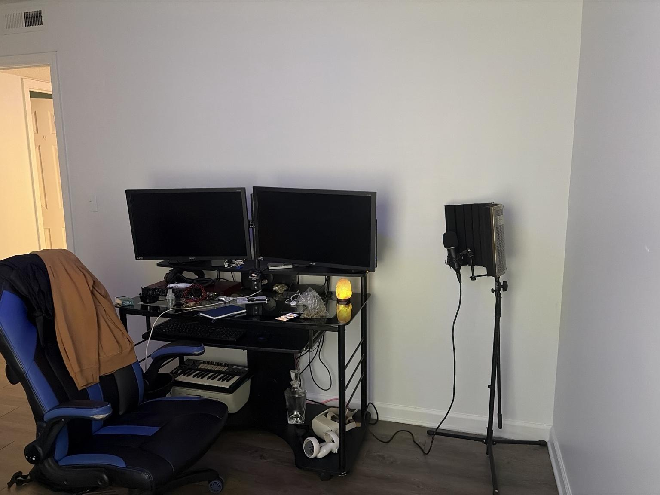 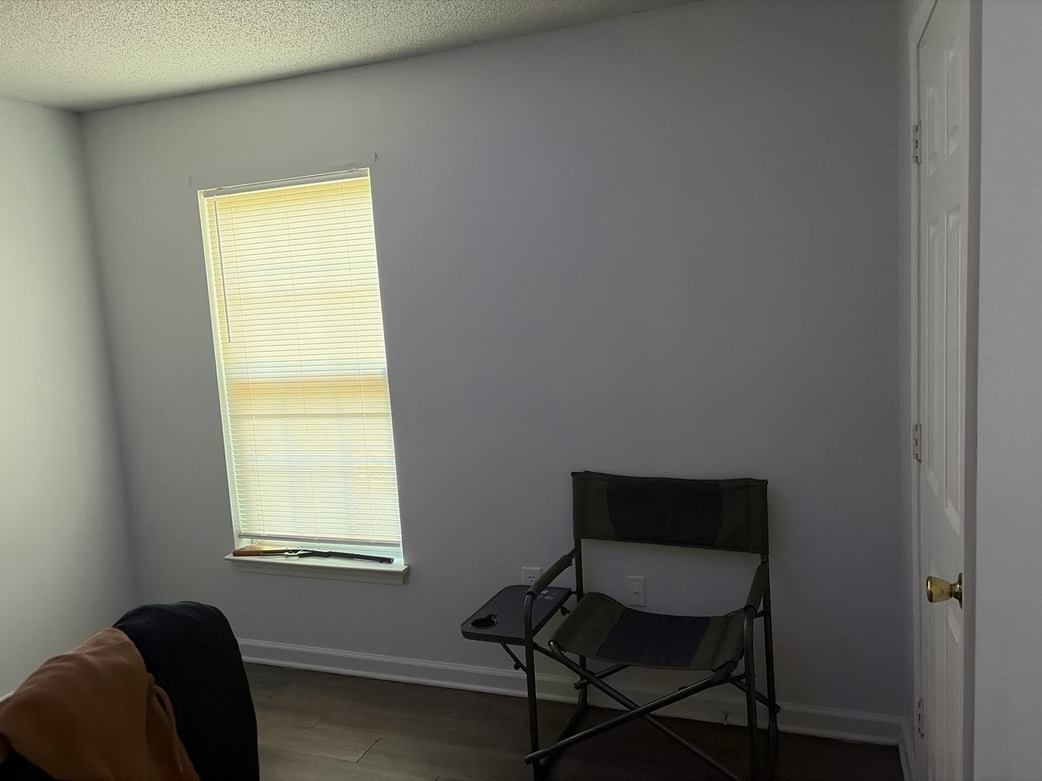is a rectangular private room accessed from the hallway and currently functions as a combined workstation, creative studio, music-production area, and recording space.
• A flush-mount ceiling fixture with an installed color-capable smart light provides the room’s primary built-in illumination; the light is shown operating in blue.
• One exterior window with horizontal blinds supplies natural light and is positioned on the wall opposite or adjacent to the main workstation zone.
• The primary workstation includes a glass-and-metal desk, two monitors, keyboard tray, computer accessories, a compact MIDI keyboard, an office chair, and substantial visible cabling.
• A freestanding microphone, isolation shield, and tripod-style stand occupy the right side of the workstation wall and establish a dedicated recording function.
• A second folding chair with an attached side tray is positioned near the window and opposite wall.
• A standard duplex receptacle and a separate coaxial or communications wall plate are visible on one wall.
• A separate wall receptacle is located behind the desk and supplies or is positioned to supply the workstation equipment.
• Additional low wall receptacles are visible near the window and other room edges.
• One full-height door serves the room entry, and a second full-height door appears to serve the Office closet.
• The central and window-side floor areas remain largely open, providing flexibility for future furniture, acoustic treatment, and movement.
• The room has continuous dark wood-look flooring and light neutral walls consistent with the rest of the apartment.
• Current workstation surfaces and floor areas contain loose accessories, cables, bags, and equipment that reduce visual clarity and service access.

Electrical, equipment, and circulation requirements:
• OF-SAF-001 — The wall receptacle behind the desk shall remain accessible and shall not be concealed permanently by fixed cabinetry, wall panels, or immovable equipment.
• OF-SAF-002 — The workstation load shall be consolidated through a properly rated surge protector or uninterruptible power supply rather than multiple unverified adapters or daisy-chained extension devices.
• OF-SAF-003 — Monitor, computer, audio, lighting, and charging cables shall be separated, labeled where useful, and routed clear of chair wheels and walking paths.
• OF-SAF-004 — The coaxial or communications wall plate shall remain accessible until its service function and future value are confirmed.
• OF-SAF-005 — The microphone stand and isolation shield shall be positioned so their legs, cables, and boom components do not create a trip hazard or obstruct the entry or closet door.
• OF-SAF-006 — The Office and closet doors shall retain full operating clearance.
• OF-SAF-007 — Window access, blind operation, and any required emergency egress clearance shall remain unobstructed.
• OF-SAF-008 — Heat-producing electronics shall receive adequate ventilation and shall not be enclosed tightly against walls, curtains, or acoustic materials.
• OF-SAF-009 — Any future acoustic panels, shelving, lighting, or wall-mounted equipment shall use renter-safe methods and shall avoid unidentified wiring and outlet locations.

Design and system implications:
• The Office’s permanent Sanctuary identity is Command Center, with creation, concentration, production quality, flexibility, and controlled visual energy taking priority.
• The main desk wall is the operational center of the room and should be developed as a unified workstation rather than a collection of disconnected devices.
• Cable management is the highest-priority immediate improvement: under-desk trays, short replacement cables, labeled power routing, and a single controlled power hub will materially improve safety and appearance.
• The visible receptacle behind the desk should be treated as the primary workstation power source, subject to circuit-capacity confirmation.
• The microphone area should become a defined recording zone with controlled cable routing, a stable equipment footprint, and renter-safe acoustic treatment.
• Acoustic treatment should prioritize first-reflection points, the microphone-facing wall, and corner control while preserving the window, outlets, closet, and door swings.
• The open wall opposite the workstation is a strong candidate for modular shoe display, framed identity pieces, or a flexible creative backdrop, but final use should be coordinated with acoustic needs and camera sightlines.
• The window wall should preserve daylight while gaining a more finished treatment that supports glare control, recording privacy, and temperature management.
• The ceiling light may support Studio, Create, Focus, Recording, Showcase, and Cleaning scenes; saturated blue is suitable for selected creative modes but neutral-white task lighting should remain available for accurate work.
• The Hallway may mirror selected Office modes as intentional spillover, while routine Office scenes should avoid unnecessary activation elsewhere.
• A presence sensor could support automatic task-light persistence, but it should distinguish seated work from vacancy and should never interrupt active recording or computer sessions.
• Future upgrades should favor a larger consolidated desk, monitor arms, a dedicated equipment rack or drawer system, concealed cable channels, and a controlled background wall.
• Exact room dimensions, closet interior configuration, outlet circuit capacity, coax service status, window dimensions, and final equipment inventory remain pending confirmation.

Photo BR-001 — Bedroom and Bedroom Closet Existing Conditions Survey

Figures 40–48. BR-001A through BR-001I document the Bedroom entry, electrical-panel wall, closet interior, television and window wall, bed placement, floor lamp, ceiling fixture, outlets, and room circulation.

Observed conditions: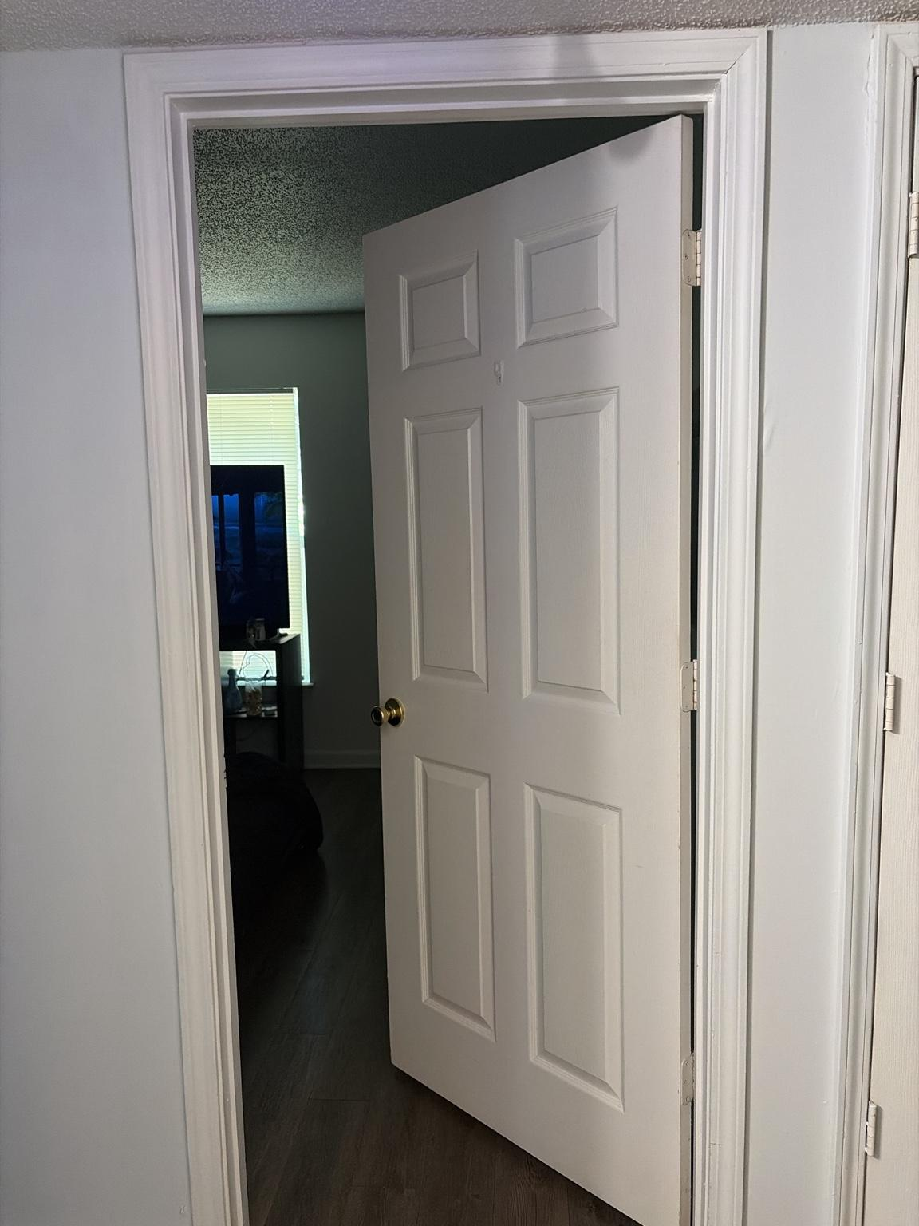
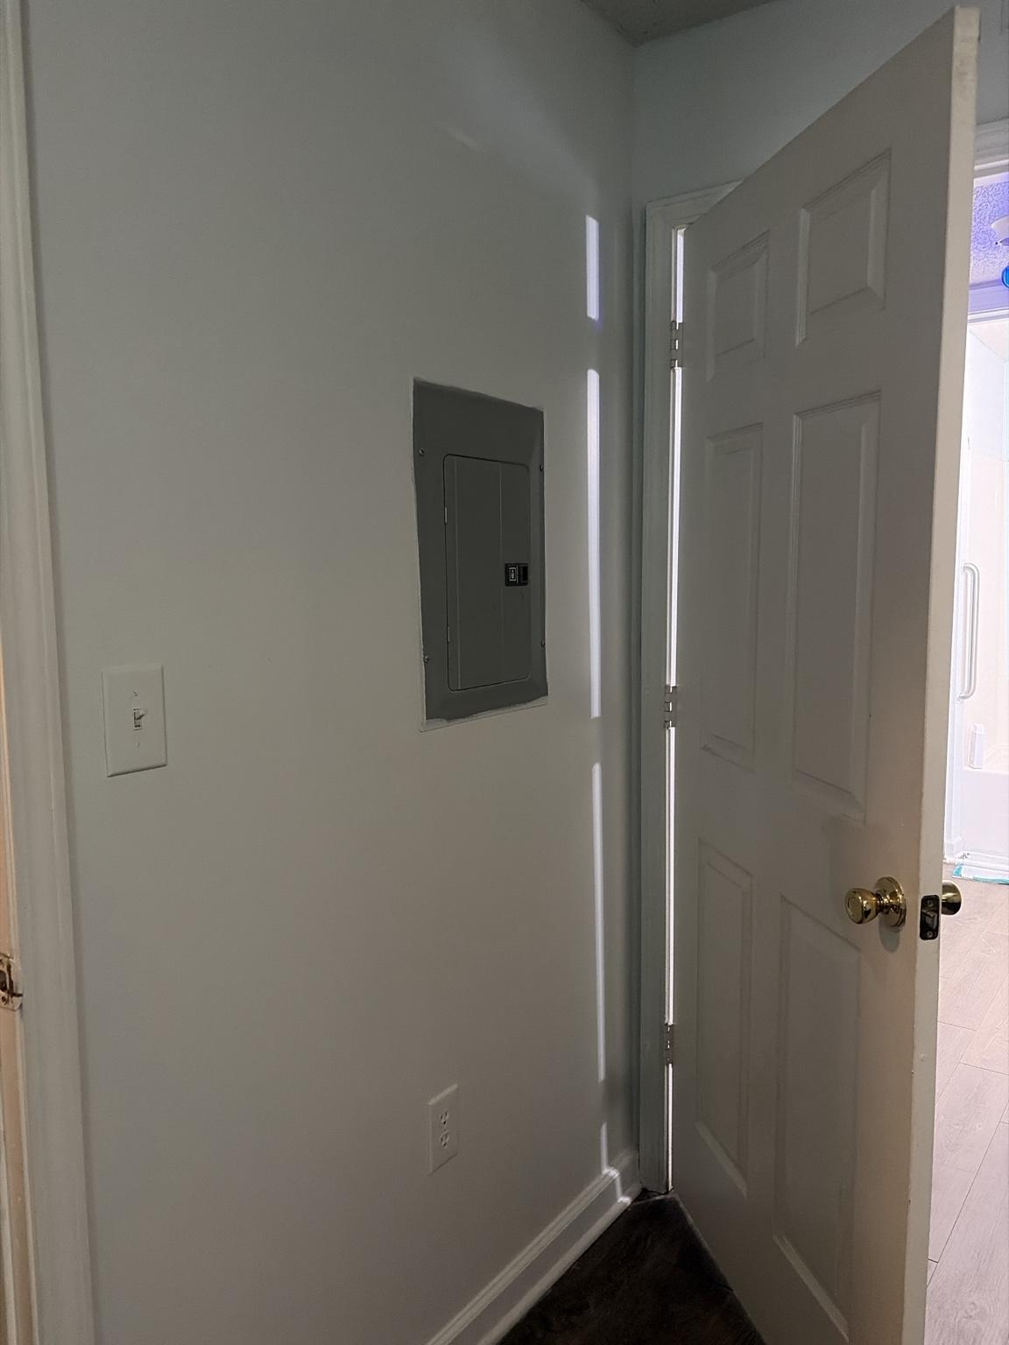•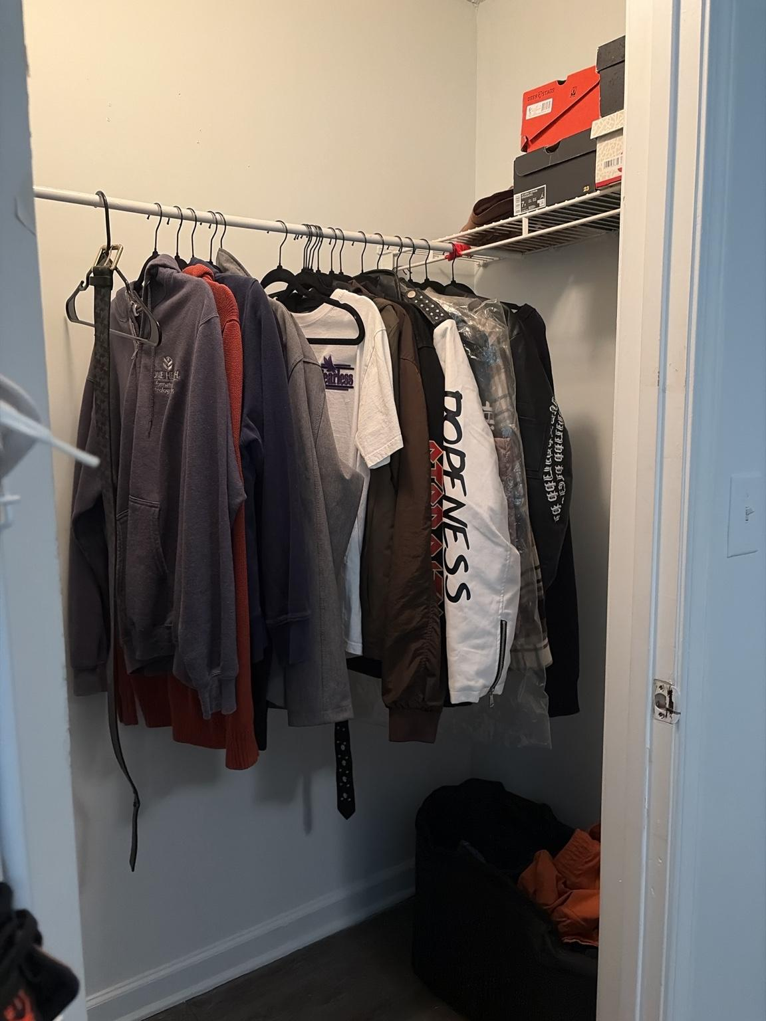 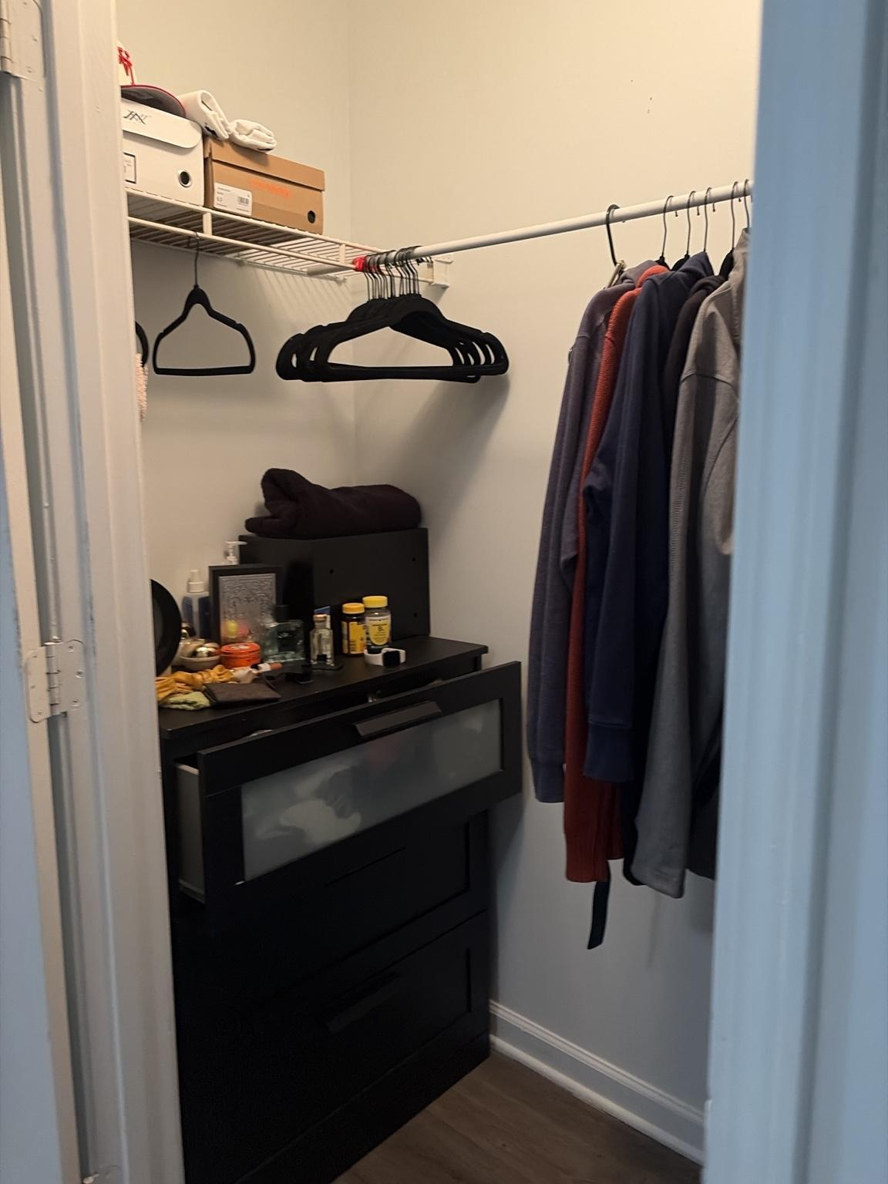T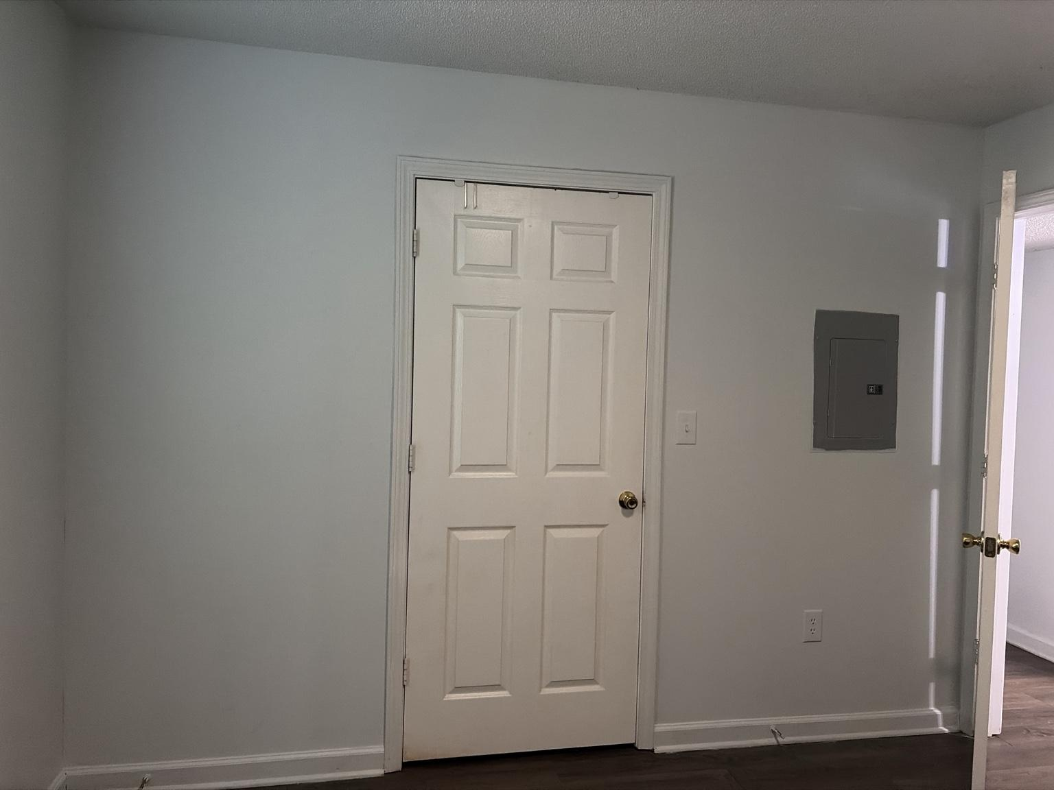h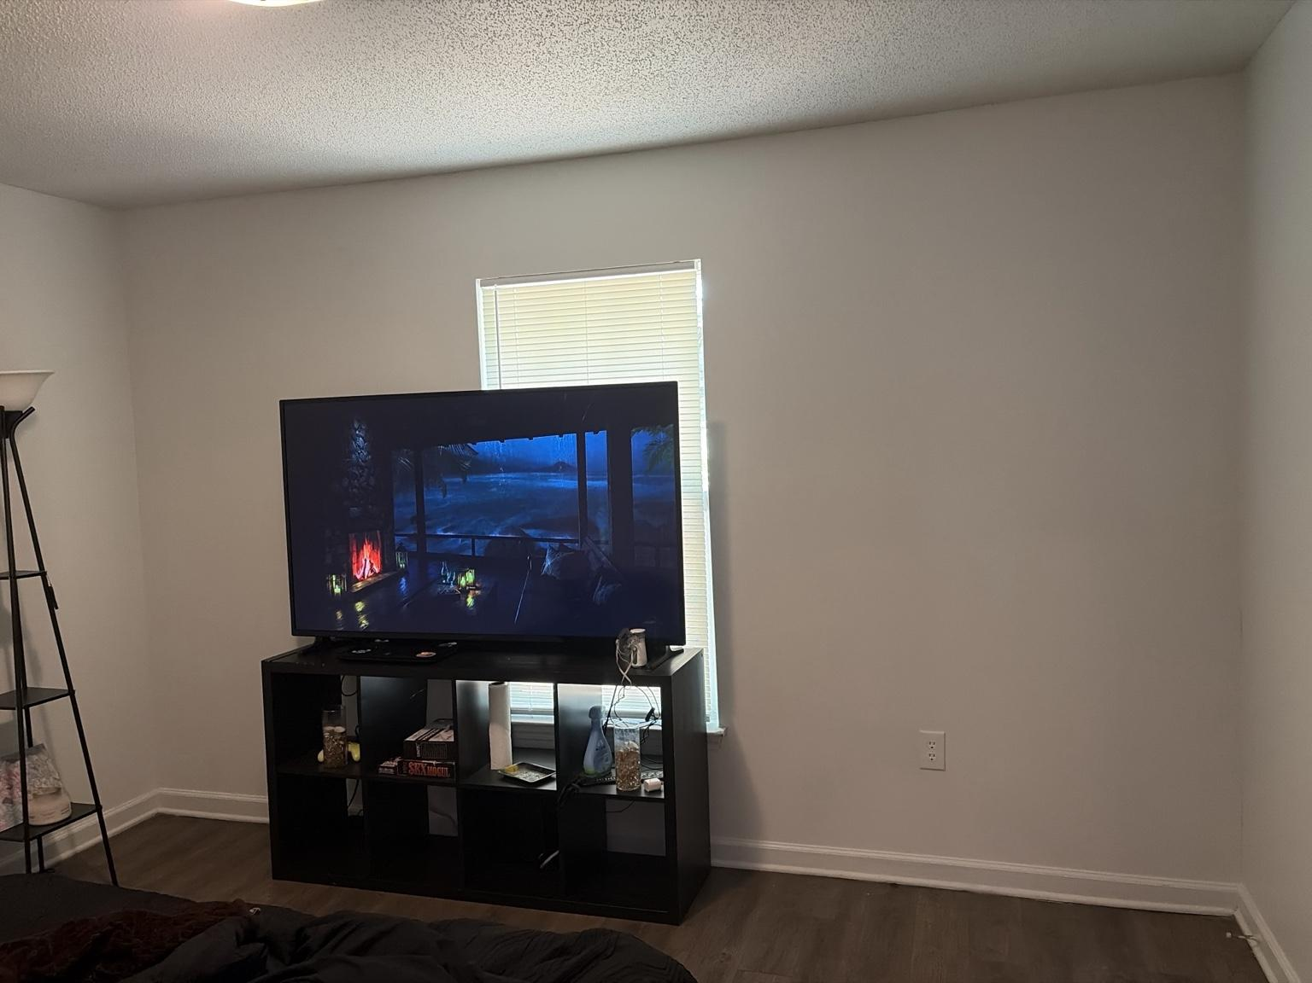e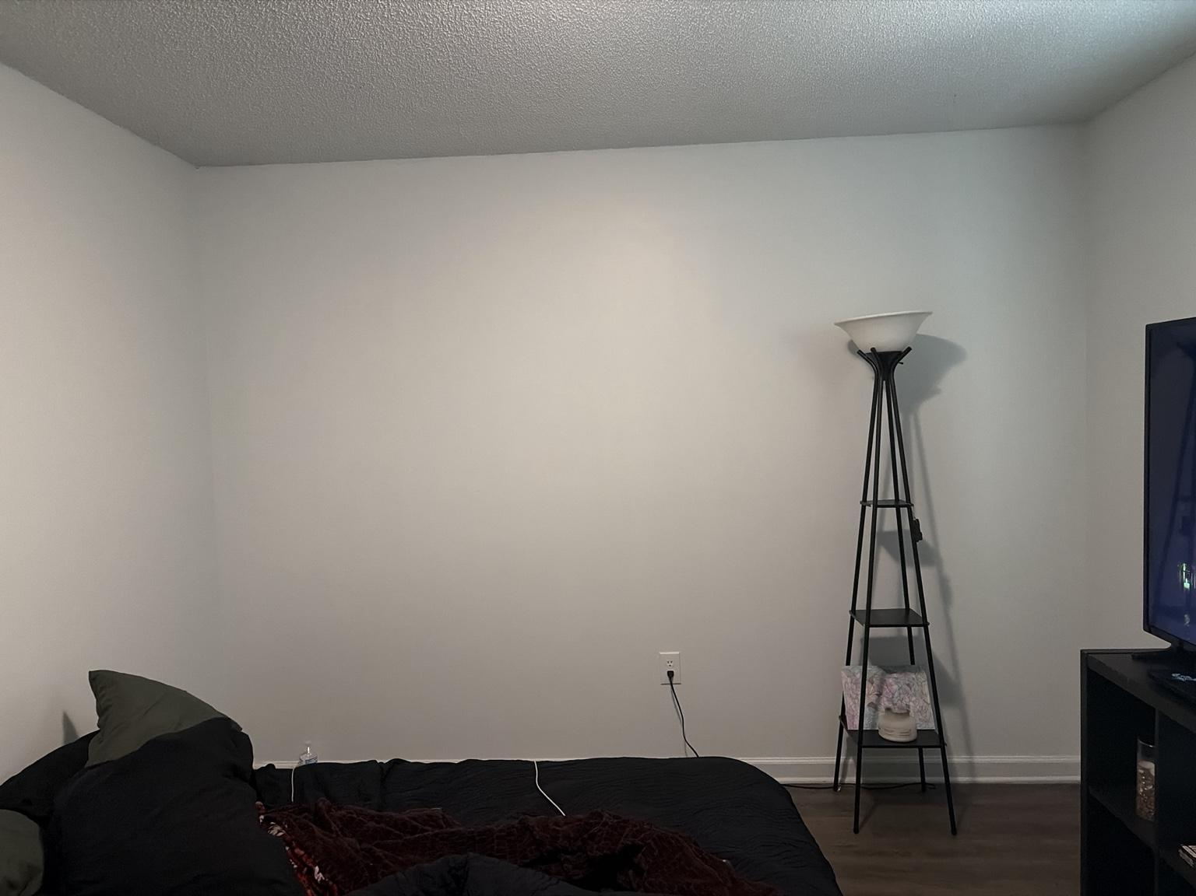 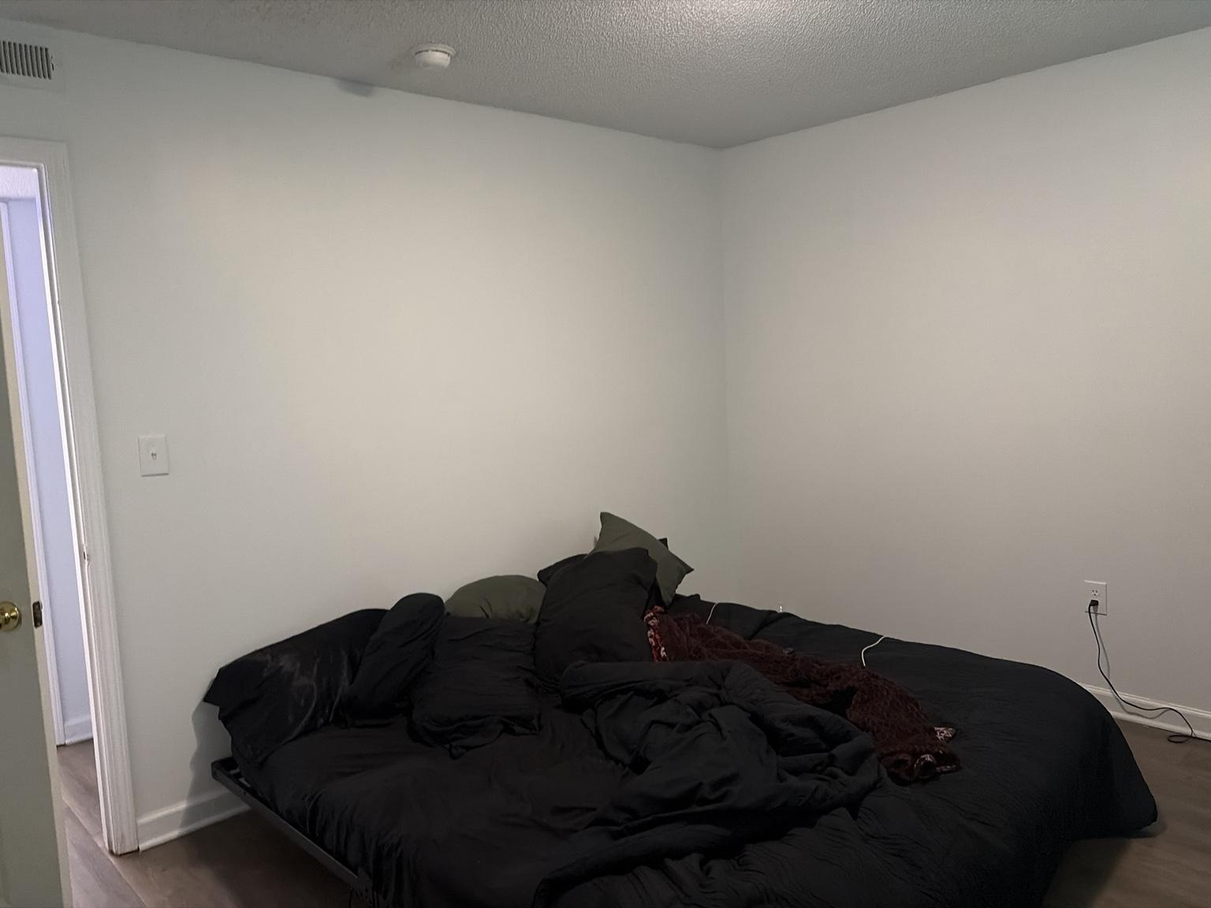B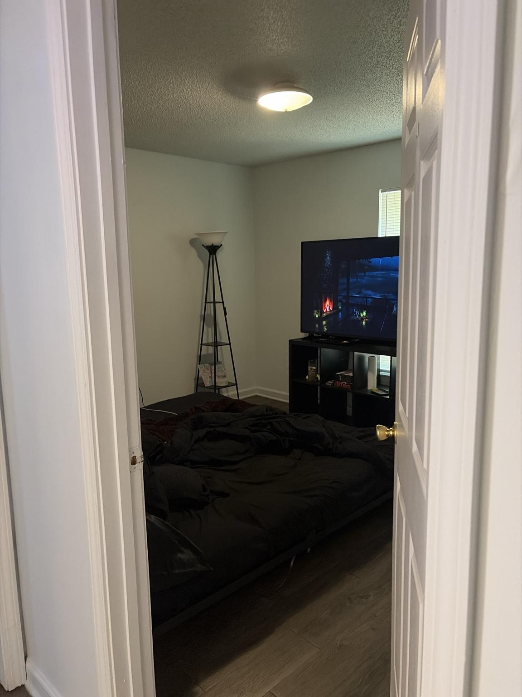edroom is a large private room accessed from the hallway and currently contains a low platform bed, 65-inch-class television, cube-style media console, floor lamp, and walk-in closet.
• A flush-mount ceiling fixture provides the primary built-in room illumination.
• One exterior window with horizontal blinds is located behind the television area and provides the room’s natural light.
• The television and media console are currently positioned directly in front of or overlapping the window zone, affecting daylight access, blind operation, and screen-glare conditions.
• The low bed occupies a substantial portion of the central floor area and is positioned close to two adjoining walls.
• A tall floor lamp with integrated shelves is located near the television side of the room.
• The Bedroom closet is a walk-in storage area with perimeter hanging rods, wire shelving, clothing, shoe boxes, personal items, and a black drawer unit.
• The electrical breaker panel is mounted on the Bedroom wall near the entry and closet area.
• A standard receptacle is visible below the electrical panel, and an entry-area wall switch is positioned nearby.
• Additional receptacles are visible around the room, including behind or near the bed and television zones.
• The user confirms that wall switches are located behind the bed and behind the television; their exact controlled circuits remain to be confirmed.
• A ceiling-mounted smoke alarm is visible near the room-entry side.
• Dark wood-look flooring and neutral walls continue through the Bedroom and closet.

Electrical, fire-safety, access, and furnishing requirements:
• BR-SAF-001 — The electrical breaker panel shall remain fully visible, reachable, and unobstructed at all times; no furniture, storage, artwork, curtains, or door position may restrict access to it.
• BR-SAF-002 — Required working clearance in front of the breaker panel shall be preserved, and the panel shall never be concealed inside decorative cabinetry or behind movable storage.
• BR-SAF-003 — The smoke alarm shall remain installed, unobstructed, tested, and free of decorative covers or nearby objects that could impair detection.
• BR-SAF-004 — The confirmed wall switches behind the bed and television shall remain accessible and shall not be permanently trapped by furniture or cable-management installations.
• BR-SAF-005 — No smart relay, switch replacement, or automation shall be applied to the behind-bed or behind-television switches until each circuit is positively identified.
• BR-SAF-006 — The television, media console, and cables shall not block window access, blind controls, required ventilation, or any applicable emergency-egress function.
• BR-SAF-007 — The bed shall maintain a clear route to the room door, closet, breaker panel, and window.
• BR-SAF-008 — Power cords serving the television, floor lamp, chargers, and bedside devices shall remain secured against walls and outside walking paths.
• BR-SAF-009 — Closet storage shall not overload wire shelving, obstruct the closet entrance, or create unstable overhead stacks.
• BR-SAF-010 — Any future television mounting must use a structurally appropriate and renter-approved method and must account for hidden electrical wiring, the window, and viewing height from the bed.

Design and system implications:
• The Bedroom’s permanent Sanctuary identity is Recovery, encompassing rest, intimacy, gradual waking, and sleep protection.
• The room should prioritize a calm bed focal point, concealed storage, controlled screen light, minimal cable visibility, and clear nighttime movement.
• The current television position conflicts with the window and should be reassessed after exact wall and furniture measurements are recorded.
• The wall opposite or adjacent to the bed may provide a more controlled television location if it preserves the breaker panel, switches, closet access, and viewing geometry.
• The bed should receive an intentional headboard wall or visual anchor rather than remaining visually unsupported against broad blank walls.
• The floor lamp can support warm ambient scenes, but its open upward light should remain dim during sleep preparation and should not compete with television viewing.
• The ceiling fixture should support Wake-Up, Getting Ready, Wind-Down, Romantic, Thunderstorm Sleep, Cleaning, and Night modes.
• Thunderstorm Sleep should transition the room to very dim, warm or muted blue ambient light and then power lighting off after the established sleep timer.
• Romantic mode should use low, warm, flattering light and avoid intense overhead brightness.
• The confirmed switches behind the bed and television may explain existing room-control behavior, but they must be mapped before furniture placement is finalized.
• The closet should become a structured wardrobe zone with consistent hangers, defined categories, controlled shoe-box storage, and a clear floor path.
• A door or presence sensor could support Bedroom arrival and sleep logic, but no sensor should trigger disruptive lighting during normal movement in bed.
• Final bed dimensions, television size and mounting plan, switch functions, outlet circuits, closet dimensions, window dimensions, and ceiling-fixture compatibility remain pending confirmation.

Photo FL-001 — Flooring Color and Finish Referen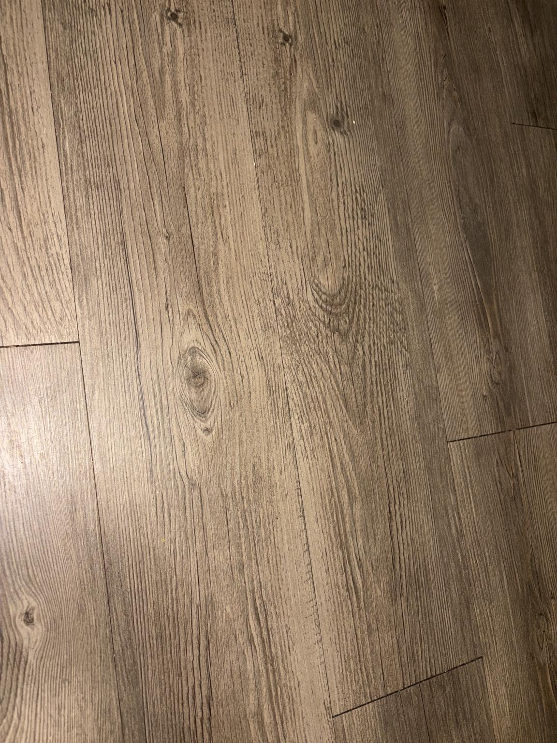ce

Figure 49. FL-001 provides a close-range color and material reference for the apartment’s continuous wood-look flooring.

Observed finish:
• The flooring has a medium-to-dark brown base with warm taupe and subtle taupe undertones.
• The printed grain includes linear oak-like texture, knots, and moderate tonal variation between planks.
• Under direct warm light, the surface reads as warm brown; in lower or cooler light, it can appear deeper espresso-brown.
• The finish is low-sheen to satin rather than glossy.
• Planks are installed in a staggered pattern and visually continue through the primary interior rooms.

Official design reference:
• Sanctuary flooring color designation: warm weathered walnut-brown with greige undertones.
• The flooring shall be treated as a permanent dark neutral in all furnishing, rug, paint, textile, and lighting decisions.
• Compatible core finishes include black, deep espresso, espresso, walnut, warm white, ivory, cream, cognac, muted olive, and restrained brass or gold accents.
• Cool blue furniture, orange-toned woods, and red-heavy brown finishes should be tested carefully because they may conflict with the floor’s warm taupe undertone.
• Rugs should provide visible contrast from the flooring rather than blending into the same mid-brown value range.
• Warm-white lighting will emphasize the brown and walnut qualities; cooler-neutral lighting will emphasize the cooler and weathered qualities.

Documentation note:
• This photograph establishes the visual color reference but does not confirm the flooring manufacturer, product name, material composition, wear rating, or exact color code.

Photo WL-001 — Wall Color and Finish Reference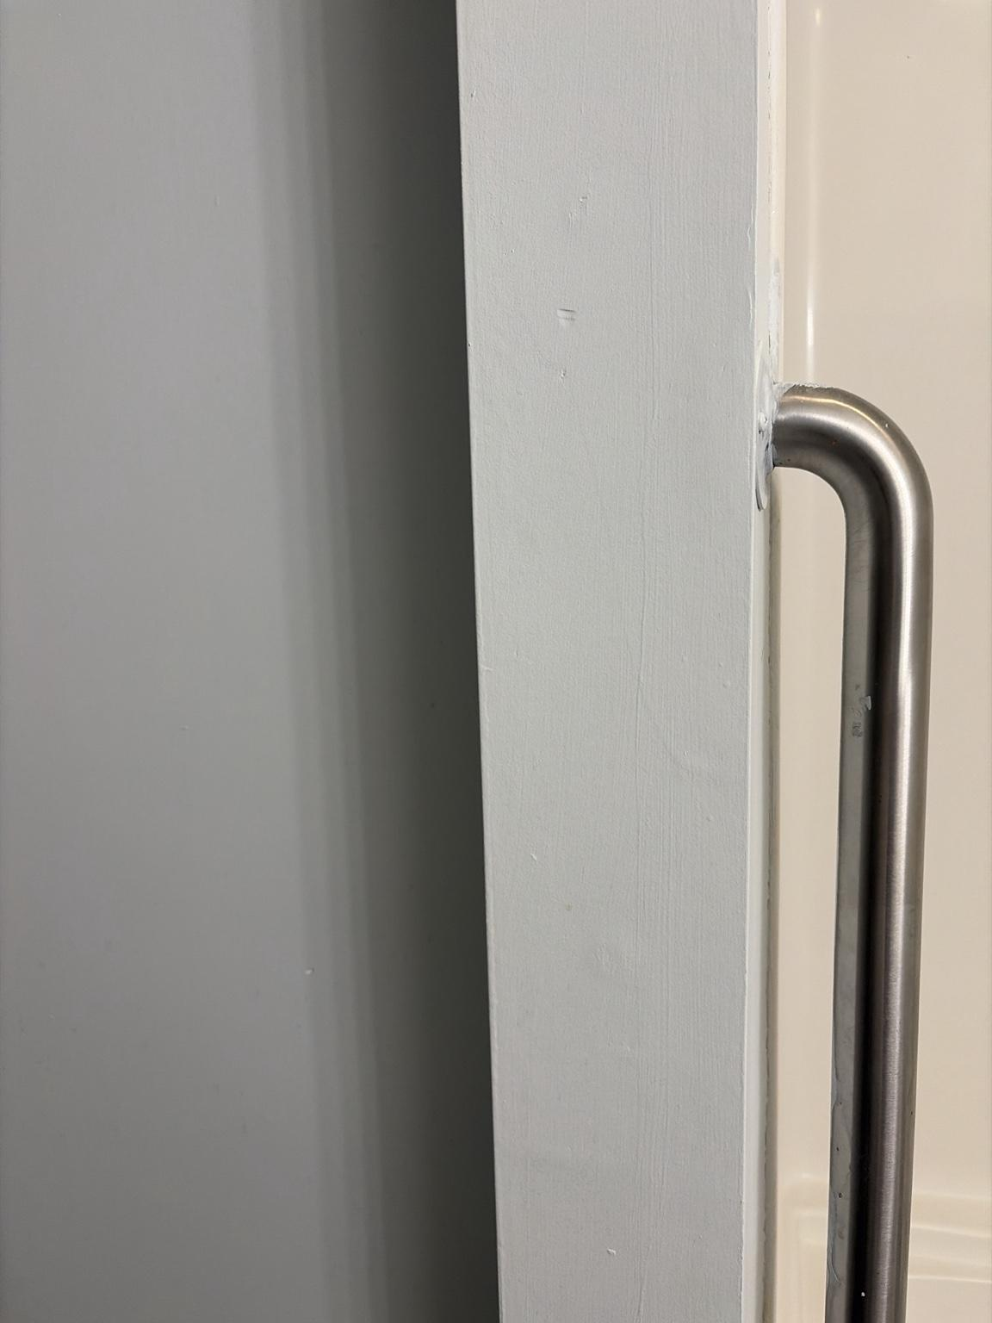

Figure 50. WL-001 provides a close-range visual reference for the apartment’s primary painted wall color beside the white tub surround and brushed-metal grab bar.

Observed finish:
• The wall color reads as an extremely pale blue-white rather than a pure neutral white.
• The undertone is cool with a muted blue cast, becoming more visibly blue in shadow or under cool lighting.
• Under warm lighting, the paint can appear closer to soft white or very light gray.
• The wall surface has a low-sheen painted finish with minor texture and ordinary surface imperfections.
• Bright white trim, doors, and bathroom fixtures create a subtle but visible contrast against the cooler wall color.

Official design reference:
• Sanctuary wall-color designation: pale blue-white with a cool gray undertone.
• The existing walls shall be treated as a cool architectural neutral, not as warm cream or beige.
• Warm woods, walnut-brown flooring, black, deep espresso, cognac, ivory, muted olive, and restrained brass will help balance the wall color and prevent the apartment from feeling cold.
• Large amounts of icy gray, bright cobalt, or blue-white lighting should be controlled carefully because they can exaggerate the blue undertone.
• Warm-white lighting in the approximate 2700K–3500K range will soften the walls and support the intended warm-modern Sanctuary atmosphere.
• Neutral task lighting may be used where accurate visibility is required, but cool high-output lighting should not become the default ambient condition.

Documentation note:
• This photograph establishes the visual wall-color reference but does not confirm the paint manufacturer, product name, finish specification, or exact color code.

1C. Smart-Home Device Inventory and Status Snapshot

Snapshot date: July 16, 2026

Source: Google Home device-status list supplied by Giovanni.

Purpose

This section records the installed smart-home device inventory and a point-in-time operational snapshot. On/off state, brightness, connectivity, and paused status are temporary observations and shall not be treated as permanent protocol requirements.

Installed device inventory

Bathroom

• Bathroom Lights — device group containing five lights.

• Bathroom Light 1

• Bathroom Light 2

• Bathroom Light 3

• Bathroom Light 4

• Bathroom Light 5

Bedroom

• Bedroom Lights — device group containing two lights.

• Bedroom Light 1

• Bedroom Light 2

Dining Area

• Dinning Room Light — single smart light; current Google Home name contains a spelling error and should be standardized to “Dining Area Light.”

• Sir Cleans-A lot — iHome robot vacuum and current Dining Area home-base device.

Hallway

• Hall Light — single smart light.

Living Room / Entry

• Entry light — single smart light serving the Entry zone.

Office

• Office Lights — device group containing two lights.

• Office Light 1

• Office light 2 — capitalization should be standardized to “Office Light 2.”

Inventory summary

• Twelve individual smart lights are represented across Bathroom, Bedroom, Dining Area, Hallway, Entry, and Office.

• One robot vacuum is represented in the Dining Area.

• No Kitchen smart-light device is present in this snapshot, reinforcing the existing priority for renter-safe under-cabinet lighting.

Operational snapshot

• Bathroom Lights: five on at 100%; Bathroom Lights 1–5 individually on at 100%.

• Bedroom Lights: one on at 80%; Bedroom Light 1 off; Bedroom Light 2 on at 80%.

• Dinning Room Light: on at 94%.

• Sir Cleans-A lot: paused.

• Hall Light: temporarily offline because the physical wall switch was in the OFF position; the bulb is expected to reconnect when continuous power is restored.

• Entry light: temporarily offline because the physical wall switch was in the OFF position; the bulb is expected to reconnect when continuous power is restored.

• Office Lights: two on at 40%; Office Light 1 and Office Light 2 individually on at 40%.

Immediate system findings

• DEV-ISS-001 — Hall Light and Entry light were reported offline because their physical wall switches were turned off, removing power from the smart bulbs. This is a power-state condition rather than confirmed bulb or network failure.

• DEV-PWR-001 — Smart bulbs shall remain continuously energized during normal operation so Google Home, voice control, and Sanctuary automations can reach them reliably.

• DEV-PWR-002 — Physical wall switches serving smart bulbs should remain in the ON position except during maintenance, bulb replacement, electrical work, or troubleshooting.

• DEV-PWR-003 — Routine lighting control shall occur through Google Home, voice commands, approved automations, or future wireless controls rather than by interrupting power at the wall.

• DEV-PWR-004 — A smart bulb shown as offline shall first be checked for wall-switch power before connectivity failure is assumed.

• DEV-ISS-002 — Device naming is inconsistent. “Dinning Room Light” and “Office light 2” should be renamed in Google Home to match Sanctuary naming standards.

• DEV-ISS-003 — Group status should always be verified against individual-device status when testing scenes; the Bedroom group currently reports one active light, correctly matching Bedroom Light 2 only.

• DEV-ISS-004 — The robot vacuum is paused. Cleaning protocols shall not assume active operation unless its state is confirmed at runtime.

• DEV-ISS-005 — Current brightness values are observations, not approved scene standards. Scene-specific brightness remains governed by the Lighting Standards, room identities, and protocol definitions.

Recommended device-naming standard

• Room Light 1, Room Light 2, and so forth for individual lights.

• Room Lights for grouped controls.

• Entry Light for the Entry-zone light.

• Sir Cleans-A-Lot may remain as the robot vacuum’s personality name, while its system role is documented as Dining Area Robot Vacuum.

1D. Lighting Calibration and Perceived-Brightness Standard

Purpose

Sanctuary lighting percentages shall be treated as device commands rather than universal measures of perceived brightness. The same percentage may feel different by room, fixture, bulb model, wall color, time of day, and the occupant’s visual adaptation.

Confirmed finding

• A 5% brightness setting on the current smart bulbs remains noticeably bright and is not automatically suitable for Moonlight, overnight navigation, Thunderstorm Sleep, or other darkness-preserving states.

Calibration principle

• Lighting shall be specified first by functional and emotional intent, then translated into a tested device percentage.

• Future automations shall use empirically confirmed room-and-device values rather than assuming that a generic percentage produces the same experience everywhere.

• Replacement bulbs or fixture changes require recalibration without changing the underlying scene purpose.

• Minimum dimming behavior shall be tested separately for each room and, where necessary, for each bulb group.

Provisional calibration levels

• Moonlight — Barely visible illumination that preserves dark adaptation. Initial test range: 1–2%.

• Night Navigation — Sufficient for safe movement without creating an alerting or room-filling effect. Initial test range: 1–3%.

• Thunderstorm Sleep — Very dim rainy-night ambience that does not compete with the television or interfere with sleep. Initial test range: 1–3%, subject to Bedroom testing.

• Wind Down — Low-stimulation light that clearly signals closure while preserving comfortable movement. Initial test range: 5–15%, subject to room testing.

• Ambient / Home Base — Comfortable everyday illumination without task-level intensity. Initial test range: 20–45%.

• Focus / Studio — Task-supportive illumination appropriate to the Office and active work. Current observed reference: approximately 40% in the Office.

• Grooming / Getting Ready — Bright functional illumination for clothing selection, hygiene, and accurate visibility. Current observed reference: approximately 80% in the Bedroom when preparing.

• Cleaning / Inspection — High-output illumination used temporarily when maximum visibility is required. Current observed reference: 90–100%, including 100% in the Bathroom.

Testing procedure

1. Test one room at a time after dark.

2. Begin at 1% and increase in one-percentage-point steps through 5%.

3. Observe the room from the normal occupied position and from adjacent circulation paths.

4. Record whether the light is barely visible, navigable, comfortable, stimulating, or excessive.

5. Repeat tests after several minutes of darkness so visual adaptation is represented.

6. Record separate values where multiple bulbs create substantially more perceived output than a single bulb.

7. Preserve manual override throughout all testing.

Calibration record status

• 5% — Confirmed too bright for the intended lowest-light condition.

• 1% — Pending test.

• 2% — Pending test.

• 3% — Pending test.

• 4% — Pending test.

• Office at 40% — Useful current reference for moderate work illumination; final scene assignment remains subject to testing.

• Bedroom at 80% — Useful current reference for bright preparation lighting; not an ambient or sleep value.

• Bathroom at 100% — Useful current reference for grooming, cleaning, or inspection; not a normal Wellness ambient value.

Governance requirement

LIGHT-CAL-001 — No future automation specification shall assign a low-light percentage solely from convention. The selected value must be validated in the actual room with the installed bulbs and documented against the intended experience.

• SAFETY-001 — The Entry internet-power switch remains protected infrastructure and shall never be a target of a lighting scene, automation, or smart relay.
• DEVICE-001 — The current Home Assistant registry contains eleven commissioned Tuya lights. Office Light 1 requires Office-area assignment; the second Bedroom light and the robot vacuum are not currently commissioned and shall appear as readiness facts rather than failed controls.
• COMMISSION-001 — Automated schedules remain disabled until their required room levels pass real-room calibration, conflict testing, manual-override testing, and failure testing.
• SLEEP-001 — Thunderstorm lighting remains at the calibrated 1–2% darkness-preserving level until Sunrise. Media behavior is independent from lighting behavior.
• NAME-001 — Dining Area is the canonical room name. The historic Home Assistant area identifier and display name ‘Dinning Room’ shall be migrated without breaking device discovery.
• CONTROL-001 — Home Assistant is the authoritative local control plane. LifeOS owns durable context, explanation, proposal, and action-audit functions. Google Home remains an optional voice and device bridge.
Effective August 23, 2026, the following decisions govern implementation and supersede conflicting earlier statements while preserving all safety, renter, accessibility, and manual-control requirements.

1E. Version 1.2 Approved Operating Decisions

Chapter 2 — The Sanctuary Manifesto

Chapter 1 explains what Sanctuary OS is. Chapter 2 defines what it believes.

This chapter should function like a constitution. Every automation, purchase, room design, and future AI behavior should be checked against these principles.

2.1 Home Is the Foundation

Home is not simply where life happens after work. It is the place that restores energy, protects peace, supports growth, and gives daily life structure.

Sanctuary OS begins with the belief that home should feel like:

Peace.
Calmness.
Safety.
Ownership.
Renewal.
Belonging.

The apartment should reinforce the idea:

This is my kingdom. This is where I return to myself.

2.2 The Home Should Feel Like an Experience

A well-designed home should create a feeling from the moment someone enters.

Sanctuary should feel:

Peaceful.
Welcoming.
Inviting.
Intelligent.
Personal.
Premium.
Comfortable.

The goal is not merely to make the apartment look good. The goal is to make living there feel distinct.

A guest may not understand which automation changed or why a room feels balanced, but they should recognize that the apartment feels intentional.

2.3 Intentional Over Impressive

Sanctuary should never chase technology, furniture, or decoration simply because it looks impressive.

Every item should earn its place.

Every automation should solve a real need.

Every room should have a defined purpose.

A feature belongs in Sanctuary only when it improves one or more of the following:

Comfort.
Function.
Peace.
Focus.
Recovery.
Hospitality.
Beauty.
Ease of use.

Flash without purpose creates clutter.

Purpose creates luxury.

2.4 Expensive-Looking Without Waste

Sanctuary is designed to feel expensive without requiring unnecessary spending.

The premium effect should come from:

Consistent lighting.
Thoughtful placement.
Controlled color palettes.
Clean surfaces.
Layered textures.
Clear room identities.
Good proportions.
Reliable routines.
Intentional restraint.

Luxury is not defined by price tags. It is defined by how well the environment works together.

2.5 Technology Should Disappear

The best smart-home experience is not one where technology constantly announces itself.

The technology should fade into the background.

The occupant should notice:

The room feels right.
The path is already lit.
The environment supports the current activity.
The home seems prepared.

The occupant should not constantly think:

Which bulb is running?
Which routine triggered?
Which device needs attention?
Which app needs to be opened?

Technology is successful when the experience feels natural.

2.6 Guide, Never Command

Sanctuary should guide behavior without becoming controlling.

Examples:

A warm bedroom at 9:30 PM encourages winding down.
A bright entry light at 7:20 AM draws attention toward leaving.
A focused office scene reduces distraction.
A soft recovery scene helps lower stimulation.

The home should not shame, pressure, or aggressively interrupt.

It should create an environment that makes the next good decision easier.

2.7 Protect the Vision

Sanctuary should be proactive because its purpose is to protect the life being built inside it.

That means the system should eventually help protect:

Sleep.
Focus.
Peace.
Personal goals.
Promises made to oneself.
Recovery after difficult days.
Important routines.
Creative momentum.
Financial discipline.
The long-term apartment vision.

The home should act like a trusted combination of:

Best friend.
Business partner.
Life coach.
Butler.
Five-star concierge.

It should be supportive without becoming intrusive.

2.8 Reduce Cognitive Load

Sanctuary should make daily life require less mental effort.

The system should help reduce decisions such as:

Which lights should be on?
How bright should the room be?
What atmosphere fits the current activity?
Did I shut down the apartment?
Is the pathway ready at night?
Is the office prepared for work?
Is the home ready for cleaning?

Repeated decisions should gradually become reliable environmental routines.

2.9 Adapt to Real Life

Sanctuary must be built around actual behavior, not an idealized version of behavior.

This means the system should respect that:

Mornings may start late.
Hyperfocus may last for hours.
Arrival routines vary.
Some days require recovery.
Some days require celebration.
Vacation days differ from workdays.
Guests change room usage.
Mood and energy affect what happens next.

Real-world use should override assumptions.

The hallway-night-light decision is a model for this principle:

Initial assumption: the hallway should provide overnight navigation.
Real-world result: even low hallway light disturbed the bedroom.
Final solution: Bathroom Light 5 became the night beacon.

Sanctuary evolves through lived experience.

2.10 Emotional Purpose Comes First

Every protocol should have one clear emotional purpose.

Examples:

Wind Down: begin releasing the day.
Thunderstorms: feel safe enough to sleep.
Sunrise: wake gradually.
Welcome Home: feel that work is over.
Recovery: lower pressure.
Focus: remove distractions.
Create: encourage imagination.
Business: create clarity.
Victory: acknowledge accomplishment.

Lighting, music, sensors, and automation are implementation tools. The emotional purpose is the actual design target.

2.11 One Primary Room

Every active Sanctuary state should identify one primary room.

The primary room is the destination or center of the experience.

Examples:

Sleep → Bedroom.
Spa → Bathroom.
Studio → Office.
Movie Night → Living room.
Cleaning → Entire apartment, with the current work area temporarily primary.

The primary room receives the strongest visual identity.

Supporting rooms should reinforce it.

Background rooms should remain quiet.

2.12 Supporting Rooms Should Echo

Supporting rooms should not compete with the primary room.

They may:

Mirror the primary color at lower brightness.
Use a complementary temperature.
Create a path toward the destination.
Keep necessary movement safe.
Preserve visual continuity.

For example, during Create mode:

Office: blue at 40%.
Hallway: blue at 8%.
Dining and entry: warm and subdued.

The office is the source.

The hallway is the echo.

2.13 Background Rooms Should Fade

Not every room needs to participate strongly in every state.

Background rooms should usually be:

Dim.
Warm.
Unchanged.
Off, when appropriate.

This preserves hierarchy and prevents the apartment from feeling visually chaotic.

2.14 Never Interrupt an Active Room Without Cause

Sanctuary should avoid unexpectedly turning off a room that may be actively in use.

This is especially important for:

Bathroom use.
Hyperfocus in the office.
Changing clothes in the bedroom.
Cooking or getting food.
Guest activity.

Automatic shutdowns should be reserved for clear state endings such as:

Bedtime.
Confirmed departure.
Away mode.
Cleaning completion.
Safety events.

Where occupancy cannot yet be detected, the system should bias toward leaving active rooms untouched.

2.15 States Should Persist Until Replaced

A Sanctuary state should remain active until another state intentionally replaces it.

Examples:

Thunderstorm Sleep remains active until Sunrise begins.
Studio remains active until Focus, Create, Recover, Sleep, or another state replaces it.
Home Base remains active until the occupant chooses what comes next.

This creates clean transitions and avoids undefined gaps.

2.16 Consistency Creates Recognition

Sanctuary should use a consistent visual language.

Over time, the occupant should recognize a state without checking an app.

Examples:

2200K and very dim → nighttime.
3000K and moderate brightness → home and welcome.
4000K → command center.
4500K → focus.
5000K → business or full wake-up.
Blue → thunderstorm sleep, creativity, or recovery depending on room and brightness.

Consistency helps the apartment communicate without words.

2.17 The Occupant Remains in Control

Sanctuary should be proactive, but control always remains with the occupant.

The system should support:

Manual overrides.
Voice commands.
Temporary changes.
Vacation behavior.
Guest behavior.
Changes in mood.
Changes in schedule.

Prediction should never become coercion.

Automation should never make the occupant feel trapped by the home.

2.18 Build in Layers

Sanctuary should grow in layers.

Layer 1 — Environment
Lights.
Color.
Brightness.
Timers.
Scheduled routines.

Layer 2 — Awareness
Motion sensors.
Presence detection.
Door sensors.
Room occupancy.
Device state.

Layer 3 — Interaction
Speakers.
Greetings.
Music.
Affirmations.
Mood check-ins.
Voice commands.

Layer 4 — Intelligence
Pattern recognition.
Prediction.
Adaptive routines.
Goal support.
Emotional context.
Personalized recommendations.

Each layer should strengthen the previous one rather than replacing it.

2.19 Build Systems, Not Tricks

Sanctuary should avoid isolated gimmicks.

A one-off color change may be interesting, but a system is more valuable.

Examples of systems:

Sleep Protocol.
Morning Protocol.
Arrival Protocol.
Studio Collection.
Wellness Collection.
Cleaning Protocol.
Guest Mode.
Vacation Mode.

Each system should have:

A purpose.
A naming standard.
Defined states.
Supporting-room behavior.
Future upgrade paths.
Version history.

2.20 The Sanctuary Promise

Sanctuary OS promises to pursue one outcome:

Make home feel more peaceful, more supportive, more intentional, and more aligned with the life being built inside it.

Every future addition should honor that promise.

Chapter 2 Requirements Summary

These principles can later be assigned formal identifiers:

MAN-001: Home shall support peace, recovery, and personal ownership.
MAN-002: Technology shall remain secondary to the experience.
MAN-003: Automations shall guide rather than command.
MAN-004: Protocols shall be designed around actual behavior.
MAN-005: Each protocol shall define one emotional purpose.
MAN-006: Each state shall identify a primary room.
MAN-007: Supporting rooms shall reinforce without competing.
MAN-008: Active rooms shall not be interrupted without clear cause.
MAN-009: States shall persist until intentionally replaced.
MAN-010: The occupant shall retain manual control.
MAN-011: Sanctuary shall evolve through real-world testing.
MAN-012: New features shall protect the long-term vision.
End of Chapter 2

Chapter 3 — Requirements Specification
Occupant Interview → System Requirements

3.0 Purpose

Sanctuary OS is not designed around generic smart-home assumptions. It is engineered around the routines, behaviors, preferences, and long-term goals of its primary occupant.

This chapter translates the original Sanctuary interview into formal engineering requirements.

Every protocol, automation, room identity, lighting state, hardware purchase, and future AI behavior shall trace back to one or more requirements contained within this chapter.

When lifestyle changes occur, this chapter shall be updated before implementation changes are made elsewhere in the system.

3.1 Occupant Profile

The primary occupant uses the apartment as multiple environments throughout the day.

The apartment functions simultaneously as:

• Home
• Recovery Space
• Office
• Creative Studio
• Entertainment Space
• Learning Environment
• Personal Headquarters

Unlike a traditional residence, Sanctuary must continuously transition between these identities without feeling disruptive.

3.2 Primary Design Objectives

The apartment shall always attempt to increase one or more of the following:

• Peace
• Focus
• Productivity
• Recovery
• Comfort
• Confidence
• Consistency
• Luxury
• Simplicity

Every automation shall improve at least one of these objectives.

3.3 Daily Lifecycle

Sanctuary divides every weekday into five operational phases.

Phase 1 — Morning
Wake
Prepare
Plan
Leave

Phase 2 — Away
Minimal power
Security
Standby

Phase 3 — Arrival
Transition
Recovery
Dinner

Relaxation

Phase 4 — Studio

Personal work
Projects
Learning
Entertainment

Phase 5 — Evening Care and Sleep

Shower Time
Wind Down
Thunderstorms
Deep Sleep
Recovery

Every automation belongs to one or more of these phases.

3.4 Morning Requirements

MR-001 — Morning routines shall begin gradually. Abrupt lighting changes are prohibited.

MR-002 — Bedroom lighting shall simulate sunrise rather than acting as an alarm.

MR-003 — The bedroom shall remain the primary room until approximately 7:00 AM.

MR-004 — The office shall become available before departure.

Reason: The office frequently serves as the first destination after waking.

Typical activities include:
• Computer
• Planning
• Writing
• Checking messages
• Preparing for work
• Weighted vest

MR-005 — The bathroom shall provide task-capable morning lighting sufficient for alertness and grooming, without requiring maximum brightness every day.

Purpose: Increase alertness.

MR-006 — The living room shall remain visually quiet during weekday mornings.

MR-007 — Approximately ten minutes before departure, the apartment shall begin visually encouraging movement toward the exit.

3.5 Workday Requirements

WR-001 — Monday through Friday, the apartment shall assume normal working hours unless manually overridden.

WR-002 — Lighting shall minimize unnecessary energy consumption.

WR-003 — Future versions shall verify presence before activating routines.

WR-004 — Future AI shall learn recurring departure and arrival patterns.

3.6 Arrival Requirements

AR-001 — Arrival shall feel emotionally different from departure.

Primary emotion: Relief.

AR-002 — Lighting shall communicate “You are home” without requiring announcements.

AR-003 — The Bedroom shall remain softly available for changing clothes, while Arrival shall recognize that the Office is currently the most common first destination.

AR-004 — The Office shall be prepared because it is currently the most common first destination after arriving home.

AR-005 — Arrival shall support emotional variants.

Current variants:
• Easy Day
• Recovery
• Amazing Day

Future variants:
• Celebration
• Low Energy
• Focused Evening
• Social Evening

3.7 Evening Requirements

ER-001 — Wind Down shall begin before bedtime.

ER-002 — Evening lighting shall progressively reduce stimulation. Shower Time uses purple; Wind Down transitions through low blue toward the darker Thunderstorm state.

ER-003 — Thunderstorms shall become the nightly bedroom identity.

ER-004 — Sleep shall remain active until Morning intentionally replaces it.

ER-005 — Bathroom Light 5 shall provide overnight navigation.

Reason: Real-world testing demonstrated hallway lighting negatively affected sleep.

ER-006 — Thunderstorm lighting shall remain at the calibrated darkness-preserving level until the authoritative weekday Sunrise sequence begins. Media playback remains independent and shall never be required for the lighting routine to function.
ER-007 — Shower Time shall begin daily at 8:00 PM and remain active for approximately one hour.
ER-008 — Normal Shower Time shall use an apartment-wide purple cue with a luxury-spa Bathroom interpretation.
ER-009 — Guest Mode and Date Night shall reduce Shower Time to a discreet Bathroom-only cue.
ER-010 — Active vocal recording and confirmed Away status shall suppress normal Shower Time behavior.
ER-011 — At approximately 9:00 PM, Shower Time shall transition into low-blue Wind Down rather than back into an alert work state.

3.8 Weekend Requirements

WK-001 — Weekend mornings shall not assume workday departure.

WK-002 — Weekend lighting shall prioritize relaxation.

WK-003 — Future AI shall recognize weekends automatically.

3.9 Cleaning Requirements

CR-001 — Sunday is the primary apartment reset day.

CR-002 — Cleaning shall occur room by room.

CR-003 — Robot-vacuum schedules shall integrate with cleaning routines.

CR-004 — Future sensors shall support confirmation of completed cleaning tasks.

3.10 Environmental Preferences

Preferred atmosphere:

• Warm
• Natural
• Premium
• Calm
• Organized
• Layered
• Purposeful
• Wood accents
• Soft indirect lighting
• Minimal clutter
• Technology that disappears

3.11 Interior Design Requirements

The apartment shall appear:

• Premium
• Intentional
• Sophisticated
• Comfortable
• Modern
• Masculine
• Warm

The apartment shall not feel:

• Flashy
• Cold
• Clinical
• Overly decorative

Luxury shall come from consistency rather than cost.

3.12 Audio Requirements

Current nighttime standard:
• Thunderstorm audio

Future capabilities:
• Whole-home audio
• Context-aware playlists
• Ambient environments
• Room-aware playback
• Voice announcements only when valuable

3.13 AI Requirements

Future Sanctuary Intelligence shall understand:

• Schedules
• Focus
• Mood
• Energy
• Goals
• Calendar
• Weather
• Habits
• Guests
• Seasonal behavior
• Long-term objectives

AI shall support, not replace, human decision-making.

3.14 Change Management

Sanctuary is expected to evolve.

Every significant lifestyle change shall first modify this Requirements Specification.

Only after requirements are updated shall protocols, hardware, or automations be modified.

This ensures implementation always follows design intent.

3.15 Requirements Traceability Matrix

Requirement | Description | Protocol(s)
MR-001 | Gradual wake-up | SP-002A, SP-002B, SP-002C
MR-002 | Sunrise simulation | SP-002A–SP-002D
MR-004 | Office available before departure | SP-002D
MR-005 | Task-capable Bathroom morning lighting | SP-002D
MR-007 | Departure guidance | SP-002E
AR-001 | Emotional arrival transition | SP-003A
AR-003 | Bedroom prepared after work | SP-003A
AR-004 | Office prepared after work | SP-003A
ER-001 | Wind Down | SP-001A
ER-003 | Thunderstorm bedtime | SP-001B, SP-001D
ER-004 | Sleep persists until Morning | SP-001B, SP-001C, SP-002A
ER-005 | Bathroom Light 5 overnight beacon | SP-001A, SP-001B, SER-007 | Daily 8:00 PM Shower Time | Future Wellness / Evening protocol
ER-008 | Purple whole-home cue and Bathroom spa interpretation | Future Wellness / Evening protocol
ER-009 | Guest and Date Night private Bathroom cue | Future Guest, Date Night, and Wellness protocols
ER-010 | Recording and Away suppression | Future Recording, Away, and Wellness protocols
ER-011 | Shower Time to Wind Down transition | Future Sleep and Wellness protocols
CR-001 | Sunday reset | Future SP-008
WK-001 | Weekend behavior | Future SP-011

This matrix shall expand as Sanctuary OS evolves so every automation remains traceable to an intentional design requirement.

End of Chapter 3
Volume II — Occupant Profile
Giovanni Profile — Behavioral and Predictive Configuration

Profile Status: Living Specification
Profile Version: 1.0

Source: Sanctuary planning interview and real-world testing

Purpose

The Giovanni Profile records occupant-specific habits, routines, preferences, energy patterns, and environmental responses. It functions as the configuration layer for Sanctuary OS and provides the initial data model for future adaptive and predictive intelligence.

The profile is descriptive rather than judgmental. It must represent actual behavior, not an idealized routine. When behavior changes consistently, this profile should be revised before predictive automations are altered.

P.1 Core Identity

Primary occupant: Giovanni
Home role: Personal headquarters, recovery environment, creative studio, office, entertainment space, and long-term self-development platform.

System relationship: Giovanni remains the final authority. Sanctuary may guide, prepare, and suggest, but it shall not coerce or remove manual control.

P.2 Weekday Schedule Baseline

6:30 AM — Alarm and Sunrise Start.
6:30–6:55 AM — Gradual waking period; Giovanni commonly remains in bed.
Approximately 6:55 AM — Leaves the bed and usually enters either the bathroom or office.
7:00 AM — Full Wake and Launch environment begins.
7:00–7:20 AM — Personal care, office stop, preparation, writing, computer use, or retrieving the weighted vest.
7:20 AM — Departure cue begins.
Approximately 7:30 AM — Normal weekday departure.
Approximately 5:45 PM — Normal weekday return.
9:30 PM — Wind Down begins.
10:00 PM — Thunderstorm Sleep begins.
10:30 PM — Target deep-sleep period and final daytime-room shutdown.

This schedule is a baseline, not a rigid command. Future intelligence should detect deviations before assuming failure or applying stronger prompts.

P.3 Morning Behavior

Morning activation is gradual. Abrupt brightness is undesirable in the bedroom.

The bedroom remains the recovery and wake-transition room until approximately 7:00 AM.

The bathroom is the primary morning grooming and alertness zone. Brighter neutral-white lighting is available when needed, but should remain task-appropriate rather than automatically maximum-output.

The office is a reliable morning destination. Giovanni may enter it to:
• Write or record an idea.
• Use the computer.
• Check messages or plans.
• Prepare for the day.
• Retrieve the weighted vest.
• Sit briefly before departure.
• Smoke or roll a blunt.

The kitchen is generally the final room entered before leaving. The dining area serves as the route into the kitchen.

The living room is not a normal morning destination and should remain visually quiet.

P.4 Workday and Absence Pattern

Monday through Friday, Giovanni is normally away between approximately 7:30 AM and 5:45 PM.

During this period, Sanctuary should favor low power use, standby behavior, and future security or presence verification.

Schedules should not override confirmed occupancy. Vacation days, sick days, schedule changes, and late departures must remain valid exceptions.

P.5 Arrival and After-Work Pattern

Arrival should communicate relief and separation from the workday.
A common sequence is:
• Enter through the Living Room entry area and remove shoes soon after arrival.
• Go first to the Office most often, with the Bedroom or Bathroom as common alternatives.
• Change clothes either before entering the Office or shortly after settling there.
• Use the Patio for smoking and decompression once it is cleaned and furnished.
• Move among the Office, Bedroom, Bathroom, and Kitchen according to energy, hygiene, and meal needs; the unfurnished Living and Dining Areas currently function mainly as circulation spaces.

The office is frequently an after-work destination. It may support personal projects, computer use, creativity, planning, learning, or casual decompression.

Arrival is mood-dependent. Sanctuary currently recognizes:
• Welcome Home — neutral home-base preparation.
• Easy Day — calm, comfortable arrival.
• Recovery — low-stimulation support after a difficult day.
• Amazing Day — energetic, celebratory arrival.

Future profiles may add Low Energy, Focused Evening, Social Evening, Overwhelmed, and Celebration states.

P.6 Energy and Attention Profile

Morning energy: Low to rising. Requires gradual stimulation and clear environmental sequencing.

Workday energy: Primarily outside the home and not directly observable without calendar, presence, or wearable data.

Early-evening energy: Variable. May require recovery, comfort, food, smoking, changing clothes, or renewed focus.

Creative window: Often available after work and centered on the office.

Late-evening energy: Should progressively reduce. Warm light and fewer active rooms support disengagement.

Attention pattern: Hyperfocus may continue for long periods, particularly in the office. Automations should avoid interrupting the office without a clear state ending or confirmed departure.

Decision load: Repeated environmental decisions should be automated where reliable, while unusual days should remain easy to override.

P.7 Sleep Profile

Target weekday bedtime: By approximately 10:30 PM.

Primary sleep ritual:
• Bedroom television.
• YouTube.
• Thunderstorm audio.
• Blue bedroom lighting.
• Low-stimulation apartment state.

Thunderstorm lighting shall persist at the calibrated darkness-preserving level until Sunrise. The earlier shutdown preference is superseded by the approved Version 1.2 decision.

The hallway light is unsuitable for overnight use because even low brightness spills into the bedroom and disrupts the sleep environment.

Bathroom Light 5 is the preferred overnight beacon.

The dining-room light may remain extremely dim and warm to support the route toward the kitchen.

P.8 Cleaning and Reset Profile

Sunday is the primary apartment reset day.

Typical cleaning begins at approximately 12:00 PM.

Cleaning is understood as a whole-home reset rather than a single task. Future Cleaning Protocols should support room-by-room progression and coordinate with the iHome robot vacuum.

The system should eventually distinguish between:
• Quick pickup.
• Standard Sunday reset.
• Deep cleaning.
• Guest preparation.

• Post-project or post-event recovery.

P.9 Room Affinity and Functional Identity

Office — Command Center
Highest recurring personal-use room outside sleep. Supports writing, computer use, creativity, learning, planning, smoking preparation, equipment storage, and personal projects.

Bedroom — Recovery
Supports sleep, changing clothes, decompression, television, thunderstorm audio, romantic states, and gradual waking.

Bathroom — Wellness
Supports personal care, full wake-up, spa states, hygiene, and the overnight beacon.

Living Room — Hospitality
Supports entry, welcome, entertainment, guests, and future movie or social modes. It is not central to the weekday morning path.

Dining Area — Transition
Acts as the pass-through between living room and kitchen and supports low-level navigation.

Kitchen — Nourishment
Usually the final weekday-morning destination before departure. Current fixed lighting limits direct automation; future under-cabinet lighting is a priority.

Hallway — Navigation
Useful as a route and echo zone during selected office modes, but unsuitable as an overnight path because of bedroom light spill.

Patio / Outside — Reflection and Smoking

Functions as an external decompression point and may interrupt otherwise predictable room sequences.

P.10 Lighting Preferences

General preference: Warm, layered, intentional light with strong mode recognition.
Night and Wind Down:
• Shower Time uses a recognizable purple cue.
• Wind Down uses low blue that deepens toward the rainy-night Thunderstorm state.
• Brightness remains low and active rooms are minimized.

Home and Arrival:
• Warm light near 2700–3000K.
• Moderate brightness.
• Comfortable rather than stimulating.

Office:
• 3800–4000K for Studio or general use.
• 4200K for Learn.
• 4500K for Focus.
• Brighter neutral-white light for Business or maximum clarity, limited to the active professional rooms rather than spread across the apartment.
• Blue may represent Create or Recovery depending on brightness and context.

Bathroom Wake:
• Approximately 5000K.
• High brightness.
Bedroom Sleep:
• Very dim rainy-night blue.
• Thunderstorm lighting persists at the calibrated darkness-preserving level until Sunrise unless manually replaced.

P.11 Interior and Sensory Preferences

Desired design language:
• Expensive-looking without unnecessary expense.
• Warm modern.
• Premium and intentional.
• Masculine without becoming cold.
• Sophisticated, comfortable, and personal.
• Clean lines with layered texture.
• Wood elements and the scent of wood.
• Darker practical surfaces where appropriate.
• Technology integrated quietly rather than displayed as clutter.

The apartment should not feel sterile, clinical, excessively minimalist, or decorative without purpose.

P.12 Technology Preferences

Primary smart-home platform: Google Home.

The system should prioritize compatibility with existing Google Home routines and devices.

Current or established components include:
• Smart lighting throughout major rooms.
• iHome robot vacuum.
• Insignia Fire TV in the bedroom.
• Bedroom television used for YouTube thunderstorm audio.
• Google-oriented voice control.

Future priorities include:
• Under-cabinet kitchen lighting.
• Television backlighting.
• Whole-home Google speakers.
• Motion, door, and presence sensors.
• Smart plugs only where they add measurable value.

• Context-aware audio and room-based playback.

P.13 Emotional-State Mapping

Recovery — Lower stimulation, reduce pressure, preserve comfort, and avoid demands.
Easy Day — Warm, mellow, and available without pushing productivity.
Amazing Day — Brighter, energetic, and celebratory.
Focus — Reduce distraction and make the office visually dominant.
Create — Encourage experimentation and imagination; office color may spill softly into the hallway.
Business — Create clarity and professional confidence. The Office is primary; the Living Room participates when business guests or meetings require it.
Learn — Support sustained attention without the severity of Business mode.
Victory — Acknowledge achievement and reinforce momentum.
Sleep — Communicate safety, closure, and permission to rest.
Morning — Transition from recovery to activation without abruptness.

Welcome Home — Mark the psychological end of the workday.

P.14 Predictive Data Inputs

Future Sanctuary Intelligence may use the following data only when available, authorized, and useful:
• Actual wake time.
• Alarm dismissal time.
• First room entered.
• Time spent in the bathroom and office.
• Departure and return times.
• Presence and occupancy.
• Calendar status.
• Day of week and holidays.
• Weather and daylight.
• Sleep duration and quality.
• Frequency and duration of office hyperfocus.
• Manual scene selections.
• Lighting overrides.
• Cleaning completion patterns.
• Robot-vacuum activity.
• Media and audio preferences.
• Guest presence.
• Vacation or away status.
• Seasonal changes.

• Self-reported mood and energy.

P.15 Prediction Rules and Guardrails

Predictions shall be confidence-based rather than treated as facts.

A single deviation shall not rewrite the profile.

Repeated behavior should be observed over multiple occurrences before becoming a new baseline.

Presence data should override schedule assumptions.

Manual overrides should be treated as valid context, not disobedience.

Sensitive behavioral data should be minimized, purpose-limited, and kept under occupant control.

Sanctuary should explain meaningful adaptive changes in plain language and allow them to be reversed.

No emotional, health, or productivity inference should be presented as a diagnosis.

P.15A Confirmed Supplemental Interview Data

Implementation and purchasing behavior

• Sanctuary shall be built incrementally, one useful item or subsystem at a time, rather than through a single large furnishing or technology purchase.
• Small, high-impact improvements are generally preferred before expensive decorative purchases.
• The target aesthetic is consistently described as expensive-looking without unnecessary expense.
• Purchases should favor clear functional value, broad compatibility, visual consistency, and future reuse.
• Smart plugs shall not be purchased for every outlet; they are justified only where they create a measurable automation, safety, convenience, or energy-management benefit.

• Google Home is the preferred ecosystem because the existing devices and routines are already established there and have been comparatively easy to configure.

Known hardware and upgrade priorities

• The bedroom contains a 65-inch-class Insignia Fire TV used as part of the nightly sleep environment.
• The iHome robot vacuum is active and currently docks in the Dining Area.
• Smart lighting is the present foundation layer of Sanctuary OS.
• Under-cabinet lighting is a priority because the Kitchen’s fixed lighting is not currently part of the controllable smart-light system.
• Television backlighting and distributed Google-compatible speakers remain desired future upgrades.

• Sensors are expected to follow the lighting and media foundation rather than precede it.

Personal identity and display requirements

• Giovanni collects shoes and intends to rebuild the collection over time.
• Shoe storage and display should therefore be treated as a planned identity feature rather than incidental clutter.
• The Office is the strongest current candidate for a curated shoe-display or identity wall, provided acoustic performance, camera sightlines, outlet access, and circulation remain protected.

• Personal style favors masculine, warm, premium, and expressive environments without becoming cold or excessively decorative.

Sensory and atmosphere baseline

• The scent of wood is a confirmed positive sensory preference.
• Wood tones, wood-associated fragrance, and warm natural materials may be used to reinforce comfort and perceived quality.
• The apartment should balance the cool pale blue-white walls with warmer flooring, textiles, lighting, and natural finishes.

• Saturated blue lighting is welcomed in selected creative and sleep contexts but should not become the default ambient condition throughout the apartment.

Social, romantic, and private-mode baseline

• Date Night and Romantic Bedroom experiences are desired future states and should be designed separately from ordinary Guest or Social Evening behavior.
• Romantic Bedroom lighting should be low, warm, flattering, and visually separate from bright task or cleaning modes.
• The Bedroom remains a privacy-sensitive zone even when the Living Room is operating as the Hospitality zone.

• The Patio is a confirmed smoking and decompression destination and may interrupt otherwise predictable arrival or evening room sequences.

Sleep-media baseline and unresolved rule conflict

• Nightly sleep commonly uses the bedroom television, YouTube, and thunderstorm audio.
• The approved operating decision keeps Bedroom lighting at the calibrated darkness-preserving level until Sunrise.
• Later Sanctuary requirements specify that the blue Thunderstorm lighting state persists until Sunrise replaces it.

• Version 1.2 resolves the earlier conflict in favor of persistence until Sunrise; media timing remains independent.

Cleaning baseline

• Sunday cleaning is a whole-apartment reset beginning at approximately 12:00 PM.
• The reset should eventually coordinate room-by-room lighting, manual cleaning, trash removal, laundry activity, and robot-vacuum operation.

• The exact room order and completion criteria remain open for interview confirmation.

Data-quality rule

• The information above is treated as confirmed historical interview data.
• Where a confirmed statement conflicts with a later requirement, the conflict shall remain documented until Giovanni explicitly resolves it.

• No automation shall be revised solely from inference when direct confirmation is available through the continuing interview.

P.15B — Confirmed Weekday Evening Behavior

• On most weekdays, the first destination after arrival is the Office. The Bedroom or Bathroom may be first on some days.
• Shoes are normally removed soon after arriving.
• Changing clothes occurs early but may happen either before entering the Office or after settling there.
• The Patio is expected to become part of normal after-work life after cleaning and furnishing; until then it is not a regular destination.
• The Office is the primary evening occupancy zone and receives most waking time after work.
• The unfurnished Living Room is not currently a major leisure destination. The Dining Area mainly serves as circulation to the Kitchen.
• Television viewing is limited; the Bedroom television primarily supports nightly thunderstorm audio.
• Dinner and cooking are inconsistent. Meal preparation is a desired future habit, so Sanctuary should support it without assuming it already occurs reliably.
• The desired routine is to shower before bed, reducing morning preparation. Sanctuary should encourage this behavior rather than assume completion.

• Flexible evening behavior requires time, occupancy, active-mode, and exception logic rather than a rigid room sequence.

P.15C — Hyperfocus Risk and Intervention Requirements

• Office hyperfocus is recurring. Giovanni may repeatedly extend work by one more part while losing awareness of time.
• Hyperfocus can delay meals, hydration, showering, and sleep and may conflict with fitness and recovery goals.
• Sanctuary shall treat hyperfocus as a support condition, not misconduct.
• Environmental intervention comes first: lighting color, brightness, room hierarchy, and apartment atmosphere should gradually shift from alert focus toward calm disengagement.
• Phone or computer notifications may provide a second channel for meals, hydration, Shower Time, or bedtime when environmental cues are insufficient.
• Recording, saving work, file transfers, updates, and other interruption-sensitive activity shall never be terminated without explicit confirmation.
• Stronger intervention shall remain staged and reversible: subtle cue, clear visual transition, personal notification, optional verbal prompt, and only a later-approved shutdown action.

• Automatic workstation shutdown is not currently authorized as a default.

P.15D — Confirmed Evening Timing

• The weekday objective is to be lying in bed between approximately 9:30 PM and 10:00 PM and asleep around 10:30 PM.
• The former proposal to begin the active evening transition at 9:00–9:15 PM is superseded by the confirmed 8:00 PM Shower Time start.
• From approximately 9:00 PM until 9:30–10:00 PM, Giovanni may return to the Office for low-intensity wrap-up or address dinner if it has not been eaten.

• Around 9:30 PM, the apartment should begin a stronger gradual shutdown that reduces stimulation and makes the Bedroom visually dominant.

P.15E — Confirmed Shower-Time and Sleep-Color Protocol

• Lighting color is a behavioral language, not decoration alone.
• Shower Time is an unmistakable apartment-wide purple state scheduled every day from 8:00 PM to approximately 9:00 PM.
• The hour represents the entire hygiene and grooming regimen, not only time under running water.
• Purple is intended to interrupt Office hyperfocus clearly and establish protected personal-care time.
• Wind Down follows Shower Time and uses low blue that transitions toward the darker rainy-night Thunderstorm blue.
• Thunderstorm Sleep should resemble a very dim rainy night sky.

• Thunderstorm lighting persists until Sunrise under the approved Version 1.2 operating rule.

P.15F — Shower-Time Exceptions and Morning Continuity

• Guest Mode, Date Night, active vocal recording, and confirmed Away status are Shower Time exceptions.
• Choosing to stay up late is not an automatic exception.
• During Guest Mode or Date Night, the apartment-wide purple state is suppressed and reduced to a discreet Bathroom-only purple cue.
• Active vocal recording and Away status fully suppress the normal cue unless a delayed prompt is later authorized.

• Sunrise remains the authoritative morning protocol and shall not be altered inadvertently by evening changes.

P.15G — Bathroom Luxury-Spa Experience

• During normal Shower Time, the Bathroom should feel like a luxury spa rather than a saturated party-light scene.
• The Bathroom may use muted violet or plum ambience balanced with warm or neutral functional light.
• Lighting shall remain sufficient for safe showering, movement, shaving, skincare, hair care, and basic grooming.

• Strong purple shall not obscure the tub edge, floor, vanity, doorway, or product identification.

P.15H — Confirmed Shower-Time Activity Sequence

• The one-hour block includes showering, brushing teeth, skincare, shaving, hair care, clothing selection before or after bathing, and restoring all products and tools.
• Shower Time is not complete until the Bathroom is reset and used items are returned to their proper places.

• Storage, countertop organization, and lighting should support a clear bathing-to-grooming-to-reset sequence.

P.15I — Post-Shower Office Return and Final Wind-Down

• Giovanni will usually return to the Office after Shower Time rather than go directly to bed.
• Dinner status may alter the sequence.
• The post-shower Office period is low-intensity wrap-up time, not a return to full-focus or hyperfocus conditions.
• Bright task lighting should not automatically reactivate after Shower Time.

• Light planning, saving work, reviewing unfinished tasks, and closure activities are appropriate; beginning a new extended work session is not the intended use.

P.16 Known Variables Requiring Future Interview Updates

The following items remain open or require periodic confirmation:
• Exact weekend wake and sleep patterns.
• Typical dinner schedule.
• Frequency and duration of smoking breaks.
• Preferred audio by office mode.
• Guest frequency and hosting patterns.
• Seasonal changes in energy and lighting preference.
• Vacation-day routines.
• Exercise schedule and weighted-vest use.
• Preferred interventions during prolonged hyperfocus.

• Sensor and data-sharing comfort levels.

P.17 Profile Maintenance

This profile is a living configuration document.

Update it when:
• Work hours change.
• Sleep schedules change.
• A new recurring habit emerges.
• A room changes function.
• New hardware creates better observations.
• Manual overrides reveal a flawed assumption.
• Giovanni explicitly changes a preference.
• The apartment or household changes.

Behavioral updates should be dated and validated through either direct confirmation or repeated real-world observation.

End of Giovanni Profile — Version 1.0

Chapter 4 — Sanctuary Architecture
How Sanctuary OS Is Organized

4.0 Purpose
Sanctuary Architecture defines how the operating system is organized and how its major components relate to one another. Chapters 1 through 3 establish the vision, philosophy, and requirements. This chapter establishes the structural blueprint used to translate those ideas into rooms, protocols, automations, hardware, and future intelligence.

The official apartment floor plan serves as the physical reference for this architecture. The architecture described here maps directly onto that plan: room identities define purpose, movement paths define navigation, protocols define environmental behavior, and devices implement those decisions within the actual apartment.

4.1 Architectural Principle
Sanctuary shall be designed from purpose downward, never from devices upward.

The approved sequence is:

Vision
↓
Manifesto
↓
Requirements
↓
Room Identity
↓
Environmental Design
↓
Protocols
↓
Automations
↓
Hardware
↓
Artificial Intelligence

No purchase, device, or automation should bypass this sequence. Hardware is selected only after the desired experience and system requirement are clear.

4.2 System Layers
Sanctuary OS is composed of eight architectural layers.

Layer 1 — Vision
Defines the life the home is intended to support and the experience it should create.

Layer 2 — Requirements
Translates occupant behavior, preferences, constraints, and goals into formal system requirements.

Layer 3 — Room Identity
Assigns each room a permanent operational purpose:
• Office — Command Center
• Bedroom — Recovery
• Bathroom — Wellness
• Living Room — Hospitality
• Dining Area — Transition
• Kitchen — Nourishment
• Hallway — Navigation
• Entry — Welcome
• Patio / Outside — Reflection and Decompression

Layer 4 — Environmental Design
Defines lighting, color, brightness, contrast, sound, atmosphere, furniture relationships, and movement paths.

Layer 5 — Protocols
Defines complete behavioral and emotional experiences such as Morning, Arrival, Studio, Cleaning, Wellness, and Sleep.

Layer 6 — Automations
Implements protocol behavior through schedules, voice starters, sensors, presence, conditions, and device commands.

Layer 7 — Hardware
Provides the physical execution layer: lights, speakers, televisions, sensors, plugs, robot vacuum, networking, and future environmental controls.

Layer 8 — Intelligence
Learns patterns, interprets context, predicts useful transitions, and adapts the system while preserving occupant control.

Each layer shall strengthen the layer below it rather than replace it.

4.3 Core Subsystems
Sanctuary contains seven major subsystems.

4.3.1 Environmental System
Controls lighting, color temperature, brightness, atmosphere, audio ambience, and future temperature or air-quality behavior.

4.3.2 Behavioral System
Contains the protocols that guide recurring life patterns, including Morning, Away, Arrival, Studio, Cleaning, Wellness, Entertainment, Guest, Vacation, and Sleep.

4.3.3 Navigation System
Uses the floor plan and room relationships to support safe, intuitive movement. Navigation lighting should create paths without over-lighting the apartment or disturbing active rooms.

Current examples include:
• Bedroom to bathroom during overnight use.
• Living-room entry through dining toward the kitchen.
• Bedroom or bathroom toward the office during weekday preparation.
• Office activity softly echoed through the hallway during selected Studio states.

4.3.4 Identity System
Maintains each room's permanent purpose. A room identity does not change when a scene changes. The Office remains the Command Center whether it is in Focus, Create, Business, Learn, Recover, or an inactive state.

4.3.5 Communication System
Allows the apartment to communicate through environmental cues rather than constant notifications. Its vocabulary includes color, temperature, brightness, contrast, direction, room emphasis, audio, and controlled darkness.

4.3.6 Intelligence System
Contains future sensing, context, pattern recognition, prediction, calendar awareness, weather awareness, goal support, and adaptive behavior.

4.3.7 Experience System
Represents the final human-facing output: peace, focus, recovery, hospitality, confidence, flow, comfort, and perceived luxury. Every other subsystem exists to produce this result.

4.4 State Hierarchy
Every operational state shall belong to the following hierarchy:

Apartment
↓
Collection
↓
Protocol
↓
Scene
↓
Device

Example:
Apartment → Sleep Collection → Thunderstorm Protocol → Bedroom Scene → Bedroom Light 1 and Bedroom Light 2.

This hierarchy prevents isolated commands from becoming disconnected from the larger system.

4.5 Collections
Collections group related protocols under a shared purpose.

Sleep Collection
• Wind Down
• Thunderstorm Bedtime
• Deep Sleep verification
• Sunrise transition

Arrival Collection
• Welcome Home
• Easy Day
• Recovery
• Amazing Day
• Future emotional variants

Studio Collection
• Studio Launch
• Focus
• Create
• Business
• Learn
• Recover
• Victory

Cleaning Collection
• Sunday Reset
• Room-by-room Cleaning
• Robot Vacuum coordination
• Deep Clean
• Guest Preparation

Wellness Collection
• Shower Time
• Spa
• Recovery
• Meditation
• Personal-care support

Entertainment Collection
• Movie Night
• Music
• Social Evening
• Date Night

Away and Protection Collection
• Departure
• Away
• Vacation
• Security
• Energy conservation

Collections provide consistent naming, shared rules, and clear expansion paths.

4.6 Room Relationship Model
No room operates as an isolated system. Every protocol shall assign rooms to one of three roles.

Primary Room
The destination or emotional center of the state. It receives the strongest visual and functional identity.

Supporting Rooms
Rooms that create a path, echo the primary room, preserve continuity, or support necessary movement at lower intensity.

Background Rooms
Rooms that remain warm, dim, unchanged, or off so they do not compete with the active experience.

Example — Create:
• Primary: Office, blue at approximately 40%.
• Supporting: Hallway, blue at approximately 8%.
• Background: Dining and entry, warm and subdued.
• Protected: Bedroom and bathroom remain untouched unless the protocol has clear cause to alter them.

The apartment floor plan determines which rooms can realistically support or echo one another. Adjacency, sightlines, doorways, light spill, and normal travel routes must be considered before assigning room roles.

4.7 Spatial Architecture and Floor-Plan Integration
The official Sanctuary OS floor plan is the authoritative spatial model.

All architecture decisions shall reference:
• Actual room orientation.
• Entry location.
• Adjacency between rooms.
• Normal weekday movement paths.
• Overnight travel paths.
• Sightlines and light spill.
• Existing fixture locations.
• Future sensor and speaker placement.

The floor plan confirms several current architectural decisions:
• The Dining Area is a transition zone between the Living Room and Kitchen.
• The Office occupies the second-bedroom space and serves as the Command Center.
• The Hallway connects the Bedroom, Bathroom, and Office but cannot serve as the overnight beacon because of bedroom light spill.
• Bathroom Light 5 is positioned to support overnight navigation with less disruption.
• The Living Room contains the entry experience and therefore anchors Welcome and Departure behavior.

Future sensor maps, speaker maps, lighting zones, and hardware overlays shall use the same orientation and room names as the official floor plan.

4.8 Decision Hierarchy
Every design or implementation decision shall be evaluated in this order:

1. Does it support the Sanctuary vision?
2. Does it comply with the Manifesto?
3. Which requirement does it satisfy?
4. Which room identity does it support?
5. Which collection and protocol does it belong to?
6. What automation behavior is required?
7. What hardware is necessary?
8. How will success be tested in real life?

A proposed purchase or automation that cannot answer these questions should not be implemented.

4.9 System Lifecycle
Sanctuary grows through controlled stages.

Stage 1 — Environmental Foundation
Smart lighting, color, brightness, schedules, voice control, and core room identities.

Stage 2 — Interaction and Media
Smart plugs where valuable, Google speakers, television control, backlighting, under-cabinet lighting, and contextual audio.

Stage 3 — Awareness
Motion sensors, door sensors, room occupancy, presence detection, and device-state awareness.

Stage 4 — Adaptive Intelligence
Pattern recognition, schedule learning, confidence-based predictions, calendar and weather context, and adaptive routines.

Stage 5 — Sanctuary Intelligence
A unified home intelligence capable of coordinating environment, behavior, goals, and context while remaining explainable, reversible, and subordinate to occupant control.

New stages shall not invalidate earlier architecture. Each stage must integrate with and strengthen the existing system.

4.10 Architectural Governance Rules
ARCH-001: Every feature shall support an approved requirement.
ARCH-002: Every room shall have one permanent identity.
ARCH-003: Every protocol shall define one emotional purpose.
ARCH-004: Every active state shall identify one primary room unless the protocol explicitly defines the entire apartment as primary.
ARCH-005: Supporting rooms shall reinforce without competing.
ARCH-006: Background rooms shall remain visually quiet.
ARCH-007: Active rooms shall not be interrupted without clear cause.
ARCH-008: States shall persist until intentionally replaced.
ARCH-009: Hardware shall be selected after the desired experience is defined.
ARCH-010: The floor plan shall be the authoritative spatial reference.
ARCH-011: Real-world behavior shall override untested assumptions.
ARCH-012: Manual control shall remain available.
ARCH-013: Adaptive behavior shall be explainable and reversible.
ARCH-014: New components shall integrate into an existing collection, protocol, or approved architectural expansion.
ARCH-015: Sanctuary shall remain a unified operating system rather than a collection of independent tricks.

4.11 Architecture Validation
An architectural decision is valid only when:
• It supports a documented requirement.
• It respects permanent room identities.
• It has a defined emotional or functional purpose.
• Its primary, supporting, and background rooms are clear.
• It fits the physical floor plan.
• It does not create unnecessary cognitive load.
• It can be manually overridden.
• Its real-world result can be observed and evaluated.

4.12 Chapter Summary
Chapter 4 establishes the structural blueprint for Sanctuary OS. The vision defines the desired life, the Manifesto defines the governing beliefs, the Requirements Specification defines what the system must accomplish, and the floor plan defines where those behaviors occur.

The chapters that follow shall use this architecture to define room specifications, lighting language, protocol design, hardware standards, automation rules, and future intelligence.

End of Chapter 4

Chapter 5 — Occupant Profile and Operational Requirements
Behavioral Translation of the Sanctuary Interview

5.0 Purpose

This chapter translates Giovanni’s confirmed interview responses, observed routines, stated preferences, and real-world lighting tests into an authoritative occupant profile for Sanctuary OS. It defines the person the system serves before any room specification, purchase plan, protocol, or automation is finalized.

The profile is descriptive rather than aspirational. Sanctuary shall be designed around actual behavior while still supporting desired improvements in sleep, personal care, organization, cooking, fitness, focus, and recovery. When a recurring behavior changes, this chapter shall be updated before downstream implementation is revised.

5.1 Occupant Overview

Primary occupant: Giovanni.

Home role: The apartment functions as a personal headquarters, recovery environment, office, creative studio, learning environment, entertainment space, wardrobe and shoe-collection base, and long-term self-development platform.

Primary desired experience: The apartment should feel calm, intentional, warm, masculine, sophisticated, comfortable, intelligent, and expensive-looking without unnecessary expense.

System relationship: Giovanni remains the final authority. Sanctuary may prepare, guide, remind, and recommend, but it shall not coerce, diagnose, shame, or remove meaningful manual control.

Core personal priorities:
• Peace and recovery.
• Productivity and creative momentum.
• Organization and reduced cognitive load.
• Reliable routines.
• Smart-home convenience that remains visually restrained.
• A premium atmosphere created through consistency rather than cost.
• Gradual improvement through useful, high-impact purchases.

5.2 Daily Operational Rhythm

Weekday baseline:
• 6:30 AM — Alarm and Sunrise Start.
• 6:30–6:55 AM — Gradual waking; Giovanni commonly remains in bed.
• Approximately 6:55 AM — Movement begins toward the Bathroom or Office.
• 7:00 AM — Full Wake and Launch environment.
• 7:00–7:20 AM — Grooming, planning, computer use, writing, retrieving the weighted vest, or brief Office activity.
• 7:20 AM — Departure guidance begins.
• Approximately 7:30 AM — Normal weekday departure.
• Approximately 5:45 PM — Normal weekday return.
• 8:00–9:00 PM — Shower Time and personal-care block.
• Approximately 9:00 PM — Low-intensity Office wrap-up or unresolved dinner activity may continue.
• Approximately 9:30 PM — Stronger Wind Down begins.
• 10:00 PM — Thunderstorm Sleep environment begins.
• Approximately 10:30 PM — Target sleep period.

This schedule is a baseline rather than a rigid command. Presence, manual overrides, vacation days, sick days, delayed departures, guests, recording activity, and unusual work demands shall remain valid exceptions.

Weekend baseline:
• Weekend mornings shall not assume a workday departure.
• Lighting should prioritize relaxation and natural pacing.
• Exact weekend wake, activity, and sleep timing remains variable and shall not be inferred without additional confirmation.

Sunday reset:
• Sunday is the primary whole-apartment reset day.
• Typical cleaning begins around 12:00 PM.
• Cleaning shall proceed room by room.
• Manual cleaning, trash removal, laundry activity, patio maintenance, and robot-vacuum operation should eventually operate as one coordinated reset system.
• Deep-cleaning opportunities, such as the patio pressure-wash and wet-vac reset, may temporarily replace the normal room order.

5.3 Morning Behavior Requirements

Morning activation shall be gradual. Abrupt full brightness in the bedroom is prohibited.

The Bedroom remains the primary recovery and wake-transition room until approximately 7:00 AM. The Bathroom and Office must become available before departure because either may be the first destination after leaving the bed.

The Bathroom is the primary grooming and alertness zone. It shall provide task-capable light without requiring maximum output every morning.

The Office is a reliable morning destination and may support writing, computer use, planning, checking messages, preparing for work, retrieving the weighted vest, or sitting briefly before departure.

The Kitchen is generally the final room entered before leaving. The Dining Area functions as the approach and transition route into the Kitchen. The Living Room is not normally a weekday-morning destination and should remain visually quiet.

Morning requirements:
• MOR-001 — Wake lighting shall increase gradually.
• MOR-002 — Bedroom lighting shall never jump directly from darkness to full output under normal conditions.
• MOR-003 — Bathroom and Office readiness shall precede the normal departure window.
• MOR-004 — The final pre-departure environment shall visually encourage movement toward the Entry.
• MOR-005 — Morning behavior shall remain easy to override on non-workdays or unusual mornings.

5.4 Arrival and Evening Behavior

Arrival should communicate relief and separation from the workday.

Shoes are normally removed soon after entry. The Office is the most common first destination after work, while the Bedroom or Bathroom may become primary depending on energy, clothing, hygiene, or recovery needs.

The Living Room currently functions more as the arrival and circulation zone than as the main evening leisure destination. The Dining Area primarily supports movement toward the Kitchen. The Patio is intended to become a regular smoking and decompression destination after cleaning and furnishing.

Arrival is mood-dependent. Sanctuary should preserve multiple emotional interpretations:
• Welcome Home — neutral home-base preparation.
• Easy Day — warm, mellow, and comfortable.
• Recovery — low stimulation after a difficult day.
• Amazing Day — brighter and celebratory.
• Future variants may include Low Energy, Focused Evening, Social Evening, Overwhelmed, and Celebration.

Evening behavior is flexible. Cooking and dinner are inconsistent, although improved meal preparation is a desired future habit. Sanctuary should support nourishment without assuming that dinner has already occurred.

Evening requirements:
• EVE-001 — Arrival shall feel emotionally distinct from departure.
• EVE-002 — The Office shall be treated as the most probable first destination, not the guaranteed first destination.
• EVE-003 — Bedroom and Bathroom availability shall be preserved during Arrival.
• EVE-004 — The Patio shall remain an optional decompression branch once operational.
• EVE-005 — Flexible evening behavior requires time, occupancy, active-state, and exception logic rather than a rigid room sequence.

5.5 Focus, Creativity, and Hyperfocus Profile

The Office is the highest-use working room and the apartment’s Command Center. It supports writing, computer use, music production, recording, planning, learning, business activity, personal projects, smoking preparation, equipment storage, and creative work.

Giovanni may enter prolonged hyperfocus and repeatedly extend work by one more task while losing awareness of time. Hyperfocus can delay meals, hydration, Shower Time, and sleep.

Sanctuary shall treat hyperfocus as a support condition rather than misconduct. Environmental intervention comes first:
1. Subtle lighting or atmosphere cue.
2. Clearer visual transition.
3. Personal notification.
4. Optional verbal prompt.
5. Any stronger action only after later approval.

Recording, file saving, transfers, updates, and other interruption-sensitive activity shall not be terminated automatically. Automatic workstation shutdown is not authorized as a default behavior.

Focus requirements:
• FOC-001 — Active Office work shall not be interrupted without clear cause.
• FOC-002 — Hyperfocus interventions shall be gradual, staged, reversible, and explainable.
• FOC-003 — Recording and critical computer processes shall receive explicit protection.
• FOC-004 — Focus, Create, Business, Learn, Recover, and Victory shall remain distinct future operational states.
• FOC-005 — The Hallway may echo selected Office states at lower intensity but shall remain subordinate.

5.6 Wellness and Personal-Care Profile

The Bathroom is the Wellness zone. Its priorities are cleanliness, flattering light, humidity control, safe movement, personal care, and a luxury-spa atmosphere.

Shower Time is a confirmed daily behavioral cue beginning at approximately 8:00 PM and lasting about one hour. It includes showering, brushing teeth, skincare, shaving, hair care, clothing selection, and returning products and tools to their proper locations.

Normal Shower Time uses a recognizable purple apartment-wide cue, while the Bathroom interprets that cue as muted violet or plum balanced with sufficient functional light. Strong color shall never obscure the tub edge, floor, vanity, doorway, or product identification.

Guest Mode and Date Night reduce Shower Time to a discreet Bathroom-only cue. Active vocal recording and confirmed Away status suppress the normal cue. Choosing to remain awake later is not automatically an exception.

Wellness requirements:
• WEL-001 — Shower Time shall protect personal-care time from Office hyperfocus.
• WEL-002 — Bathroom lighting shall preserve safe visibility during every spa-oriented state.
• WEL-003 — Personal-care completion includes restoring the Bathroom, not only bathing.
• WEL-004 — Moisture, GFCI access, exhaust ventilation, and slip prevention override ambiance.
• WEL-005 — Leak and humidity sensing remain high-value future capabilities.

5.7 Sleep and Recovery Profile

Target weekday bedtime is approximately 10:30 PM.

The nightly sleep ritual commonly includes the Bedroom television, YouTube, thunderstorm audio, blue Bedroom lighting, and a low-stimulation apartment state.

Wind Down begins after Shower Time and moves through low blue toward a darker rainy-night Thunderstorm blue. The Bedroom becomes the primary room while active daytime rooms gradually fade.

Real-world testing established that even very low Hallway light can disturb the Bedroom. Bathroom Light 5 is therefore the preferred overnight beacon. The Dining Area may provide an extremely dim warm route toward the Kitchen only after calibration confirms that it does not disrupt sleep.

The Thunderstorm duration decision is resolved: Bedroom lighting remains at the calibrated darkness-preserving level until Sunrise. Media playback remains independent and may stop, continue, or be changed without altering the lighting state.

Sleep requirements:
• SLP-001 — Sleep protection takes priority over decorative participation by background rooms.
• SLP-002 — Hallway lighting shall not serve as the default overnight beacon.
• SLP-003 — Bathroom Light 5 shall remain the preferred low-impact navigation source.
• SLP-004 — Thunderstorm lighting shall remain very dim and visually resemble a rainy night sky.
• SLP-005 — Thunderstorm lighting shall persist at the calibrated darkness-preserving level until Sunrise unless Giovanni manually selects another mode.

5.8 Lighting and Sensory Preferences

General lighting preference: warm, layered, intentional light with strong state recognition.

Confirmed real-world finding: 5% brightness is still too bright for the lowest-light nighttime condition. Moonlight and Night Navigation shall therefore be calibrated below 5%, beginning with 1–3% tests by room and bulb group.

Brightness percentages are command values rather than universal measures of perceived brightness. Room size, surface reflectance, bulb count, fixture design, color, and dark adaptation all affect the result.

Current reference points:
• The office at 40% has functioned as a comfortable general working reference.
• Bedroom at 80% is appropriate for brighter preparation activity.
• Bathroom at 100% is appropriate for maximum-detail grooming or cleaning.
• These values are reference observations, not permanent scene specifications.

Color and sensory preferences:
• Home and Arrival favor warm light around 2700–3000K.
• Office general use favors approximately 3800–4000K.
• Learn favors approximately 4200K.
• Focus favors approximately 4500K.
• Business and full wake may use brighter neutral-white light.
• Selected Create, Recovery, Wind Down, and Thunderstorm states may use blue.
• Shower Time uses purple as a behavioral language.
• Wood tones and the scent of wood are confirmed positive sensory elements.
• Technology and cables should disappear visually wherever practical.

5.9 Design, Purchasing, and Organization Profile

The desired design language is warm, modern, masculine, expressive, sophisticated, and comfortable without becoming cold, sterile, overly decorative, or excessively minimalist.

Luxury shall be created through:
• Consistent lighting.
• Controlled color palettes.
• Clean surfaces.
• Layered texture.
• Warm natural materials.
• Good proportions.
• Concealed cords and packaging.
• Clear room identities.
• Reliable routines.
• Intentional restraint.

Sanctuary shall be built incrementally. Small, useful, high-impact improvements are preferred before expensive decorative purchases.

Every purchase shall answer:
1. What documented problem does it solve?
2. Which room identity does it support?
3. Does it reduce or add cognitive load?
4. Does it fit the design language?
5. Is it renter-safe?
6. Does it preserve circulation, ventilation, service access, and electrical safety?
7. Is the benefit worth the cost and maintenance?
8. Can it integrate with the existing Google Home ecosystem where relevant?

Smart plugs shall not be purchased for every outlet. They are justified only when they create measurable automation, convenience, safety, or energy-management value.

Shoe storage and display is a planned identity feature. The Office is the strongest current candidate for a curated shoe or identity wall, provided acoustics, camera sightlines, outlets, and circulation remain protected.

5.10 Hospitality, Privacy, and Social States

The Living Room is the Hospitality zone and anchors Entry, Welcome, future entertainment, guests, and social behavior.

The apartment should feel intentional to guests even when the technology is not visible or explained. Entry lighting, clear circulation, controlled clutter, consistent temperature, and restrained cable management establish the first impression.

The Bedroom remains privacy-sensitive during all Hospitality states. Date Night and Romantic Bedroom behavior shall be designed separately from ordinary Guest or Social Evening behavior.

Hospitality requirements:
• HOS-001 — Entry and Living Room shall create a calm, prepared first impression.
• HOS-002 — Guest behavior shall not expose or disrupt Bedroom recovery states unnecessarily.
• HOS-003 — Date Night shall remain distinct from general Guest Mode.
• HOS-004 — Bathroom presentation matters because it is visible from the Living Room when the door is open.
• HOS-005 — Public-room lighting shall coordinate across Entry, Living Room, Dining Area, and Kitchen sightlines.

5.11 Technology, Privacy, and Control Requirements

Primary smart-home platform: Google Home.

Current established components include smart lighting, the iHome robot vacuum, the Bedroom Insignia Fire TV, YouTube thunderstorm audio, and Google-oriented voice control.

Future priorities include under-cabinet Kitchen lighting, television backlighting, distributed Google-compatible speakers, motion sensors, door sensors, presence detection, leak sensors, and context-aware audio.

Smart bulbs shall remain continuously powered during normal operation. A bulb shown as offline must first be checked for wall-switch power interruption before connectivity failure is assumed.

Technology requirements:
• TEC-001 — Manual override shall remain available.
• TEC-002 — Predictions shall be confidence-based rather than treated as facts.
• TEC-003 — Presence and direct user input shall override schedule assumptions.
• TEC-004 — Sensitive behavioral data shall be minimized, purpose-limited, explainable, and reversible.
• TEC-005 — No emotional, health, or productivity inference shall be presented as a diagnosis.
• TEC-006 — New devices shall integrate into an approved room purpose, requirement, collection, or future protocol.
• TEC-007 — Technology shall remain secondary to the human experience.

5.12 Success Metrics

Sanctuary OS is succeeding when:
• The apartment feels calmer and more intentional.
• Daily routines require fewer repeated decisions.
• Giovanni can identify environmental states without checking an app.
• Morning activation feels gradual rather than abrupt.
• Arrival creates relief.
• Office work is supported without trapping Giovanni in hyperfocus.
• Shower Time and bedtime become easier to begin.
• Sleep is protected from unnecessary light spill.
• Sunday cleaning becomes a predictable whole-home reset.
• Cords, devices, cleaning supplies, and storage appear controlled.
• Guests experience the apartment as prepared and cohesive.
• New purchases create measurable functional or emotional value.
• Manual overrides reveal useful feedback rather than being treated as failure.

5.13 Profile Governance

This chapter is a living operational specification.

It shall be updated when:
• Work hours or commute patterns change.
• Wake or sleep schedules change.
• A new recurring habit emerges.
• A room changes function.
• Lighting calibration changes.
• New hardware provides better observations.
• Manual overrides reveal a flawed assumption.
• Guest, relationship, cooking, exercise, or cleaning patterns materially change.
• Giovanni explicitly changes a preference.

A single deviation shall not rewrite the profile. Repeated behavior should be observed across multiple occurrences or confirmed directly before becoming a new baseline.

End of Chapter 5

Chapter 6 — Room Specifications
Authoritative Environmental and Operational Requirements by Space

6.0 Purpose
This chapter converts Sanctuary OS architecture and the occupant profile into room-level specifications. Each room is treated as an independent subsystem with a permanent identity, defined constraints, environmental targets, technology requirements, maintenance expectations, and measurable success criteria.

Room specifications govern interior design, furniture selection, lighting intent, smart-home planning, storage, circulation, maintenance, purchasing, and future automation design. They do not contain Google Home YAML. Implementation shall occur only after the manual is complete and the relevant room requirements have been validated.

When a proposed purchase, layout, device, scene, or automation conflicts with an approved room specification, the room specification shall control until it is formally revised.

6.1 Governing Principles
ROOM-GOV-001 — Every room shall retain one permanent Sanctuary identity.
ROOM-GOV-002 — Safety, access, ventilation, moisture control, electrical requirements, and required service clearances override ambiance and decoration.
ROOM-GOV-003 — Existing-condition observations shall remain distinct from future design intent.
ROOM-GOV-004 — Furniture and décor shall preserve normal circulation, door operation, outlets, switches, HVAC components, windows, and maintenance access.
ROOM-GOV-005 — Technology shall integrate quietly and shall not become visual clutter.
ROOM-GOV-006 — Lighting values shall be calibrated in the actual room with the installed bulbs; untested percentages shall not become permanent standards.
ROOM-GOV-007 — Public, private, service, and transitional spaces shall receive different privacy and presentation requirements.
ROOM-GOV-008 — Every room shall define completion and success in observable terms.
ROOM-GOV-009 — Renter-safe and reversible solutions are preferred unless property approval authorizes permanent work.
ROOM-GOV-010 — Room specifications shall trace to the requirements, occupant profile, floor plan, and existing-condition survey.

6.2 Standard Room-Specification Template
Every room specification shall use the following structure.

6.2.1 Identity and Classification
Record the official room name, permanent Sanctuary identity, room classification, primary mission, secondary missions, privacy level, and relationship to adjacent rooms.

Room classifications:
• Public — intended for entry, guests, hospitality, or shared presentation.
• Private — intended primarily for Giovanni, recovery, work, wardrobe, or personal activity.
• Service — intended for nourishment, hygiene, laundry, utilities, storage, or building systems.
• Transitional — intended primarily for movement, orientation, or connection between destinations.
• Exterior — an outdoor or semi-outdoor extension of Sanctuary subject to weather and property rules.

6.2.2 Existing Conditions
Summarize the verified physical condition of the room without duplicating the complete Chapter 1 photo survey. Record:
• Confirmed dimensions and measurements.
• Flooring, wall, ceiling, doors, windows, and fixed finishes.
• Built-in lighting and wall controls.
• Outlets, communications connections, plumbing, HVAC, and utility components.
• Current furnishings, storage, devices, and equipment.
• Rental restrictions, safety constraints, unresolved conditions, and required maintenance.

Unknown information shall be marked Pending Confirmation rather than inferred.

6.2.3 Design Intent
Define the intended emotional and visual result of the room. This section shall state:
• What the room should help Giovanni accomplish.
• How the room should feel during normal use.
• The desired first impression.
• The balance of warmth, contrast, texture, color, and visual energy.
• What the room must not become.

6.2.4 Functional Zones
Divide rooms into practical internal zones where useful. Each zone shall define:
• Purpose.
• Required furniture or equipment.
• Lighting relationship.
• Circulation and clearance.
• Storage responsibility.
• Technology and power needs.
• Relationship to other zones.

A room shall not be divided into artificial zones that add complexity without improving use.

6.2.5 Operational Requirements
Translate Chapter 5 behavior into room-level requirements. Applicable states may include:
• Morning and departure.
• Arrival and after-work use.
• Focus, Create, Business, Learn, or recording.
• Shower Time and personal care.
• Wind Down, Thunderstorm Sleep, and overnight navigation.
• Meals and nourishment.
• Cleaning and Sunday Reset.
• Guest, Social Evening, Date Night, and privacy protection.
• Patio decompression and smoking.
• Away, Vacation, maintenance, or emergency conditions.

Operational requirements define intended behavior only. Automation code is deferred.

6.2.6 Environmental Standards
Define the room’s:
• Ambient, task, accent, and navigation lighting intent.
• Color-temperature and color-language boundaries.
• Tested or provisional brightness ranges.
• Daylight, glare, privacy, and window-treatment requirements.
• Acoustic goals and acceptable sound spill.
• Scent and material preferences where relevant.
• Ventilation, moisture, and temperature considerations.
• Nighttime darkness and adjacent-room light-spill limits.

6.2.7 Technology and Infrastructure
Record:
• Installed smart devices and device groups.
• Current power and connectivity dependencies.

• Protected switches, circuits, outlets, or infrastructure.
• Planned speakers, sensors, smart plugs, media devices, lighting, or controls.
• Cable-management and equipment-ventilation requirements.
• Network, battery, firmware, and maintenance expectations.
• Manual-control and failure-state behavior.

Technology shall be justified by measurable value and compatibility with Google Home where relevant.

6.2.8 Furniture, Décor, and Storage
Record current items, retained items, planned purchases, replacement candidates, and prohibited placements. Each specification shall address:
• Furniture scale and layout.

• Rug, textile, artwork, mirror, and plant opportunities.

• Storage categories and permanent homes for recurring items.
• Cable, packaging, cleaning-supply, and accessory concealment.
• Personal-identity display.
• Materials and finishes that coordinate with the walnut-brown flooring and pale blue-white walls.

6.2.9 Safety, Access, and Renter Constraints
Preserve and cross-reference all applicable safety requirements, including:
• Egress and walking paths.
• Door, window, closet, cabinet, and appliance clearances.
• HVAC airflow and thermostat accuracy.
• Electrical panels, GFCI receptacles, switches, outlets, and circuit identification.

• Plumbing, leak, humidity, ventilation, and slip control.

• Smoke alarms, fire extinguishers, and utility access.
• Exterior weather exposure.
• Landlord or property-management approval requirements.

6.2.10 Maintenance Standard
Each room shall define practical daily, weekly, monthly, quarterly, seasonal, and annual tasks only where they add value. The maintenance plan shall identify:
• Cleaning sequence.
• Reset condition.
• Device and cable inspection.
• Filter, battery, or consumable replacement.
• Moisture, pest, wear, or damage checks.
• Decluttering and storage review.
• Property-maintenance escalation triggers.

6.2.11 Development Roadmap
Room improvements shall be staged:
• Phase 0 — Safety, repairs, cleaning, measurement, and verification.
• Phase 1 — Immediate high-impact function and organization.

• Phase 2 — Core furniture, lighting, storage, and technology.

• Phase 3 — Refinement, styling, sensors, media, and convenience.
• Phase 4 — Luxury or dream-state upgrades.

A later phase shall not undermine an unresolved Phase 0 requirement.

6.2.12 Room Success Criteria
Every room shall have observable completion tests. Typical tests include:
• The room performs its primary mission without unnecessary setup.
• Required paths, doors, controls, outlets, windows, and service areas remain accessible.
• Every recurring object has a defined home.

• Lighting supports the intended activity without excessive output or disruptive spill.

• Technology and cables appear controlled.
• The room can be reset within a defined, realistic period.
• The room coordinates visually with adjacent spaces.
• The space feels intentional in normal use, not only in photographs.
• Manual control and safe failure behavior remain available.

6.3 Room Register and Specification Order

Room specifications shall follow the physical and experiential path through the apartment:

6.3.1 Entry — Welcome
Classification: Public / Transitional.
Mission: Provide safe arrival, departure, orientation, infrastructure protection, and the first expression of Sanctuary.

6.3.2 Living Room — Hospitality
Classification: Public.
Mission: Support welcome, relaxation, conversation, entertainment, guests, first impressions, and access to the Patio and private-room Hallway.

6.3.3 Dining Area — Transition
Classification: Public / Transitional.
Mission: Connect the Living Room and Kitchen while supporting meals, conversation, robot-vacuum home-base operation, and low-level navigation.

6.3.4 Kitchen — Nourishment
Classification: Service.

Mission: Support safe food preparation, hydration, storage, cleaning, and the development of more reliable meal habits.

6.3.5 Hallway — Navigation

Classification: Transitional / Service Access.
Mission: Provide clear movement among public and private rooms while protecting HVAC access and minimizing disruptive nighttime light spill.

6.3.6 Bathroom and Laundry Closet — Wellness and Utility
Classification: Private / Service.
Mission: Support grooming, bathing, Shower Time, spa-oriented personal care, safe overnight navigation, humidity control, and future laundry operations.

6.3.7 Bedroom — Recovery

Classification: Private.
Mission: Support sleep, intimacy, changing, decompression, television-based thunderstorm audio, gradual waking, and privacy.

6.3.8 Bedroom Closet — Wardrobe
Classification: Private / Service.

Mission: Organize clothing, shoes, accessories, and preparation needs while preserving a clear floor path and safe shelf loading.

6.3.9 Office — Command Center
Classification: Private.

Mission: Support focused work, creativity, recording, music production, learning, business activity, equipment management, and curated personal identity.

6.3.10 Patio / Outside — Reflection and Decompression
Classification: Exterior / Private-Use.

Mission: Support fresh air, smoking, decompression, reflection, and a controlled connection between the apartment and the outdoors.

6.4 Adjacency and Cross-Room Coordination
Room specifications shall account for direct relationships:
• Entry lighting influences the Living Room first impression.
• Living Room activity affects Entry, Dining Area, Hallway, Bathroom sightlines, and Patio access.
• Dining Area lighting spills into both Living Room and Kitchen.

• Kitchen activity depends on Dining Area circulation.
• Hallway light directly affects Bedroom sleep and Office spillover.
• Bathroom light may be visible from the Living Room and Bedroom path.

• Bedroom darkness depends on Hallway, Bathroom, television, and window control.

• Office modes may echo softly into the Hallway but shall not dominate private recovery spaces.
• Patio use begins and ends through the Living Room sliding door.

Adjacent rooms shall coordinate color, brightness, privacy, circulation, and sound without losing their permanent identities.

6.5 Measurement and Verification Status
No room shall receive final furniture dimensions, rug size, wall-mounted placement, sensor location, or permanent lighting value until the required measurements and conditions are confirmed.

The following verification categories shall be tracked by room:

• Room length, width, and ceiling height.

• Door and window dimensions and swing.
• Clear walking widths.
• Outlet, switch, vent, thermostat, plumbing, and panel locations.
• Furniture dimensions.
• Fixture type and bulb compatibility.
• Network and signal conditions.
• Daylight, glare, and nighttime spill.
• Property restrictions and maintenance responsibilities.

6.6 Room Requirement Identification
Future room requirements shall use these prefixes:
• EN — Entry.
• LR — Living Room.
• DR — Dining Area.
• KT — Kitchen.
• HL — Hallway.
• BA — Bathroom.
• LA — Laundry Closet.
• BR — Bedroom.
• BC — Bedroom Closet.
• OF — Office.
• PT — Patio / Outside.

Requirement categories may append:
• ID — Identity.
• FUN — Function.
• ENV — Environment.
• LGT — Lighting.
• TEC — Technology.
• FUR — Furniture.
• STO — Storage.
• SAF — Safety.
• MNT — Maintenance.
• RD — Roadmap.
• VAL — Validation.

Example: OF-LGT-001 identifies the first Office lighting requirement.

6.7 Chapter Governance
Chapter 6 is a living specification. Room-level changes shall be dated and supported by at least one of the following:
• Direct occupant confirmation.
• Verified measurement.
• Existing-condition evidence.
• Repeated real-world observation.
• Approved property-maintenance information.
• Successful room calibration or validation test.

Purchases and future automation specifications shall cite the applicable room requirement. Unresolved measurements, device behavior, or lifestyle questions shall remain visible as open items rather than being resolved by assumption.

6.8 Chapter Completion Standard
Chapter 6 will be considered fully complete when every room in the register has:
• A finalized identity and classification.
• A verified existing-condition summary.
• An approved design intent.
• Defined functional zones where necessary.
• Operational and environmental requirements.
• A technology and infrastructure plan.
• Furniture, décor, and storage direction.
• Safety and renter constraints.
• A maintenance standard.
• A phased roadmap.
• Measurable success criteria.
• A list of unresolved items requiring confirmation.

The standard template and room register established here are approved immediately. Individual room specifications shall be developed and validated one room at a time before implementation or YAML construction begins.

6.4 Completed Room Specifications

6.4.1 Entry — Welcome

Room identity and classification
Official name: Entry. Permanent identity: Welcome. Classification: Public / Transitional. The Entry is the first physical and emotional interface with Sanctuary OS. It supports arrival, departure, guest reception, shoe removal, orientation, and access to the entry closet.

Existing conditions and constraints
The Entry is compact and opens directly into the Living Room. It contains the apartment front door, a ceiling-mounted smart Entry Light, the entry closet, and a two-position wall control. The first switch serves the Entry Light. The second switch serves internet equipment and is protected infrastructure that must remain on continuously. The floor is continuous dark wood-look material, and circulation must remain clear around the front door and closet.

Design intent
The Entry shall feel calm, prepared, uncluttered, and immediately intentional. It should communicate that the apartment is organized without becoming decorative or crowded. Warm materials, restrained contrast, and clean surfaces should create a premium first impression. The protected internet-power switch must be visually identified without making the wall look technical.

Functional zones
• Arrival zone — door operation, key handling, shoe removal, and temporary landing.
• Departure zone — final check, outerwear retrieval, and movement toward the front door.
• Closet-access zone — uninterrupted door swing and storage access.
• Welcome-light zone — immediate orientation without flooding the Living Room.

Environmental and lighting standards
The Entry Light shall remain continuously powered at the wall. Normal Welcome and Home Base behavior should use warm light near 2700–3000K at a tested moderate brightness. Departure may use brighter neutral-warm light when clearer orientation is needed. Night use shall remain low-glare and shall not spill unnecessarily into the Living Room or private hallway. Any percentage used below 5% requires direct calibration.

Technology and control
Current device: Entry Light. Future high-value additions may include a renter-safe door sensor, wireless scene control, discreet contact sensor, or protected-switch guard. No device may interrupt power to the internet circuit. Smart control shall target the bulb directly.

Furniture, storage, and décor
Only shallow, renter-safe additions are appropriate. A compact key tray, narrow wall-mounted organizer, restrained mirror, or small shoe-management solution may be used if door, closet, switch, and walking clearances remain protected. Floor-standing furniture is discouraged unless measurements prove adequate clearance.

Safety and maintenance
The second wall switch shall remain on, labeled, and protected from accidental use. The front-door path shall remain free of bags, shoes, cords, and décor. Weekly maintenance includes clearing the landing area, wiping high-touch surfaces, checking the protected switch, and restoring the closet approach.

Development roadmap
Phase 1: switch protection, clutter removal, key and shoe organization.
Phase 2: restrained mirror or wall organizer and improved Entry presentation.
Phase 3: door sensing and context-aware Welcome behavior.

Success criteria
The Entry is complete when the door and closet operate freely, the internet circuit cannot be mistaken for a normal light switch, arrival items have defined homes, lighting feels welcoming rather than harsh, and the area can be made guest-ready in under two minutes.

6.4.2 Living Room — Hospitality

Room identity and classification
Official name: Living Room. Permanent identity: Hospitality. Classification: Public Living Space. It is the apartment’s primary public room, central circulation hub, arrival backdrop, future entertainment space, and connection point to the Dining Area, Hallway, Entry, and Patio.

Existing conditions and constraints
The Living Room has continuous dark wood-look flooring, pale blue-white walls, a broad entry-adjacent wall, a patio-door wall with vertical blinds and networking equipment, and an HVAC wall containing a supply register, thermostat, and return grille. The room currently functions more as circulation and arrival space than as a completed leisure room. The patio path, hallway opening, thermostat, air grilles, outlets, blinds, and networking equipment must remain accessible.

Design intent
The Living Room shall communicate warm modern sophistication, comfort, order, and restrained luxury. It should feel inviting without appearing staged. Technology shall be integrated quietly, natural light shall remain available, and the room shall become the strongest expression of Hospitality in the apartment.

Functional zones
• Arrival and Entry transition.
• Conversation and seating zone.
• Entertainment and media zone.
• Patio-access corridor.
• Hallway circulation corridor.
• Networking and service zone.

Environmental and lighting standards
Ambient light should favor 2700–3000K with layered, low-to-moderate brightness. Public scenes must coordinate with Entry and Dining because all three are visually connected. Movie or evening states should reduce glare and keep the patio-door wall dark enough for screen comfort. Cleaning requires temporary high-output neutral light. Saturated color may be used for selected social or celebration states but shall not become the default ambient condition.

Technology and control
Current technology includes networking equipment near the patio door and the adjacent Entry Light influence. Future priorities include television or projector planning, television backlighting, Google-compatible audio, renter-safe accent lighting, and possible patio-door sensing. Networking equipment must remain powered, ventilated, accessible, and visually controlled without being sealed inside a heat-trapping enclosure.

Furniture, storage, and décor
A properly scaled sofa or sectional, contrasting area rug, restrained media console, one or two occasional tables, and controlled artwork are appropriate. Furniture shall preserve a direct route from Entry to Hallway and Patio. The HVAC wall is unsuitable for full-width furniture or dense display. The broad entry-adjacent wall may support a media, sofa, console, or art function only after exact measurements and glare relationships are resolved.

Safety and maintenance
No object may block the return grille, supply register, thermostat, patio door, blinds, outlets, or walkway. Weekly maintenance includes floor clearing, cable control, surface reset, blind operation, and removal of items from circulation routes. Networking ventilation and cable condition should be checked monthly.

Development roadmap
Phase 1: measurements, layout decision, cable management, and rug selection.
Phase 2: primary seating and media furniture.
Phase 3: layered lighting, audio, television backlighting, and refined artwork.
Phase 4: sensors and advanced Hospitality protocols.

Success criteria
The Living Room is complete when it supports comfortable seating, preserves all circulation and HVAC clearances, hides or organizes technology, coordinates visually with Entry and Dining, remains patio-accessible, and can transition between quiet Home Base, guests, entertainment, and cleaning without rearranging major furniture.

6.4.3 Dining Area — Transition

Room identity and classification
Official name: Dining Area. Permanent identity: Transition. Classification: Public / Transitional. It connects the Living Room and Kitchen, supports meals and conversation, and currently serves as the home base for the iHome robot vacuum.

Existing conditions and constraints
The Dining Area is compact, open on two sides, and receives borrowed daylight. It contains a pendant-style smart light, a broad wall, a narrower partition wall with HVAC and unidentified wall connections, a robot-vacuum charging wall, and an unidentified full-height door. Circulation between Kitchen and Living Room must remain continuously clear.

Design intent
The Dining Area shall feel intentional and finished without becoming visually heavy. It should bridge the Living Room’s Hospitality identity and the Kitchen’s Nourishment identity. Furniture and décor shall reinforce flow, proportion, and calm rather than fill every available surface.

Functional zones
• Dining table and seating zone.
• Kitchen-to-Living circulation zone.
• Robot-vacuum dock and service zone.
• Focal wall or mirror zone.
• Low-level nighttime navigation zone.

Environmental and lighting standards
The Dining Area Light should support warm meals and low-level circulation. Home and meal settings should favor approximately 2700–3000K. Night Navigation may use an extremely dim warm value only after testing confirms that it does not disturb Bedroom sleep. Cleaning may use higher neutral output. Because light spills into both Kitchen and Living Room, brightness shall be coordinated rather than designed in isolation.

Technology and control
Current devices: Dining Area Light and Sir Cleans-A-Lot robot vacuum. The light’s Google Home name should be standardized from “Dinning Room Light” to “Dining Area Light.” The robot dock requires constant power, clear departure space, secured cords, and confirmation that the vacuum is not paused before cleaning protocols assume operation.

Furniture, storage, and décor
The dining table shall be scaled to preserve chair pull-out clearance and both room openings. A shallow console, mirror, or restrained artwork may be used on the broad wall after measurements. The partition wall shall not support heavy storage or a television because of HVAC, circulation, and unidentified connections.

Safety and maintenance
The robot dock, unidentified door, pendant clearance, switch, receptacles, and walking path shall remain unobstructed. Weekly maintenance includes clearing the table, checking dock clearance, securing cords, and removing floor obstacles. Monthly maintenance includes vacuum-dock cleaning and inspection of the charging area.

Development roadmap
Phase 1: correct device name, confirm door and switch functions, measure table clearance, and stabilize vacuum dock.
Phase 2: dining table and chairs.
Phase 3: restrained focal-wall treatment and optional accent lighting.
Phase 4: navigation and cleaning integration.

Success criteria
The Dining Area is complete when four functions coexist without conflict: comfortable dining, unrestricted circulation, reliable robot docking, and coordinated lighting with Living Room and Kitchen.

6.4.4 Kitchen — Nourishment

Room identity and classification
Official name: Kitchen. Permanent identity: Nourishment. Classification: Service / Daily Living. It supports food storage, preparation, cooking, dishwashing, hydration, and the final weekday-morning stop before departure.

Existing conditions and constraints
The Kitchen is a compact U-shaped space with light wood-look cabinetry, pale counters, dark flooring, refrigerator, electric coil range, recirculating hood, dishwasher, double sink, pantry, wall-mounted fire extinguisher, countertop appliances, and no visible exterior window. Existing fixed lighting is not represented as smart-controllable. The space borrows light from Dining and Living rooms.

Design intent
The Kitchen shall feel clean, efficient, warm, and controlled. Visual simplification takes priority over decorative layering. Appliances and daily-use objects should be grouped into deliberate stations, while counters retain clear preparation space. Safety and accurate task visibility override color effects.

Functional zones
• Food preparation zone.
• Cooking and range zone.
• Dishwashing and drying zone.
• Appliance station.
• Pantry and food-storage zone.
• Refrigerator landing zone.
• Trash and recycling zone.

Environmental and lighting standards
Task lighting should be neutral-to-warm white, approximately 3000–4000K depending on activity, with high enough output for safe preparation. Renter-safe under-cabinet lighting is the highest-value lighting upgrade. Evening ambient spill from Dining may remain warm and subdued, while Kitchen task light activates only when needed. Saturated color is inappropriate for routine food preparation.

Technology and control
Current fixed-light controls remain unverified. Future priorities include under-cabinet lighting, leak sensors beneath the sink and dishwasher, refrigerator-area power or temperature awareness, and possibly a Google-compatible speaker placed away from splash and heat zones. The two-switch plate near the refrigerator shall not be automated until both circuits are identified.

Furniture, storage, and décor
No freestanding furniture should restrict the compact work triangle. Countertop appliances shall be grouped by frequency of use, with cords controlled and ventilation preserved. The trash can should be relocated or integrated so it does not narrow the entrance. Pantry storage should use categories and visible labels where useful.

Safety and maintenance
The fire extinguisher, range, hood, GFCI receptacles, appliance doors, pantry door, and refrigerator ventilation shall remain accessible. Combustibles and cords shall remain clear of burners. Daily maintenance includes wiping counters, restoring the sink, and returning appliances. Weekly maintenance includes pantry and refrigerator review, floor cleaning, and degreasing high-use surfaces.

Development roadmap
Phase 1: declutter counters, define appliance stations, relocate trash, identify switches.
Phase 2: install renter-safe under-cabinet lighting and cable concealment.
Phase 3: add leak detection and improved pantry organization.
Phase 4: context-aware Nourishment support and meal-preparation cues.

Success criteria
The Kitchen is complete when at least one clear preparation surface remains available, all appliances operate without unsafe cord arrangements, task lighting is sufficient without relying on adjacent rooms, pantry and trash access are unobstructed, and the space can be reset after a meal in ten minutes or less.

6.4.5 Hallway — Navigation

Room identity and classification
Official name: Hallway. Permanent identity: Navigation. Classification: Transitional / Service Access. It links Living Room, Bathroom, Bedroom, Office, and HVAC access.

Existing conditions and constraints
The Hallway is narrow, contains an exposed-bulb smart Hall Light, a two-position wall switch of unconfirmed function, a receptacle, multiple door swings, and the HVAC closet. Light from adjoining rooms spills directly into it. Real-world testing has shown that hallway illumination can disturb Bedroom sleep.

Design intent
The Hallway shall remain visually quiet, legible, and free of unnecessary objects. It is a path rather than a destination. Décor, lighting, and technology should support movement without narrowing the corridor or competing with adjoining rooms.

Functional zones
• Public-to-private transition.
• Bedroom-to-Bathroom route.
• Office approach and optional Office echo zone.
• HVAC service-access zone.

Environmental and lighting standards
Routine night navigation shall not rely on the Hall Light because of Bedroom spill. Bathroom Light 5 remains the preferred overnight beacon. Hall lighting may support morning movement, cleaning, arrival, and selected Office states. Warm low-glare output is preferred for routine navigation; blue or saturated color is reserved for intentional mode communication and must remain subordinate to the primary room. Values below 5% require calibration.

Technology and control
Current device: Hall Light. The bulb should remain powered at the wall during normal operation. Future motion or presence sensing may add value only if it avoids triggering from adjacent-room movement and preserves manual override. Switch functions must be identified before replacement or automation.

Furniture, storage, and décor
No floor-standing furniture or storage is permitted. Minimal flat artwork may be used where it does not interfere with controls, receptacles, doors, or service access.

Safety and maintenance
The HVAC closet and all door swings shall remain clear. The corridor shall remain free of cords, shoes, bags, cleaning tools, and robot-vacuum obstacles. Weekly maintenance includes floor clearing and checking that no object has migrated into the path.

Development roadmap
Phase 1: keep switch powered, identify controls, and calibrate non-sleep navigation levels.
Phase 2: replace or visually improve the exposed fixture using renter-safe methods.
Phase 3: conservative motion or presence sensing.

Success criteria
The Hallway is complete when every door and HVAC access point operates freely, nighttime Bedroom sleep is not disturbed, daytime navigation is clear, and the Hall Light supports adjacent modes without becoming visually dominant.

6.4.6 Bathroom and Laundry — Wellness and Utility

Room identity and classification
Official names: Bathroom and Laundry Closet. Permanent identities: Wellness and Utility. Classification: Private Service Space. The Bathroom supports hygiene, grooming, Shower Time, spa states, morning activation, and overnight navigation. The adjoining Laundry Closet supports future appliance installation and utility storage.

Existing conditions and constraints
The Bathroom contains a tub-shower combination, toilet, vanity, mirror, four-lamp smart vanity fixture, GFCI receptacle, exhaust fan or fan/light, grab bar, and two-switch entry plate with unconfirmed functions. Five smart Bathroom lights are represented in Google Home. The Laundry Closet contains water valves, drain, receptacle, dryer vent, wire shelf, and no installed washer or dryer.

Design intent
The Bathroom shall feel clean, restorative, flattering, and spa-like without compromising functional visibility. Shower Time should feel luxurious rather than like a party-light scene. The Laundry Closet should remain orderly and serviceable, not become uncontrolled overflow storage.

Functional zones
• Vanity and grooming zone.
• Tub and shower zone.
• Toilet zone.
• Overnight beacon zone using Bathroom Light 5.
• Laundry hookup and future appliance zone.
• Personal-care storage and reset zone.

Environmental and lighting standards
Morning grooming may use brighter neutral-white light, potentially near 4500–5000K when accurate visibility is required. Spa and Luxury states should combine muted violet, plum, or warm ambience with functional white light. Shower Time uses a recognizable purple cue while preserving safe identification of floors, products, and edges. Cleaning may use 90–100%. Bathroom Light 5 shall be calibrated as the lowest-impact overnight beacon; 5% is already confirmed too bright for the lowest-light condition.

Technology and control
Current devices: Bathroom Lights group and Bathroom Lights 1–5. Future priorities include leak sensors at vanity and laundry hookups, humidity sensing, and possible exhaust reminders after circuit verification. All devices must be moisture-appropriate and remain outside direct splash zones. The entry switch plate shall not be replaced until fan and light circuits are identified.

Furniture, storage, and décor
Daily-use products should be consolidated into trays, drawers, or controlled containers so the vanity remains usable. Towels, paper goods, and cleaning chemicals shall be separated and secured. Laundry storage must remain above or beside—but never obstruct—valves, drain, receptacle, or vent.

Safety and maintenance
GFCI access, grab bar, exhaust operation, tub edge, floor, doorway, and laundry hookups shall remain unobstructed. The fan should operate during bathing and afterward. Daily maintenance includes returning products, drying wet surfaces, and clearing the floor. Weekly maintenance includes disinfecting, laundering textiles, inspecting moisture, and restoring the Laundry Closet.

Development roadmap
Phase 1: organize vanity, separate chemicals, calibrate Bathroom Light 5, confirm switch functions.
Phase 2: improve spa presentation and storage.
Phase 3: leak and humidity sensing.
Phase 4: verified washer/dryer purchase after measurements and property requirements.

Success criteria
The Bathroom is complete when Shower Time supports the full bathing-to-grooming-to-reset sequence, the vanity remains clear enough for daily use, overnight navigation is safe without disturbing Bedroom sleep, moisture is controlled, and Laundry hookups remain fully serviceable.

6.4.7 Bedroom — Recovery

Room identity and classification
Official name: Bedroom. Permanent identity: Recovery. Classification: Private Living Space. It supports sleep, gradual waking, television-based thunderstorm audio, changing clothes, intimacy, decompression, and private retreat.

Existing conditions and constraints
The Bedroom contains a low platform bed, 65-inch-class Insignia Fire TV, media console, floor lamp, two smart ceiling lights, exterior window with blinds, walk-in closet, electrical breaker panel, smoke alarm, and wall switches behind the bed and television. The current television position overlaps the window zone. Breaker-panel access, smoke detection, door, closet, window, outlets, and hidden switches must remain accessible.

Design intent
The Bedroom shall feel calm, dark, protected, warm, and visually anchored around the bed. Screen light, exposed cables, and storage clutter should be minimized. Recovery, privacy, and sleep protection take precedence over public-room coordination.

Functional zones
• Bed and sleep zone.
• Television and thunderstorm-media zone.
• Dressing and clothing-selection zone.
• Window and daylight-control zone.
• Breaker-panel service zone.
• Closet transition zone.

Environmental and lighting standards
Wake-Up shall rise gradually from darkness; abrupt full brightness is prohibited. Getting Ready may use approximately 80% as a current reference, subject to calibration. Wind Down should reduce stimulation and move toward very dim blue. Thunderstorm Sleep shall resemble a rainy night sky, remain below the brightness that competes with the television or interferes with sleep, and persist until Sunrise. Romantic lighting should be low, warm, flattering, and independent of cleaning or task states.

Technology and control
Current devices: Bedroom Lights group, Bedroom Light 1, Bedroom Light 2, Insignia Fire TV, and YouTube thunderstorm audio. Future priorities include television backlighting, Google-compatible speaker or audio integration, renter-safe bedside control, and occupancy sensing that does not react to normal movement in bed. Wall switches must be mapped before furniture or smart-switch changes.

Furniture, storage, and décor
The bed requires a defined headboard wall or visual anchor. Television placement should be reassessed to restore window and blind access while maintaining comfortable viewing. Nightstands or bedside storage should control chargers and personal items. Textiles should add warmth and contrast against the dark floor and cool wall color.

Safety and maintenance
The breaker panel requires permanent working clearance. The smoke alarm shall remain tested and uncovered. Cords shall stay out of walking paths. Weekly maintenance includes bedding, floor clearance, cable reset, screen cleaning, and restoration of dressing surfaces.

Development roadmap
Phase 1: measure room and furniture, map switches, clear breaker panel, resolve television layout.
Phase 2: headboard or bed focal treatment, bedside storage, cable management.
Phase 3: television backlighting and refined Thunderstorm environment.
Phase 4: occupancy-aware recovery and sleep behavior.

Success criteria
The Bedroom is complete when the bed is visually anchored, the television no longer compromises window function, the breaker panel and smoke alarm remain accessible, sleep lighting is genuinely dim, waking is gradual, and the room can shift among Recovery, Getting Ready, Romantic, Thunderstorm, and Cleaning without conflicting furniture or controls.

6.4.8 Bedroom Closet — Wardrobe

Room identity and classification
Official name: Bedroom Closet. Permanent identity: Wardrobe. Classification: Private Storage. It supports clothing, shoes, accessories, seasonal rotation, dressing preparation, and identity expression.

Existing conditions and constraints
The walk-in closet contains perimeter hanging rods, wire shelving, shoe boxes, clothing, personal items, and a drawer unit. Storage density is high, and overhead stacking, floor obstruction, and inconsistent categories reduce access.

Design intent
The closet shall feel structured, visible, and easy to maintain. It should support the rebuilding shoe collection without turning boxes and clothing into uncontrolled clutter. The goal is fast selection, reliable return, and accurate awareness of what is owned.

Functional zones
• Everyday hanging zone.
• Work clothing zone.
• Casual clothing zone.
• Shoe and shoe-box zone.
• Drawer and accessory zone.
• Seasonal and low-frequency storage zone.
• Clear central dressing and access path.

Environmental and lighting standards
Closet lighting should be bright enough for accurate clothing and color selection without unnecessary heat. Neutral-white output is preferred. Any future smart closet light must remain continuously powered and must not spill disruptively into the sleeping area.

Technology and control
Future options include a smart closet bulb, door sensor, inventory labels, or simple digital wardrobe tracking. Technology shall not add more maintenance than it removes.

Furniture, storage, and décor
Consistent hangers, labeled categories, stable shoe storage, drawer dividers, and controlled overhead bins are preferred. Heavy or unstable stacks are prohibited. Valuable or display-worthy shoes may remain in the Office identity wall rather than overloading the closet.

Safety and maintenance
The entrance and floor path shall remain clear. Wire shelving shall not be overloaded. Monthly maintenance includes returning misplaced items, reviewing seasonal categories, and removing packaging or empty boxes that no longer serve a storage purpose.

Development roadmap
Phase 1: category reset, consistent hangers, clear floor.
Phase 2: dedicated shoe system and drawer organization.
Phase 3: lighting improvement and optional inventory support.

Success criteria
The closet is complete when every clothing and shoe category has a defined location, the floor path remains clear, items can be selected without moving unrelated stacks, and weekly return-to-place takes less than ten minutes.

6.4.9 Office — Command Center

Room identity and classification
Official name: Office. Permanent identity: Command Center. Classification: Private Work / Creative Space. It is the highest-use waking room and supports work, writing, computer use, music production, recording, learning, planning, equipment storage, and creative expression.

Existing conditions and constraints
The Office contains a glass-and-metal desk, dual monitors, MIDI keyboard, chair, microphone, isolation shield, recording stand, second chair, window, closet, multiple receptacles, communications plate, two smart ceiling lights, and substantial visible cabling. Door, closet, window, outlets, ventilation, microphone footprint, and walking routes must remain clear.

Design intent
The Office shall feel focused, creative, masculine, professional, flexible, and personally expressive. It may carry stronger visual energy than other rooms, but technology, cables, and equipment shall read as an integrated workstation rather than accumulated gear. The room should support both deep work and presentation-ready identity.

Functional zones
• Primary workstation.
• Recording and microphone zone.
• Learning and reading zone.
• Equipment storage zone.
• Shoe or identity display wall.
• Window and daylight-control zone.
• Flexible open floor zone.

Environmental and lighting standards
General Studio use may favor approximately 3800–4000K. Learn may use approximately 4200K, Focus approximately 4500K, and Business brighter neutral-white light when required. Create may use controlled blue, with the Hallway echoing at lower intensity. Office at 40% is a useful current working reference, not a permanent universal setting. Recording states shall avoid disruptive transitions. Post-Shower-Time Office use should remain low intensity and shall not reactivate full Focus automatically.

Technology and control
Current devices: Office Lights group, Office Light 1, Office Light 2, workstation computer and monitors, MIDI equipment, microphone and recording hardware. The Google Home capitalization of Office Light 2 should be standardized. Future priorities include a properly rated UPS or surge system, monitor arms, equipment rack or drawers, task lighting, Google-compatible speaker, and presence sensing capable of recognizing seated occupancy.

Furniture, storage, and décor
Cable management is the immediate priority: under-desk trays, short cables, labels, controlled power routing, and separation of audio and power lines. A larger consolidated desk may eventually replace the current arrangement. The identity wall may display shoes, framed pieces, or a controlled creative background while preserving acoustics and camera sightlines. Acoustic treatment shall remain renter-safe and avoid windows, outlets, doors, and unidentified wiring.

Safety and maintenance
No daisy-chained adapters or unsecured cables in chair or walking paths. Heat-producing electronics require ventilation. Microphone stand legs and cables shall not obstruct doors. Weekly maintenance includes desk reset, file and equipment return, cable inspection, floor clearance, and dust control. Recording gear should have defined setup and storage states.

Development roadmap
Phase 1: cable management, device naming, workstation power consolidation.
Phase 2: desk and monitor improvements, equipment storage, controlled backdrop.
Phase 3: acoustic treatment, task lighting, shoe or identity display.
Phase 4: presence-aware Focus and hyperfocus-support systems.

Success criteria
The Office is complete when the workstation is safe and visually unified, recording can begin without rebuilding the room, cables do not cross walking paths, each mode has a distinct tested lighting target, the room can be presentation-ready within five minutes, and hyperfocus cues support disengagement without terminating active work.

6.4.10 Patio — Reflection and Decompression

Room identity and classification
Official name: Patio / Outside. Permanent identity: Reflection and Decompression. Classification: Exterior Private-Use Space. It supports fresh air, smoking, after-work decompression, quiet sitting, and eventual connection to Living Room hospitality.

Existing conditions and constraints
The Patio is a covered ground-level concrete slab connected by sliding glass door. It includes painted railing, structural posts, brick bases, a hinged exterior door of unconfirmed function, damaged exterior light fixture, unidentified electrical box, downspout and drain extension, vegetation exposure, dirt and staining, and stored materials. Only exterior-rated equipment may be used.

Design intent
The Patio shall become a clean, compact retreat rather than a storage area. It should feel lighter, calmer, and intentional despite the shaded enclosure. Warm wood tones, weather-resistant textiles, and controlled greenery may reinforce the Sanctuary aesthetic.

Functional zones
• Sliding-door arrival and threshold zone.
• Seating and decompression zone.
• Smoking zone.
• Hinged-door service-clearance zone.
• Drainage and downspout zone.
• Optional plant or visual-softening zone.

Environmental and lighting standards
Any future light must be warm, low-glare, weather-rated, and considerate of neighbors. The damaged fixture shall not receive a smart bulb until inspected and repaired. Portable exterior-rated lighting may be considered only with protected connections and renter-safe installation.

Technology and control
Future options include a sliding-door sensor, weather-aware reminders, exterior-rated speaker, or safe portable accent light. The unidentified electrical box shall not be modified or covered. No automation shall depend on the existing exterior fixture until condition, circuit, and switch are verified.

Furniture, storage, and décor
Use compact, moisture-resistant seating that preserves the route among sliding door, railing opening, and hinged door. Furnishings shall resist pests and be easy to clean. Storage shall be minimized and never block drainage, doors, posts, or railing.

Safety and maintenance
The patio requires a full reset before decorating. Remove stored materials, sweep, pressure-wash only appropriate concrete and masonry surfaces, gently clean painted and siding surfaces, wet-vac pooled water and sludge, clean the sliding-door track with controlled water, and request maintenance for damaged building components. Do not pressure-wash the damaged light, electrical box, receptacles, sliding-door seals at close range, soffit, or interior flooring. Weekly maintenance includes debris removal and threshold clearing; seasonal maintenance includes drainage, vegetation, fixture, and pest inspection.

Development roadmap
Phase 1: full cleaning reset, documentation, and maintenance requests.
Phase 2: compact seating and smoking-management solution.
Phase 3: weather-resistant textiles, controlled greenery, and safe lighting.
Phase 4: door sensing and optional exterior audio.

Success criteria
The Patio is complete when the slab and threshold are clean, all doors and drainage remain accessible, no unsafe electrical condition is decorated over, seating supports decompression without narrowing travel, smoking materials have a controlled location, and the space can be restored after use in under five minutes.

6.5 Cross-Room Completion Matrix

The following cross-room conditions govern Chapter 6 completion:
• Entry, Living Room, and Dining Area shall coordinate as one public arrival sequence.
• Dining Area and Kitchen shall preserve a continuous Nourishment route.
• Hallway, Bathroom, Bedroom, and Office shall preserve private-room access and sleep protection.
• Bathroom Light 5 shall remain the preferred overnight beacon unless later testing proves a better solution.
• The Hallway shall not become the default overnight light source.
• Office modes may echo into the Hallway only at lower intensity.
• Bedroom privacy and recovery override public-room participation.
• Patio use shall not compromise the Living Room sliding-door route.
• HVAC, electrical panels, internet power, plumbing hookups, GFCI receptacles, smoke alarms, and damaged exterior electrical components remain protected infrastructure.
• All low-light values require empirical calibration; 5% is not presumed dim enough.
• Smart bulbs remain continuously powered during normal operation.
• No YAML or automation implementation shall be finalized until the room requirements in this chapter are accepted and unresolved conflicts are documented.

6.6 Chapter 6 Validation Status

Chapter 6 is considered complete at the specification level. It now defines the identity, current constraints, design intent, functional zones, environmental behavior, technology, furniture, storage, safety, maintenance, development roadmap, and success criteria for every documented room.

Items that remain pending are implementation inputs rather than missing room specifications. These include exact measurements, confirmed switch functions, final furniture selections, calibrated brightness values, the Bedroom Thunderstorm duration decision, property-maintenance responses, and future hardware purchases. Those items shall update the relevant room record without changing the chapter’s governing structure.

End of Chapter 6
Chapter 7 — Sanctuary Design Language Standards
Apartment-Wide Visual, Material, Lighting, and Sensory System

7.0 Purpose
Chapter 7 establishes the permanent design language of Sanctuary OS. It converts the architectural baseline, room specifications, occupant interview, and real-world lighting observations into one coordinated system for color, materials, furniture, textiles, décor, lighting, scent, sound, organization, and purchasing.

The objective is not to make every room identical. Each room may express its own permanent identity, but all rooms shall remain visibly related to the same apartment. The existing wall and floor colors are fixed architectural neutrals. Every room palette shall be built around those conditions rather than designed as an independent theme.

This chapter governs future furniture, rugs, window treatments, artwork, storage, visible technology, accessories, and decorative purchases. When a proposed item conflicts with the approved room palette or design standards, the chapter shall control until formally revised.

7.1 Interview-Derived Design Direction
The following direction is confirmed from Giovanni’s interview and shall govern the apartment-wide design language:

• The apartment should feel warm, modern, masculine, sophisticated, comfortable, personal, and premium.
• It should look expensive without requiring unnecessary expense.
• Luxury shall come from consistency, proportion, lighting, organization, layered texture, and restraint rather than brand names or excessive decoration.
• The home shall not feel cold, clinical, sterile, flashy, overly decorative, or excessively minimalist.
• Warm woods and the scent of wood are positive sensory preferences.
• Dark practical surfaces may be used where appropriate, but they shall be balanced with warm light and lighter textiles.
• Technology and cables should disappear visually wherever practical.
• Personal identity may be expressed through shoes, music and recording equipment, watches, selected artwork, and meaningful objects rather than generic decorative clutter.
• Small, high-impact improvements are preferred before large decorative purchases.
• Every item shall earn its place through function, emotional value, identity, or long-term design contribution.

7.2 Fixed Architectural Palette
The apartment’s existing architectural shell is the permanent starting point for every palette.

7.2.1 Wall Color
Official designation: pale blue-white with a cool gray undertone.

The wall color shall be treated as a cool architectural neutral, not as cream or beige. It may appear more blue in shadow or under cool light and softer white under warm light. Large quantities of icy gray, bright cobalt, or blue-white ambient lighting shall be controlled because they can make the apartment feel colder than intended.

7.2.2 Flooring
Official designation: warm weathered walnut-brown with greige undertones.

The floor is a medium-to-dark permanent neutral with warm brown, taupe, and muted gray variation. Rugs, furniture, and wood finishes shall create deliberate contrast rather than blend into the same mid-brown value. Orange-heavy or red-heavy woods require testing before approval.

7.2.3 Trim, Doors, and Fixed White Elements
Bright white trim, doors, bathroom fixtures, and other fixed white elements provide crisp contrast against the pale blue-white walls. New warm-white textiles may be used, but they should remain visually distinct from the brighter architectural trim.

7.3 Master Sanctuary Palette
The apartment-wide palette consists of fixed neutrals, supporting neutrals, natural materials, and controlled accents.

Fixed architectural neutrals:
• Pale blue-white walls with cool gray undertone.
• Warm weathered walnut-brown flooring with greige undertones.
• Bright white trim and fixed fixtures.

Approved supporting neutrals:
• Warm white.
• Ivory.
• Cream.
• Taupe.
• Mushroom.
• Greige.
• Deep Espresso.
• Soft black.
• Espresso.

Approved natural and identity tones:
• Walnut.
• Cognac.
• Camel.
• Muted olive.
• Forest green.
• Deep navy.
• Muted plum.
• Rainy-night blue.

Approved metal finishes:
• Matte black as the primary modern metal.
• Brushed nickel where existing fixtures require continuity.
• Restrained brass or aged gold as an accent only.

Palette restrictions:
• No room shall use every approved accent simultaneously.
• Bright primary colors shall be temporary scene colors, not dominant furnishing colors.
• Cool blue furniture shall be tested carefully against the walls and flooring.
• Red-heavy brown, orange oak, chrome-heavy décor, and mixed uncontrolled metal finishes are discouraged.
• Saturated blue and purple are approved behavioral lighting colors but shall not become the apartment’s default daytime appearance.

7.4 Material and Finish Standards
Wood
Walnut is the preferred primary wood expression because it coordinates with the floor without copying it exactly. Espresso, blackened wood, natural bamboo, and carefully selected medium oak may be used where they create contrast. Wood grain should appear natural or restrained rather than highly orange, glossy, or artificial.

Metal
Matte black is the preferred modern structural finish for furniture frames, lighting, shelving, and cable-management components. Brushed nickel should remain where it already exists in the Bathroom or fixed hardware. Brass or aged gold shall appear only as a limited luxury accent.

Textiles
Preferred textiles include cotton, linen-look fabrics, woven upholstery, performance fabric, low-pile rugs, soft knits, and controlled velvet accents. Fabrics should add warmth and tactile depth while remaining practical to clean. High-maintenance white upholstery is not required to achieve luxury.

Glass and reflective surfaces
Clear or smoked glass may be used sparingly in the Office or public rooms. Mirrors are preferred where they improve light, depth, grooming, or transition. Reflective surfaces shall not create screen glare or make technology more visually prominent.

Surface sheen
Low-sheen, satin, matte, and softly textured finishes are preferred. High-gloss finishes should be limited to small accents or existing appliances because excessive shine can make the apartment feel less calm and reveal clutter.

7.5 Contrast, Pattern, and Texture
Sanctuary shall use layered texture more often than loud pattern.

Approved texture sources include:
• Woven rugs.
• Wood grain.
• Linen-look curtains.
• Knitted throws.
• Leather or leather-look accents.
• Matte metal.
• Controlled greenery.
• Acoustic fabric.
• Ribbed, fluted, or subtly dimensional surfaces.

Patterns should remain geometric, abstract, tonal, or organic. Large novelty graphics, excessive wording, repeated slogans, and unrelated pattern mixtures are discouraged. Custom identity pieces may be expressive, especially in the Office, but shall remain coordinated with the room palette and purpose.

A room should normally contain:
• One dominant neutral family.
• One secondary material or color family.
• One controlled accent color.
• Multiple textures at similar visual intensity.

7.6 Lighting as Part of the Design Palette
Lighting is both functional infrastructure and a design material.

Apartment-wide default:
• Home Base and Arrival: approximately 2700–3000K, warm and comfortable.
• General warm-modern ambient range: approximately 2700–3500K.
• Office Studio: approximately 3800–4000K.
• Learn: approximately 4200K.
• Focus: approximately 4500K.
• Business or full-wake tasks: brighter neutral-white light when required.
• Shower Time: recognizable purple interpreted through muted violet or plum with safe functional white light.
• Wind Down: low blue progressing toward darker rainy-night blue.
• Thunderstorm Sleep: extremely dim rainy-night blue.
• Cleaning and inspection: temporary high-output neutral light.

Brightness percentages are device commands, not universal visual measurements. Five percent is confirmed too bright for the lowest intended nighttime condition. Moonlight, Night Navigation, and Thunderstorm values shall begin with room-specific testing in the 1–3% range.

Warm-white lighting is the default method for balancing the cool wall undertone. Cool high-output lighting shall remain task-specific and shall not become the normal whole-apartment condition.

7.7 Furniture Standards
Furniture shall be selected for scale, circulation, durability, maintenance, and visual integration.

Required principles:
• Measure before purchase.
• Preserve doors, windows, outlets, switches, HVAC, plumbing, panels, and service access.
• Favor fewer correctly scaled pieces over many small unrelated pieces.
• Prioritize hidden or controlled storage where it reduces recurring clutter.
• Use visible legs or controlled floor clearance where robot-vacuum access is beneficial.
• Avoid furniture that traps cords, blocks ventilation, or requires unsafe extension wiring.
• Prefer pieces that can move with Giovanni to a future home.
• Multi-function furniture is approved only when both functions work well.
• Matching sets are not required; coordinated proportions and finishes are more important.

Primary furniture finishes should generally come from walnut, espresso, matte black, deep espresso, warm ivory, cognac, or carefully selected muted green and navy textiles.

7.8 Décor and Personal Identity Standards
Décor shall communicate identity, not merely occupy surfaces.

Approved identity categories include:
• Curated shoe display.
• Selected watch presentation.
• Music and recording identity.
• Framed photography or artwork.
• Architectural or design books.
• Controlled plants.
• Minimal sculptures or objects.
• Wood elements.
• Meaningful quotes used selectively rather than repeatedly.

The Office is the strongest candidate for a curated shoe or identity wall because it is Giovanni’s Command Center and creative environment. The display shall preserve acoustics, camera sightlines, outlet access, and circulation.

Public-room décor should remain more restrained than Office décor. The Bedroom shall protect calm and privacy. The Bathroom shall prioritize cleanliness and spa presentation. The Hallway shall remain visually quiet.

7.9 Organization and Surface Standards
Every recurring object shall have a defined home.

Surface rules:
• Frequently used items may remain visible only when grouped and intentionally contained.
• Packaging, spare cords, bags, cleaning tools, and unrelated equipment shall not become permanent décor.
• Public-room surfaces should be reset quickly for guests.
• Bedroom surfaces should support recovery and dressing without accumulating unrelated items.
• Office surfaces may contain active tools, but inactive equipment shall have storage.
• Bathroom products shall support the bathing-to-grooming-to-reset sequence.
• Kitchen counters shall retain at least one clear food-preparation area.
• Storage systems shall remain simple enough to maintain during ordinary weeks.

7.10 Room Palette Cards
Each room palette card combines the fixed architectural shell with a room-specific emotional identity. These cards are purchasing and styling controls, not requirements to buy every listed color or material.

7.10.1 Entry — Welcome
Design theme: Warm, polished arrival.

Base: pale blue-white walls, walnut-brown floor, bright white trim.
Primary colors: warm white, walnut, soft black.
Secondary colors: cognac or camel.
Accent: restrained brass or aged gold.
Preferred materials: walnut, matte black metal, woven storage, glass mirror.
Lighting mood: warm 2700–3000K, immediate but not harsh.
Interview connection: shoes are removed soon after arrival, and the apartment should communicate relief and preparation without visible technological clutter.
Avoid: bulky furniture, exposed baskets of miscellaneous items, bright cool light, or décor that competes with door and closet access.

7.10.2 Living Room — Hospitality
Design theme: Warm modern hospitality with quiet luxury.

Base: pale blue-white walls and walnut-brown floor.
Primary colors: deep espresso or deep warm gray, ivory or cream, walnut.
Secondary colors: cognac and muted olive.
Accent: restrained brass, black, or deep navy.
Preferred materials: performance upholstery, contrasting woven rug, walnut, matte black, linen-look window layers, controlled glass.
Lighting mood: layered 2700–3000K for Home Base, lower and glare-controlled for entertainment.
Interview connection: the room should become welcoming and guest-ready even though it is not currently Giovanni’s main weekday leisure destination.
Avoid: a brown rug that disappears into the floor, icy gray furniture, blocked patio access, or visible networking clutter.

7.10.3 Dining Area — Transition
Design theme: Refined bridge between Hospitality and Nourishment.

Base: pale blue-white walls and walnut-brown floor.
Primary colors: walnut, warm white, soft black.
Secondary colors: mushroom, taupe, or muted olive.
Accent: restrained brass or cognac.
Preferred materials: walnut or black dining furniture, woven seating, mirror or restrained artwork.
Lighting mood: warm 2700–3000K for meals; extremely dim warm navigation only after sleep-spill testing.
Interview connection: the room primarily supports movement to the Kitchen today but should evolve into an intentional dining space without disrupting the robot vacuum.
Avoid: oversized tables, heavy storage, visually loud walls, or furniture that narrows either opening.

7.10.4 Kitchen — Nourishment
Design theme: Clean, warm, efficient utility.

Base: pale blue-white walls where visible, light wood-look cabinets, pale counters, walnut-brown floor, stainless and black appliances.
Primary colors: warm white, soft black, natural light wood.
Secondary colors: deep espresso and muted olive.
Accent: restrained cognac, bamboo, or brushed metal.
Preferred materials: washable textiles, clear or amber containers, bamboo or wood accessories, matte black organizers.
Lighting mood: neutral-to-warm 3000–4000K task light; renter-safe under-cabinet lighting prioritized.
Interview connection: cooking is inconsistent but is a desired future habit, so the palette must support cleanliness and low-friction meal preparation rather than decorative counter clutter.
Avoid: saturated task lighting, too many countertop colors, loose cords, and decorative items near the range.

7.10.5 Hallway — Navigation
Design theme: Quiet continuity.

Base: pale blue-white walls, walnut-brown floor, bright white doors.
Primary colors: warm white and walnut.
Secondary color: soft black in minimal amounts.
Accent: none required; Office color may appear temporarily through smart-light scenes.
Preferred materials: flat artwork, slim black or walnut frames.
Lighting mood: warm, low-glare navigation; no default overnight illumination.
Interview connection: real-world testing confirmed that Hallway light disturbs Bedroom sleep, while selected Office modes may spill softly into the Hallway.
Avoid: floor furniture, storage, gallery-wall density, bright overnight light, or décor around HVAC access.

7.10.6 Bathroom and Laundry — Wellness and Utility
Design theme: Masculine luxury spa with clean utility.

Base: pale blue-white walls, bright white tub and fixtures, light wood-look vanity, walnut-brown floor, brushed metal.
Primary colors: warm white, light wood, soft black.
Secondary colors: stone, taupe, or deep espresso.
Accent: muted plum or violet for Shower Time; restrained eucalyptus or muted olive in textiles or plants.
Preferred materials: washable cotton, stone-look trays, clear or amber containers, matte black accessories where compatible.
Lighting mood: flattering warm or neutral white for normal care; muted plum/violet plus functional white for Shower Time; bright neutral light for grooming and cleaning.
Interview connection: the full one-hour bathing, grooming, clothing-selection, and reset sequence must feel luxurious while remaining safe and easy to restore.
Avoid: party-like saturated purple, excessive countertop products, loose rugs, mixed containers, or décor that blocks GFCI, fan, grab bar, or laundry hookups.

7.10.7 Bedroom — Recovery
Design theme: Warm masculine hotel retreat.

Base: pale blue-white walls, walnut-brown floor, bright white trim.
Primary colors: deep espresso, warm ivory, walnut.
Secondary colors: deep navy, forest green, or mushroom.
Accent: cognac for daytime warmth; rainy-night blue as a lighting state.
Preferred materials: upholstered or wood headboard, layered bedding, blackout-capable textiles, soft woven rug, matte black media furniture.
Lighting mood: gradual warm Sunrise, low warm Romantic light, low-blue Wind Down, extremely dim rainy-night Thunderstorm.
Interview connection: the room supports television-based thunderstorm audio, sleep, changing, intimacy, and gradual waking; privacy and darkness override participation in public-room scenes.
Avoid: glossy media furniture, exposed charging cables, cold blue-gray bedding, bright overhead evening light, or décor that blocks the breaker panel, window, or switches.

7.10.8 Bedroom Closet — Wardrobe
Design theme: Organized private showroom.

Base: pale blue-white walls and walnut-brown floor.
Primary colors: black, warm white, and natural wardrobe colors.
Secondary color: walnut or deep espresso.
Accent: none required; shoes and clothing provide controlled color.
Preferred materials: consistent hangers, clear or labeled boxes, black or walnut drawers, neutral bins.
Lighting mood: accurate neutral-white selection light without heat or Bedroom spill.
Interview connection: Giovanni intends to rebuild the shoe collection, so storage must distinguish everyday wardrobe, protected collection, and display-worthy identity pieces.
Avoid: mismatched unstable boxes, overloaded wire shelves, floor piles, and decorative storage that hides contents without improving access.

7.10.9 Office — Command Center
Design theme: Executive creative studio.

Base: pale blue-white walls and walnut-brown floor.
Primary colors: matte black, walnut, deep espresso.
Secondary colors: warm white and muted olive.
Signature accents: deep creative blue, restrained brass, and selected shoe colors.
Preferred materials: black metal, walnut, acoustic fabric, controlled glass, leather or leather-look details.
Lighting mood: 3800–4000K Studio, 4200K Learn, 4500K Focus, brighter neutral Business, controlled blue Create, low-intensity post-Shower-Time wrap-up.
Interview connection: the Office is the highest-use waking room, supports writing, recording, music, learning, and business, and is the strongest candidate for personal identity and shoe display. Its design must also help communicate time and reduce hyperfocus without shutting down active work.
Avoid: uncontrolled RGB effects, exposed cable webs, too many unrelated posters, high-gloss furniture, or a display wall that damages acoustics and camera sightlines.

7.10.10 Patio — Reflection and Decompression
Design theme: Warm shaded outdoor retreat.

Base: existing siding, painted railing, brick, and concrete.
Primary colors: weathered wood, warm beige, soft black.
Secondary colors: muted olive and warm gray.
Accent: cognac, rust in small amounts, or restrained deep green.
Preferred materials: exterior-rated wood-look finishes, washable outdoor textiles, black metal, pest-resistant planters.
Lighting mood: warm, low-glare, weather-rated, and neighbor-conscious.
Interview connection: the Patio is intended for smoking, fresh air, and after-work decompression after the required cleaning and maintenance reset.
Avoid: indoor-only materials, excessive storage, bright exposed string lighting, blocked drainage, or décor that conceals damaged electrical conditions.

7.11 Scent Standards
The scent of wood is a confirmed positive preference and may be used as a recurring Sanctuary signature.

Preferred scent families:
• Cedar.
• Sandalwood.
• Teakwood.
• Dry amber.
• Light leather.
• Fresh linen.
• Subtle eucalyptus in the Bathroom.
• Clean rain or storm ambience in the Bedroom.

Scent shall remain controlled and room-appropriate. Multiple strong fragrances shall not compete across adjacent rooms. Kitchen and Dining scents shall not conflict with food. The Bedroom should favor calm, low-intensity scent. The Patio requires outdoor-safe and neighbor-conscious use. Any fragrance that causes irritation or becomes difficult to remove shall be discontinued.

7.12 Sound and Acoustic Presentation
Audio should reinforce room identity without becoming constant background noise.

• Bedroom: thunderstorm audio is the established nightly standard.
• Office: music, recording playback, learning audio, or silence according to mode.
• Living Room: future hospitality, entertainment, and ambient music.
• Bathroom: optional low-volume spa or grooming audio.
• Patio: optional quiet exterior audio only when neighbor-conscious.
• Hallway and Entry: no independent continuous audio requirement.

Whole-home audio may be added through Google-compatible speakers, but room-aware playback is preferred over playing every source everywhere. Recording privacy, sleep, guests, and nighttime quiet shall override decorative audio.

7.13 Purchasing Approval Standard
Before any visible furnishing or décor purchase is approved, answer:

1. Which room identity does it support?
2. Which palette-card colors and materials does it match?
3. Does it coordinate with the fixed wall and floor colors?
4. Does it solve a documented functional or emotional need?
5. Does it reduce, preserve, or increase cognitive load?
6. Does it preserve circulation, ventilation, service access, and safety?
7. Is it renter-safe and realistically maintainable?
8. Is its benefit worth its cost?
9. Can it move to a future home or remain useful if the room evolves?
10. Does it integrate quietly with Sanctuary OS and Google Home where relevant?

An item that is merely inexpensive is not automatically valuable. An item that is visually attractive but conflicts with the room palette, scale, maintenance, or mission shall not be purchased.

7.14 Design Validation
A room palette is successful when:

• The fixed walls and flooring appear intentional rather than tolerated.
• Warmth balances the cool wall undertone.
• The floor remains visible as a rich neutral without making the room uniformly brown.
• The room identity is recognizable without relying on signage.
• Furnishings coordinate without appearing like a rigid matching set.
• Technology and cables appear controlled.
• At least one lighter value, one darker value, and one natural texture are present where appropriate.
• Accent colors remain controlled.
• Lighting supports both the palette and the room’s behavior.
• The room remains attractive during normal use, not only after staging.
• New purchases can be evaluated objectively against the palette card.

7.15 Chapter Governance
Chapter 7 is a living design standard. Palette changes shall be based on direct occupant approval, verified material samples, installed-item testing, or repeated real-world observation.

Because photographs and screens alter color, major textiles, rugs, upholstery, wood finishes, and large wall-adjacent items should be tested against the actual floor, wall, daylight, and evening lighting whenever possible.

Room palette cards may be refined as furniture is selected, but the fixed architectural palette and interview-derived design direction shall remain controlling unless Giovanni explicitly changes the vision.

Chapter 7 is complete at the design-standard level. Exact manufacturer colors, product SKUs, rug selections, upholstery samples, and final furniture finishes are implementation decisions 7.18 Cool-Neutral Exclusion Standard

Gray, greige, silver-gray, and charcoal shall not be used as intentional palette colors, furniture finishes, textiles, rugs, or decorative accents within Sanctuary OS.

Approved neutral substitutes are warm ivory, cream, sand, camel, taupe, cognac, walnut, deep espresso, and matte black. Blue and olive may be used as controlled accent colors when they remain muted and sophisticated.

All future room specifications and purchasing decisions shall comply with this exclusion standard.

to be documented during purchasing and installation.

End of Chapter 7

Chapter 8 — Entry Engineering Specification

8.1 Purpose

The Entry serves as the transition zone between the outside world and Sanctuary. It establishes the apartment’s first impression, supports secure arrival and departure, and provides the first environmental cues of calm, order, warmth, and intentionality.

The Entry shall remain visually controlled and free of unnecessary clutter while supporting the occupant’s daily routines, guest arrival, safe circulation, and the infrastructure required for Sanctuary OS.

8.2 Functional Objectives

The Entry shall:

• Welcome the occupant and guests without feeling crowded.
• Provide immediate, appropriate illumination upon arrival.
• support safe nighttime navigation into the apartment.
• Maintain unobstructed egress at all times.
• Protect the internet and smart-home infrastructure located in the zone.
• Provide designated locations for essential daily-carry items.
• Serve as the first physical and automated transition point for Arrival, Leaving Home, Guest, Sleep, and Away behaviors.
• Extend the warm-modern, masculine quiet-luxury design language established in Chapter 7.

8.3 Existing Conditions

8.3.1 Architectural Conditions

• Apartment entry door with bright-white trim.
• Existing pale blue-white walls with a cool-gray undertone.
• Existing warm, weathered walnut-brown flooring with greige undertones.
• Standard ceiling fixture fitted with a smart bulb.
• Adjacent entry storage or closet area.
• Direct visual and circulation transition into the hallway and the remainder of the apartment.
• Limited footprint requiring strict control of furniture depth and visual clutter.

8.3.2 Electrical Conditions

• Two wall switches are located within the entry zone.
• The left switch controls the ceiling fixture.
• The right switch supplies continuous power to internet equipment and shall remain ON.
• Any switch control associated with smart lighting shall remain in the required operating position so Sanctuary OS retains device control.

8.3.3 Existing Technology

• Smart ceiling bulb integrated with Google Home.
• Internet gateway and related network equipment located nearby.
• Google Home serves as the primary automation ecosystem.
• The Entry currently relies on voice, schedule, presence, or whole-home routine logic rather than a dedicated motion or door-contact sensor.

8.4 Design Intent

The Entry shall communicate calm, order, warm hospitality, quiet luxury, and readiness. It should feel like an intentional threshold into Sanctuary rather than a storage area or equipment zone.

The design shall remain masculine and modern without becoming cold. Warm wood, controlled black accents, soft illumination, and minimal accessories shall balance the cool undertone of the existing walls. Technology shall remain accessible and ventilated but visually subordinate.

The space shall never feel crowded. Every object introduced into the Entry must support arrival, departure, safety, organization, or the established design language.

8.5 Entry Palette Card

8.5.1 Architectural Base

Walls: Existing pale blue-white with a cool-gray undertone.
Flooring: Existing warm weathered walnut-brown with greige undertones.
Trim and doors: Existing bright white.

8.5.2 Primary Colors

• Warm white
• Walnut brown
• Matte black

8.5.3 Secondary Colors

• Deep Espresso
• Soft gray
• Muted greige

8.5.4 Approved Accent Materials

• Natural or walnut-toned wood
• Matte-black steel
• Frosted or clear glass used sparingly
• Low-sheen woven textiles

8.5.5 Palette Application

The existing flooring shall provide the dominant warmth. Warm white shall soften the cool wall color, while matte black shall provide structure in small, deliberate quantities. Deep Espresso and warm ivory may appear in an entry mat, tray, or limited textile element. No additional saturated accent color is required unless a future artwork selection is formally approved against Chapter 7.

8.6 Lighting Specification

8.6.1 General Requirements

Entry lighting shall prioritize visibility, welcome, and transition. It shall not produce harsh glare, remain unnecessarily bright, or disrupt Bedroom recovery and Sleep conditions. Transitions should feel deliberate rather than abrupt whenever device capabilities permit.

8.6.2 Morning Condition

Color temperature: 3000K.
Brightness: 25–35%.

Morning lighting shall support safe departure preparation without making the Entry the visual center of the apartment.

8.6.3 Day Condition

The light shall remain OFF when daylight and adjacent-room illumination provide adequate visibility. Manual or automated activation is permitted when conditions require it.

8.6.4 Evening Arrival Condition

Color temperature: 3000K.
Brightness: 45–60%.

Evening Arrival shall feel warm, clear, and welcoming. The light shall establish a visible path into the Hallway and Living Room without flooding the entire apartment.

8.6.5 Night Navigation Condition

Color temperature: approximately 2200K, or the warmest reliably supported setting.
Brightness: 1–3%, subject to the confirmed low-level calibration behavior documented elsewhere in the manual.

No direct glare or excessive light spill should be visible from the Bedroom. If the fixture or bulb cannot operate reliably at this level, the minimum stable brightness shall be documented and used.

8.6.6 Guest Condition

Guest lighting may increase brightness above the normal Arrival level while retaining a warm color temperature. The result shall improve facial visibility and navigation without creating a clinical or overly bright first impression.

8.7 Automation Requirements

8.7.1 Arrival Behavior

When the occupant arrives home during an appropriate low-light period:

• The Entry light activates at the correct time-of-day setting.
• The Hallway establishes a safe path into the apartment.
• The Living Room may enter the Welcome condition.
• The Office remains inactive unless deliberately selected or required by a separate routine.
• The Bedroom remains protected when Sleep or recovery logic is active.
• Conflicting Away, Cleaning, or Sleep behaviors shall be resolved according to the Sanctuary OS mode hierarchy.

8.7.2 Leaving Home Behavior

When the occupant leaves:

• The Entry provides sufficient departure illumination.
• Nonessential lighting and devices transition to the Away condition.
• Internet and required smart-home infrastructure remain energized.
• The robot vacuum may begin only when its schedule, floor condition, and occupancy logic permit.
• The Entry light turns off after the departure transition or confirmed vacancy.

8.7.3 Guest Behavior

Guest mode shall increase useful Entry and Hallway illumination while preserving the warm design language. Guest behavior shall not expose private Bedroom or Office lighting scenes unless specifically selected.

8.7.4 Sleep Protection

Entry activations during Sleep mode shall use the Night Navigation condition unless an emergency, deliberate override, or confirmed arrival requires greater visibility. Entry lighting shall not automatically trigger bright whole-home scenes during the protected sleep period.

8.7.5 Future Sensor Logic

A future door-contact or motion sensor may improve Arrival, Departure, and Night Navigation behavior. Sensor logic shall include timeout protection, false-trigger control, time-of-day conditions, and a manual override path.

8.8 Furniture and Accessories

8.8.1 Approved Items

• Slim, low-profile entry mat in deep espresso, greige, or a restrained warm-neutral pattern.
• Compact key and wallet tray in walnut, matte black, or another approved Chapter 7 finish.
• Minimal wall art sized to preserve visual breathing room.
• Low-profile shoe tray only if daily use demonstrates a functional need.
• Narrow umbrella holder as a future addition if it does not obstruct circulation.
• Discreet cable-management or equipment-concealment components that preserve ventilation and service access.

8.8.2 Prohibited or Discouraged Items

• Large or deep furniture.
• Open shelving that encourages visible accumulation.
• Oversized coat racks where closet storage is available.
• Decorative clutter, novelty signage, and unrelated accessories.
• Furniture or baskets that reduce the clear exit path.
• Fully enclosed network-equipment storage without adequate ventilation.

8.8.3 Selection Standard

Any future item shall be evaluated for footprint, function, finish, maintenance, and compatibility with the Entry palette. Because the apartment is being built incrementally, high-value and multipurpose solutions shall take priority over decorative purchases.

8.9 Technology and Infrastructure Standards

Network and smart-home equipment shall:

• Remain energized continuously unless a documented maintenance procedure requires shutdown.
• Be visually concealed where practical without compromising signal quality.
• Maintain adequate airflow and ventilation.
• Remain easily accessible for troubleshooting, reset, replacement, and cable inspection.
• Use controlled cable routing rather than visible loose cords.
• Be protected from accidental switch-off, impact, moisture, and floor-cleaning activity.

Potential future additions include:

• Door-contact sensor.
• Motion or presence sensor.
• Smart lock, subject to lease and installation restrictions.
• Video doorbell, subject to building rules, privacy, power, and mounting restrictions.
• Switch guard for the circuit that must remain continuously energized.

8.10 Organization Standards

Daily-carry items shall have defined locations, including as applicable:

• Keys
• Wallet
• Work badge
• Mail requiring action
• Temporary package placement

Mail and packages shall not become permanent Entry storage. Shoes shall be moved to their designated storage area after the immediate arrival period unless an approved daily-use shoe tray is installed.

Nothing shall remain on the floor beyond brief, purposeful placement. The door swing, walking path, switches, network equipment, and closet access shall remain unobstructed.

8.11 Safety and Accessibility Requirements

• The required egress route shall remain clear.
• No furniture, mat, cable, or stored object may interfere with the door swing.
• The entry mat shall lie flat and resist sliding or curling.
• Night lighting shall provide sufficient contrast to identify the floor, threshold, and Hallway path.
• Electrical equipment shall not be covered by fabric or placed where cleaning moisture can reach it.
• Rental-friendly installation methods shall be used unless written approval permits permanent alteration.
• Emergency access to locks, switches, and network equipment shall be maintained.

8.12 Maintenance Standard

8.12.1 Daily

• Perform a visual clutter check.
• Return daily-carry items to their designated locations.
• Remove packages, mail, and shoes that have exceeded temporary placement.

8.12.2 Weekly

• Vacuum and mop the floor as appropriate.
• Clean or shake out the entry mat.
• Wipe switch plates and high-touch surfaces.
• Dust trim, door surfaces, and visible equipment areas.
• Confirm that cables remain controlled and the walking path remains clear.

8.12.3 Monthly

• Inspect the smart bulb and fixture behavior.
• Test Arrival, Leaving Home, Guest, and Night Navigation behavior.
• Confirm that the continuous-power switch remains protected and correctly positioned.
• Inspect network-equipment ventilation and cable condition.
• Review whether any recurring clutter indicates a missing storage solution.

8.13 Future Enhancements and Priority Order

Priority 1 — Reliability and Foundation

• Install a suitable switch guard for any circuit that must remain energized.
• Select a properly scaled, non-slip entry mat that follows the approved palette.
• Complete cable control and safe visual concealment for network equipment.

Priority 2 — Responsive Lighting

• Add a motion or presence sensor if testing shows it improves navigation without producing nuisance triggers.

Priority 3 — Access Control

• Add a lease-compatible smart lock after confirming door compatibility, building rules, emergency access, and Google Home integration.

Priority 4 — State Awareness

• Add a door-contact sensor to improve Arrival, Leaving Home, open-door, and security logic.

Priority 5 — Permitted Visitor Awareness

• Consider a video doorbell only after verifying installation, privacy, connectivity, and property-management requirements.

8.14 Acceptance Criteria

The Entry is considered operationally complete when:

• Arrival lighting activates reliably under the intended conditions.
• Leaving Home behavior transitions the apartment correctly without interrupting required infrastructure.
• Internet and smart-home equipment remain continuously powered, ventilated, protected, and serviceable.
• The walking path and door swing remain unobstructed.
• The room follows the palette, materials, and visual standards established in Chapter 7.
• Morning, Evening Arrival, Guest, and Night Navigation lighting are calibrated and documented.
• Night lighting supports safe movement without excessive Bedroom light spill.
• Keys, wallet, badge, mail, shoes, and packages have defined handling rules or storage locations.
• Furniture and accessories remain proportional to the limited footprint.
• Maintenance and automation tests can be completed without moving permanent obstructions.

End of Chapter 8

Chapter 9 — Living Room Engineering Specification

9.1 Purpose

The Living Room is the primary Hospitality Zone of Sanctuary OS. It shall support daily decompression, entertainment, conversation, guest reception, and selected romantic or cinematic experiences without sacrificing order, circulation, or visual calm.

The room shall communicate modern masculine quiet luxury: warm, intentional, technology-forward, and expensive-looking without unnecessary expense.

9.2 Functional Objectives

The Living Room shall:

• Provide comfortable seating for daily use and guests.
• Support television, streaming, music, and future ambient media lighting.
• Maintain a clear circulation path between the Entry, Dining Area, Kitchen, Hallway, and Patio.
• Conceal cables, power strips, adapters, and device clutter.
• Transition smoothly between daytime, arrival, hospitality, movie, romantic, cleaning, away, and sleep states.
• Use furnishings and décor that coordinate with the apartment-wide design language established in Chapter 7.

9.3 Existing Conditions

Architectural baseline:

• Pale blue-white walls with a cool gray undertone.
• Warm weathered walnut-brown flooring with greige undertones.
• Bright white doors and trim.
• Open visual relationship with the Dining Area.
• Primary television wall suitable for a 65-inch display.
• Apartment circulation passes near or through the room.

Technology baseline:

• Google Home ecosystem.
• Smart lighting.
• Television and streaming capability.
• Robot vacuum access.
• Planned television backlighting and distributed Google speakers.

All final dimensions, outlet locations, furniture clearances, and mounting conditions shall be field-verified before purchase or installation.

9.4 Design Intent

The Living Room shall feel polished but not fragile, impressive but not theatrical, and comfortable enough for routine use. It is not a showroom. It is the social center of the apartment and must remain usable, easy to reset, and visually controlled.

The room identity is Hospitality.

Target impression:

• Warm modern luxury.
• Masculine restraint.
• Strong television wall.
• Soft layered texture.
• Minimal visible technology.
• Controlled contrast rather than excessive color.

9.5 Official Palette Card

Existing wall color:
• Pale blue-white with cool gray undertone.

Existing floor color:
• Weathered walnut-brown with greige undertones.

Primary colors:
• Warm cream.
• Walnut brown.
• Deep Espresso.

Secondary colors:
• Soft taupe.
• Warm gray.
• Muted black.

Accent colors:
• Deep forest green, navy, or restrained bronze in limited quantities.

Wood finish:
• Medium-to-dark walnut with visible natural grain.

Metal finish:
• Matte black as the default; aged brass or bronze only as a controlled secondary accent.

Fabric direction:
• Durable textured upholstery, low-sheen woven fabrics, soft performance textiles, and limited velvet or suede-like accents.

Lighting mood:
• Warm, layered, dimmable, and cinematic after sunset.

Design theme:
• Warm Modern Hospitality.

9.6 Space Planning and Circulation

Furniture shall be arranged to support both the television and conversation. The seating group shall feel anchored rather than pushed randomly against walls.

Required planning rules:

• Preserve a clear path to adjacent rooms and the Patio.
• Avoid placing furniture where doors, vents, switches, or outlets become inaccessible.
• Maintain sufficient clearance for the robot vacuum.
• Do not allow the rug, coffee table, or media furniture to create a trip hazard.
• The television shall be viewable from the primary seating position without requiring an uncomfortable neck angle.
• Furniture scale shall be selected from measured room dimensions, not listing photographs.

The preferred hierarchy is:

1. Television wall.
2. Primary seating.
3. Rug.
4. Coffee table or ottoman.
5. Secondary storage or accent furniture.
6. Décor and accessories.

9.7 Rug Specification

The rug is the primary visual anchor of the Living Room and shall coordinate the seating area with the walnut-toned flooring.

Preferred characteristics:

• Approximate target size: 8 x 10 feet, subject to final room and furniture measurements.
• Dark, medium, or patterned ground capable of tolerating normal daily use.
• Cream, taupe, gray, deep espresso, black, muted gold, or walnut-compatible patterning.
• Low- to medium-pile construction suitable for robot-vacuum operation.
• Soft enough for comfort but not so plush that furniture becomes unstable.

Placement standard:

At minimum, the front legs of the primary seating shall rest on the rug. The rug shall appear intentionally connected to the seating group and shall not float as a small isolated rectangle.

Avoid:

• Stark white or highly delicate rugs.
• Cool blue-gray patterns that conflict with the warm flooring.
• High-pile construction that traps debris or obstructs the robot vacuum.
• Undersized rugs selected only because of price.

9.8 Furniture Standards

Primary seating shall prioritize comfort, durability, and visual weight. Upholstery should preferably be cream, taupe, warm gray, deep espresso, cognac, or another Chapter 7-approved neutral.

Media console requirements:

• Proportional to the 65-inch television.
• Visually wider than or appropriately balanced with the television.
• Capable of concealing cables, power strips, controllers, and streaming devices.
• Ventilated where electronics are enclosed.
• Walnut, black, or a coordinated combination of both.

Coffee table or ottoman requirements:

• Rounded or softened edges are preferred where circulation is tight.
• Finish shall coordinate with the media console rather than introduce a competing wood tone.
• Surface shall tolerate daily use and remain easy to reset.

Accent furniture shall be limited. Every item must provide seating, storage, lighting, or a deliberate visual function.

9.9 Television Wall and Entertainment System

The television wall shall serve as the room’s primary architectural focal point.

Standards:

• Television size: 65 inches unless future field conditions justify revision.
• Mounting height shall prioritize seated eye level and comfortable viewing, not maximum wall height.
• Cables shall be routed through approved raceways, concealment channels, furniture cavities, or other lease-compliant methods.
• Devices shall not hang visibly beneath the television.
• Remotes, controllers, and accessories shall have assigned storage.
• Screen glare shall be evaluated during daytime and evening conditions.

Future fireplace consideration:

A fireplace console or electric fireplace may be introduced only if it fits the television wall without forcing the television too high, obstructing circulation, creating heat risk, or overpowering the room. Visual effect alone is not sufficient justification.

9.10 Lighting Engineering

The Living Room shall use layered lighting behavior rather than one permanently bright setting.

Daytime:

• Natural light shall be used first.
• Ceiling light remains off unless required.
• When used, target 3500–4000K at 35–55% brightness.

Evening arrival:

• Target 3000K at 35–50% brightness.
• The room should feel welcoming immediately upon entry without appearing fully illuminated for cleaning.

Hospitality / Guest mode:

• Target 3000–3200K at 50–70% brightness.
• Faces, seating, and walking paths shall remain clearly visible.
• Lighting shall avoid harsh blue-white output.

Movie Night:

• Main lighting at approximately 2200–2700K and 3–12% brightness.
• Television backlighting, once installed, shall provide low-level bias illumination without distracting color effects.
• Light sources shall not reflect directly on the screen.

Romantic / Date Night:

• Warm amber, candlelight, soft red, muted rose, or deep warm white may be used.
• Typical brightness range: 1–10%.
• Color effects shall remain slow, restrained, and non-flashing.

Night navigation:

• 2200K or the warmest stable setting.
• 1–3% brightness.
• Illumination shall support safe passage without waking the apartment or producing glare toward the Bedroom.

Sunday Reset / Deep Clean:

• 4000–5000K at 85–100% brightness.
• Full visibility shall be available for vacuuming, dusting, stain inspection, cable inspection, and furniture reset.

9.11 Smart Home Integration

The Living Room shall participate in whole-home routines but retain room-specific scene control.

Required routines:

Arrive Home:
• Living Room enters a warm Welcome state.
• Hallway and Entry provide a visual path into the room.
• Entertainment devices remain off unless intentionally activated.

Leaving Home:
• Living Room lights turn off.
• Television and supported accessories turn off or enter standby.
• Robot vacuum may begin according to schedule and occupancy logic.

Movie Night:
• Main lighting dims to the calibrated cinematic level.
• Future TV backlighting activates.
• Unnecessary nearby lighting turns off or reduces.

Date Night:
• Living Room and Dining Area coordinate rather than using unrelated colors.
• Lighting remains warm, low, and flattering.

Sleep:
• Living Room powers down.
• Only required navigation lighting remains available.
• No automated lighting shall reactivate brightly after Sleep mode without a safety or manual trigger.

Sunday Reset:
• Cleaning illumination activates.
• Robot vacuum behavior shall not conflict with active manual cleaning.

Vacation / Away:
• No continuous decorative lighting.
• Optional occupancy simulation may be added later using restrained, believable timing.

9.12 Audio and Speaker Standards

Future Google speakers shall support whole-home audio without creating visible equipment clutter.

Speaker placement shall:

• Avoid blocking ventilation or walkways.
• Minimize exposed cords.
• Support balanced listening at moderate volume.
• Coordinate with the room’s black, walnut, or neutral palette.

Audio behavior:

• Daytime music may be clear and energetic.
• Evening audio should support conversation.
• Movie mode shall prioritize television audio synchronization.
• Sleep-related thunderstorm audio belongs primarily to the Bedroom and shall not continue loudly in the Living Room.

9.13 Cable and Power Management

All permanent or semi-permanent cables shall be routed, bundled, labeled where useful, and visually concealed.

Requirements:

• No loose cable piles behind or beside furniture.
• Power strips shall not remain openly visible.
• Extension cords shall not cross walking paths.
• Cable routing shall preserve access for maintenance.
• Smart plugs shall be used only where they add meaningful control or energy management.
• Devices requiring continuous network or standby power shall not be placed on routines that cause unintended shutdowns.

9.14 Décor and Styling Standards

Décor shall reinforce hospitality and personal identity without overcrowding the room.

Approved categories:

• One strong art grouping or focal piece.
• A restrained selection of books or objects.
• Textured pillows and one coordinated throw.
• One or two natural or sculptural elements.
• Limited metallic accents.
• A controlled wood-inspired fragrance.

Styling rule:

Negative space is part of the design. Surfaces shall not be filled merely because space is available.

Avoid:

• Numerous small unrelated objects.
• Excessive inspirational text.
• Competing metallic finishes.
• Visible retail packaging.
• Décor that obstructs speakers, ventilation, controls, or the television.

9.15 Fragrance and Sensory Standards

The preferred Living Room fragrance direction is warm wood, cedar, sandalwood, amber, leather, or a restrained blend that supports the apartment’s masculine quiet-luxury identity.

Fragrance shall be noticeable on entry but not overpowering. Smoke, cooking odors, and fragrance products shall not combine into a heavy or stale atmosphere.

Sound, lighting, temperature, and scent shall work together. No single sensory element should dominate the room.

9.16 Organization Standards

The Living Room shall reset quickly after use.

Assigned storage shall be provided for:

• Remotes.
• Controllers.
• Charging cables.
• Blankets.
• Mail or temporary carry-in items before redistribution.
• Cleaning accessories used specifically in the room.

The coffee table, seating, and floor shall not become long-term storage surfaces.

9.17 Cleaning and Maintenance

Daily or after use:

• Return remotes and accessories.
• Remove dishes, packaging, and temporary items.
• Reset pillows and throw.
• Confirm walking paths are clear.

Weekly:

• Vacuum rug and exposed flooring.
• Dust television, console, tables, speakers, and décor.
• Clean high-touch controls and switch plates.
• Inspect visible cables and charging areas.

Monthly:

• Clean behind accessible electronics and furniture.
• Inspect rug edges and pad position.
• Test lighting scenes and smart-home routines.
• Review décor density and remove visual clutter.
• Check furniture hardware and television mounting components where accessible.

Seasonally:

• Deep-clean upholstery and rug according to manufacturer instructions.
• Reassess sunlight, glare, and seasonal lighting calibration.
• Rotate or refresh textiles while preserving the approved palette.

9.18 Purchasing Priorities

Priority 1 — Foundation:

• Correctly scaled rug.
• Primary seating, if not already established.
• Functional media console and cable concealment.

Priority 2 — Experience:

• Television backlighting compatible with Google Home where practical.
• Improved audio or Google speaker integration.
• Coffee table or ottoman.

Priority 3 — Layering:

• Window treatment improvements, subject to lease limits.
• Art, pillows, throw, and controlled décor.
• Additional task or accent lighting if needed.

Priority 4 — Optional upgrades:

• Fireplace console after dimensional and ergonomic validation.
• Sensors for occupancy or ambient-light behavior.
• Advanced media automation.

Purchases shall be made incrementally. Price alone shall not justify an item that fails scale, palette, function, durability, or concealment standards.

9.19 Safety and Accessibility

• Egress paths shall remain unobstructed.
• Furniture shall not block doors, vents, switches, or required outlets.
• Rugs shall use an appropriate pad or anti-slip method.
• Television mounting shall comply with wall type, hardware requirements, lease restrictions, and manufacturer instructions.
• Cables shall not create trip hazards.
• Heated devices and future fireplace equipment shall maintain required clearances.
• Lighting shall provide safe navigation during both normal use and emergencies.

9.20 Acceptance Criteria

The Living Room is considered operationally complete when:

• The seating arrangement supports television viewing, conversation, and clear circulation.
• The rug correctly anchors the furniture group and does not obstruct the robot vacuum.
• The television is positioned at a comfortable viewing height.
• Cables, power strips, and device accessories are substantially concealed.
• Welcome, Guest, Movie Night, Date Night, Sleep, Away, and Cleaning lighting states operate reliably.
• Night lighting remains within the calibrated 1–3% range where supported.
• The room palette conforms to Chapter 7.
• The room can be reset to an orderly condition within a few minutes.
• Furniture and décor appear coordinated rather than accumulated.
• Technology supports the experience without becoming the dominant visual feature.
• All circulation and safety requirements are satisfied.

End of Chapter 9

Chapter 10 — Office Engineering Specification
Sanctuary OS Volume II — Room Engineering

10.1 Purpose
The Office is the Command Center of Sanctuary.

It is the apartment’s primary productivity, creative, technology, planning, and personal-expression space.

Unlike the Living Room, which is designed around hospitality, the Office is designed around focus, creativity, and execution.

Every object within the Office should have a defined purpose while reinforcing the overall Sanctuary aesthetic.

10.2 Functional Objectives
The Office shall support:
• Professional work
• Creative work
• Music production
• Future streaming
• Gaming
• AI development
• Personal planning
• Reading
• Shoe collection display
• Collectible display
• Technology experimentation

The room shall remain functional for sessions lasting from 15 minutes to 12 hours.

10.3 Design Philosophy
The Office should communicate:
• Intelligence
• Precision
• Innovation
• Quiet confidence
• Creativity
• Professionalism

Visitors should immediately recognize this room as the operational heart of the apartment.

10.4 Existing Conditions
Architectural
• Pale blue-white walls
• Walnut flooring
• Closet
• Standard ceiling fixture
• Window
• Existing desk location

Technology
• Smart bulb
• Google Home integration
• Internet backbone nearby
• Future smart speakers
• Future ambient lighting

10.5 Color Standards
The Office shall comply with the Chapter 7 Cool-Neutral Exclusion Standard.

Primary
• Matte Black
• Walnut
• Deep Espresso

Secondary
• Warm Ivory
• Cream
• Sand
• Camel

Accent Colors
• Muted Olive
• Deep Navy
• Antique Brass, used sparingly
• Cognac Leather

Gray, greige, silver-gray, charcoal, and other cool-neutral finishes are prohibited. Lighting accents may introduce temporary color during automation scenes without altering the permanent physical palette.

10.6 Space Planning
The room shall be divided into four functional zones.

Command Zone
• Computer
• Desk
• Primary monitors
• Keyboard
• Mouse
• Daily work equipment

Creative Zone
• Recording
• Music
• Writing
• AI projects
• Planning

Display Zone
• Shoes
• Awards
• Collectibles
• Books
• Personal achievements

Technology Zone
• Charging
• Networking
• Storage
• Power management
• Smart devices

Each zone shall remain visually distinct while preserving clear circulation and a unified design language.

10.7 Furniture Standards
Furniture should emphasize:
• Straight lines
• Minimal visual weight
• Matte finishes
• Warm wood
• Cable concealment
• Ergonomic seating

Future additions may include:
• Premium office chair
• Floating shelves
• Display cabinet
• Storage credenza
• Acoustic wall panels in warm, non-gray finishes

10.8 Lighting Engineering
Morning
• 3000K
• 40% brightness
• Warm, low-stimulation start

Work Mode
• 4000K
• 60% brightness
• Maximum practical color accuracy

Creative Mode
• 3800K
• 45% brightness
• Soft directional lighting

Studio Mode
• 3800K
• 45% brightness
• Hallway transitions support movement into and out of the Office
• Reduced glare on displays
• Future bias lighting enabled

Gaming Mode
• Deep blue accent lighting
• Monitor bias lighting
• Minimal overhead glare

Cleaning Mode
• 5000K
• 100% brightness

10.9 Technology Standards
Required
• Computer
• Reliable internet connection
• Google Home integration
• Charging station
• Cable management system

Planned or Future
• Uninterruptible power supply
• Network-attached storage
• Dedicated AI server
• Additional monitors
• Smart sensors
• Environmental monitoring

Technology additions shall improve capability without creating visible clutter.

10.10 Cable Management
No visible cable runs shall be apparent from:
• The doorway
• The desk seating position
• Primary camera angles

Cable sleeves, raceways, desk trays, and under-desk mounting shall be used whenever practical.

Power strips, adapters, and network equipment shall be secured, ventilated, labeled where useful, and kept off primary sightlines.

10.11 Display Standards
Shoes become architectural décor.

Displays should emphasize:
• Spacing
• Lighting
• Organization
• Rotation
• Quality over quantity

Collectibles shall support—not overwhelm—the room’s design. Empty space is an intentional part of every display composition.

10.12 Automation Requirements
The Office automation system shall support:
• Work Mode
• Studio Mode
• Create Mode
• Presentation Mode
• Meeting Mode
• Gaming Mode
• Away Mode
• Vacation Mode
• Cleaning Mode
• Night Mode

Each automation shall modify lighting while preserving focus and minimizing distraction. Office scenes may coordinate with the hallway to create a controlled transition into the Command Center.

10.13 Future Expansion
Potential future upgrades include:
• RGB wall washing
• Monitor bias lighting
• Motorized desk
• Additional Google speakers
• Ambient audio
• Wall-mounted display shelving
• Acoustic treatments
• Dedicated streaming setup
• AI workstation
• Environmental sensors
• Smart occupancy detection

Expansion shall be phased so that infrastructure, power, ventilation, cable routing, and furniture capacity are considered before equipment is purchased.

10.14 Maintenance
Daily
• Reset desktop
• Return equipment to assigned locations
• Inspect visible cables

Weekly
• Dust electronics
• Clean monitors
• Vacuum flooring and beneath furniture
• Reset display surfaces

Monthly
• Review firmware updates
• Verify automations
• Inspect network equipment
• Test backup-power readiness when installed

10.15 Acceptance Criteria
The Office is considered complete when:
• The desk supports uninterrupted work without clutter.
• Cable management is effectively invisible from normal viewing positions.
• Lighting scenes transition smoothly between Work, Create, Studio, Gaming, and Cleaning modes.
• Display shelves showcase shoes and collectibles in an organized, intentional manner.
• All equipment has a permanent, logical location.
• Google Home automations operate reliably and consistently.
• The room reflects the Sanctuary OS design language established in Chapter 7.
• No prohibited gray-family colors appear in permanent furniture, textiles, rugs, décor, or finishes.
• The Office functions as the apartment’s true command center for productivity, creativity, and technology.

10.16 Why This Chapter Is Pivotal
This chapter marks the point where the manual shifts from decorating into environment engineering.

The Office is not simply another room. It is the space for work, creation, AI projects, music production, smart-home management, planning, and future expansion.

As the Sanctuary OS manual develops, the Office specification should become the benchmark against which the apartment’s other engineered environments are measured.

End of Chapter 10

Chapter 11 — Bedroom Engineering Specification

11.1 Purpose

The Bedroom is the Recovery Suite of Sanctuary OS. Its purpose is to support physical recovery, mental decompression, intimacy, privacy, and consistent sleep while preserving the warm, modern, masculine luxury established throughout the apartment.

Unlike the Office, which is engineered for focus and output, the Bedroom is engineered to reduce stimulation and prepare the body and mind for rest.

11.2 Design Philosophy

The Bedroom shall feel calm, private, sophisticated, warm, secure, minimal, and restorative. The intended experience is that of a tailored boutique-hotel suite rather than a generic residential bedroom.

Nothing in the room should create unnecessary visual clutter, harsh contrast, or technological distraction. Every visible object must contribute to comfort, function, or atmosphere.

11.3 Functional Objectives

The Bedroom shall support:

• Nightly sleep and recovery
• Morning wake-up routines
• Reading and quiet reflection
• Relaxation and television viewing
• Thunderstorm sleep audio
• Romantic evenings
• Dressing and personal preparation
• Temporary retreat from the rest of the apartment

11.4 Existing Conditions

Architectural conditions:

• Walnut-toned flooring
• Pale blue-white walls
• Standard ceiling fixture with smart bulbs
• Bedroom closet
• Bed positioned as the primary focal point

Technology conditions:

• Google Home lighting control
• 65-inch Insignia Fire TV
• YouTube thunderstorm sleep audio
• Future television backlighting
• Future Google speaker integration

11.5 Color and Material Standards

Primary palette:

• Warm Ivory
• Cream
• Walnut
• Deep Espresso
• Matte Black

Controlled accent palette:

• Cognac Leather
• Muted Olive
• Deep Navy in limited quantities
• Aged Brass in small hardware or lighting details

Approved textile families:

• Linen
• Cotton
• Woven natural fibers
• Knit throws
• Velvet used only as a controlled accent

The Bedroom shall comply with the Chapter 7 Cool-Neutral Exclusion Standard. Gray, greige, silver-gray, charcoal, and cool blue-gray finishes are not approved.

11.6 Furniture Standards

Required furniture:

• Bed and supportive mattress
• Two nightstands where spatially practical
• Dresser or concealed clothing storage
• Television and media support
• Closet organization system

Recommended future additions:

• Upholstered bench at the foot of the bed
• Full-length mirror
• Floating shelves or narrow display ledge
• Compact accent chair where circulation permits

Furniture shall use clean lines, warm wood tones, matte black accents, concealed storage, and minimal visible hardware. Oversized pieces that reduce circulation or make the room feel crowded are prohibited.

11.7 Bed and Textile Engineering

The bed is the dominant architectural element and must remain visually centered and intentionally layered.

Bedding composition should include:

• Warm ivory or cream base sheets
• Espresso, walnut, cognac, olive, or navy accents
• Two to three visible texture layers
• One structured throw or coverlet
• A restrained pillow arrangement that can be reset quickly

Patterns should remain subtle. Texture, material variation, and tonal contrast shall create depth without relying on gray or excessive color.

11.8 Lighting Engineering

Morning Wake Mode:

• Color temperature: 2700K
• Starting brightness: 15–20%
• Gradual increase over approximately 25 minutes
• Purpose: gentle wake-up without abrupt glare

Dressing Mode:

• Color temperature: 3500K
• Brightness: 60%
• Purpose: accurate visibility for clothing and grooming

Reading Mode:

• Color temperature: 3000K
• Brightness: 35%
• Purpose: comfortable reading without overstimulation

Relax Mode:

• Color temperature: 2400K
• Brightness: 15%
• Purpose: evening decompression

Romantic Mode:

• Color temperature: approximately 2200K
• Brightness: 8–12%
• Behavior: slow, subtle transitions only
• Purpose: warmth, intimacy, and visual softness

Thunderstorm Sleep Mode:

• Color temperature: approximately 2200K
• Starting brightness: 5%
• Lighting behavior: hold the calibrated darkness-preserving level until Sunrise
• Audio behavior: independent from lighting and controlled separately

Night Navigation Mode:

• Color temperature: approximately 2200K
• Brightness: 1–3%
• Purpose: safe movement with minimal sleep disruption

Cleaning Mode:

• Color temperature: 5000K
• Brightness: 100%
• Purpose: maximum visibility for cleaning and inspection

11.9 Automation Standards

Weekday Wake-Up:

• Begins at 6:30 AM, Monday through Friday
• Bedroom lighting starts warm and dim
• Brightness increases gradually before the user leaves the bed

Leave Home:

• All Bedroom lighting turns off
• Future nonessential smart plugs may also power down

Wind-Down:

• Begins at approximately 9:45 PM on work nights
• Bedroom transitions into Relax Mode
• Brightness and color temperature decrease

Bedtime:

• Target time: 10:30 PM on work nights
• Thunderstorm audio begins on the television or future speaker system
• Lighting remains at the calibrated darkness-preserving level until Sunrise

Romantic Evening:

• Bedroom enters Romantic Mode
• Living Room may transition to a complementary warm scene
• Harsh overhead lighting is prohibited

Weekend Sleep-In:

• Weekday wake-up automation is delayed or disabled
• Manual voice activation remains available

Away and Vacation:

• Bedroom lights remain off except where randomized occupancy simulation is intentionally enabled
• Entertainment and nonessential devices remain powered down

11.10 Entertainment Standards

The television shall primarily support:

• Thunderstorm and ambient sleep audio
• Movies and streaming
• Limited gaming
• Background visual ambience when appropriate

The television and supporting technology must remain visually unobtrusive when not in use. Visible cables, exposed power strips, and excessive media accessories are not permitted.

Future television backlighting shall use warm white, amber, deep navy, or other controlled colors that complement the room palette. High-saturation rainbow effects are not part of the default Bedroom design language.

11.11 Closet Integration

Closet lighting should activate automatically where sensors become available.

Closet lighting standard:

• Color temperature: 3500–4000K
• Brightness: 60–80%
• Automatic shutoff after inactivity

Closet storage shall prioritize accessibility, category grouping, seasonal rotation, and a clear location for every item.

11.12 Fragrance Standards

Approved scent families:

• Cedarwood
• Sandalwood
• Amber
• Teakwood
• Soft vanilla
• Tonka

Fragrance intensity shall remain moderate. The Bedroom should smell warm and grounded without becoming sweet, artificial, or overpowering.

11.13 Organization Standards

Daily-use items may remain visible only when they are contained and intentionally placed.

Required controls:

• Nightstand surfaces remain mostly clear
• Clothing is returned to storage or a designated hamper
• Charging cables are secured and concealed
• Remote controls have permanent locations
• Personal-care products remain grouped and contained

No floor storage is permitted except approved furniture, baskets, or intentional footwear placement.

11.14 Maintenance

Daily:

• Make the bed
• Clear nightstands
• Return clothing and accessories
• Reset lighting to the appropriate evening or away state

Weekly:

• Dust furniture and electronics
• Vacuum the floor and under accessible furniture
• Change sheets
• Clean mirrors and television screen

Monthly:

• Inspect mattress condition and rotate according to manufacturer guidance
• Test Bedroom automations
• Verify television and Google Home integrations
• Inspect cable management and charging equipment
• Review closet organization

11.15 Future Expansion

Approved future upgrades:

• Smart blackout curtains
• Sunrise wake-up integration
• Ambient television backlighting
• Occupancy and motion sensing
• Temperature and humidity monitoring
• Smart air purifier
• Smart diffuser
• Bedside Google speakers
• Under-bed navigation lighting

Each upgrade must reduce friction, improve recovery, or strengthen the room atmosphere. Technology that creates clutter without meaningful utility shall not be added.

11.16 Safety Standards

• Walkways between the bed, doorway, closet, and bathroom route must remain clear
• Power strips shall not be overloaded or hidden beneath bedding
• Candles require supervised use and a stable noncombustible surface
• Night Navigation Mode must provide sufficient visibility for safe movement
• Furniture shall not block vents, doors, or emergency egress

11.17 Acceptance Criteria

The Bedroom is considered complete when:

• The room promotes consistent, high-quality sleep and decompression
• Lighting transitions smoothly from Morning Wake through Bedtime
• Thunderstorm Sleep Mode begins reliably and holds the calibrated darkness-preserving level until Sunrise
• Furniture placement preserves open circulation
• The bed functions as the intentional focal point
• Visible clutter is eliminated or contained
• Textiles create warmth and depth without gray-family colors
• Technology remains integrated but visually unobtrusive
• Google Home automations operate reliably
• The room delivers the experience of a tailored luxury hotel suite while remaining practical for daily life

End of Chapter 11

Chapter 12 — Bathroom Engineering Specification
Sanctuary OS Volume II — Room Engineering

12.1 Purpose

The Bathroom is the Wellness Suite of Sanctuary.

Its purpose is to create an environment that supports hygiene, relaxation, grooming, recovery, and mental reset while delivering the feeling of an upscale hotel spa.

Unlike the Bedroom, which promotes sleep, the Bathroom promotes preparation and renewal.

Every element should contribute to a clean, luxurious, and calming experience.

12.2 Functional Objectives

The Bathroom shall support:

Morning preparation
Evening wind-down
Daily hygiene
Grooming
Self-care routines
Spa experiences
Guest use
Housekeeping

The room should remain clean, organized, and ready for immediate use at all times.

12.3 Design Philosophy

The Bathroom should communicate:

Cleanliness
Warm luxury
Simplicity
Calm
Precision
Comfort
Wellness

The experience should resemble a modern boutique hotel rather than a standard apartment bathroom.

12.4 Existing Conditions

Architectural

White walls
Walnut-look flooring
Standard vanity
Bathtub and shower combination
Toilet
Mirror
Exhaust fan

Technology

Google Home smart bulb
Google Home automation
Future occupancy sensor
Future humidity sensor
Future smart diffuser

12.5 Color & Material Standards

Primary Palette

Warm Ivory
Cream
Walnut
Deep Espresso
Matte Black

Accent Palette

Cognac
Antique Brass
Muted Olive (plants only)

Materials

Matte ceramic
Stone textures
Wood accessories
Cotton towels
Glass containers
Brushed metal hardware

No cool gray, greige, charcoal, chrome-heavy, or sterile hospital-like finishes shall be introduced.

12.6 Space Planning

The bathroom shall be divided into four operational zones.

Vanity Zone

Daily grooming
Mirror
Hand washing
Storage

Shower Zone

Bathing
Spa lighting
Relaxation
Waterproof storage

Linen Zone

Towels
Washcloths
Guest supplies
Replacement toiletries

Storage Zone

Cleaning products
First aid
Personal care
Extra paper products

12.7 Lighting Engineering

Morning Mode

3500K
70%
Bright enough for grooming while remaining warm.

Grooming Mode

4000K
100%
Maximum color accuracy.

Spa Mode

2400K
12%
Soft amber illumination.
Ideal for evening baths.

Night Mode

2200K
2%
Safe navigation without disturbing sleep.

Guest Mode

3000K
50%
Balanced warmth suitable for visitors.

Cleaning Mode

5000K
100%
Maximum visibility.

12.8 Automation Standards

Morning Routine

Bathroom lights activate automatically as you enter after waking.

Leave Home

Bathroom lights turn off automatically.

Spa Routine

Activated by voice.
Lighting transitions over 15 seconds into Spa Mode.

Night Navigation

Occupancy after bedtime activates low-level lighting only.
Lights automatically turn off after five minutes.

Sunday Cleaning

Bathroom enters Cleaning Mode while the whole-home cleaning routine is active.

Vacation Mode

Lighting remains off except for simulated occupancy routines.

12.9 Vanity Standards

Countertops should remain largely clear.

Permitted visible items:

Soap dispenser
Toothbrush holder
Tray
Tissue box
Small plant
Fragrance diffuser

Everything else should remain inside cabinets.

12.10 Linen Standards

Approved colors:

White
Cream
Sand

Preferred materials:

Turkish cotton
Egyptian cotton
Waffle weave

Towels shall remain folded consistently.

12.11 Fragrance Standards

Approved fragrances:

Sandalwood
Cedarwood
White Tea
Teakwood
Amber
Bergamot

Fragrances should remain subtle and never overpower the room.

12.12 Organization Standards

Cabinets shall include designated sections for:

Oral care
Hair care
Skin care
Medication
Cleaning products
Guest supplies

Every item shall have a permanent storage location.

12.13 Future Expansion

Smart mirror
Smart exhaust fan automation
Occupancy sensing
Humidity monitoring
Leak detection sensor
Smart diffuser
Heated towel rack
Under-vanity motion lighting

12.14 Maintenance

Daily

Wipe vanity
Hang towels
Return all products
Empty trash if needed

Weekly

Clean toilet
Clean shower
Mop floor
Refill supplies
Wash towels

Monthly

Deep clean grout
Clean exhaust fan
Verify Google Home automations
Inspect caulking

12.15 Acceptance Criteria

The Bathroom is considered complete when:

The room consistently feels clean, organized, and inviting.
Spa Mode creates a relaxing, luxury atmosphere.
Grooming Mode provides accurate, shadow-free lighting.
Countertops remain uncluttered.
Towels and accessories match the Sanctuary OS palette.
Smart Home automations operate reliably.
Every personal-care item has a permanent storage location.
The room delivers the experience of a high-end hotel spa while remaining practical for everyday use.

Engineering Notes

This chapter complements the Bedroom by extending the apartment's Recovery Environment. Together, Chapters 11 and 12 create a seamless evening and morning experience:

Bedroom — Recovery & Sleep
Bathroom — Wellness & Preparation

With this chapter complete, all four primary living environments—Living Room, Office, Bedroom, and Bathroom—are fully defined. The remaining chapters can focus on supporting spaces such as the Kitchen, Dining Area, Hallway, Entry, and Closet systems, completing the Sanctuary OS apartment specification.

End of Chapter 12

Chapter 13 — Kitchen Engineering Specification
Sanctuary OS Volume II — Room Engineering

13.1 Purpose

The Kitchen is the Fueling Center of Sanctuary.

Its purpose is to support nutrition, efficiency, and daily routines while maintaining a clean, premium appearance. Although the apartment’s kitchen lighting cannot currently be automated, the Kitchen shall integrate into Sanctuary OS through adjacent-room lighting, voice control, organization, and efficient workflow design.

The Kitchen is engineered for speed, cleanliness, consistency, and practical daily use.

13.2 Functional Objectives

The Kitchen shall support:

• Weekday breakfast preparation
• Evening meal preparation
• Coffee and beverage service
• Healthy meal planning
• Grocery and pantry storage
• Cleaning and sanitation
• Robot-vacuum access
• Future smart-appliance integration

The space should allow food and drinks to be prepared efficiently with minimal unnecessary movement.

13.3 Design Philosophy

The Kitchen should communicate:

• Cleanliness
• Organization
• Simplicity
• Warmth
• Functionality
• Precision

Countertops shall remain mostly clear to preserve a spacious, uncluttered, and premium appearance.

13.4 Existing Conditions

Architectural

• Existing apartment cabinetry
• Fixed overhead lighting that is not currently smart-enabled
• Refrigerator
• Range
• Sink
• Countertop workspace
• Adjacent dining area

Technology

• Google Home voice-control ecosystem
• Adjacent smart lighting in the dining area and hallway
• Future smart coffee maker
• Future smart plugs for approved countertop appliances

13.5 Color and Material Standards

Primary Palette

• Warm Ivory
• Cream
• Walnut
• Deep Espresso
• Matte Black

Accent Palette

• Antique Brass
• Cognac
• Muted Olive, limited primarily to plants and restrained accessories

Approved Materials

• Wood cutting boards
• Matte ceramic containers
• Clear glass storage jars
• Matte-black kitchen accessories
• Existing stainless-steel appliances
• Warm natural fibers where textiles are required

Gray, greige, charcoal, silver-gray, and other cool-neutral decorative elements shall not be introduced.

13.6 Operational Zones

Food Preparation Zone

Supports cutting, mixing, seasoning, assembly, and cooking preparation.

Beverage Zone

Supports coffee, tea, water, and daily drink preparation.

Cooking Zone

Supports the range, oven, cookware, utensils, and heat-safe landing areas.

Storage Zone

Supports dry goods, spices, containers, cookware, and small appliances.

Cleaning Zone

Supports the sink, dishwashing, waste disposal, recycling, and sanitation supplies.

13.7 Organization Standards

Every kitchen item shall have a permanent, logical storage location.

Visible countertop items should normally be limited to:

• Coffee or beverage station
• Wooden cutting board
• Soap dispenser
• Paper-towel holder
• One restrained decorative plant or object

All other appliances and tools should remain stored when not in active use.

Frequently used items should be placed between waist and shoulder height whenever practical. Heavy items should remain in lower cabinets. Rarely used items may occupy upper or secondary storage.

13.8 Lighting Integration

Although the kitchen ceiling fixture is not currently smart-enabled, Sanctuary OS shall create the perception of integrated lighting through coordinated adjacent-room scenes.

Morning Routine

The dining-room and circulation lighting shall illuminate before the Kitchen is entered, creating a guided path from the Bedroom or Bathroom.

Evening Routine

The Dining Area shall transition to warm light during meal preparation and dinner service.

Night Navigation

Hallway lighting shall provide low-level navigation toward the Kitchen without requiring full overhead illumination throughout the apartment.

Cleaning Mode

Adjacent smart lights shall operate at maximum practical brightness during scheduled cleaning.

Future Under-Cabinet Lighting

Future under-cabinet smart lighting shall become the Kitchen’s preferred ambient and task-lighting layer, reducing dependence on the fixed ceiling fixture.

13.9 Automation Standards

Weekday Morning

Dining and hallway lighting shall guide movement toward the Kitchen before departure.

Leave Home

Adjacent smart lights shall turn off after the household departure routine is activated.

Dinner Mode

Dining lighting shall shift to a warm, relaxed setting that supports meal service without creating a cold or overly bright environment.

Sunday Cleaning

Kitchen-adjacent lights shall enter Cleaning Mode while the whole-home cleaning routine and robot vacuum are active.

Night Mode

Only the minimum circulation lighting required for safe access shall activate.

Vacation Mode

Kitchen-adjacent lighting may participate in controlled simulated-occupancy routines without leaving unnecessary lights active.

13.10 Storage Standards

Cabinets and drawers should be organized by category:

• Cookware
• Bakeware
• Pantry goods
• Spices and seasonings
• Food-storage containers
• Utensils
• Cleaning supplies
• Small appliances

Storage shall favor visibility, accessibility, and easy reset after use. Duplicate, expired, damaged, or unused items should be removed during scheduled reviews.

13.11 Appliance and Power Standards

Countertop appliances shall be selected based on actual frequency of use, not novelty.

Smart plugs may be used only where appliance safety and manufacturer instructions permit unattended power control. Heating appliances shall not be automated in a manner that creates fire or burn risk.

Cable runs should remain short, controlled, and visually discreet. Outlets shall not be overloaded.

13.12 Sanitation and Food-Safety Standards

Food-preparation surfaces shall be cleaned before and after use.

Raw-food preparation shall be separated from ready-to-eat food whenever practical. Cleaning chemicals shall remain physically separated from food and cookware.

The sink should be returned to an empty, usable condition before bedtime.

13.13 Future Expansion

Future upgrades may include:

• Smart coffee maker
• Smart air fryer or multicooker where safely supported
• Under-cabinet smart lighting
• Motion-activated pantry lighting
• Approved smart plugs
• Smart leak detector beneath the sink
• Pantry inventory system
• Environmental or air-quality monitoring
• Voice-accessible timers and cooking routines

13.14 Maintenance

Daily

• Wipe countertops
• Wash or load dishes
• Empty and reset the sink
• Return food and tools to storage
• Remove visible crumbs and spills

Weekly

• Clean appliance exteriors
• Empty trash and recycling
• Mop the floor
• Sanitize high-touch surfaces
• Review perishable food

Monthly

• Deep-clean the refrigerator
• Organize pantry and cabinets
• Inspect under-sink plumbing
• Review appliance cords and outlets
• Verify relevant smart-home routines

13.15 Acceptance Criteria

The Kitchen is considered complete when:

• Countertops remain predominantly uncluttered.
• Every kitchen item has a designated storage location.
• Meal and beverage preparation can occur efficiently without unnecessary movement.
• Adjacent smart lighting enhances kitchen use despite the fixed ceiling fixture.
• Organization supports fast weekday routines and relaxed weekend cooking.
• The room maintains the warm Sanctuary OS design language and excludes gray-family decorative colors.
• Daily and weekly maintenance routines keep the room consistently guest-ready.
• Future smart upgrades can be added without disrupting the established layout or visual system.
• The Kitchen functions as a reliable Fueling Center for the apartment.

Engineering Notes

The Kitchen currently has fewer direct smart-home capabilities than the Office, Bedroom, or Bathroom. Its engineering therefore prioritizes workflow, organization, sanitation, and integration with neighboring automated spaces.

Under-cabinet smart lighting is the highest-value future upgrade because it can provide task lighting, nighttime navigation, and atmosphere without relying on the fixed overhead fixture.

The Kitchen shall remain practical first, visually controlled second, and technologically expandable third.

End of Chapter 13

Chapter 14 — Dining Area Engineering Specification
Sanctuary OS Volume II — Room Engineering

14.1 Purpose

The Dining Area is the Romance and Connection Space of Sanctuary.

Its purpose is to create an intimate, elevated environment designed primarily for two people. It supports romantic dinners, candlelit meals, meaningful conversation, morning coffee, special occasions, and slow evenings while maintaining an open transition between the Kitchen and Living Room.

The Dining Area shall feel like a destination rather than a pass-through or storage area.

14.2 Functional Objectives

The Dining Area shall support:

Romantic dinners
Date nights
Candlelit meals
Morning coffee
Dessert and conversation
Wine or beverage tastings
Holiday meals for two
Celebrations
Casual planning sessions
Limited laptop work

The area shall remain ready for use without requiring major setup or decluttering.

14.3 Design Philosophy

The Dining Area should communicate:

Intimacy
Warmth
Romance
Hospitality
Refinement
Comfort
Intentional simplicity

Every design decision should reinforce connection between two people. The room shall avoid the scale and formality of a traditional family dining area.

14.4 Existing Conditions

Architectural

Open-concept layout
Adjacent Kitchen
Adjacent Living Room
Smart ceiling light
Walnut-look flooring
Primary circulation route nearby

Technology

Google Home smart bulb
Integration with Living Room scenes
Integration with Bedroom romantic scenes
Future smart speaker support
Future smart candle support

14.5 Color and Material Standards

Primary Palette

Warm Ivory
Cream
Walnut
Deep Espresso
Matte Black

Accent Palette

Cognac Leather
Antique Brass
Muted Olive
Deep Navy in controlled use
Amber glass

Materials

Warm wood
Linen
Cotton
Ceramic
Clear or amber glass
Soft upholstery

Gray, greige, charcoal, silver-gray, and cool metallic decorative finishes are excluded under the Sanctuary OS Cool-Neutral Exclusion Standard.

14.6 Space Planning

The Dining Area shall be organized as a compact two-person environment.

Dining Zone

One dining table sized for two
Two primary dining chairs
Clear place settings
Comfortable conversational distance

Transition Zone

Unobstructed movement between the Kitchen, Living Room, and Hallway
No furniture shall narrow the main walking path

Romantic Accent Zone

Candles or smart flameless candles
Small floral or greenery arrangement
Decorative tray or centerpiece
Optional wall art or mirror

Decor shall enhance the experience without reducing usable table space.

14.7 Furniture Standards

The preferred configuration is:

One round dining table measuring approximately 36 to 42 inches in diameter
Two upholstered dining chairs
A compact footprint that preserves circulation

A round table is preferred because it improves conversation, softens the room geometry, and creates a more intimate restaurant-like experience.

Furniture should emphasize:

Warm wood tones
Comfortable seating
Clean lines
Easy maintenance
Visual openness
Durability

Future additions may include:

Small sideboard or bar cabinet
Decorative wall mirror
Compact wine or beverage storage
Wall-mounted artwork

14.8 Table Styling Standards

The table shall remain clear when not actively in use except for one controlled centerpiece.

Approved tabletop elements include:

Linen placemats
Cloth napkins
Amber or clear glass candle holders
Real candles used with supervision
Smart flameless candles
Small wooden tray
Fresh or high-quality artificial greenery
White or cream flowers for special occasions

Mail, keys, packages, tools, and unrelated household items shall not remain on the dining table.

14.9 Lighting Engineering

Breakfast Mode

3000K
45%

Warm, energizing light for morning coffee and breakfast.

Coffee Mode

2800K
35%

Soft daytime or early-evening lighting for conversation and planning.

Dinner Mode

2500K
25 to 30%

Warm restaurant-style illumination that keeps food visible while reducing overhead intensity.

Date Night Mode

2200K
10 to 12%

Candle-like ambient light coordinated with the Living Room.

Candlelight Mode

2100K to 2200K
5 to 8%

The lowest practical overhead level. Real or flameless candles provide the primary visual atmosphere.

Guest Mode

3000K
50%

Balanced warmth for casual visitors.

Cleaning Mode

5000K
100%

Maximum visibility for cleaning and inspection.

14.10 Candlelight Standards

Candles are a primary experience layer within the Dining Area.

Preferred placement:

One centered candle arrangement or two balanced candle holders
Flames kept away from fabric, wall art, greenery, and circulation paths
No candle placement that blocks eye contact across the table

Real candles shall never be left unattended. Smart flameless candles are preferred for automated scenes and extended use.

Approved candle colors:

Warm Ivory
Cream
Amber glass
Deep Espresso holders
Antique Brass holders

14.11 Automation Standards

Breakfast Routine

The Dining light activates before entry into the Kitchen and provides a warm transition into the morning routine.

Dinner Routine

The Dining and Living Room lights coordinate at warm color temperatures to create a unified evening environment.

Date Night Routine

Voice command example: “Hey Google, Date Night.”

The Dining Area transitions to Date Night Mode.
The Living Room enters a complementary warm ambient scene.
The Bedroom prepares its Romantic Mode for later activation.
Nonessential bright lighting is disabled.
The television remains off unless specifically requested.
Optional jazz, soul, or another selected playlist may begin through a future smart speaker.

Candlelight Routine

Overhead lighting dims to 5 to 8% at 2100K to 2200K.
Smart flameless candles activate when supported.
Adjacent rooms remain warm and subdued.

Sunday Cleaning

The Dining light enters Cleaning Mode while the whole-home cleaning routine and robot vacuum schedule are active.

Away and Vacation Modes

Dining lighting remains off except when used as part of approved simulated-occupancy routines.

14.12 Decorative Standards

Approved decorative elements include:

One refined centerpiece
Framed artwork
One mirror with a warm metal, black, or wood frame
Minimal greenery
Linen textiles
Amber glass
Seasonal décor in limited quantities

Decor should support romance and warmth without making the small space feel crowded.

14.13 Technology Standards

Current

Google Home lighting control
Coordination with adjacent room scenes
Voice-triggered routines

Future

Smart speaker
Smart flameless candles
Battery-powered table lighting
Motion-aware scenes
Smart holiday lighting
Compact hidden charging point

Technology shall remain visually unobtrusive during meals.

14.14 Maintenance

Daily

Clear the table after use
Wipe the dining surface
Return chairs to position
Remove wax or spills immediately

Weekly

Dust chairs and table base
Vacuum beneath the table
Clean candle holders
Refresh the centerpiece

Monthly

Tighten furniture hardware
Inspect chair upholstery
Verify lighting automations
Review candle safety
Rotate seasonal décor when appropriate

14.15 Acceptance Criteria

The Dining Area is considered complete when:

It comfortably accommodates two people without feeling crowded.
The table and chairs preserve clear circulation between adjacent rooms.
The space encourages lingering conversation after meals.
Dinner, Date Night, and Candlelight scenes produce a restaurant-quality atmosphere.
Candles enhance the setting without obstructing conversation or creating a safety concern.
The table remains free from everyday clutter.
Furniture and décor follow the warm Sanctuary OS palette.
Lighting coordinates smoothly with the Living Room and Bedroom.
The Dining Area feels like an intentional romantic destination rather than a pass-through.

Engineering Notes

The Dining Area is the intimate social bridge of Sanctuary OS. Its small scale is an advantage: instead of imitating a traditional dining area, it creates a carefully engineered experience for two.

The room should be measured by atmosphere, comfort, and emotional impact rather than seating capacity. When complete, it shall deliver the feeling of a private restaurant table within the apartment while remaining practical for daily meals and morning routines.

End of Chapter 14

Chapter 15 — Hallway Engineering Specification
Sanctuary OS Volume II — Room Engineering

15.1 Purpose

The Hallway is the Circulation Spine of Sanctuary.

Its purpose is to provide safe, intuitive movement between rooms while acting as the primary transition point for lighting scenes and whole-home automations.

The hallway should never compete with the apartment’s destination rooms. Instead, it should quietly guide movement, preserve visual continuity, and connect the Sanctuary OS environment into one coherent experience.

15.2 Functional Objectives

The Hallway shall support:

Safe nighttime navigation
Morning departure routines
Evening arrival routines
Transitions between rooms
Robot vacuum docking and charging
Whole-home lighting coordination
Emergency illumination
Future occupancy sensing

15.3 Design Philosophy

The Hallway should communicate:

Simplicity
Continuity
Warmth
Quiet elegance
Direction

Rather than functioning as a destination, the Hallway should seamlessly connect every destination.

15.4 Existing Conditions

Architectural

Central hallway connecting major rooms
Single smart ceiling light
Walnut-look flooring
Warm light-colored walls
Robot vacuum dock location

Technology

Google Home smart bulb
Robot vacuum dock
Whole-home automation integration
Future occupancy sensor

15.5 Color and Material Standards

Primary Palette

Warm Ivory
Cream
Walnut
Deep Espresso
Matte Black

Accent Palette

Antique Brass
Muted Olive

Materials shall coordinate with adjacent rooms to reinforce visual continuity.

Gray, greige, charcoal, silver-gray, and other cool-neutral decorative finishes shall not be introduced.

15.6 Space Planning

The Hallway shall remain a clear circulation path at all times.

Requirements:

No furniture shall obstruct normal movement.
The robot vacuum dock shall remain accessible.
Wall décor shall remain shallow and securely mounted.
Any runner rug shall maintain door clearance and safe footing.
The passage shall remain visually open from normal approach angles.

15.7 Lighting Engineering

Morning Transition

3000K
30%

Provides a gentle path from the Bedroom toward the Bathroom, Office, Dining Area, and Kitchen.

Day Mode

3500K
40%

Comfortable general illumination for daily circulation.

Evening Transition

2700K
20%

Warm lighting that supports the apartment’s wind-down sequence.

Night Navigation

2200K
2%

Low-level illumination for overnight movement without fully disrupting sleep.

Office Spill Mode

3800K
25%

Coordinates with Office Create, Work, and Studio modes so activity can visually extend into the hallway without over-lighting the apartment.

Date Night Transition

2200K
5–8%

Maintains a warm pathway between the Dining Area, Living Room, and Bedroom.

Cleaning Mode

5000K
100%

Maximum visibility during weekly cleaning and maintenance.

Away Mode

The hallway remains off unless an approved occupancy-simulation routine is active.

15.8 Automation Standards

Weekday Morning

The hallway illuminates before normal movement begins, creating a gentle path from the Bedroom toward the Bathroom, Office, and Kitchen route.

Office Mode

The hallway adopts complementary lighting characteristics when Office Work, Create, or Studio Mode is activated.

The hallway supports movement into and out of the Office without becoming brighter than the workspace itself.

Date Night

The hallway transitions to low, warm lighting that links the Dining Area, Living Room, and Bedroom while preserving the romantic atmosphere.

Leave Home

After departure is confirmed, the hallway light turns off as part of the whole-home shutdown sequence.

Arrival Home

The hallway activates early in the arrival sequence, helping establish a warm path into the apartment before or alongside adjacent rooms.

Sunday Cleaning

Cleaning Mode activates while the robot vacuum leaves and returns to its dock.

Night Navigation

Future occupancy sensing should activate Night Navigation only when movement is detected during sleeping hours. The light should turn off automatically after a short period of inactivity.

Vacation Mode

The hallway remains off unless used as part of a controlled occupancy-simulation schedule.

15.9 Robot Vacuum Standards

The Hallway shall permanently support the robot vacuum dock unless a future relocation improves navigation and concealment.

Requirements:

The dock shall remain unobstructed.
A minimum of 18 inches of side clearance should be maintained when practical.
The charging cable shall be concealed or tightly managed.
The vacuum shall be able to depart and return without moving furniture or décor.
The surrounding floor shall remain free of loose cords and lightweight objects.

15.10 Decorative Standards

Décor shall remain minimal and circulation-safe.

Approved elements include:

Framed artwork
A slim wall mirror
A shallow picture ledge, if clearance allows
Minimal greenery, if it does not reduce passage width
A low-profile runner rug, if door movement and robot navigation remain unaffected

Decorative elements shall support continuity without turning the Hallway into a storage area.

15.11 Safety and Accessibility Standards

The walkway shall remain clear at all times.

No loose charging cables shall cross the floor.

Night lighting shall provide enough visibility to identify walls, doorways, and floor transitions.

Mirrors and artwork shall be securely mounted.

Any runner rug shall use a nonslip pad and shall not interfere with doors or the robot vacuum.

15.12 Future Expansion

Motion sensor
Occupancy-based lighting
Door-contact integration
Emergency lighting routines
Smart air-quality sensor
Security notifications
Integrated pathway lighting
Under-baseboard or low-wall navigation lighting

15.13 Maintenance

Daily

Keep the walkway clear.
Ensure the robot vacuum dock remains accessible.
Return any displaced objects to their permanent locations.

Weekly

Vacuum and mop the floor.
Dust trim, artwork, and mirror surfaces.
Inspect the robot vacuum dock and charging contacts.

Monthly

Test hallway automations.
Clean the ceiling fixture.
Inspect cable concealment.
Verify future sensor operation when installed.

15.14 Acceptance Criteria

The Hallway is considered complete when:

It provides safe, intuitive movement throughout the apartment.
Lighting transitions naturally between adjacent rooms.
Office lighting modes can extend into the hallway without creating distraction.
Date Night lighting preserves a continuous romantic atmosphere.
The robot vacuum operates without obstruction.
The hallway remains free of clutter and trip hazards.
Whole-home automations reliably use the hallway as a transition space.
The design remains visually cohesive with every connected room.
Visitors experience the apartment as one continuous environment rather than a collection of disconnected spaces.

Engineering Notes

The Hallway functions as the automation backbone of Sanctuary OS. It is the invisible system connecting every engineered room, allowing movement, lighting, and routines to flow naturally across the apartment.

Its success is measured not by how much attention it attracts, but by how effortlessly it supports every transition.

End of Chapter 15

Chapter 16 — Entry & Arrival Experience Engineering Specification
Sanctuary OS Volume II — Room Engineering

16.1 Purpose

The Entry is the Threshold of Sanctuary.

Its purpose is to provide a seamless transition from the outside world into the apartment through lighting, organization, security, and automation. Every arrival should immediately communicate warmth, order, and intentional design.

The entry experience begins before the front door opens and concludes when the occupant reaches the Living Room.

16.2 Functional Objectives

The Entry shall support:

• Arrival home
• Departure routines
• Guest welcome
• Package handling
• Key and wallet organization
• Security awareness
• Weather preparation
• Whole-home mode transitions

The area should eliminate friction during arrivals and departures.

16.3 Design Philosophy

The Entry should communicate:

• Welcome
• Security
• Order
• Warmth
• Luxury
• Calm

The experience should feel like entering a boutique hotel suite rather than an apartment.

16.4 Existing Conditions

Architectural

• Apartment entry door
• Immediate access to the hallway
• Adjacent Living Room
• Existing flooring continuous with the apartment

Technology

• Google Home ecosystem
• Hallway smart lighting
• Future smart door sensor
• Future smart lock
• Future video doorbell

16.5 Color & Material Standards

The Entry shall follow the permanent Sanctuary OS palette.

Primary:

• Warm Ivory
• Cream
• Walnut
• Deep Espresso
• Matte Black

Accent:

• Cognac Leather
• Antique Brass
• Muted Olive
• Deep Navy

Gray, charcoal, greige, silver-gray, cool-white décor, and chrome-heavy finishes are prohibited.

Materials should feel durable, warm, and refined. Wood, leather, woven natural fibers, matte black metal, and antique brass are preferred.

16.6 Arrival Sequence

The arrival sequence should occur in stages.

Stage 1 — Approach

• Exterior awareness is established.
• Arrival Mode may be prepared through future geofencing or presence detection.

Stage 2 — Door Opens

• Hallway lighting activates.
• Living Room lighting transitions to Welcome Mode.
• Appropriate ambient audio may resume when enabled.
• Away Mode is disabled.

Stage 3 — Settling In

• Occupied climate settings may resume through future thermostat integration.
• Nonurgent notifications are delivered only after entry.
• Daily-carry items are returned to the landing zone.

16.7 Departure Sequence

Before leaving, the system should:

• Verify that nonessential lights are off.
• Stop media playback.
• Confirm the robot vacuum is docked or operating according to schedule.
• Enable Away Mode.
• Lock the door through future smart-lock integration.
• Arm future security devices.

Departure should require as little manual interaction as possible.

16.8 Welcome Lighting

Arrival Mode

• Color temperature: 2800K
• Brightness: 35%

This setting provides warm, inviting illumination that extends naturally into the Hallway and Living Room.

Guest Welcome

• Color temperature: 3000K
• Brightness: 45%

This setting is brighter for visibility while preserving a welcoming atmosphere.

Late-Night Arrival

• Color temperature: 2200K
• Brightness: 10%

This setting provides safe navigation without disrupting the apartment's nighttime environment.

16.9 Organization Standards

A dedicated landing zone should accommodate:

• Keys
• Wallet
• Sunglasses
• Mail tray
• Small catchall tray

Only essential daily-carry items should remain visible.

The landing zone shall remain compact, intentional, and visually controlled. Mail, packages, shopping bags, shoes, and miscellaneous items shall not accumulate in the Entry.

16.10 Security Standards

Future integrations may include:

• Smart lock
• Door-contact sensor
• Video doorbell
• Package notifications
• Entry activity log
• Temporary guest access

Security devices should integrate into the design without making the Entry feel institutional or technology-heavy.

16.11 Guest Experience

Guests should immediately experience:

• Warm lighting
• Clear circulation
• Clean sightlines
• Pleasant fragrance
• Comfortable temperature
• A clutter-free entrance

The first impression should establish the same warm, masculine, hotel-inspired design language used throughout Sanctuary OS.

16.12 Fragrance Standards

The Entry fragrance should be subtle and wood-forward.

Approved fragrance families include:

• Cedar
• Sandalwood
• Amber
• Leather
• Tobacco leaf
• Light spice

Fragrance should be noticeable upon entry but should not overpower the Living Room or Dining Area.

16.13 Future Expansion

Potential future upgrades include:

• Geofenced arrival automation
• NFC entry shortcuts
• Presence detection
• Smart package alerts
• Entry dashboard
• Voice greeting options
• Vacation arrival mode
• Smart lock and temporary access codes
• Video doorbell integration

16.14 Maintenance

Daily

• Keep the entry clear.
• Return keys and wallet to their designated location.
• Remove unnecessary mail and packaging.

Weekly

• Clean the entry door and surrounding trim.
• Vacuum and mop the entry floor.
• Dust decorative elements and the landing zone.

Monthly

• Test arrival and departure automations.
• Verify smart-device status.
• Inspect door hardware and batteries.
• Review the landing zone for clutter creep.

16.15 Acceptance Criteria

The Entry is considered complete when:

• Arrivals and departures feel effortless.
• The apartment transitions smoothly between Home and Away modes.
• The landing zone remains organized and uncluttered.
• Lighting creates an immediate sense of warmth and welcome.
• Guests receive a polished first impression.
• Security features integrate seamlessly with daily routines.
• The entry establishes the Sanctuary OS experience from the moment the door opens.
• The design complies with the permanent no-gray color standard.

Engineering Notes

The Entry is the gateway to Sanctuary OS. While other chapters define individual rooms, this chapter defines the emotional transition into the home. A successful entry experience should make the shift from the outside world to the apartment feel immediate, calm, secure, and intentional.

End of Chapter 16

Chapter 17 — Closet & Storage Systems Engineering Specification
Sanctuary OS Volume III — Systems Engineering

17.1 Purpose

The Closet and Storage System is the Organization Infrastructure of Sanctuary OS.

Its purpose is to give every possession a deliberate location while protecting the apartment’s clean sightlines, efficient circulation, and luxury hotel-inspired atmosphere.

Storage shall not be treated as a collection of unrelated containers. It shall function as one coordinated system spanning the Bedroom, Office, Bathroom, Kitchen, Entry, Dining Area, Living Room, and Hallway.

The system must support the user’s current possessions while allowing controlled expansion of the shoe, clothing, accessory, technology, and home-care collections.

17.2 Functional Objectives

The Closet and Storage System shall:

• Keep frequently used items immediately accessible.
• Conceal visual clutter.
• Protect clothing, shoes, accessories, electronics, and linens.
• Reduce unnecessary duplicate purchases.
• Make cleaning and maintenance easier.
• Support fast morning preparation.
• Preserve clear floors and circulation paths.
• Accommodate future collection growth.
• Maintain consistent organization standards across every room.

Every stored item must have an assigned home.

17.3 Design Philosophy

Storage should communicate:

• Order
• Control
• Abundance without clutter
• Masculine refinement
• Ease of use
• Visual consistency

The apartment should feel fully equipped but never overfilled.

Open storage shall be reserved for items that contribute positively to the room’s design. Utility items, packaging, cables, cleaning products, and miscellaneous household supplies should remain concealed whenever practical.

17.4 Storage Hierarchy

Items shall be assigned according to frequency of use.

Tier 1 — Daily Access

Items used every day shall remain between waist and eye level whenever possible.

Examples:

• Daily clothing
• Work shoes
• Wallet
• Keys
• Watch
• Grooming products
• Frequently used kitchen tools
• Primary charging accessories

Tier 2 — Weekly Access

Items used several times per month may occupy upper shelves, lower drawers, or secondary cabinets.

Examples:

• Alternate shoes
• Additional bedding
• Specialty cookware
• Cleaning supplies
• Backup grooming products
• Office materials

Tier 3 — Seasonal or Archival Access

Rarely used possessions shall occupy the least accessible storage locations.

Examples:

• Seasonal clothing
• Holiday décor
• Luggage
• Product boxes retained for warranty purposes
• Archived documents
• Special-event tableware

Daily-use storage shall never be blocked by seasonal items.

17.5 Permanent Color and Material Standards

Storage furniture and accessories shall comply with the Sanctuary OS palette.

Primary Finishes

• Walnut
• Deep Espresso
• Matte Black
• Warm Ivory
• Cream
• Sand
• Camel
• Taupe

Approved Accents

• Cognac Leather
• Antique Brass
• Muted Olive
• Deep Navy

Preferred Materials

• Wood or realistic wood grain
• Matte black metal
• Woven natural fibers
• Leather or high-quality leather alternatives
• Warm neutral fabric
• Clear acrylic used sparingly for visibility
• Amber or smoked glass for selected display storage

The following remain prohibited:

• Gray
• Charcoal
• Greige
• Silver-gray
• Cool white
• Chrome-heavy finishes
• Bright plastic storage bins in visible areas

Visible storage containers shall use coordinated shapes, colors, and finishes.

17.6 Bedroom Closet System

The Bedroom closet shall operate as the primary clothing and personal-accessory storage zone.

It shall support:

• Work clothing
• Casual clothing
• Formal clothing
• Shoes
• Watches
• Belts
• Fragrance
• Grooming overflow
• Seasonal rotation
• Laundry staging

The closet should support fast weekday preparation without disturbing the Bedroom’s calm appearance.

17.7 Closet Zoning

The Bedroom closet shall be divided into functional zones.

Zone A — Work Rotation

This zone shall contain the clothing and shoes most frequently used during the workweek. Items should be arranged in the order they are normally selected.

Zone B — Casual Rotation

This zone shall contain leisure clothing, weekend clothing, and casual footwear.

Zone C — Formal and Occasion Wear

Formal clothing shall remain protected, spaced properly, and separated from daily-use garments.

Zone D — Accessories

Belts, watches, jewelry, sunglasses, and similar items shall be stored in divided organizers or shallow trays.

Zone E — Seasonal Storage

Out-of-season clothing shall be cleaned before storage and placed in labeled, enclosed containers.

Zone F — Laundry Transition

A defined hamper or divided laundry system shall prevent worn clothing from accumulating on furniture or floors.

17.8 Clothing Organization Standards

Clothing shall be organized first by category and then by color or frequency of use.

Approved categories include:

• Work shirts
• Casual shirts
• Jackets
• Pants
• Denim
• Formalwear
• Activewear
• Sleepwear
• Undergarments
• Seasonal items

Matching hangers should be used throughout the primary visible hanging area.

Preferred hanger finishes include:

• Matte black
• Walnut
• Dark wood
• Slim warm-neutral velvet

Mixed plastic and wire hangers should be phased out.

Garments should have enough space to hang without being compressed.

17.9 Shoe Collection System

The shoe collection is a major personal-design feature and shall receive dedicated planning.

The system must:

• Protect footwear from dust and crushing.
• Allow the collection to remain visible or quickly identifiable.
• Support future expansion.
• Separate daily shoes from collectible or occasional footwear.
• Prevent shoe storage from overtaking bedroom circulation.

Daily Footwear

Frequently worn shoes should be stored in the most accessible section.

Display Footwear

Selected premium or visually significant pairs may be displayed in the Office or closet when they strengthen the room’s design narrative.

Protected Collection Storage

Collectible footwear should use coordinated stackable boxes, preferably with clear or drop-front access.

Visible boxes should be identical or closely matched.

Capacity Control

A defined maximum capacity shall be established for each shoe-storage unit.

When capacity is reached, the system must be expanded intentionally or the collection reviewed. Shoes shall not be stored in uncontrolled floor piles.

17.10 Closet Lighting Engineering

The closet light shall provide accurate visibility without feeling harsh.

Daily Dressing Mode

• Color temperature: 3500K
• Brightness: 70%

This provides balanced visibility for selecting clothing and distinguishing colors.

Detail Mode

• Color temperature: 4000K
• Brightness: 100%

This mode supports cleaning, garment inspection, and detailed organization.

Night Access Mode

• Color temperature: 2200K–2500K
• Brightness: 10%

This provides low-level visibility without disrupting Sleep Mode.

Closet-Off Standard

The closet light must turn off automatically after a defined period when practical.

Future door-contact or occupancy sensing is recommended.

17.11 Closet Automation Standards

Recommended routines include:

Weekday Preparation

The closet light activates shortly before the normal dressing period and returns to off after the departure sequence.

Night Access

The closet uses low warm lighting during nighttime hours.

Sunday Reset

The closet enters full-brightness Detail Mode during weekly laundry, outfit preparation, and organization.

Away Mode

The closet light remains off while the apartment is unoccupied.

17.12 Office Storage System

The Office shall separate display storage from operational storage.

Display Storage

Approved display items include:

• Selected shoes
• Watch display
• Framed achievements
• Books
• Curated technology
• Branded or personally meaningful objects

Display shelves must remain edited and intentional.

Operational Storage

The following should remain concealed:

• Spare cables
• Chargers
• Documents
• Shipping supplies
• Printer materials
• Tools
• Product manuals
• Technology accessories

Cable and technology storage should use labeled compartments organized by function.

17.13 Entry Storage System

The Entry shall contain only immediate arrival and departure essentials.

Approved visible items include:

• Keys
• Wallet
• Sunglasses
• One mail tray
• One catchall tray

Shoes, bags, packages, and mail shall not accumulate in the Entry.

Any entry storage furniture must remain slim enough to preserve circulation and sightlines.

17.14 Bathroom Storage System

Bathroom storage shall separate daily grooming products from backups and maintenance supplies.

Daily Grooming Zone

This zone may contain:

• Tooth-care items
• Daily skincare
• Hair-care essentials
• Deodorant
• Frequently used fragrance
• Shaving products

Linen Zone

Towels and washcloths shall be folded consistently and organized by size.

Backup Zone

Replacement toiletries and unopened products shall remain grouped together.

Cleaning Zone

Cleaning products must remain separate from grooming and linen storage.

Countertops should display only a controlled number of attractive daily-use items.

17.15 Kitchen Storage System

Kitchen storage shall follow the work zones established in Chapter 13.

Categories include:

• Daily cookware
• Food preparation tools
• Dry goods
• Dishware
• Glassware
• Cleaning products
• Small appliances
• Food-storage containers

Frequently used items shall remain closest to their point of use.

Food-storage containers shall use matching systems where practical, and containers without usable lids or matching bases shall be removed.

Expired food and duplicate products shall be reviewed during the monthly reset.

17.16 Dining Area Storage

The Dining Area is a Romance and Connection Space and must not become overflow storage.

A small concealed storage location may hold:

• Cloth napkins
• Placemats
• Candles
• Candle tools
• Table runner
• Special glassware
• Date-night accessories
• Seasonal centerpiece items

The dining table itself shall never serve as permanent storage.

17.17 Living Room Storage

Living Room storage shall support entertainment without introducing visible clutter.

Approved categories include:

• Remote controls
• Game accessories
• Media devices
• Charging cables
• Throws
• Limited books or magazines
• Entertainment accessories

Remote controls should have one permanent location.

Cables and device accessories shall remain concealed in a media console, drawer, or coordinated container.

17.18 Hallway Storage Restrictions

The Hallway is a circulation spine and shall not be used for general overflow storage.

Only the following may be permanently located there:

• Robot vacuum and dock
• Necessary charging cable
• Approved wall décor
• Slim runner, when installed
• Emergency item stored without obstructing circulation

Boxes, laundry, footwear, shopping bags, and furniture shall not narrow the walking path.

17.19 Labeling Standards

Labels should be used where they improve retrieval but should not create visual noise.

Recommended labeling locations include:

• Seasonal bins
• Technology storage
• Backup supplies
• Archived documents
• Cleaning products
• Luggage contents
• Shoe boxes without clear fronts

Labels should use one consistent font, size, and format.

Handwritten temporary labels should eventually be replaced with permanent matching labels.

17.20 Inventory Control

The storage system should prevent accidental overbuying.

The following categories should be periodically inventoried:

• Toiletries
• Cleaning products
• Paper goods
• Food staples
• Light bulbs
• Batteries
• Smart-home accessories
• Linens
• Fragrance products

New products should be placed behind existing products so older inventory is used first.

Backstock limits should be established according to available storage capacity.

17.21 Decluttering Standard

Every possession should meet at least one of the following conditions:

• It is actively used.
• It is meaningfully displayed.
• It has significant personal value.
• It is required for maintenance or emergencies.
• It has a defined future use.

Items that meet none of these conditions should be donated, sold, recycled, or discarded responsibly.

Storage shall not be expanded simply to avoid making decisions about unused possessions.

17.22 Expansion Strategy

Storage expansion shall occur vertically before consuming additional floor area.

Preferred expansion methods include:

• Adjustable shelving
• Over-door storage where visually appropriate
• Stackable coordinated containers
• Drawer dividers
• Under-bed storage
• Closet shelf extensions
• Wall-mounted display systems
• Furniture with concealed storage

Any new storage unit must match the room’s design language and have a defined purpose before purchase.

17.23 Smart Storage Expansion

Future system upgrades may include:

• Closet door-contact sensor
• Occupancy-triggered closet lighting
• Digital wardrobe inventory
• Outfit-planning system
• Smart mirror integration
• NFC inventory tags
• Low-stock household-supply alerts
• Climate and humidity monitoring
• Automated laundry reminders
• Shoe-collection catalog

Technology should reduce friction rather than make basic organization more complicated.

17.24 Maintenance Schedule

Daily

• Return daily-carry items to their assigned locations.
• Place worn clothing in the hamper.
• Return shoes to their storage position.
• Clear visible surfaces before Sleep Mode.

Weekly

• Complete laundry and return all clothing to storage.
• Reset the closet and shoe zones.
• Empty unnecessary packaging and mail.
• Restore the dining table, bathroom counter, and office surfaces.
• Check that the robot vacuum dock remains unobstructed.

Monthly

• Review backup supplies.
• Remove expired products.
• Inspect storage containers for damage.
• Clean shoe-storage units.
• Review items that have migrated away from their assigned zones.
• Rebalance overcrowded shelves or drawers.

Seasonal

• Rotate clothing.
• Review the shoe collection.
• Wash or replace storage liners.
• Donate unused items.
• Review linens and towels.
• Inspect luggage and archival storage.
• Reassess remaining capacity.

17.25 Purchasing Standards

No storage product shall be purchased without answering:

1. What exact category will it hold?
2. Where will it be positioned?
3. What are the maximum acceptable dimensions?
4. Does it comply with the Sanctuary OS palette?
5. Does it improve access or merely conceal excess?
6. Can the same need be solved by reorganizing existing storage?
7. Will the product still be useful if the collection grows?

Storage purchases should be measured before ordering.

Matching systems should be expanded using the same product line when possible.

17.26 Acceptance Criteria

The Closet and Storage System is considered complete when:

• Every regularly used item has an assigned location.
• Daily clothing and footwear can be selected quickly.
• The shoe collection is protected and organized.
• Visible surfaces remain substantially free from clutter.
• Storage products comply with the permanent Sanctuary OS palette.
• The Bedroom supports calm rather than visible overflow.
• The Office separates curated display from operational storage.
• Bathroom, Kitchen, Entry, Dining, Living Room, and Hallway storage follow their assigned functions.
• Daily and weekly reset routines are realistic and maintainable.
• Storage capacity allows controlled future growth.
• No storage solution obstructs circulation, automation, cleaning, or robot-vacuum operation.

Engineering Notes

Storage is the infrastructure that protects the visible design of Sanctuary OS.

Luxury is not created only through furniture, lighting, or décor. It is also created by the absence of uncontrolled objects, the ease of locating possessions, and the ability to restore every room to its intended condition quickly.

A successful storage system should make the apartment easier to operate while allowing the user’s clothing, footwear, technology, and lifestyle collections to grow without compromising the Sanctuary experience.

End of Chapter 17

Chapter 18 — Whole-Home Automation Engineering Specification

Automation Authority Standard

Whole-Home routines own all automation triggers. Individual room chapters define only the lighting behavior of that room after the trigger has been activated. Entry and Hallway scenes function as subordinate responses to Whole-Home automations and do not independently control occupancy logic.

Sanctuary OS Volume III — Systems Engineering

18.1 Purpose

Whole-Home Automation is the Operational Intelligence Layer of Sanctuary OS.

Its purpose is to coordinate lighting, entertainment, cleaning, arrival, departure, sleep, work, and lifestyle routines across the apartment.

Individual room automations shall not operate as isolated features. They shall function as parts of one unified system in which each room responds appropriately to the user’s location, schedule, activity, and selected environment.

The objective is not to automate every possible action. The objective is to remove repetitive decisions, reduce friction, and make the apartment respond predictably to daily life.

18.2 Core Automation Principles

All Sanctuary OS automations shall follow these principles:

• Simple voice commands
• Predictable results
• Minimal unnecessary notifications
• Clear distinction between scheduled and manually activated routines
• Safe nighttime operation
• Easy manual override
• Consistent naming
• No conflicting lighting instructions
• No unnecessary device activation
• Graceful behavior when a device is unavailable

An automation is successful only when it is easier than performing the action manually.

18.3 Platform Standard

Home Assistant shall remain the authoritative local control plane for devices, scenes, automations, safety policy, and audit history. Google Home remains an optional voice and device bridge and shall not override Home Assistant state or Sanctuary policy.

The system currently includes or may include:

• Google Home app
• Google Assistant voice control
• Google-compatible smart bulbs
• Google-compatible smart plugs
• Robot vacuum
• Insignia Fire TV
• Future Google speakers or displays
• Future Matter-compatible devices
• Future sensors
• Future smart lock
• Future video doorbell
• Future climate controls

New devices should integrate locally with Home Assistant whenever practical. Google Home or Matter compatibility may be added for voice convenience, but cloud availability shall not be a dependency for essential operation.

18.4 Automation Classification

Sanctuary OS routines shall be divided into four categories.

Household Routines

Household routines affect the apartment as a shared environment rather than one specific person.

Examples:

• Away Mode
• Arrival Mode
• Sunday Cleaning
• Guest Mode
• Date Night
• Vacation Mode
• Emergency Lighting

Personal Routines

Personal routines are tied primarily to the user’s schedule, habits, or voice commands.

Examples:

• Weekday Wake-Up
• Work Mode
• Create Mode
• Studio Mode
• Wind Down
• Thunderstorm Sleep
• Morning Preparation

Room Scenes

Room scenes control one room or a tightly connected group of rooms.

Examples:

• Bathroom Spa
• Bathroom Luxury
• Office Focus
• Bedroom Romantic
• Dining Candlelight
• Living Room Cinema

System Routines

System routines coordinate devices, infrastructure, and maintenance.

Examples:

• Robot vacuum scheduling
• Device health checks
• Lighting shutdown
• Network recovery procedures
• Low-battery reminders
• Monthly automation testing

18.5 Naming Standard

Routine names shall be short, distinct, and easy to pronounce.

Preferred naming pattern:

SP-[Number][Letter] — Routine Name

Examples:

• SP-001A — Weekday Wake-Up
• SP-002A — Leave Home
• SP-003A — Welcome Home
• SP-004A — Studio
• SP-005A — Create
• SP-006A — Date Night
• SP-007A — Thunderstorm Sleep
• SP-008A — Sunday Cleaning

Voice commands should use natural language.

Examples:

• “Hey Google, start Studio.”
• “Hey Google, start Date Night.”
• “Hey Google, start Sunday Cleaning.”
• “Hey Google, good night.”
• “Hey Google, I’m leaving.”
• “Hey Google, I’m home.”

Names that sound too similar shall not be used.

18.6 Routine Priority Standard

When multiple routines could affect the same room, the following priority order shall apply:

1. Emergency and safety routines
2. Manual voice commands
3. Sleep and nighttime safety routines
4. Arrival and departure routines
5. Scheduled lifestyle routines
6. Room scenes
7. Decorative or entertainment scenes

A higher-priority routine may temporarily override a lower-priority routine.

For example, Night Navigation may override Bedroom Romantic lighting when the user needs to move safely through the hallway.

18.7 Weekday Morning Sequence

The weekday morning sequence shall support the established Monday-through-Friday schedule.

Stage 1 — Wake-Up

Approximate start:

6:30 AM

Bedroom lighting begins gradually.

Recommended settings:

• 2700K
• Low initial brightness
• Gradual increase

The objective is to create a softer transition than an immediate full-brightness light.

Stage 2 — Out-of-Bed Window

Approximate start:

6:55 AM

The Bedroom becomes slightly brighter.

The Bathroom or Office may activate depending on the user’s normal first destination.

Stage 3 — Preparation

The Bathroom, Bedroom closet, and Office support grooming, clothing selection, and preparation.

Lighting shall remain bright enough for visibility without creating an excessively cool environment.

Stage 4 — Kitchen Transition

The Dining Area and Hallway provide the primary automated light path toward the Kitchen.

Because the Kitchen ceiling light is not currently automated, adjacent lighting shall compensate.

Stage 5 — Departure

By approximately 7:30 AM:

• Nonessential lights turn off.
• Media stops.
• Away Mode activates.
• The robot vacuum may begin a scheduled cleaning cycle when appropriate.

18.8 Away Mode

Away Mode shall reduce energy use and place the apartment into an unoccupied state.

Actions should include:

• Turn off nonessential lighting.
• Stop entertainment playback.
• Confirm Bedroom and Office lights are off.
• Keep the robot vacuum available for scheduled cleaning.
• Disable unnecessary decorative scenes.
• Maintain security devices when installed.
• Adjust climate control when available.
• Preserve only essential device power.

Away Mode may be activated by:

• Voice command
• Scheduled weekday departure
• Future geofencing
• Future door and occupancy sensors

A manual override must remain available when the user stays home during normal work hours.

18.9 Arrival Mode

Arrival Mode shall create a staged return-home experience.

Typical weekday arrival occurs around 5:45 PM.

Stage 1 — Entry

• Hallway activates first.
• Entry and Living Room lighting use warm Welcome settings.
• Away Mode deactivates.

Stage 2 — Occupancy Restoration

• Selected rooms become available for normal use.
• Entertainment devices remain off unless specifically requested.
• Nonessential rooms remain dim or off.

Stage 3 — Evening Transition

The apartment enters an evening-ready state based on the time of arrival.

Recommended Welcome lighting:

• 2800K
• 30–40%

Late-night arrivals shall use lower brightness and warmer color temperature.

18.10 Office Mode Architecture

The Office functions as the primary productivity and creative center.

Office routines may extend into the Hallway to make the Office feel larger and establish a visual path.

Work Mode

Purpose:

Focused administrative or professional work.

Recommended behavior:

• Office at balanced neutral-warm light
• Hallway at low complementary brightness
• Entertainment distractions minimized
• Other rooms remain off or subdued

Focus Mode

Purpose:

Concentrated work requiring fewer distractions.

Recommended behavior:

• Office lighting becomes brighter and more task-oriented
• Hallway remains dim
• TV and entertainment devices remain off

Create Mode

Purpose:

Design, writing, brainstorming, and creative work.

Recommended behavior:

• Office adopts a more atmospheric light scene
• Hallway mirrors selected Office characteristics
• Living Room remains visually quiet
• Optional instrumental or ambient audio

Studio Mode

Purpose:

High-energy creative work, recording, presentation, or visual content production.

Recommended behavior:

• Office becomes the visual center of the apartment
• Hallway creates a controlled transition into the Office
• Lighting may use stronger contrast while remaining within the approved design language
• Background audio may activate when selected

Office modes shall not unnecessarily activate Bedroom or Bathroom lighting.

18.11 Evening Wind-Down Sequence

The evening wind-down sequence should begin before the established 10:30 PM bedtime.

Recommended sequence:

Stage 1 — Evening Reduction

• Living Room brightness lowers.
• Dining and Hallway lighting shift warmer.
• Office lighting indicates the end of the work period.

Stage 2 — Bedroom Preparation

• Bedroom enters Wind-Down Mode.
• Bathroom lighting becomes softer.
• Entertainment volume should be reduced.

Stage 3 — Sleep Preparation

• Nonessential rooms turn off.
• Hallway enters Night Navigation readiness.
• Bedroom prepares Thunderstorm Sleep.

This sequence should help communicate that the active day is ending.

18.12 Thunderstorm Sleep Routine

Thunderstorm Sleep is a permanent nightly lifestyle routine.

The routine should support:

• Bedroom TV
• YouTube thunderstorm content
• Low warm bedroom lighting
• Automatic lighting shutdown
• Minimal hallway illumination
• Reduced visual stimulation

Recommended sequence:

1. Bedroom lights transition to 2200K.
2. Brightness lowers to the calibrated 1–2% darkness-preserving level.
3. Thunderstorm content begins on the Bedroom TV when supported.
4. Bedroom lights remain at the calibrated darkness-preserving level through the protected sleep period.
5. Bedroom lights remain dim until the authoritative Sunrise sequence replaces Thunderstorm Sleep.
6. Hallway remains available only for Night Navigation.
7. Other rooms remain off.

Because media launching may depend on Fire TV and Google Home compatibility, the lighting portion must remain independently functional.

18.13 Date Night Routine

Date Night shall coordinate the Dining Area, Living Room, Hallway, and Bedroom.

Recommended sequence:

Dining Area

• Candlelight Mode
• Approximately 2100K–2200K
• Approximately 5–12% brightness
• Real or smart flameless candles prepared separately

Living Room

• Warm ambient lighting
• Entertainment remains off unless selected
• Visual clutter minimized

Hallway

• Very low warm transition light
• Enough illumination for safe movement

Bedroom

• Romantic Mode prepared at low intensity
• Lighting remains off or subdued until needed

Audio

The user may select:

• Jazz
• R&B
• Instrumental music
• Fireplace ambience
• Thunderstorm ambience
• No audio

Date Night shall be manually activated and shall not run on a fixed schedule.

18.14 Bathroom Experience Routines

Bathroom scenes shall remain available as room-level routines that may integrate into larger sequences.

Spa Mode

Purpose:

Relaxation, showering, and decompression.

Lighting should feel warm, soft, and calming.

Luxury Mode

Purpose:

Grooming, dressing, and a polished hotel-bathroom experience.

Lighting should be brighter and more refined than Spa Mode.

Morning Preparation

Purpose:

Practical weekday grooming.

Lighting should support visibility and color accuracy.

Night Access

Purpose:

Low-level bathroom use without waking the user fully.

Night Access shall override brighter bathroom scenes during designated sleep hours unless manually changed.

18.15 Sunday Cleaning Routine

Sunday Cleaning shall begin at approximately 12:00 PM.

The routine shall coordinate the entire apartment.

Actions may include:

• Activate bright cleaning light in each room.
• Use approximately 4000K–5000K where appropriate.
• Set brightness to 100%.
• Start or prepare the robot vacuum.
• Keep the Hallway and dock area unobstructed.
• Pause decorative and romantic scenes.
• Support laundry and closet reset.
• Maintain sufficient lighting in the Bathroom and Kitchen.
• Return the apartment to normal daytime settings after completion.

The routine should not automatically end until cleaning is complete or the user manually selects a normal mode.

18.16 Guest Mode

Guest Mode shall prepare the apartment for visitors.

Recommended actions:

• Entry at warm welcome brightness
• Living Room at balanced social lighting
• Dining Area prepared for conversation or dinner
• Bathroom in clean Luxury Mode
• Hallway safely illuminated
• Bedroom and Office kept private unless intentionally opened
• Personal or sensitive displays minimized
• Appropriate fragrance activated manually or through future devices
• Entertainment available but not automatically playing

Guest Mode should create a polished experience without exposing private storage or work areas.

18.17 Entertainment Modes

Entertainment routines shall remain intentional rather than continuously active.

Cinema Mode

• Living Room lighting low and warm
• TV viewing glare minimized
• Hallway reduced but not fully dark
• Other rooms off

Casual Viewing

• Living Room at moderate warm brightness
• Dining and Hallway remain available
• Bedroom unaffected

Music Mode

• Lighting may remain warmer and slightly brighter
• TV screen may remain off
• Future speakers may provide whole-home or room-specific audio

Entertainment routines shall not override Sleep Mode without a manual command.

18.18 Night Navigation

Night Navigation is a safety routine.

It shall provide low-level illumination between:

• Bedroom
• Bathroom
• Hallway
• Kitchen path

Recommended lighting:

• 2100K–2200K
• Approximately 1–5% brightness

Future motion sensors should activate only the necessary path and automatically turn lights off after a short interval.

Night Navigation must never trigger full-brightness lighting unless requested.

18.19 Vacation Mode

Vacation Mode shall prepare the apartment for extended absence.

Actions may include:

• Turn off nonessential devices.
• Maintain security equipment.
• Run occupancy-simulation lighting when appropriate.
• Schedule limited robot vacuum operation if safe.
• Pause normal weekday wake-up and arrival routines.
• Maintain necessary internet and smart-home infrastructure.
• Reduce climate use when future controls are installed.
• Provide security and device alerts.

Vacation Mode shall require manual activation and deactivation.

18.20 Emergency Lighting

Emergency routines shall take priority over lifestyle routines.

Potential triggers include:

• Smoke or carbon-monoxide alert
• Power restoration
• Security alert
• Manual emergency command

Recommended behavior:

• Illuminate the Hallway and Entry.
• Provide clear access to the front door.
• Override decorative color scenes.
• Use sufficient brightness for safe movement.
• Preserve Bedroom and Bathroom visibility.
• Send notifications through supported devices.

Emergency routines shall remain simple and reliable.

18.21 Robot Vacuum Integration

The robot vacuum shall be treated as a whole-home device.

Its automation must account for:

• User work schedule
• Sunday cleaning
• Hallway dock access
• Doors and room access
• Floor obstructions
• Date Night and Guest Mode
• Sleep hours

Recommended weekday operation:

• Begin after departure when practical.
• Avoid running during expected arrival.
• Return to the Hallway dock before evening use.

The vacuum shall not operate during Date Night, active Guest Mode, or Thunderstorm Sleep unless manually requested.

18.22 Lighting Coordination Standards

Whole-home scenes must use consistent color-temperature logic.

Morning

• Warm-neutral
• Approximately 2700K–3500K

Daytime Work and Cleaning

• Neutral
• Approximately 3500K–5000K

Evening

• Warm
• Approximately 2500K–3000K

Romantic and Sleep

• Extra warm
• Approximately 2100K–2400K

Adjacent rooms should not have extreme color-temperature differences unless the contrast is intentional.

No routine shall introduce cool-gray visual styling into the apartment.

18.23 Manual Override Standard

Every automation shall permit manual control.

Manual actions include:

• Wall switch
• Google Home app
• Voice command
• Device-specific app
• Physical remote

When a user manually changes a device during an active routine, the system should not immediately reverse that action unless required for safety.

Automations shall support the user rather than fight the user.

18.24 Failure and Recovery Standards

Automations shall be designed to fail safely.

If one device is unavailable:

• Remaining devices should still complete their actions.
• Lights should remain manually controllable.
• Critical routines should not depend on one decorative device.
• Media failure should not prevent lighting routines.
• Vacuum failure should not prevent Away Mode.
• Internet loss should not make the apartment unusable.

Recovery steps should include:

1. Confirm physical power.
2. Confirm Wi-Fi connection.
3. Confirm Google Home device status.
4. Test the device in its native app.
5. Restart the device when appropriate.
6. Reconnect or reassign only after basic checks fail.

18.25 Routine Testing Standard

Every new routine shall be tested in stages.

Functional Test

Confirm that each listed device responds.

Timing Test

Confirm that delays and transitions feel natural.

Conflict Test

Activate another relevant routine and confirm priority behavior.

Manual Override Test

Confirm the user can change or stop the routine.

Failure Test

Confirm the remaining routine behaves acceptably if one device is unavailable.

A routine shall not be considered complete after only one successful test.

18.26 Routine Change Control

Automation changes shall be documented.

Each routine should record:

• Routine name
• Routine identifier
• Trigger
• Conditions
• Device actions
• Timing
• Dependencies
• Manual override
• Last revision
• Known limitations

Major routine revisions should retain the original intent unless the user deliberately redesigns the experience.

Old or unused routines should be disabled before deletion until the replacement has been tested.

18.27 Notification Standards

Notifications shall be limited to meaningful events.

Approved notifications may include:

• Security activity
• Door left open
• Smart lock status
• Robot vacuum error
• Device offline for an extended period
• Smoke or carbon-monoxide alert
• Water leak alert
• Low battery on critical sensors
• Vacation Mode concern

Routine lighting changes should not create notifications.

The system should remain quiet unless attention is required.

18.28 Privacy Standards

Smart-home devices shall be positioned and configured with privacy in mind.

Standards include:

• Avoid unnecessary cameras inside private rooms.
• Review microphone and camera permissions.
• Use strong account security.
• Enable multifactor authentication where available.
• Remove old household members or unused accounts.
• Avoid exposing private routines through shared access.
• Review device activity and permissions periodically.

Guest access should be limited to the functions guests need.

18.29 Expansion Roadmap

Future automation improvements may include:

Phase 1

• Additional Google speakers
• Smart plugs
• TV backlighting
• Under-cabinet Kitchen lighting
• Closet lighting improvements

Phase 2

• Motion sensors
• Door-contact sensors
• Smart lock
• Video doorbell
• Smart flameless candles
• Temperature and humidity sensors

Phase 3

• Smart thermostat
• Air-quality monitoring
• Leak sensors
• Whole-home audio
• Advanced presence sensing
• Automated shades, where permitted

Each expansion must improve an existing routine or solve a defined problem.

18.30 Acceptance Criteria

Whole-Home Automation is considered complete when:

• Daily routines reduce repetitive manual actions.
• Scheduled routines match the user’s actual lifestyle.
• Room scenes operate without unnecessary conflicts.
• Arrival and departure sequences feel natural.
• Office modes integrate with the Hallway.
• Date Night coordinates the Dining Area, Living Room, Hallway, and Bedroom.
• Thunderstorm Sleep reliably controls bedroom lighting.
• Sunday Cleaning supports the entire apartment.
• Night Navigation provides safe low-level movement.
• Manual overrides remain available.
• Device failures do not make essential functions unusable.
• Routine names are clear and consistent.
• New devices can be incorporated without redesigning the entire system.

Engineering Notes

Whole-Home Automation is the layer that transforms Sanctuary OS from a decorated apartment into a responsive environment.

The system should not constantly announce its presence. Its success should be felt through smooth transitions, fewer repeated tasks, appropriate lighting, and the sense that each room is prepared for the activity taking place.

The strongest automation is not the one with the most actions. It is the one that consistently produces the correct atmosphere with the least effort.

18.30 Whole-Home Audio and Voice Architecture

Objective
Sanctuary OS shall provide synchronized music throughout the apartment with no intentional dead zones in primary living spaces. Voice control is secondary to continuous, room-appropriate audio coverage.

Approved Speaker Layout
• Living Room — Google Nest Audio. Primary hospitality, concierge, entertainment, and whole-home playback anchor.
• Bedroom — Google Nest Audio. Recovery, sleep, morning, and private listening zone.
• Office — Google Nest Audio. Productivity, Studio, Focus, Create, Business, and work-session audio zone.
• Bathroom — Google Nest Mini. Dedicated wellness and shower-time speaker. This speaker is required because shower and exhaust-fan noise can overpower audio coming from adjacent rooms.

System Behavior
All four speakers shall be added to one primary Google Home speaker group named Sanctuary. The Sanctuary group is the default destination for whole-apartment music and synchronized ambient audio.

Optional secondary groups may include:
• Morning — Bedroom, Bathroom, and Living Room
• Recovery — Bedroom and Bathroom
• Studio — Office only
• Social — Living Room and Office
• Sleep — Bedroom only

Coverage Standard
The system must maintain clearly audible music in the Living Room, Dining Area, Kitchen, Bedroom, Office, Hallway, Entry, and Bathroom under normal conditions. Bathroom coverage must remain usable with the shower running and the door in its typical position.

Purchase Sequence
1. Google Nest Audio — Living Room
2. Google Nest Audio — Bedroom
3. Google Nest Audio — Office
4. Google Nest Mini — Bathroom

Design Rationale
Nest Audio units are assigned to the three main occupied rooms because they provide stronger room-filling sound than Nest Mini units. The Bathroom receives a dedicated Nest Mini because local placement is more important there than maximum bass response. The Hallway, Entry, Dining Area, and Kitchen are treated as overlap zones covered by adjacent speakers rather than separate speaker locations.

Voice Interaction Rule
Arrival greetings and whole-home announcements shall originate from the Living Room speaker because it is closest to the Entry and shared spaces. The system must not depend on the Office speaker hearing a person at the front door.

Implementation Note
Google Home routines may announce a greeting such as “Welcome home” or “How was your day?” However, an announcement does not necessarily create an open-ended conversational exchange. Follow-up voice commands may still require the standard wake phrase.

Expansion Rule
No additional speaker should be purchased until the four-speaker system is installed and tested. Additional devices are justified only when a documented dead zone remains or a specific room requires independent playback.

End of Chapter 18

Chapter 19 — Smart Home Infrastructure & Device Standards
Sanctuary OS Volume III — Systems Engineering

19.1 Purpose

The Smart Home Infrastructure is the technical foundation of Sanctuary OS.

Its purpose is to establish consistent engineering standards for every connected device, ensuring the apartment remains reliable, expandable, secure, and easy to maintain.

Technology shall support the home without becoming the focus of the home. Every smart device purchased must improve daily life, integrate with existing systems, and reinforce the warm, luxury aesthetic established throughout Sanctuary OS.

19.2 Engineering Philosophy

Smart-home technology shall prioritize:

- Reliability over novelty
- Simplicity over complexity
- Automation over manual repetition
- Long-term compatibility
- Quiet operation
- Easy maintenance
- Future scalability

No device shall be purchased solely because it is smart. Every device must solve a defined problem.

19.3 Platform Standard

Primary ecosystem:

Google Home

Supporting standards:

- Matter
- Thread, preferred where available
- Wi-Fi
- Bluetooth as a secondary connection method
- Google Assistant

Future devices should integrate directly into Google Home whenever possible. Cloud-only ecosystems that cannot communicate with Google Home should be avoided unless they provide significant value.

19.4 Current Infrastructure

Implementation Status

Installed Equipment

• 12 Monster Matter smart bulbs
• iHome robot vacuum

Future Expansion

• Google speakers
• Smart plugs
• Motion sensors
• TV backlighting
• Under-cabinet lighting
• Additional hardware approved through Sanctuary OS change control

Dimensional Status

Dimensional data is pending field verification. Measurements shall be recorded room by room during implementation and added to this manual without estimating or inventing values.

Current connected systems include:

Lighting

- Bedroom smart bulbs
- Office smart bulbs
- Living Room smart bulb
- Dining Area smart bulb
- Hallway smart bulb
- Bathroom smart bulb
- Bedroom closet smart bulb

Entertainment

- Insignia Fire TV
- Bedroom television
- YouTube Thunderstorm Sleep routine

Cleaning

- Robot vacuum
- Hallway charging dock

Network and Control

- Home Wi-Fi
- Google Home application
- Google Assistant

19.5 Device Naming Standard

Every smart device shall use a descriptive, room-based name.

Preferred format:

Room + Device + Number

Examples:

- Office Light 1
- Office Light 2
- Bedroom Light 1
- Bedroom Light 2
- Hall Light
- Bathroom Light
- Living Room Light
- Dining Light
- Bedroom Closet Light

Routine names shall remain separate from device names. Similar-sounding names should be avoided because they increase voice-control errors.

19.6 Network Standards

The smart-home network shall support:

- Stable Wi-Fi coverage throughout the apartment
- Automatic device reconnection
- WPA2 or WPA3 security
- Reliable internet service
- Minimal dead zones
- Sufficient capacity for future devices

The network shall be treated as critical infrastructure.

Whenever possible:

- Keep router and device firmware updated.
- Position networking equipment for maximum apartment coverage.
- Keep the router continuously powered.
- Avoid hiding the router inside dense enclosed cabinetry.
- Document the network name and administrative access securely.
- Review offline devices before resetting the entire network.

19.7 Lighting Standards

Lighting remains the highest-priority automation investment.

Approved color-temperature ranges:

Morning

- 2700K–3500K

Daytime and Work

- 3500K–5000K

Evening

- 2500K–3000K

Romantic and Sleep

- 2100K–2400K

Approved color scenes must support the Sanctuary OS design language. Novelty RGB effects should be reserved for intentional holidays, celebrations, or special creative scenes.

Bulbs installed in the same fixture or room should match in brand, brightness capability, color range, and transition behavior whenever practical.

19.8 Smart Plug Standards

Smart plugs shall automate devices that do not require continuous power and that safely resume operation when power is restored.

Recommended uses include:

- Accent lighting
- Holiday lighting
- Wax warmers used within safe operating limits
- Decorative lamps
- Approved small appliances with safe restart behavior
- Future flameless candle systems

Smart plugs shall not control devices that could create a fire, heating, cooking, water, or mechanical hazard if power returns unexpectedly.

19.9 Audio Infrastructure

Future audio expansion should remain within the Google ecosystem.

Recommended device categories include:

- Google Nest Mini
- Google Nest Audio
- Google smart display

Audio objectives include:

- Voice control
- Music playback
- Ambient sound
- Whole-home announcements
- Multi-room audio
- Thunderstorm and relaxation sound

Speakers should blend into the room and remain visually subordinate to the interior design.

19.10 Entertainment Standards

Televisions shall integrate with automation without becoming visually distracting when not in use.

Future improvements may include:

- TV backlighting
- Voice-controlled media
- Automatic Thunderstorm Sleep playback where supported
- Entertainment scenes linked to Living Room and Bedroom lighting
- Controlled power management for accessories

Lighting routines must remain functional even if a television, Fire TV, or media service is unavailable.

19.11 Sensor Standards

Future sensors should improve automation without creating unnecessary complexity.

Recommended sensors include:

- Motion sensors
- Door-contact sensors
- Temperature sensors
- Humidity sensors
- Water-leak sensors
- Air-quality sensors
- Presence sensors

Every sensor must have a defined automation purpose before purchase.

Battery-powered sensors shall be positioned where batteries can be replaced without damaging walls, furniture, or décor.

19.12 Security Devices

Future security infrastructure may include:

- Smart lock
- Video doorbell
- Entry door sensor
- Smoke and carbon-monoxide integration
- Water-leak sensors
- Security notifications

Security devices shall prioritize reliability, privacy, and manual fallback operation.

A smart lock must retain a dependable physical or approved emergency-entry method.

19.13 Power Management

Critical devices should remain continuously powered.

Examples include:

- Router
- Smart-home control devices
- Robot vacuum dock
- Google speakers
- Security devices
- Primary television and media control equipment

Decorative devices may be powered down through routines when appropriate.

Switches controlling smart bulbs should normally remain in the powered position. Physical switch access must still be maintained for troubleshooting and emergencies.

19.14 Cable Management Standards

Technology cables shall be managed as part of the design system.

Standards include:

- Conceal excess cable length.
- Use cable channels or clips where appropriate.
- Keep power and charging cables out of primary sightlines.
- Label cables that connect similar devices.
- Avoid unsupported cords crossing walkways.
- Keep robot vacuum and networking cables clear of cleaning paths.

Cable-management accessories should use matte black, warm white, or a finish that visually disappears against the surrounding surface.

19.15 Device Maintenance

Monthly

- Install appropriate firmware updates.
- Test essential Google Home routines.
- Check battery-powered devices.
- Review offline devices.
- Confirm that device names remain accurate.

Quarterly

- Clean smart bulbs and fixtures.
- Dust speakers and network equipment.
- Inspect cables and plugs.
- Review automation failures.
- Remove unused device integrations.

Annually

- Review the device inventory.
- Replace unreliable or unsupported equipment.
- Reassess network capacity.
- Review account access and security settings.

19.16 Purchasing Standards

Before purchasing any smart device, answer:

1. What exact problem does this solve?
2. Does it work reliably with Google Home?
3. Does it support Matter or another durable standard?
4. Will it improve an existing routine?
5. Does it have acceptable reliability and support?
6. Does it match Sanctuary OS aesthetics?
7. Can it still be used manually if the internet fails?
8. Will it remain useful as the system expands?
9. Does it create a new maintenance burden?
10. Is there already a device in the apartment that solves the same problem?

A purchase should be reconsidered when several answers are unfavorable.

19.17 Technology Roadmap

Phase 1 — Foundation

- Smart lighting
- Robot vacuum
- Google Home
- Fire TV
- Internet infrastructure

Phase 2 — Enhancement

- Smart plugs
- TV backlighting
- Under-cabinet Kitchen lighting
- Google speakers
- Smart flameless candles

Phase 3 — Intelligence

- Motion sensors
- Door-contact sensors
- Smart lock
- Video doorbell
- Smart thermostat
- Water-leak detection

Phase 4 — Full Sanctuary

- Whole-home audio
- Advanced occupancy detection
- Environmental monitoring
- Expanded Matter ecosystem
- Predictive automation
- Advanced energy management

Each phase shall build on a stable previous phase. New technology shall not be added faster than it can be configured, tested, documented, and maintained.

19.18 Acceptance Criteria

The Smart Home Infrastructure is considered complete when:

- Every connected device integrates reliably with Google Home or has a documented reason for operating separately.
- Device names follow a consistent standard.
- Lighting behaves consistently throughout the apartment.
- The network provides stable coverage in every room.
- Critical devices retain manual fallback control.
- Smart devices solve defined problems rather than adding unnecessary complexity.
- Cables and equipment remain visually controlled.
- New devices can be added without redesigning existing automations.
- The technology remains visually unobtrusive and supports the apartment’s warm, luxury aesthetic.

Engineering Notes

Technology should disappear into the experience of the home. The most successful smart-home system feels effortless, responds predictably, remains reliable, and enhances daily life without demanding constant attention.

End of Chapter 19

Chapter 20 — Sanctuary OS Operations & Maintenance Manual

Maintenance Authority

Chapter 20 is the authoritative maintenance schedule for Sanctuary OS. Maintenance recommendations appearing within individual room chapters are informational and support the requirements defined in Chapter 20. In the event of any conflict, Chapter 20 takes precedence.

Sanctuary OS Volume IV — Ownership, Governance & Long-Term Stewardship

20.1 Purpose

The Sanctuary OS Operations & Maintenance Manual is the master reference for operating the apartment as one complete, evolving system.

Its purpose is to preserve the design language, maintain smart-home reliability, guide routine reviews, control future purchases, and ensure that every room continues to support the user’s lifestyle.

This chapter converts the manual from a design plan into an owner’s operating system.

20.2 Operating Philosophy

Sanctuary OS shall be managed according to the following principles:

- The home must remain easier to use than to maintain.
- Automation shall reduce friction rather than create dependence.
- Design consistency shall be protected across all future purchases.
- Every room shall retain a clear primary purpose.
- Visible luxury shall be supported by concealed organization.
- Technology shall remain reliable, quiet, and visually controlled.
- New features shall be added only when the existing system is stable.
- Manual control shall remain available for essential functions.

The system should evolve deliberately rather than through disconnected purchases.

20.3 Permanent Design Governance

The permanent Sanctuary OS design language is:

- Warm luxury
- Masculine refinement
- Hotel-inspired comfort
- Wood-forward materials
- Matte black structure
- Controlled technology integration
- Rich but uncluttered styling

Primary palette:

- Warm Ivory
- Cream
- Sand
- Camel
- Taupe
- Walnut
- Deep Espresso
- Matte Black

Accent palette:

- Cognac Leather
- Antique Brass
- Muted Olive
- Deep Navy

The following remain permanently excluded unless the manual is formally revised:

- Gray
- Charcoal
- Greige
- Silver-gray
- Cool white interiors
- Chrome-heavy finishes

A future purchase shall not be approved simply because it is attractive in isolation. It must also belong to the complete Sanctuary OS environment.

20.4 Room-Purpose Governance

Each room shall retain its defined operating identity.

- Entry: Threshold and Arrival Experience
- Hallway: Circulation and Automation Spine
- Living Room: Social and Entertainment Lounge
- Dining Area: Romance and Connection Space
- Kitchen: Fueling Center
- Bedroom: Recovery Suite
- Bathroom: Wellness Suite
- Office: Productivity, Creation, and Studio Center
- Closet and Storage: Organization Infrastructure

When a room begins accumulating items unrelated to its purpose, the system shall be reviewed before additional storage is purchased.

20.5 Daily Operating Standard

The daily operating standard is the minimum reset required to preserve the Sanctuary experience.

Morning:

- Complete the weekday or weekend wake-up sequence.
- Return sleep-related items to their assigned positions.
- Place worn clothing in the hamper.
- Restore the Bedroom before departure when practical.
- Confirm essential daily-carry items are in the Entry landing zone.

During the day:

- Allow Away Mode and scheduled cleaning routines to operate as configured.
- Avoid leaving smart bulbs physically switched off unless troubleshooting.
- Keep the Hallway and robot vacuum path unobstructed.

Evening:

- Return remote controls to their assigned location.
- Clear the Dining Area after use.
- Restore Bathroom and Kitchen counters.
- Return shoes, clothing, and accessories to storage.
- Transition the apartment into Wind-Down Mode.

Before sleep:

- Activate Thunderstorm Sleep or the selected sleep routine.
- Confirm nonessential lights are off.
- Keep Night Navigation available.
- Verify that candles, cooking equipment, and heat-producing devices are off.

20.6 Weekly Operating Standard

The weekly reset shall normally occur on Sunday beginning at approximately 12:00 PM.

The weekly operating cycle includes:

- Activate Sunday Cleaning.
- Run or prepare the robot vacuum.
- Vacuum and mop accessible floors.
- Clean the Bathroom and Kitchen.
- Complete laundry and linen replacement.
- Reset the Bedroom closet and shoe storage.
- Dust visible surfaces and smart-home equipment.
- Clear mail, packaging, and unnecessary paper.
- Restore the Dining Area for two-person use.
- Refill approved household supplies.
- Test any automation that failed during the week.

The weekly reset is complete only when each room has returned to its defined purpose.

20.7 Monthly System Review

Once per month, complete a Sanctuary OS system review.

Review categories:

Design

- Identify items that no longer fit the palette.
- Remove visible clutter.
- Confirm that new purchases reinforce the established design direction.
- Review decorative displays for overcrowding.

Automation

- Test primary routines.
- Review failed or conflicting actions.
- Disable routines no longer used.
- Confirm voice commands remain easy to remember.

Technology

- Check for offline devices.
- Install appropriate firmware updates.
- Review sensor batteries.
- Inspect cables, plugs, and network equipment.

Storage

- Review backstock.
- Remove expired products.
- Restore categories that have migrated into the wrong room.
- Confirm that the shoe collection and closet remain within capacity.

Maintenance

- Inspect light fixtures.
- Clean vents and appliance surfaces.
- Check the robot vacuum dock and brushes.
- Inspect candles, smart plugs, and extension devices for damage.

20.8 Quarterly Review

Every three months, complete a deeper operational audit.

The quarterly review shall include:

- Review all routine names and triggers.
- Confirm the weekday schedule still reflects actual life.
- Reassess morning, arrival, wind-down, and sleep timing.
- Review device security and account access.
- Inspect furniture placement and circulation paths.
- Review future purchase priorities.
- Assess storage capacity.
- Clean behind major furniture where accessible.
- Review the technology roadmap.
- Confirm that unfinished projects still support the current vision.

A feature that has not been used for an entire quarter should be reviewed for removal, redesign, or simplification.

20.9 Seasonal Reset

At the beginning of each season:

- Rotate clothing and linens.
- Review footwear.
- Inspect HVAC or climate-related equipment where applicable.
- Update seasonal fragrance and décor within the approved palette.
- Review holiday lighting and smart-plug routines.
- Inspect window treatments.
- Deep-clean selected upholstery and rugs.
- Review weather-related Entry needs.
- Update Vacation Mode and travel preparation procedures.

Seasonal décor shall never overwhelm the permanent design language.

20.10 Annual Sanctuary Audit

Once per year, conduct a complete audit of the apartment.

The annual audit shall answer:

1. Does every room still perform its assigned purpose?
2. Which routines save meaningful time?
3. Which routines are ignored or frequently overridden?
4. Which devices are unreliable or no longer supported?
5. Which furniture or décor purchases created the most value?
6. Where has clutter accumulated?
7. Which storage zones are nearing capacity?
8. Which room requires the next major investment?
9. Does the apartment still feel warm, intentional, and luxurious?
10. What should be removed before anything new is added?

The results shall guide the next annual upgrade plan.

20.11 Upgrade Planning Standard

Upgrades shall follow a controlled sequence.

Step 1 — Define the problem

Identify the exact functional, aesthetic, comfort, or reliability issue.

Step 2 — Confirm the room objective

Ensure the upgrade supports the room’s assigned purpose.

Step 3 — Check the design standard

Confirm color, material, scale, and style compatibility.

Step 4 — Check infrastructure

Confirm dimensions, outlet access, network coverage, device compatibility, and automation impact.

Step 5 — Establish budget priority

Classify the upgrade as:

- Essential
- High-value improvement
- Lifestyle enhancement
- Decorative refinement
- Future concept

Step 6 — Purchase intentionally

Avoid buying multiple incomplete solutions when one better solution is available.

Step 7 — Install, test, and document

A new item is not complete until it is positioned, configured, tested, and incorporated into maintenance routines.

20.12 Purchase Approval Standard

Before any home purchase, answer:

- What problem does it solve?
- Which room owns it?
- Where will it be stored or positioned?
- Does it fit the permanent palette?
- Does it improve comfort, function, or atmosphere?
- Does it obstruct circulation or robot-vacuum access?
- Does it duplicate an existing item?
- What maintenance does it require?
- Will it still fit the long-term design direction?
- Is another planned purchase more important?

A purchase that lacks a defined room, purpose, or location shall be postponed.

20.13 Budget Governance

Sanctuary OS shall be built one controlled improvement at a time.

Recommended spending order:

1. Safety and essential infrastructure
2. Smart-home foundation
3. Lighting
4. Storage and organization
5. Major furniture
6. Comfort and textiles
7. Entertainment enhancements
8. Decorative refinement
9. Advanced automation

Low-cost purchases should not displace higher-value priorities simply because they are easier to buy.

20.14 Automation Change Procedure

When revising an automation:

1. Record the existing routine name and purpose.
2. Identify the exact failure or desired improvement.
3. Change the smallest necessary set of actions.
4. Test the routine manually.
5. Test timing and transitions.
6. Test for conflicts with related routines.
7. Confirm manual override.
8. Observe the routine during normal use.
9. Disable the old version only after the replacement is stable.
10. Update the manual when the operating intent changes.

Routine changes should preserve simplicity and predictable behavior.

20.15 Smart-Home Recovery Procedure

When a device stops responding:

1. Confirm the physical switch or power source is on.
2. Test the device manually.
3. Check Google Home status.
4. Check the native device application.
5. Confirm Wi-Fi service.
6. Restart only the affected device when possible.
7. Restart network equipment only when broader failure is confirmed.
8. Reconnect the device if necessary.
9. Confirm its room assignment and name.
10. Retest all routines that use the device.

Do not delete and rebuild an entire automation system before basic troubleshooting is complete.

20.16 Network and Account Continuity

The following information should be securely documented outside public view:

- Internet service details
- Router administrative access
- Google Home account ownership
- Device-native application accounts
- Smart-lock emergency access procedures
- Warranty information
- Important model and serial numbers

Multifactor authentication should be enabled where available.

Unused household members, guests, applications, and integrations should be removed during periodic security reviews.

20.17 Manual Fallback Standard

Sanctuary OS must remain usable when automation, internet service, or voice control is unavailable.

Manual fallback shall remain available for:

- Lighting
- Television
- Entry access
- Climate control when installed
- Cleaning equipment
- Essential appliances

The user shall know how to operate critical devices without Google Home.

20.18 Safety Standard

Safety takes priority over atmosphere and automation.

Standards include:

- Never leave real candles unattended.
- Keep candles away from fabric, paper, and airflow.
- Do not automate unsafe heat-producing appliances.
- Keep exits and hallways clear.
- Do not overload outlets or extension devices.
- Replace damaged cables and plugs immediately.
- Keep cleaning chemicals separated from grooming and food storage.
- Maintain smoke and carbon-monoxide protection.
- Preserve manual entry access.
- Use Emergency Lighting to prioritize visibility over decorative scenes.

20.19 Documentation Standard

The manual shall remain the authoritative reference for Sanctuary OS.

Major updates should document:

- Room-purpose changes
- Permanent palette changes
- New automation architecture
- New infrastructure standards
- Major furniture or storage systems
- Safety procedures
- Maintenance responsibilities
- Long-term upgrade priorities

Temporary experiments do not need to become permanent standards until they have been tested and accepted.

20.20 Version Control

Major revisions should be identified by version.

Recommended structure:

- Major version: foundational redesign or operating-model change
- Minor version: new room system, automation family, or infrastructure standard
- Maintenance revision: corrections, device updates, and routine refinements

A brief change record should identify what changed and why.

20.21 Future-Expansion Governance

Future concepts may include:

- Whole-home audio
- Smart thermostat
- Smart lock and video doorbell
- Motion and presence sensing
- Water-leak protection
- Air-quality monitoring
- Under-cabinet Kitchen lighting
- Advanced TV backlighting
- Smart shades where permitted
- Energy monitoring
- Digital wardrobe and inventory systems

A future feature shall move into active planning only when:

- It solves a defined problem.
- The required infrastructure is stable.
- It fits the current budget sequence.
- It integrates with Google Home or has a justified exception.
- Its maintenance requirements are understood.
- It will not create unnecessary visual clutter.

20.22 Completion Criteria for a Room

A room is operationally complete when:

- Its primary purpose is clear.
- Furniture placement supports circulation.
- Lighting supports all major activities.
- Storage is sufficient and organized.
- Technology is configured and tested.
- Maintenance can be completed realistically.
- The room complies with the permanent palette.
- Visible clutter is controlled.
- Future upgrades are optional rather than required for basic function.

A room may continue evolving after completion, but it should no longer feel unresolved.

20.23 Completion Criteria for Sanctuary OS

Sanctuary OS is considered fully operational when:

- Every room has a defined purpose.
- The apartment presents one continuous design language.
- Daily routines reduce friction.
- Arrival, departure, work, sleep, cleaning, guest, and date-night experiences operate reliably.
- The smart-home network is stable.
- Manual fallback remains available.
- Storage protects clear sightlines.
- Maintenance routines are realistic.
- Purchases follow established standards.
- Future upgrades can be added without compromising existing systems.
- The apartment consistently feels calm, warm, masculine, luxurious, and personal.

20.24 Owner’s Operating Creed

Sanctuary OS shall remain intentional.

Nothing enters the home without a purpose.
Nothing remains visible without contributing to function or atmosphere.
No automation survives merely because it is technically possible.
No room becomes storage for unresolved decisions.
No trend overrides the permanent design language without deliberate revision.

The home exists to support recovery, ambition, creativity, connection, and daily life.

Engineering Notes

Sanctuary OS is not a finished decorating project. It is a living operating system for the home.

Its value comes from the coordination of design, lighting, organization, technology, habits, and maintenance. Each individual feature may be simple, but together they create an environment that feels deliberate, responsive, and complete.

The system shall evolve as the user’s life evolves, while preserving the standards that make the apartment feel unmistakably like Sanctuary.

End of Chapter 20

End of Sanctuary OS Master Design Manual

6.2.3 Measured Floor Plan and Field-Dimension Protocol

Status: The current floor-plan image establishes room relationships, doors, closets, plumbing zones, and circulation, but it does not contain a verified drawing scale. The manual also identifies final room, furniture, doorway, closet, window, outlet, and fixture dimensions as pending confirmation. Therefore, no purchase-critical dimension may be inferred from the image alone.

Measurement standard
• Use a laser distance meter when available; a locking tape measure is acceptable.
• Measure finished surface to finished surface at baseboard level.
• Label each room wall clockwise as Wall A, B, C, and D, beginning at the entry door.
• Record total room width and length, then every uninterrupted wall segment between corners, doors, windows, and built-ins.
• Record doorway clear width, door-swing direction, window width and height, sill height, closet width and depth, ceiling height, and patio width and depth.
• Record outlets, switches, vents, thermostats, and fixed fixtures by measuring from the nearest corner and from the finished floor.
• Photograph each wall straight-on after measuring it.

Calibration rule
One verified long wall measurement can be used to create an approximate scale for concept planning. Furniture orders, rugs, mounting, clearances, and built-ins require direct field measurements of the affected space.

Priority measurement sequence
1. Office / Bedroom #2, because it is the principal daily-use and always-presentable domain.
2. Living Room and Covered Patio, because they are the future primary social zones.
3. Dining Room and Kitchen circulation.
4. Bedroom #1, bathrooms, closets, entry, and utility areas.

Minimum submission format
Room name — overall width × length × ceiling height; then Wall A, Wall B, Wall C, Wall D; openings and fixed elements listed under the wall on which they occur.

CONCEPTUAL FURNISHED FLOOR PLAN — ESTIMATED VISUAL

A first-pass decorating visual has been produced from the available apartment information: the source floor plan, the advertised 858-square-foot total, and the Sanctuary OS design manual. This image is intended for furniture zoning, décor direction, and circulation planning only. It is not a measured drawing and must not be used for construction, mounting, or final furniture-clearance decisions.

Adobe visual:
https://photoshop-api.adobe.io/v2/short-url/urn:aaid:ps:US:51a1d1de-82f2-4216-843b-4f08bda74553

Planning assumptions shown:
• Bedroom #2 functions as the polished, guest-ready Office and primary personal domain.
• The Living Room and covered patio become the long-term social zones.
• The Dining Room receives a compact four-seat table.
• Bedroom #1 remains the restful primary bedroom.
• Kitchen improvements remain renter-safe, including under-cabinet lighting.
• Door swings, closet access, and robot-vacuum circulation should remain unobstructed.

Accuracy note: Adobe generated this as a conceptual interpretation rather than a traced, dimensionally faithful overlay. The original leasing floor plan remains the authoritative reference for room relationships until field measurements are added.

Version 1.2 Revision Record
Approved August 23, 2026 by Giovanni Biscotti.
This revision establishes the Home Assistant/LifeOS authority split, resolves Thunderstorm persistence through Sunrise, canonicalizes Dining Area terminology, records the calibration-first commissioning gate, and documents the live-device readiness baseline.

